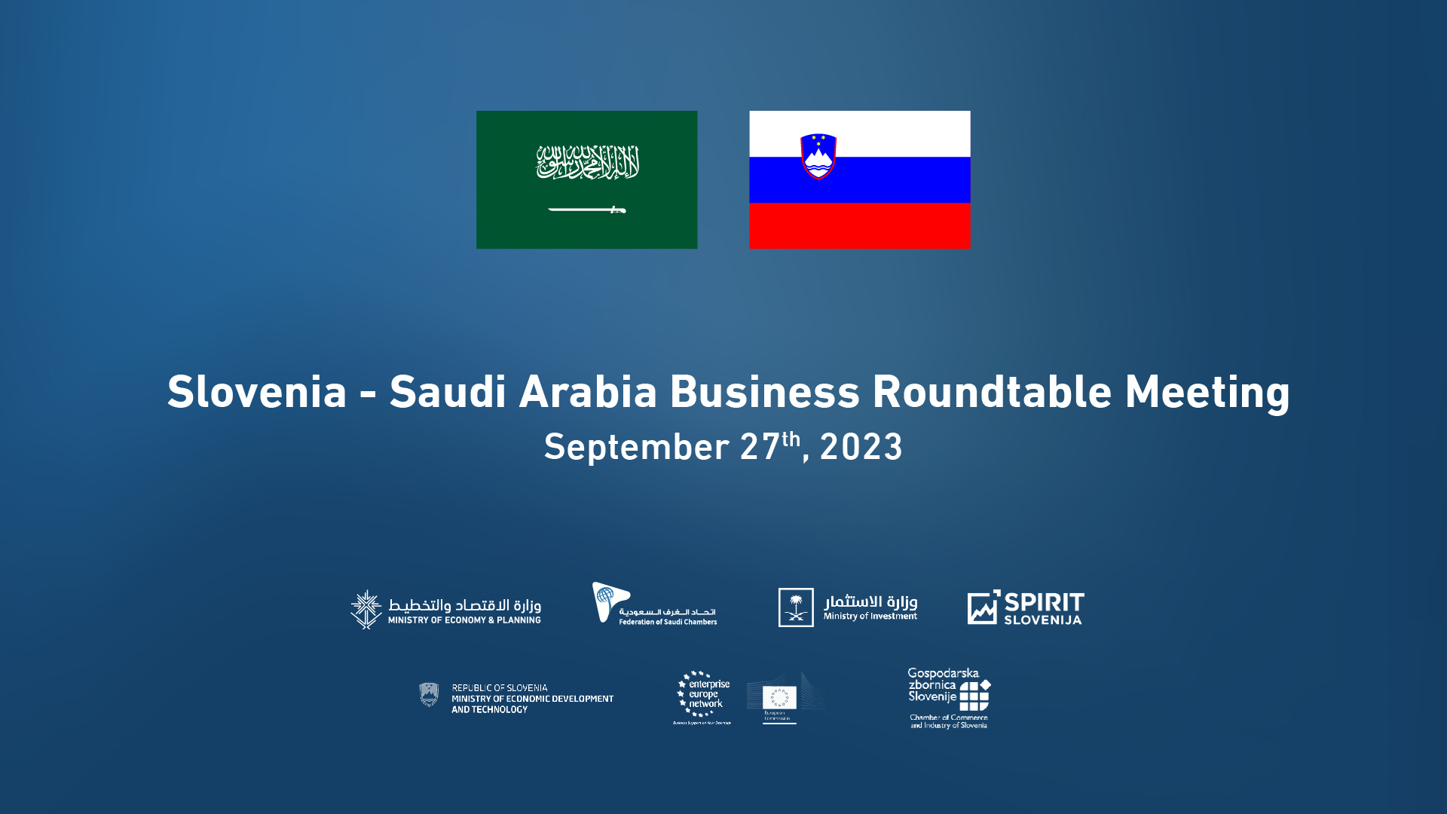

Ljubljana @CCIS, Dimičeva 13

MC: Mr Sebastjan Šik, Director, Corporate Communications, CCIS

|  |  |  |  |
| --- | --- | --- | --- |
| 11:00 – 11:30 | | **Registration** | |
|  | |  | |
| 11:30 – 12:30 | | **Business Networking Session @Business Oasis, 7th Floor** | |
|  | |  | |
| 12:30 – 12:50 | | Welcoming Remarks  Chamber of Commerce and Industry of Slovenia by Mr Matej Rogelj, Director, International Relations Department  Federation of Saudi Chambers by Mr Khalid F Alboayz, Honorary Consul of Slovenia in KSA | |
|  | |  | |
| 12:50 – 13:25 | | **Presentations by KSA**  Videos by MISA  Invest Saudi by Rakan I. Algaraawi, International Office, MISA | |
|  | |  | |
| 13:25 – 14:25 | | **Presentations by SLO**  SLO Business and Investment Environment by Vid Habjan, Head, FDI Deparment, SPIRIT Slovenia Business Development Agency  Successful SLO projects in Saudi Arabia  Robotina Group by Mr Devid Palčič, President, Robotina Group  Duol d.o.o. by Mr Mohamed Elkatafany, Sales Manager, MENA, SE Asia, North & South America, Oceania  Knauf Insulations by Ms Julija Gruden, Senior Technical Sales and Specification Manager, Knauf Insulation Middle East | |
|  | |  | |
| 14:25 – 14:50 | | **Riyadh Expo 2030 Presentations & Film**  Royal Commission of Riyadh City | |
|  | |  | |
| 14:50 – 15:10 | | **Short Coffee Break @Hall A, 1st Floor** | |
|  | |  | |
| 15:10 – 15:35 | | **Closing Session**  Welcome & Briefing by Mr Tibor Šimonka, President, CCIS  H.E. Faisal F. Al-Ibrahim, Minister, Ministry of Economy and Planning | |
|  | |  | |
| 15:35 – 15:45 | | **Signing the Memorandum of Understanding on the Establishment of Saudi – Slovenia Business Council** between the Federation of Saudi Chambers of Commerce and the CCIS & exchanging gifts and group photo | |

|  |  |
| --- | --- |
| 15:45 | **Buffet Lunch & VIP Business Networking** |