

ERASMUS+ SECTOR SKILLS ALLIANCE
[PROJECT DURATION: November 2014 – October 2017]

READING TECHNICAL DOCUMENTATION- ELECTRO

LEARNING MATERIAL
[WORK PACKAGE 3: Designing joint curriculum programu]
[OUT 3.2:Learning materials]
PREPARED BY: P8-SIOV SLOVAKIA

Authors: Alexandra Junaskova
Translated by: SIOV, ZEP SR

June 2016
The European Commission support for the production of this publication does not constitute endorsement of the contents which reflects the views only of the authors, and the Commission cannot be held responsible for any use which may be made of the information contained therein.

CONTENT
LIST OF PICTURES, TABLES A CHARTS 2
LIST OF APPENDIXES 2
1 INTRODUCTION 3
2 TECHNICAL DOCUMENTATION 4
2.1 Types of technical documentation 4
2.2 Technical documentation management 8
3 TECHNICAL STANDARDISATION 9
3.1 Types of standards 10
3.2 Terminology in Elektrotechnics 11
3.3 Technical regulation 11
4 SYMBOLS AND MARKS 12
4.1 Signs 12
4.2 Lines 13
4.3 Values and units, indices 14
4.4 Selected numbers, series 14
4.5 Signal 15
4.6 Conductors 16
4.7 Labelling the components 18
5 PRINTED CIRCUITS 21
5.1 Material 24
6 MEASURING APPLIANCES IN ELECTRICAL ENGINEERING 26
6.1 Measurement accuracy 29
BIBLIOGRAPHY AND REFERENCES 33

LIST OF PICTURES, TABLES A CHARTS
Picture 1: Overview scheme of a radio 6
Picture 2: Block scheme of dynamo voltage regulation 7
Picture 3: Functional scheme of tape recorder 7
Picture 4: Signs – examples of the specified outlets 13
Table 1: Line examples in electrotechnics schemes 13
Picture 5: Signal flow direction 15
Picture 6: References to signals 16
Picture 7: Labelling of a beam of 5 conductors. 17
Picture 8: Sequence of conductors – labelled by a dot. 17
Picture 9: Sequence of conductors – labelled by letters. 17
Picture 10: Connecting, turning 18
Picture 11: Information bus 18
Table 2: Alphabetic labelling of components: 18
Picture 12: IP camera Edimax – 3 printed circuit boards 21
Picture 13: Drawing of conductive pattern 22
Picture 14: Picture of printed circuit board of the amplifier LME 49810 23
Table 3: Construction classes 23
Picture 15: Digital oscilloscope 28
Picture 16: Multimeter 28

LIST OF APPENDIXES
Appendix 1: Assessment example

1 INTRODUCTION
Technical documentation belongs to key aspects of the production process. Is the carrier of information, which constitute the basis for technological processes in manufacturing, construction, wiring of electrical appliances etc.
The purpose of this module is to master an independent reading of technical documentation which reflects developments in the metalworking and electrical industries. The material is also aimed at the correct treatment (management) of technical documentation. Without this ability it is not possible to properly install wiring and ensure the quality of each step of the manufacturing process.
The submitted guide has an indicative nature and it primarily outlines the main areas which the teachers and learners have to focus on. Its use requires the utilisation of other supportive resources (scientific literature, internet sources) for fixing the subject, depending on national and local circumstances and needs. The document contains links to other websites with educational content, from which teachers and learners shall continue to draw. It also foresees the use of own resources and educational content of educational institute/provider.

2 TECHNICAL DOCUMENTATION
It is necessary to follow certain rules when working with the technical documentation - for example, marking and numbering of the document, document archiving etc. The technical documentation is the property of the company/enterprise and it is necessary to handle it accordingly.
The working method with the documentation depends on what kind of documentation is involved. Firstly, the technical documentation must include a clear specification (label) of the product, part or semi-product. The specification can be:
- full
  - name
  - dimension data
  - material identification (numerical, alpha-numerical, verbal)
  - identification of a document which supplement the requirements on the product, its part or semi-product
- simplified
We do not understand "drawings" or "scheme" only under the technical documentation. Technical data can also be found in the commercial documentation (advertising materials, catalogues) or in the service documentation (user manuals, service manuals).

2.1 Types of technical documentation
Types of technical documentation in electro-industry can by divided according to:
1) purpose of its use
- production:
  - construction: e. g. drawings, calculations, test results, technical reports, material certificates, certificates of overtaken components etc.
  - technological: e. g. manufacturing drawings of parts adapted for a specific manufacturing technology, material and semi-products specifications, technological processes etc.
  - operational: e. g. instructions for operation and maintenance, spare parts list, quality certificates, special documentation for special technical devices (classification, elements list, revisions plan, revisions book) etc.
- commercial
- patent
2) processing method
- traditional means of drawing: drawing by hand using the drawing tools and drawing paper
- Modern - computer - technology (the result is printed on the printer or plotter), e. g .:
  - CAD – Computer Aided Design, e. g. AutoCAD, AutoDesk, Inventor
  - CAPP – Computer Aided Process Planning
3) way of drawing (in electrical engineering):
- single-pole - several conductors of the same function (single line), several identical components (single mark)
- several poles - a separate line/mark for separate conductors/components
- undistributed - marks for all elements of the functional units are drawn together,
e.g. wired/interconnect drawing - with regards to the spatial arrangement of appliances
- distributed - marks of all elements of the functional units are drawn separately
e.g. line drawing - different parts of the circuit comprise a straight line (unfolded drawing)
- loop - the various components form a loop (distributed/undistributed drawing)

In this material, we will focus on two types of technical documentation: electrical schemes and commercial documentation. Electrical schemes are divided according to the provided information:
- overall information on the electrical appliance, its functioning, connection etc.:
- overview: the main parts of the device, their purpose and connections (Fig. 1):
- overview schemes of transmission
- overview schemes of equipment
- block: simplified representation of parts of electrical equipment using symbols for block diagrams (Fig. 2)
- teaching: highlighting the objective pursued
- functional: expresses the sequence of processes
- composition of the device, detailed description of the functioning:
- circuit: it includes all functional units, communications
- substitute: parameters analysis and calculation
- electrical connections of an equipment or its parts used for other documentation, especially topographic drawings identifying laying wires and methods of thei attachment, etc.:
- wiring scheme of internal circuits
- wiring scheme of external circuits
- distribution frame scheme
- scheme for the development of other documents, in the manufacture and operation of the device:
- situation: the spatial distribution of the parts of the device (e. g. network situation scheme)
- topographic drawing: shapes of the power lines routes or arrangement of electrical appliance parts
- signal diagram: graphical presentation of variables, e. g. regulatory system by branches and nodes
- modulation diagram: frequency bands with a multiple modulation
- diagram of availability: the order and time intervals of consecutive operations of the functional units of the device
- table of connections: interconnected terminals
- signal box diagram (dog chart): Overview of prescribed electrical and mechanical dependencies determining the scope and operation of the device.
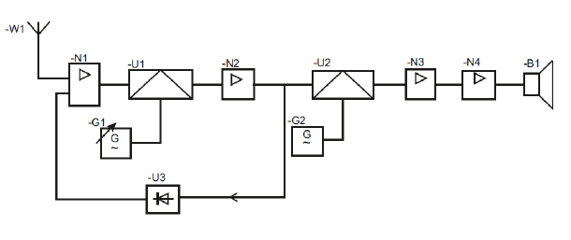
Picture 1: Overview scheme of a radio
Picture 2: Block scheme of dynamo voltage regulation
Picture 3: Functional scheme of tape recorder

Diagrams, software diagrams, sequence conditions, signal diagrams etc. are part of the technical documentation in electrical engineering. Furthermore, explanations of device functions, operating instructions, repairs and maintenance are also part of technical documentation. Due to the fact that electrical devices comprise also energy distribution and wiring in buildings, it is essential to be able to read the maps or building wiring.

2.2 Technical documentation management
The technical documentation is part of the company's property. Management (or the administration) of the technical documentation now increasingly depends on the use of modern technologies. The reason and purpose of the use of tools which are computer-assisted is the fact that these systems allow, for example:
- develop a product
- manufacture a product
- modify product
- direct connection to the production cycle
- the direct connection and communication between the different departments within the company but also with suppliers/customers by using the cloud
- monitor product life
One of the trends that meet this requirement, is the PLM (Product Lifecycle). PLM manages the life cycle of the product from planning to its disposal.
Solutions (tools) based on PLM are several:
- systems connected to CAD or directly built on CAD, e. g.:
- LSD2000 (Czech software) for development of technical documentation in the area of electrical engineering and electronics
- ExpressSCH for schemes development and ExpressPCB for development of printed circuit boards development
- EAGLE for schemes and printed circuit boards development
- OrCAD
- systems not based on CAD
Some tools may be used already by mobile phones (iPad, iPhone, Android) (eg. 360 Mobile PLM).
Systems ERP (Enterprise Resource Planning) integrate processes related to the production activity of the company: production, logistics, distribution etc.
Currently, however, there does not exist a complete programmes "package" that would address comprehensively the PLM - solutions are provided by programmes (modules) which are often not connected to each other. Another problem is also, for example, that these programs are not able to work with the mutual data. Efforts to interconnect and develop complex, interrelated as well as interdisciplinary instruments, for example, proves. EPLAN-Vault Connector that links ECAD for electrical engineering planning (EPLAN Electric P8) with tools for document management Autodesk Vault and with enterprise ERP application.
The technical documentation must be archived and registered in accordance with the agreed rules. Each document has a designated validity, the author, owner, manager must be known and it must contain additional information:
- identifier
- designation, title or document name
- date of completion, issue
- place of archiving
- the type (assembly drawings, wiring diagrams, management ...) and size (A4, A3 ...)
- status of changes - preliminary edition, final, designation according to the last changes, discarded
- other information, e. g. acknowledgment and approval of inspection bodies, certificates, belonging to the set of documentation, author, language, etc.
- information on users - the number and location of distributed copies.

Original drawings are not stocked. Copies of all formats are made according to STN 01 3111 for A4 format. Copies may be stocked: free, direct binding to files or to bond with a strip.

3 TECHNICAL STANDARDISATION
Technical standardization is a process the purpose of which is to provide solutions that are economical, effective and designed to ensure the quality of the processes and products. According to the Act no. 264/1999 Z. z. on Technical Requirements for Products and on Conformity Assessment and on amendments to certain laws : "Technical Standard contains rules, guidelines, characteristics and results of operations aimed at achieving the most suitable arrangement in the area and in general and repeated use."
The technical standards are based on validated and conventional results of science, as well as practice. The result is a generalization of standardization of species and types of products (products, parts, assemblies, as well as services), their properties and parameters, e. g .:
- materials and their properties
- calculations
- production processes.

3.1 Types of standards
We distinguish:
- basic norms: basic standards related to terminology, conventions, metrology, signs and symbols;
- product standards or standards for services: minimum defined parameters that have the products/services comply with (health, safety or the environment, necessary documentation to the products etc.);
- standards for analysis and methods: the properties are measured towards these standards;
- organisational standards: they describe the functioning of the company/firm/ organization, relationships and activities (e. g. the processes of quality assurance, logistics, management, organisation of production etc.);
- according to the territorial validity:
- international standards by the International Organisation for Standardisation, available to the public,
- European standards adopted by European standardisation body, available to the public,
- Slovak technical standards, publicly available,
- foreign standards adopted by a foreign national standardisation body and made available to the public.

An overview of Slovak, European and international standards is published on the website of the Slovak Office of Standards, Metrology and Testing: Published european and international standards. This office publishes also valid Slovak technical norms STN. European standards are furthermore published by European Committee for Standardisation CEN: http://www.cen.eu/Pages/default.aspx. International norms are published by International Organisation for Standardisation ISO: http://www.iso.org/iso/home.html .
The European Committee for Electrotechnical Standardisation CENELEC in the field of electrical engineering is set up which, in addition to the standards, issues so-called harmonisation documents (HD) in the case that the international norm is adopted with major modifications, e. g.:
EN IEC 60332-1 HD 405.1 S1 Flame Propagation Test for a Single Insulated Cable
On the lower level there are the so-called corporate standards - these relate to processes within the company/organisation, but they must comply with the higher standards (national, international). An example might be a Corporate Energetics Standard PNE382161.

3.2 Terminology in Elektrotechnics
Elektrotechnics belongs to the most progressive evolving field. It was necessary - for example, due to the need to correct translation of the instructions for use, service manuals and so on – to introduce a uniform language. The IEC organization is responsible for the unification of the terminology and it issued and updates the International Electrotechnical Vocabulary IEV International Electrotechnical Vocabulary.
The dictionary contains a precise definition of each item and each has its own specific numerical code. The Slovak version of IEV is published as IEC STN (xxx), while the number in brackets indicates the chapter number.

3.3 Technical regulation
Technical regulation is generally binding regulation which contains:
- technical specifications;
- other requirements;
- rules regarding the services;
- regulation prohibiting the manufacture, import, retail or use of a product or prohibiting the provision or use of a service, or establishment of a service provider.
'Technical specifications' states product characteristics such as size, labelling, packaging, quality standards, compliance assessment procedures etc. This term also includes the methods and processes of production.
'Other requirements' include requirements such as conditions for use, reuse or recycling. These conditions affect the composition or character of the product or its sale.

4 SYMBOLS AND MARKS
In principle, the technical drawing in electrotechnics follow the same rules as in metal industry. At this point we recommend to draw from the learning material "Reading Technical Documentation - Metal." Of course, given the diversity of usage of electrical schemes, there are differences. For example, drawing electrician scheme does not include in the label an information on material. The following chapters will be devoted to the differences.

4.1 Signs
Signs and connections used in the electrical system are set out in the standard STN IEC 60617.
We distinguish the standardised signs:
- general (basic) – common for a group of components with the same function
- complementary – they specify the meaning of general signs
These signs can be mutually combined to clarify the meaning.
There are also non-standardised signs used by individual producers and they can be found for example in product catalogues.
In the STN EN 60617 there are some of the signs introduced without outlet. If the sign is in the standard specified with outlet, their position must be maintained their position, as this could cause confusion between the signs, for example the relay coil (Fig. 4a) and a resistor (Fig. 4b).
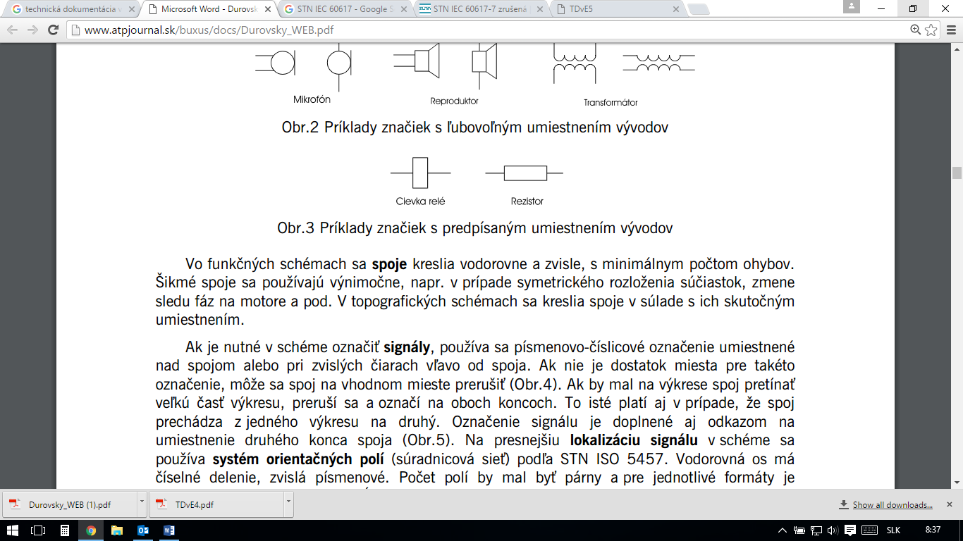
a – relay coil b - resistor
Picture 4: Signs – examples of the specified outlets

4.2 Lines
Electrical schemes usually use one line thickness. Exceptions represent, for example, the main or power circuits, which are plotted with a thick line. It is recommended unified line thickness when using CAD systems. Tab. 1 shows examples of using different types of lines:
Table 1: Line examples in electrotechnics schemes
Line thickness | thin | thick | very thick
Line type
full | elektrical connections generally | main circuits | bus bar
full | elektrical connections generally | bus bar | harness
full | reference line | harness | electric wiring by distinguishing the type
dashed | non-electric connections
dot chain | bounded parts of appliance
dot chain | earthed protective wire
dotted | Repetition of parts or circuits

4.3 Values and units, indices
Physical quantities are used to describe the properties of devices, products or materials. Units are used to express their size. These are listed in the International System of Units SI. Physical quantities referred to in this system are:
- independent of each other - basic. In electrical engineering there are used 4 basic parameters (length, mass, time, electric current);
- derived from the basic (e. g. speed = m.s⁻¹ = kg.m.s² (Newton, N)),
- supplementary (radian, steradian).

Equations express the relations between the variables. It is appropriate in practice to select a set of units so that the equations between the units correspond with the equations between the values - so-called coherent system of units.
Values are written in italics in the technical documentation. Units are written in upright letters. The prefixes are written in upright letters without spaces.
Indices are written:
- physical value – in italics
- other – upright letters
Bold letters are used to mark the matrices and vectors.

4.4 Selected numbers, series
During the design of equipment, appliances and components in electrical engineering the calculations are used intensively. Their output can be different values, which could lead to the design of products with different parameters. Therefore, the different elements (components) are normalized - in different series:
- arithmetic: e. g. for switchboards, assembly boxes. Disadvantage: big number of terms in decade.
- geometric: e. g. in electrotechnics to limit the number of nominal values of manufactured passive components - resistors and capacitors. Disadvantage: the absolute difference between two adjacent higher members of the series is big.
- module: the combination of abovementioned. The members of the series are calculated: 2^{m}.n.d
m – integral number
n – defined as „N≤n≤2N-1“
N – numerical basis of the module series where N is a positive number bigger than 0
d – dimensional coefficient

Module series is marked as: mod(N;d)

4.5 Signal
Placing the signal signs in the electrical documentation respects:
- functional layout: signal flow and functions regardless of the actual location of elements
- topographical layout: respects the deployment of elements

Symbols for the direction of the signal flow in electrotechnical drawings is defined by norms from left to right.

Signal flow direction
left to right | bottom up | right to left | up to down
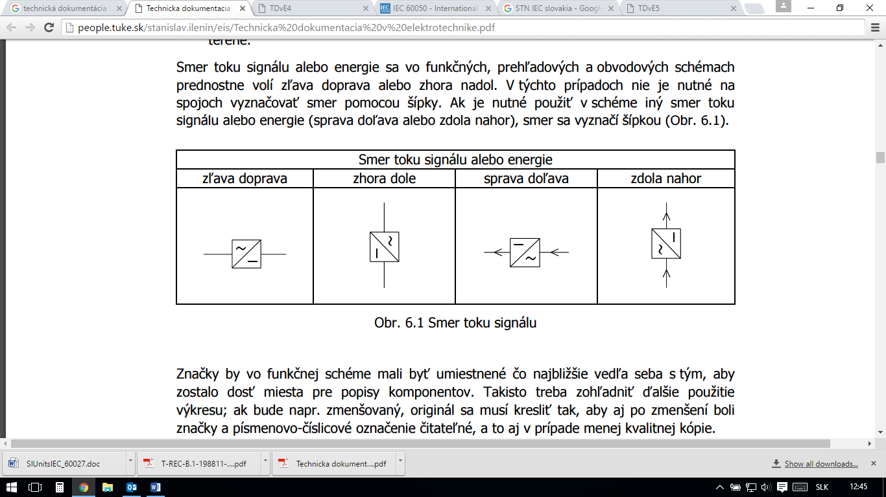

Picture 5: Signal flow direction

If it is necessary to indicate signal in the scheme, alphanumeric designation above the joint or left to the joint next to the vertical lines is used (in this case it is possible to interrupt the connection). If it crosses the big part of the drawing or continues on another drawing, i tis marked on both ends.
Coordinate system (system of orientation fields) is used for signal localization whereas the horizontal axis contains the numerical division, vertical axis uses the letter division (Fig. 6).
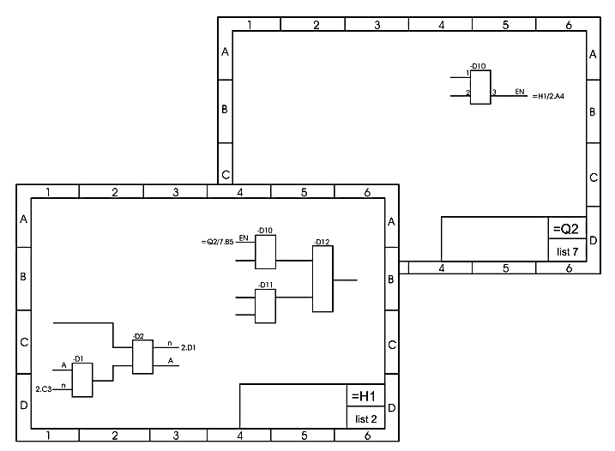
Picture 6: References to signals

4.6 Conductors
It is possible to group the conductors in the overview and surveillance and circuit schemes by their functions in case of 6 (resp. 5) or more parallel conductors. Group of conductors can be thus replaced by a beam. The beam is labelled with the number and the slash (Fig. 7) or a thick line.
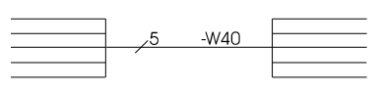

Picture 7: Labelling of a beam of 5 conductors.

Sequence of conductors is labelled by a dot or by letters (Picture 8 and 9).
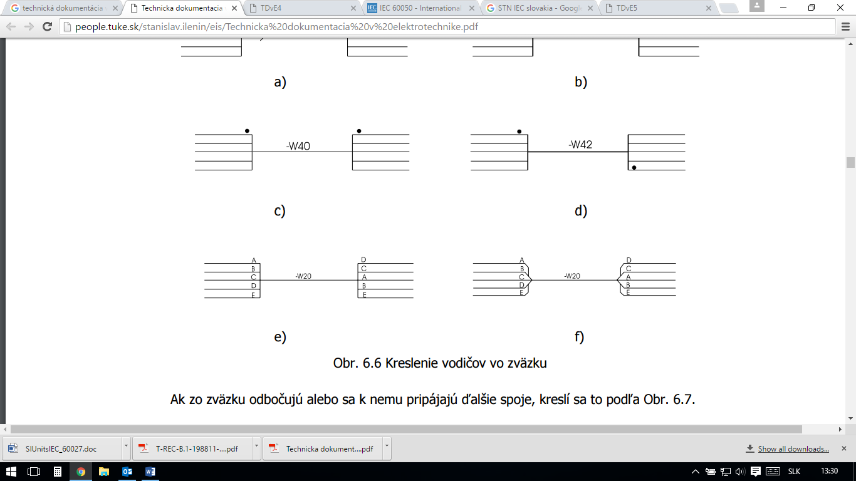

Picture 8: Sequence of conductors – labelled by a dot.

Picture 9: Sequence of conductors – labelled by letters.

Picture 10 shows different ways of connections and turns. Turning and crossing of joints are drawn:
- a conductive connection: in the shape of a "T"
- non-conductive connection: cruciform
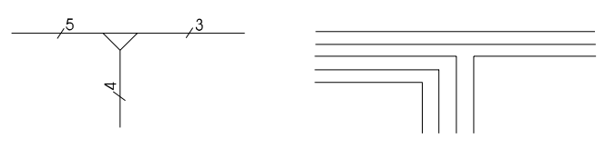
Picture 10: Connecting, turning
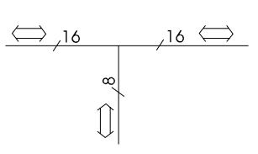
Supplementary mark is used for boards that represent information bus (Fig. 11).

Picture 11: Information bus

4.7 Labelling the components

Components are labelled by alphabetical letters:
Table 2: Alphabetic labelling of components:

A | Functional blocks, assembly and subassembly: e. g. amplifiers, receivers, transmitters
B | Convertors of non-electrical values to electrical and vice versa: e. g. microphones, loudspeakers, piezoelectric transducers
C | Condensers
D | Digital elements and appliances: e. g. microprocessors, delay lines
E | Various components: e. g. heaters, lights
F | Securing and protection device: e. g. current relay, surge protection
G | Energy sources and signals: e. g. cells and batteries, oscillators, frequency converters
H | Signaling devices: e. g. sound - bells, light bulbs, lighting - LED
K | Electrically operated switch: e. g. auxiliary relay, time
L | Inductors, reactors and chokes
M | Motors, servomotors
N | Analog components and devices: e. g. analog integrated circuits
P | Measuring instruments and testing equipment: e. g. measures of current, voltage
Q | Switches in the energy and power circuits: e. g. short-circuit, earthings
R | Resistors
S | Switches in communication and auxiliary circuits: e. g. monitoring (level, pressure) sensors
T | Transformers
U | Converters of electric quantities to power: e. g. modulators, modems
V | Electric vacuum and semiconductor devices: e. g. tubes, cathode ray tubes, diodes
W | Lines and waveguides and antennas: e. g. cables, optic fibres
X | Connecting electromechanical components: e. g. terminal blocks, connectors
Y | Electrically operated mechanical devices: e. g. brakes, electromagnets
Z | Finishing elements, filters, limiters: e. g. active/passive filters, electric shunts

Labelling defines the following:
- pertinence to the higher unit
- the type and serial number of the device part
- access point
- location
In case of a simple scheme, only points 1 and 2 apply.
For the parts of a device the following symbols are used:
znak | blok
= | functional block
- | funkctional unit
: | access point
+ | topographic location

For example, the signs on the Picture 6: References to signals
express:
=H1 | drawing of the module výkres marked as H with the consecutive number 1
=Q2-D10:3 | module Q with the consecutive number 2, digital circuit D with consecutive number 10, terminal 3

5 PRINTED CIRCUITS
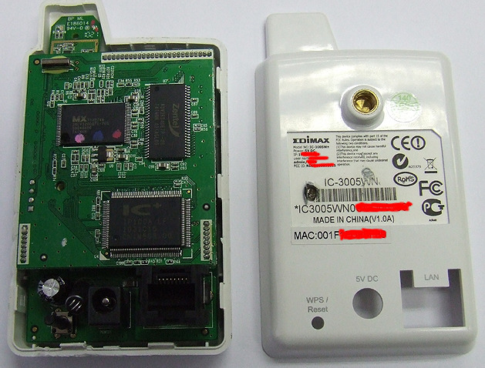
Today, we can find the circuit boards in almost any electrical or electronic device:

Picture 12: IP camera Edimax – 3 printed circuit boards

Printed circuit board (Fig. 12) is the link between the components of electrical or electronic equipment. The printed circuit board consists of:
- carrier plate (non-conductive material: e. g. paper, ceramics, glass cloth epoxy, etc.).
- conductive films (used electrolytic copper 99%, thickness 8μm - 70 μm)
According to the arrangement of conductive paths we distinguish boards:
- single sided
- double sided with a through-hole plating
For production and technology of circuit boards, we recognize the following types of documentation:
- wiring diagram
- the drawing of the board:
- indication of the board outline
- dimensions external dimensions and shapes of the board
- marking checkpoints
- table of circular holes (data for coordinate drilling machines)
- drawing of circular holes (position and number of all circular holes, checking and filing points, the starting point of drilling, marking board outline)
- drawing of conductive pattern:
- drawing of conductive pattern
- marks for checkpoints
- dimension of control rate
- approximate indication of a special holes
- board marking
- printing drawing

Picture 13: Drawing of conductive pattern

Furthermore, we define the accuracy classes, the basic material, type and thickness of the coating, the list of documents (i. e. list of all production drawings).
Printed circuits are realised by thin sheet conductors:
- situated inside the base material (the multilayer board).
- applied to the surface of the base material (in case of single- or double-sided boards)
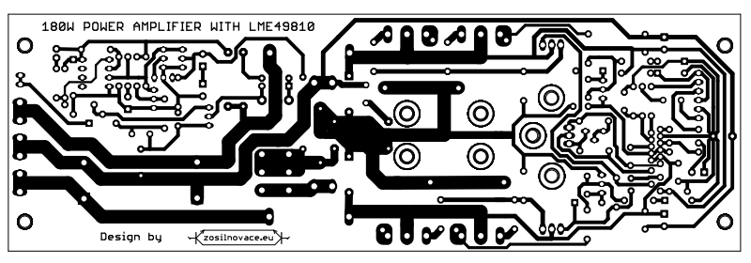
Picture 14: Picture of printed circuit board of the amplifier LME 49810

Design of printed circuit boards is divided into six structural classes (Tab. 3) and according to the scope of manufacturing tolerances six structural classes correspond with six accuracy classes.
Accuracy class is set by:
- required smallest centre to centre spacing of the two connecting points;
- smallest diameter circular solder pads (d+) to the hole diameter (d);
- minimum width of the strips and the insulating gaps;
Table 3: Construction classes

Parameter | Class
Parameter | I. | II. | III. | IV. | V. | VI.
Centre distance of connection points | 5 | 3,54 | 2,5 | 2,5 | 2,5 | 2,5
The number of drivers passing through the attachment points | 1 | 0 | 0 | 1 | 2 | 3
The minimum diameter of the drill hole of connection point d | 0,8 | 0,8 | 0,8 | 0,7 | 0,7 | 0,7
The minimum diameter of solder pads d+ | 1,9 | 1,45 | 1,05 | 0,7 | 0,5 | 0,5
The minimum width of the strips | 0,5 | 0,4 | 0,35 | 0,3 | 0,2 | 0,15
The minimum width of the insulating gaps | 0,9 | 0,7 | 0,45 | 0,35 | 0,25 | 0,2

5.1 Material
Printed circuit boards – their parameters – are influenced mainly by the material used for their manufacture.
It is necessary to take into account certain parameters for the materials:
- insulation resistance: surface resistivity (usually R_{p}=10¹²Ω) and internal resistance (usually R_{v}=10¹³Ω). They specify thresholds of conductivity and short circuits. They are measured by the mega ohmmeter.
- electric strength: it determines the resistance of a material to an electrical discharge, perpendicular to the electrodes. It is stated in [V/m].
- breakdown voltage: it determines the resistance of a material to an electrical discharge to the laminate. It is stated in [V].
- dielectric constant (permittivity): it determines the material ability to capture electrostatic energy. It is measured by capacitive bridge routinely at 1 MHz.
- loss factor: This is the rate of dielectric losses.
- Thermal Coefficient of Expansion TCE and glass transition temperature T_{g}: TCE changes at T_{g}, when the material turns into a viscous and elastic. Exceeding this temperature results in destruction of PCB.

5.1.1 Boards
During the manufacture of printed circuit boards the directive RoHS (Restriction of Hazardous Substances) is applied which sets maximum levels of certain toxic substances such as lead, cadmium, hexavalent chromium etc.
Overall, we divide materials from which the board are made as follows:
- on the basis of phenolic resins: they have good electrical properties, they are cost effective. The content of the bitumen is about 35-58% to avoid brittleness of the material.
- based on epoxy bitumen: they have good electrical and mechanical properties, the material is stable and resistant to acids and alkalis. The disadvantage is its softening at high temperatures, although it is one of the most used material.
- on the basis of the polyamide: they have high temperature resistance, but they are economically disadvantageous (high costs).
- based on polytetrafluoroethylene (Teflon): This is a composite material in combination with glass fibres; they have excellent electrical properties, however, they ares economically disadvantageous and it is difficult to produce multi-layer boards).
- based on polyester bitumen: despite the economic advantages they show problems with board bending and the plating is difficult.
- inorganic materials: they are rigid, used only for special applications, for example, due to problems with mechanical stress.
Some boards have special technology of production - for example, by inserting a metal core (typically an alloy), which increases the thermal conductivity of the plate and reduces the linear extensibility.
Another possibility of improving the properties of printed circuit boards is to create a 3D model - multi-layer circuit boards with integrated passive and active components inserted into the ceramic structure.

5.1.2 Conducting paths
The circuits are typically designed using CAD technology. The motif is transferred to the transparent film serving as a template for creating printed circuit boards.
Current capacity of the circuit is approximately 5 times higher compared to conventional wire due to better heat dissipation plate. The temperature must not exceed the long-term temperature T_{g} of the base material of printed circuit.
Insulation resistance of PCB is a gap between two printed circuit boards.
Parasitic capacitance and inductance are reflected between the separate layers of the circuits, between the joints etc. Its size depends on the size of the overlapping areas, the distance and dielectric constant (we consider the material to be of high quality those with lower dielectric constant).
When we are designing PCB we consider e. g.:
- proper filtration
- blocking of voltage
- minimizing the loops and connections lengths
- minimizing the current value
- minimizing the transfer rate
- electrostatic and electromagnetic shielding

6 MEASURING APPLIANCES IN ELECTRICAL ENGINEERING
We divide measuring appliances in electrical engineering from several aspects:
- according to the method of determining the measured quantity from the instrument:
- absolute measuring instruments - allow to state the measured value without comparison to another instrument. They allow to determine the measured value based on the dimensions of some parts of the measuring instrument on the basis of weight, they are the most accurate and the most expensive.
- secondary measuring instruments - we determine the measured value compared to the value that was determined using a more accurate measuring device. All commonly used measuring instruments belong to this category.
- according to measuring accuracy:
- Etalons - operate with the highest possible precision.
- Basic measuring instruments - serve as instruments for the verification of laboratory measuring instruments for a very precise measurements. Typically, they have accuracy class 0,1.
- Laboratory devices - used for a sufficiently accurate measurements in operations.
- Operation devices - for routine measurements at operation sites.
- according to the type of measured value: ammeters, voltmeters, wattmeters, galvanometer ohmmeters, electricity meters, frequency meters, phase meters, devices for measuring non-electrical quantities and others.
- according to used current system: for DC, AC single-phase, multi-phase.
- according to the method of measurement and measurement data values:
- analogue measuring instruments - they measure and state the continuous change of the measured quantity continuously. An output variable of the analogue measuring device is commonly expressed by deflection the pointer or of the light spot on the television screen.
- numerical (digital) measuring devices - they change measured analog quantity for discrete and indicate continuous change in numerical form.
- according to the method of determining measured variable:
- direct measurements - measured variable value is determined directly, without calculation
- indirect measurement - value measured variable is determined by a calculation from the other variables
- combined measurement
- according to measuring mechanism:
- magneto-electric
- devices with rotating magnet
- ferromagnetic
- electrodynamic and ferro-dynamic
- induction (Ferraris)
- thermal (expansion, with wire, to binary)
- electrostatic
- vibration (resonance)
- according to the way of reading measured variable:
- analogue devices
- recording (registration) devices - they graphically record on the registration strip immediate, effective, medium or peak value of measured variable
- vibrators - show the measured variable by an amplitude of resilient tongues or the size of the amplitude of the light beam
- devices with a light indicator
- according to the provided information on the measured value:
- indicating devices - inform about the presence of the measured variables (eg. testers)
- devices that provide information about the size of measured variable
- devices that inform about the waveform parameters within a short period of time (oscilloscopes)
- devices that transcribe the measured values over a longer period of time (oscilloscope)
- devices that write changes in the value over a long period of time (recorders)
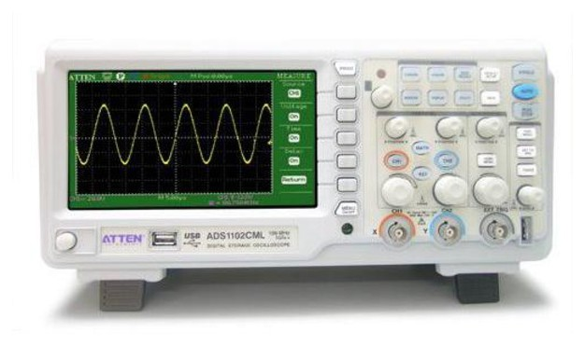

Picture 15: Digital oscilloscope

Currently there are available measuring instruments that can measure, for example, all the basic electrical values:
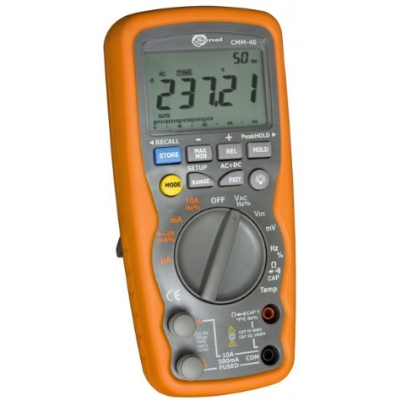

Picture 16: Multimeter

Some parameters of the multimeter from the picture 15:
- current measurement: from 0,01μA to 10A AC/DC TrueRMS (20A: max. 30 seconds with limited accuracy)
- best accuracy: 0,06% +4 dig. / DC voltage
- resistance in the range of: from 400Ω to 40MΩ
- capacity in the range of: from 40nF to 40mF
- the frequency in the range of: from 40Hz to 100MHz
- duty cycle measurement in the range of: from 0,10 to 99,9% (at 5Hz...150kHz)
- diode and continuity test (acoustic)
- temperature with thermocouple K: from -50°C to +1200°C

6.1 Measurement accuracy
It is never possible to determine quite accurately the actual measured value. Measurement accuracy is expressed indirectly by the error value. Errors are reported in %.
Electrical measuring instruments belong to the classes of accuracy:
- 0,1 – the most accurate appliances
- 0,2 – very accurate laboratory appliances
- 0,5 – accurate laboratory appliances
- 1 – mounting devices (accurate)
- 1,5 – switchgear devices
- 2,5 – other devices (pocket etc.)
We distinguish two basic measurement errors:
a) absolute (∆):the difference between the measured value (N) and actual value (S)
∆ = N - S
The actual value is not ascertainable - it is replaced by the so-called conventional true value. This can be obtained only by evaluating the high number of measurements or theoretical calculations.
b) relative (δ):
$δ= \frac{∆}{N}∙100$ or $δ= \frac{∆}{N}∙100 \left[\%\right]$

Analog measuring instruments:
a) allowed maximum error (∆X_{mx}):
$$∆X_{mx}=\frac{tp∙X_{r}}{100}$$
tp – accuracy class
X_{r} – scope in the units values

b) allowed (maximum) relative error (δ_{x mx}):
$$δ_{x mx}= \frac{∆X_{mx}}{X}∙100$$
Example: What is the value of measured electric current, what is the maximum allowed relative error of measurement, if the ampermeter shows 50 pieces at 120 segment scale? Ampermeter range is 360 mA, accuracy class is 0,5.

Solution:
a) Measured value is ascertained by simple equation:
$$I=k_{A}∙α_{A}=\frac{I_{r}}{α_{r}}∙α_{A}=\frac{360∙{10}^{-3}}{120}∙50=150∙{10}^{-3}=150 mA$$
where
k – instrument constant
α – indicator deviation

b) Maximal allowed relative error is calculated as follows:
$$δ_{I mx}= \frac{∆I_{mx}}{I}∙100==\frac{tp∙I_{r}}{100∙I}∙100=1,2\%$$

Digital measuring devices:
a) absolute error
$$∆X_{dov}=±\left(a_{1}X_{x}+a_{2}X_{r}\right)$$
b) relative error
$$δX_{dov}=±\left(a_{1}+a_{2}\left(\frac{X_{r}}{X_{X}}\right)\right)$$
where
a₁, a₂ – constants
X_{x} – measured value
X_{r} – used range

We distinguish errors according to the method the occurrence to:
- constant errors (systematic): by repeating the of the same measurement they have the same size.
- random errors: by repeated measurements they are of different sizes.
According to the reason of the occurrence, we distinguish the following errors:
- errors of measuring method – measurement accuracy depends also on the selected measuring method. If lower accuracy is sufficient, we can use simpler and faster method.
- errors of measuring instruments
- errors caused by disturbing influences - the measuring instruments are exposed to different influences which influence their data, for example:
- mechanical influences (e. g. bearing friction)
- temperature
- external electromagnetic field
- frequency

According to sources of error:
- subjective: e. g caused by staff
- objective

7 REFERENCES
Monograph
[1] BALOGH J. (2001). Technical documentation in electrotechnics. ISBN 978-80-553-0983-5

More authors
[1] ĎUROVSKÝ F., SEMAN S. (2001). Technical documentation in electrotechnics. ISBN 966-80-553-0259-2

[2] MOJŽIŠ M., MOLNÁR J. (2009). Electotechnical practise. ISBN 978-80-553-0259-1

Electronic sources

[1] Drawing in electrical engeineering. http://www.atpjournal.sk/buxus/docs/Durovsky_WEB.pdf [23.3.2016].

[2] Elektrical practise. http://kteem.fei.tuke.sk/dokumenty/ep/EP_VseobecnaCast.pdf [22 .09. 2016].

[3] Norm STN IEC 60617. http://people.tuke.sk/dusan.medved/Subory/TDvE5.pdf [22 .09. 2016].

[4] Electrotechnics. http://www.tonko.eu/ele/node/166 [22 .09. 2016].

[5] Amplifiers. http://zosilnovace.eu/LME49810.htm [22 .09. 2016].

APPENDIX 1: ASSESSMENT EXAMPLE
Reading technical documentation - electro assesment paper
Learning outcome 1: Using the theoretical knowledge of working with digital pictures

Name and surname: ____________________________ Date: _____________________
Signature: ____________________________________ Points: _____________________

2 point
- Write the name of the component for each mark.

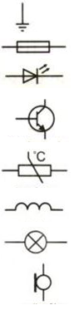

2 point
- Identify the component, type and value of the component.

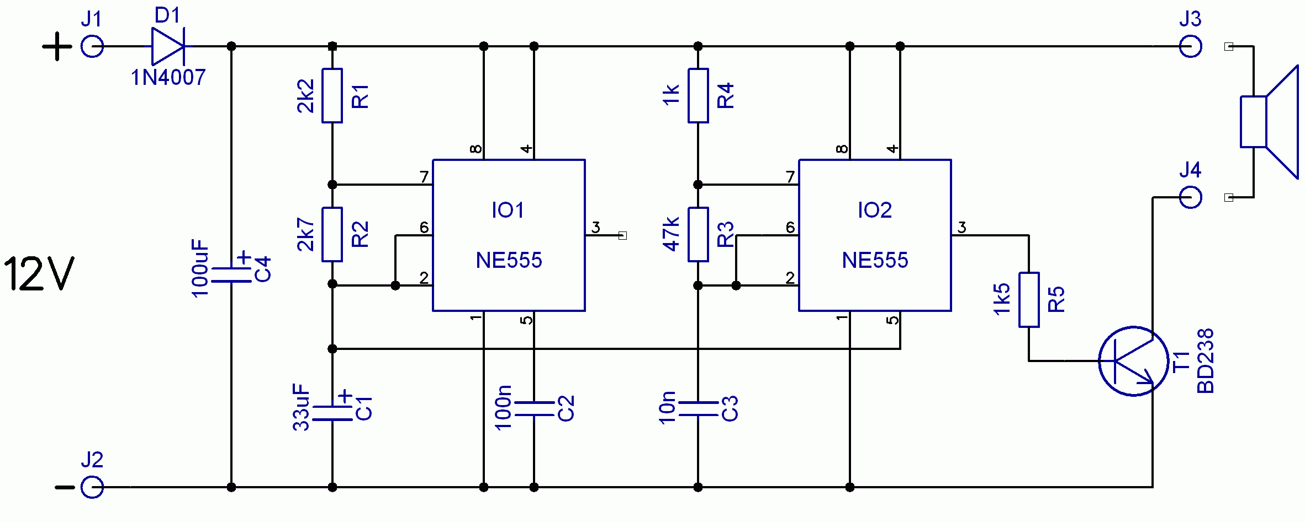

R1:
C3:
R3:
C4:
D1:
T1:

- Write the type of electrical scheme on the picture below.
1 points

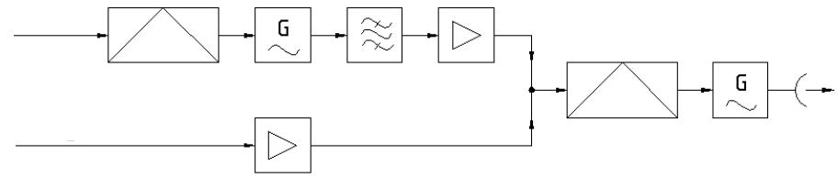
2 point
- What is the meaning of the following picture? Please, write the meaning of numbers and letters and explain them.
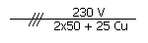

- Identify the type of the schemes on the following pictures and explain difference of their working between them.
2 point

- Connect by line symbol of logical element with appropriate norm according to which it has been drawn.
1 point
Symbol Norm
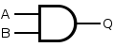
IEC
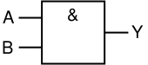
ANSI / MIL
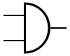
DIN
5 points
- Identify the name of scheme on the picture below, describe its characteristic and list each component on scheme.
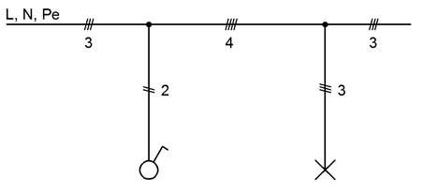

- Identify all wiring components in the rooms “KITCHEN” a “BEDROOM 2”.
8 points

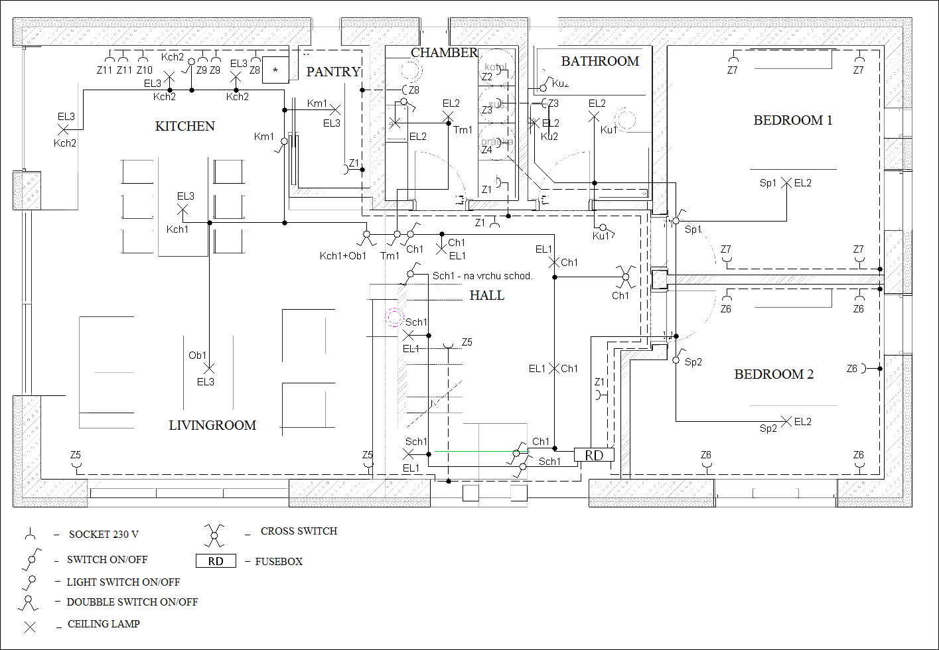
- Look at the scheme and answer the following questions:
7 points
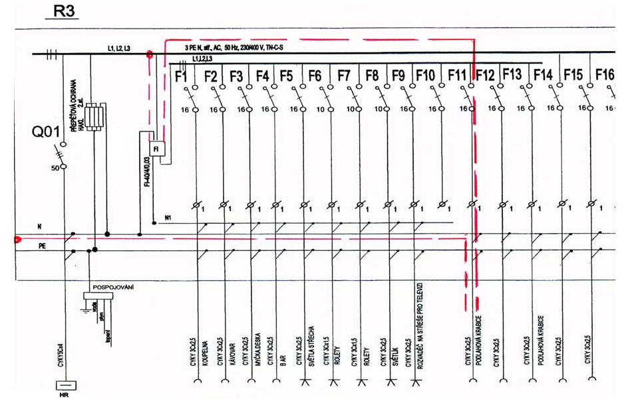

a) Identify the appliance from the scheme (its mark).
b) Explain the meaning of the component – F10 on the scheme, what are its parameters and its purpose.
c) Explain the meaning of the component – Q01 on the scheme, what are its parameters on actual scheme?
d) What does the mark CYKY 3C2,5 mean?

- Look at the drawing and answer the following questions:
5 points

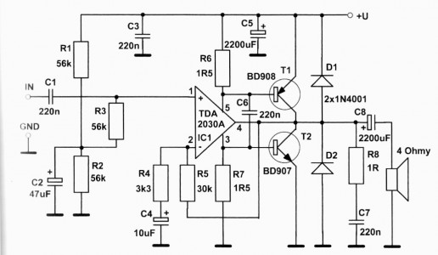

- What is the purpose of the electrical circuit on the scheme?
b) How many rezistors with value 56 kΩ are on the scheme?
c) What is the value of the component R7?

- What type of scheme is presented on the picture and specify it.
2 points

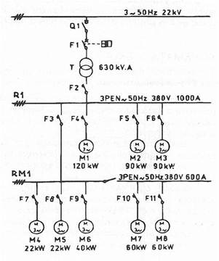

Oral test:

1 point
- Question………………………………………………………………………………….

1 point
- Question………………………………………………………………………………….

1 point
- Question……………………………………………………………………………….

Pod termínom „komponent“ v elektrotechnike rozumieme všeobecný názov pre funkčný prvok, súčiastku atď. v prípade, že sa nevyžaduje bližšia definícia.
http://people.tuke.sk/stanislav.ilenin/eis/Technicka%20dokumentacia%20v%20elektrotechnike.pdf
http://people.tuke.sk/stanislav.ilenin/eis/Technicka%20dokumentacia%20v%20elektrotechnike.pdf
http://eur-lex.europa.eu/legal-content/EN/TXT/?uri=OJ%3AJOL_2015_241_R_0001
Príklady: http://people.tuke.sk/dusan.medved/Subory/TDvE5.pdf
It is not recommended nowadays to draw a full circle.
PCB – Printed Circuit Board
http://zosilnovace.eu/LME49810.htm
http://www.tonko.eu/ele/node/166

