

ERASMUS+ SECTOR SKILLS ALLIANCE
[PROJECT DURATION: November 2014 – October 2017]

CAD/CAM

SCHOOL MATERIAL
[WORKPACKAGE 3: Designing joint curriculum]
[OUT 3.2: Learning materials]
PREPARED BY: P12-Strojarska tehnička škola Fausta Vrančića

Author: Snježana Korčij
Translated by: Strojarska tehnička škola Fausta Vrančića

June 2016
The European Commission support for the production of this publication does not constitute endorsement of the contents which reflects the views only of the authors, and the Commission cannot be held responsible for any use which may be made of the information contained therein.

TABLE OF CONTENT
1 . INTRODUCTION 4
2 . TYPES OF PROGRAMMING THE CNC MACHINE TOOLS 4
3 . CAD/CAM 5
3.1. CAD - Computer Aided Design 5
3.2. CAM– Computer Aided Manufacturing 7
3.3. Advantages and possibilities of using CAD/CAM 11
3.2. Algorithm of CAD/CAM programming 12
4. 5-Axis processing 15
4.1. 5-axis processing in the moulds and tools industry 15
4.2. 5-axis processing of cutting tool holders 16
4.3. 5-axis processing of propellers 16
4.4. The 5-axis processing of turbine blades 17
4.5. Kinematics of CNC machines 18
5. EXAMPLE OF CAD/CAM PROGRAMMING FOR FIVE-AXIS MILLING 20
5.1. Assignment description: 20
5.2. Assignment solving procedure 22
5.2.1. Sketch analysis 22
5.2.2. 3D model development 22
5.2.3. Development of blade processing technology 27
5.2.3.1. Defining the 5-axis CNC machine for blade production 27
5.2.3.2. Defining the milling operation 29
6. TITLE, REFERENCES 37
APPENDIX 1: PART OF G CODE FOR 5-AXIS MILLING OF A TURBINE BLADE 39
APPENDIX 2: TECHNOLOGICAL DOCUMENTATION 41
LIST OF PICTURES, TABLES AND CHARTS
Figure 1: 3D models created in two different CAD programs ready for import into CAM[13] 6
Figure 2: CAD systems[13] 7
Figure 3 CAD/CAM system[13] 8
Figure 4: CAM sytem[13] 9
Figure 5: CAM programming of CNC machine in two different CAM programs[13] 12
Figure 6: The most famous CAD/CAM systems[13] 12
Figure 7: Algorithm of CAD/CAM programming[13] 12
Figure 8: Mould core processing[5] 15
Figure 9: Processing bevel tools[5] 16
Figure 10: Final processing of propeller blades[5] 17
Figure 11: Rough machining of a turbine blade[5] 17
Figure 12: Final processing of a turbine blade[5] 18
Figure 13: Five-axis mill[5] 19
Figure 14: A workshop blade sketch[12] 21
Figure 15: Blade profile coordinates[12] 22
Figure 16: Interpolating the previously obtained referential cross-section of the blade[12] 23
Figure 17: Extracting the body of blade[12] 24
Figure 18: Final 3D model of the blade[12] 25
Figure 19: Processed item model[13] 26
Figure 20: Model of the blade and processed item[13] 26
Figure 21: CAM module of Machining_Prismatic Machining environment[12] 27
Figure 22: Five-axis CNC machine[12] 28
Figure 23: Clamping of the workpiece on the machine[12] 29
Figure 24: Defining the processing parameters for rough milling of the blade[12] 29
Figure 25: Simulation of the blade profile rough milling on the machine[12] 31
Figure 26: Defining the processing parameters for blade’s external surfaces milling[12] 32
Figure 27: Simulation of milling the blade’s external surfaces on the machine[12] 33
Figure 28: Simulation of final finishing of blade’s external surfaces in CATIA program[12] 34
Figure 29: Simulation of face milling of blade top in CATIA program[12] 35
Figure 30: Defining the processing parameters for face milling of the blade top[12] 35
Figure 31: Turbine propeller blade[12] 36

LIST OF APPENDIXES
Appendix 1: Part of G code for 5-axis milling of a turbine blade
Appendix 2: Technological documentation

1 . INTRODUCTION
This manual is intended for students who will attend the CAD/CAM module.
In the module classes, students will learn how to program a 5-axis CNC mill by using some of the CAD/CAM programs, how to perform the presetting of the machine and produce their first piece on the 5-axis mill.

2 . TYPES OF PROGRAMMING THE CNC MACHINE TOOLS
CNC machine tools programming is a procedure of developing a program according to a pre-defined technology for the development of a product and it can be done manually or with the assistance of a computer.

Manual programming is the oldest and technologically the lowest level of programming the NC and CNC machines. It is implemented in the technological elaboration of processing parts of simple geometry and in case thery is a small share of CNC machines. In developing an original program of manufacturing one part (like a NC-code), a programmer-technologist guides the tool from one point to another following the the processing contour, taking into account the technological parameters: machinability of processed item, features, optimal parameters of processing, etc.

Disadvantages of manual programming are the following:
- Manual programming when there is a large number of machines and complicated parts becomes a “bottle neck” in production
- More qualified programmers are needed
- the technological procedure itself of manufacturing parts lasts longer due to the slow programming procedure which increases the product price
- there is a greater possibility for error, particularly when creating more complex parts
- Computer-aided programming means automatic programming based on selected parameters such as: dimensions of prepared item, path and selection of tools, processing regimes, etc. in specific softwares
In computer-aided programming, the NC code is generated on the basis of 3D geometry of manufactured item, the available tools and processing regimes through CAD/CAM system.
The computer-aided programming has prevailed over manual programming due to:
- Faster development of program
- Less possibility for error
- Better use of resources

3 . CAD/CAM

Cad/Cam is a technology enabling an automatic transfer from product design to its production.

Cad/Cam represents the integration of design (CAD) and production activities (CAM) through computer systems.

3.1. CAD - Computer Aided Design
CAD - Computer Aided Design is a manner of using computer programs in order to help with creating, modifying, analysing and optimizing design.
CAD programs are used in the development or improvement of product construction, from concept design to documentation production.
CAD programs represent support to the design process, in creating geometric presentation of what is being designed, then to the process of dimensioning and tolerances, managing changes, archiving and exchange of information on parts and assemblies.

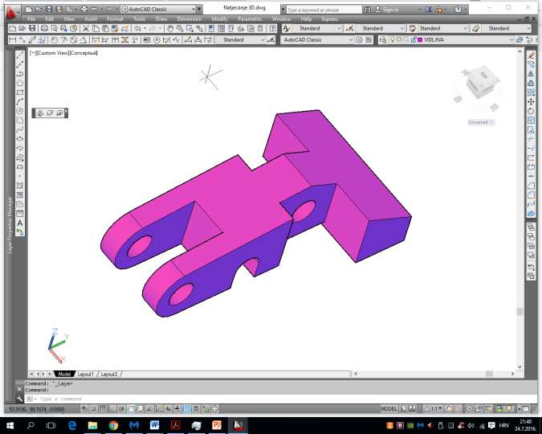
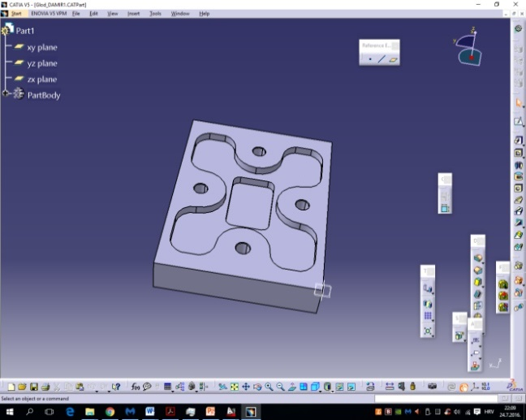
Figure 1: 3D models created in two different CAD programs ready for import into CAM[13]
CAD system consists of inter-related elements:
- User (constructor) who knows how to work on the computer and other hardware equipment, uses the CAD sofware and other necessary programs and is able to resolve an established construction problem

- Hardware consists of the computer and its equipment. Hardware needs to be adjusted to the user and it is important to ensure efficient functioning of CAD software (more RAM, faster processor, good quality monitor...) so that he can address specific construction assignments. For particular assignments, some additional specific I/O equipment is required.

- Software consists of primarily the CAD software, but it also uses the operation system and various assisting programs. Special additional CAD software modules are used for particular purposes.
- A problem and construction assignment present an entry point into the proces of constructing and developing a product. The established assignment affects other CAD system elements. The specific problems require the constructor’s specific expert knowledge. The specific problems also require particular characteristics and/or harware and software solutions

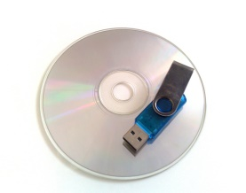
CAD
User
Hardware
Software
Problem

Figure 2: CAD systems[13]

3.2. CAM– Computer Aided Manufacturing
CAM– Computer Aided Manufacturing is an efficient use of computer technology to plan, manage and control the production processes. On the basis of CAD model, the generating of G code for processing on computer managed machines is done. Today, almost all types of processing are based on CAM technologies.
Unlike CAD, which used to help in modelling and constructing products, processes and manufacturing plants, CAM is used as program support in manufacturing, i.e. the control of CNC machines used for processing and manufacturing of processed items. Traditionally, CAM is seen as a program tool for numerical control (NC) where the CAD system helps generate two-dimensional or three-dimensional models. By using the data on model geometry obtained from the models and drawings created in the CAD system, it is possible in the CAM program to generate a tool path for different manufacturing procedures. A typical process of developing a program for CNC machine management includes manufacturing parts and lists of parts in the CAD program up to the final point and also manufacturing the layers of geometric features required for the CAM processing program.
The description of a part made in the CAD program is translated into the adjusted format, such as DXF or IGES, which is then loaded into the CAM program where it is used to make a tool path which follows the description previously made in CAD

DXF File
CAD PROGRAM
Computer
Aided Design
Creating the geometry of all integral parts
CAM PROGRAM
Computer Aided Manufacturing
Taking over the geometry from CAD and its description by G code
NC File
CNC PROGRAM
Computer Numerical Control
CNC machining

Figure 3 CAD/CAM system[13]

Similar to the CAD system, the CAM system is made up of mutually inter-connected elements.

- The CAD model represents the entry for CAM system. In defining the CAD model (in the construction phase) the manufacturing technology is already defined or the selection of possible technologies is significantly limited.
- The hardware in the CAM system consists of, primarily the CNC machines, machining centres, flexible manufacturing systems, etc., as well as a computer. The complexity and price of CNC machines significantly exceed the complexity and price of computers, and contemporary machines usually have their own computer.
- A CAM software can be independent or connected to a particular machine.

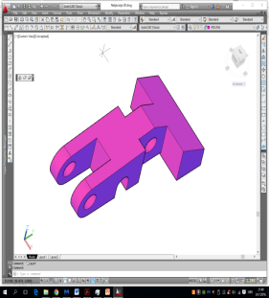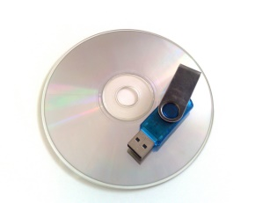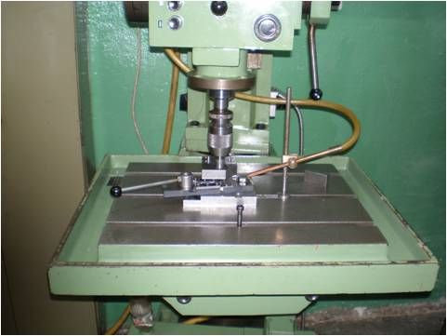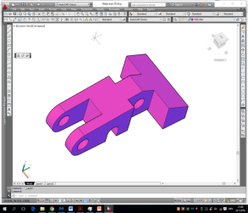
CAM
User
Hardware
Software
CAD model
=

Figure 4: CAM sytem[13]

The basic functions of CAM system are related to the production and technological processes planning.
They include the following:
• generating the prepared item
•generating and optimizing the tool paths
• creating and using the data bases and catalogues of cutting conditions and tools
• calculation of manufacturing time
• generating the NC programs
• simulation and visualisation of manufacturing processes
• generating the production documentation

The geometric model of the product represents the final form that needs to be achieved after manufacturing whereas the prepared item that the individual machinge element comes from has a different shape. The CAM systems have a possibility to generate the prepared item automatically on the basis of a geometric model of the product. This function is based on the so-called logic of the additional items for processing, i.e. the logic of standard dimensions of material. Using the gauge dimensions of geometric model, the Cam system generates the model of prepared item and merges it with the prodoction and tedchnological model. In some cases the prepared item takes over the size of gauge dimensions of model while keeping the standard shape of cube (for prismatic models) or of cylinder (for rotational models). The process of automatically generating the prepared item is not always possible, or is not always preferential, so the user has the possibility to intervene directly and create the prepared item.

Generating and optimizing the tool path is a CAM function usually performed in the framework of technological planning. However there are manufacturing situations requiring additional verification of tool path and possibly their correction and regeneration. These are mostly done in the manufacturing of more complex products when the tool paths are limited not just by the product configuration, but also by the configuration of machine, equipment and work environment.
Creating and using data bases and digital catalogues of machines, equipment, tools, accessories, cutting conditions and other important elements of manufacturing process is crucial for a quick and efficient modelling and production simulation. The CAM systems have special modules for this purpose.
The calculation of manufacturing time is performed automatically on the basis of other production and technological parameters taking into consideration the product size and configuration. Generally, the manufacturing time, apart from the cutting time, includes all preparatory, auxiliary and final time periods.
Prior to generating the program for CNC machine and other manufacturing equipment (robots, means of transport, etc.), and before the final process of generating the product documentation, it is necessary to conduct the simulation of individual technological processes, as well as of the entire production process. The CAM systems have very good functions for this purpose enabling the user to detect irregularities in the initially created production and technological procedure. The objective is to avoid entirely any changes before the actual production starts, or at least to minimize them as much as possible. During simulation, the CAM system visually shows all relevant information, particularly marking the places of possible problems and flaws.
The process of generating the NC program which is used to computer-manage the production equipment is entirely automatic. This is performed through special functions of CAM system, on the basis of geometric and technological model.
Generating production documentation in contemporary CAM system refers, primarily, to the creation of documentation in electronic format convenient for exchange among various participants in the product development. Since the communication of this type is carried out in the Internet environment, the generating of production documentation means automatic creation (hyper text) of document in HTML format. So, for example, for the operation of milling a prismatic machine element, a document containing all relevant data on that operation is generated.

3.3. Advantages and possibilities of using CAD/CAM
Applying the CAD/CAM system provides its users with many benefits, so the question of whether to use the system or not is really not relevant. However, the prevailing issues are which optimal solutions should be applied in a particular production or development company. Below are some advantages provided by the CAM/CAD system:

- Increased production (speed) – this is one of the most important requirements for companies today. Having the right solution at the right time is a condition for progress and survival in the world of global competition.
The speed can be increased in the following way:
- Automation of routine tasks in order to increase creativity,
- Entry of standard parts from the data base,
- Fast development of prototype,
- Support changes on the construction: easy and reliable changes of construction enable, on the one hand, to remove the errors that appear in the construction process, and on
- the other hand, which is even more important, enable the possibility of creating numerious varieties and their improvements in the process of optimizing construction solutions. The easy construction changes are carried out as follows:
- There is no need for repeated drawing of all parts after each change
- The previous construction itearations are saved
- Communication, can be observed from the following aspects:
- With other teams/engineers (manufacturers, suppliers...)
- With other programs (CAD, CAM, CAE, ...)
- With marketing (realistic representation of construction)

Figure 5: CAM programming of CNC machine in two different CAM programs[13]
Regarding the market statistics, the commercial subjects dominating the CAD/CAM industry are shown in the picture.

Manufacturer | Program
 | 
 | 
 | 
 | 
 | 
 | 
 | 
 | 

Figure 6: The most famous CAD/CAM systems[13]

3.2. Algorithm of CAD/CAM programming
The CAD/CAM programming is conducted in several steps:
1. Analysis of sketches and corresponding documentation
2. Designing 3D models of processed items in one of the CAD programs
3. Defining the technology of processing, tools, cutting conditions etc., in a CAD program
4. Simulation of processing and correction in one of the CAD programs
5. Generating the NC code and technological documentation
- Selecting type of processing
- Selecting CNC machine
- Adopting the tool set
- Adopting auxiliary accessories

- Defining geometry of initial material
- Defining additional item for processing
- Analysis of 3D model of the product created in a CAD program
- Analysis of all other information on product
Collecting information on product
Adopting processing parameters
Defining prepared item
Defining processable planes
Postprocessing
Conducting operational activities
- Automatic recognition of processable surfaces

- Defining work planes

- Generate cutting path
- Define work regimes
- Define tools
- Adjust other parameters

- Simulation of processing
- Generating NC code
- Generating documentation

Figure 7: Algorithm of CAD/CAM programming[13]

4. 5-Axis processing
The 5-Axis processing emerged with the development of 5-axis machines with modern managing devices. Programming the 5-Axis machines is complex. That is why the programmers usually use CAD/CAM systems to program 5-Axis machines.
5-Axis processing is applied in the production of processed items with complex geometry and surfraces curved under various angles. Before 5-axis processing appeared, the problem of such processed items was solved with 3-axis processing combined with various special tools which prolonged the manufacturing time and made the product more expensive.

4.1. 5-axis processing in the moulds and tools industry
One of the most significant roles of processing by metal cutting is generally present in the mold manufacturing industry. The molds for the manufacturing of polymeric manufactured items can have very complicated surfaces whose geometry can only be achieved through 5-axis processing.

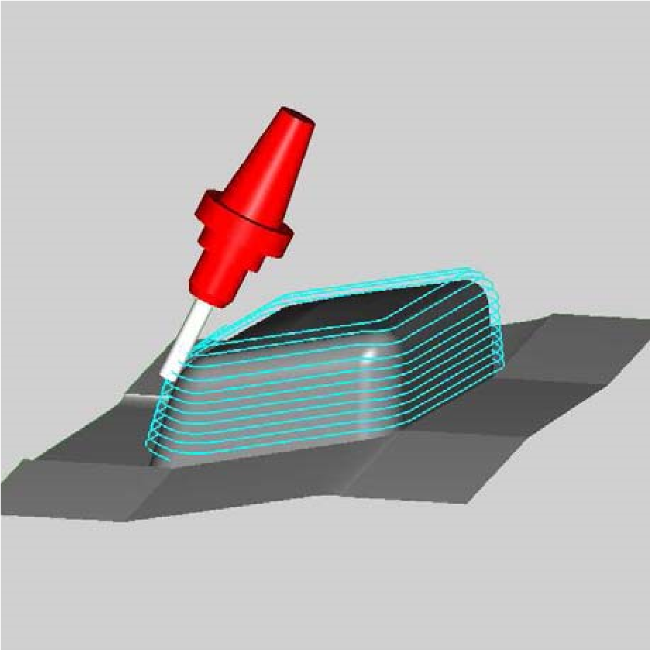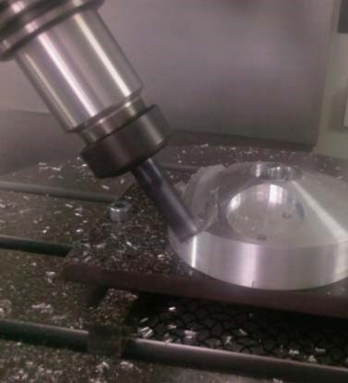

Figure 8: Mould core processing[5]

4.2. 5-axis processing of cutting tool holders
While processing holders of cutting tools for metal processing it is necessary to conduct the procedure of milling the bolsters of interchangeable plates in simultaneous 5-axis mode. In many cases it is necessary to conduct the processing at several different depths, depending on the tool type. A shorter processing time is crucial since this is a very expensive processing procedure. Shortening the processing time is only possible by ensuring a smooth tool path which is supported in the system of 5-axis management computers.

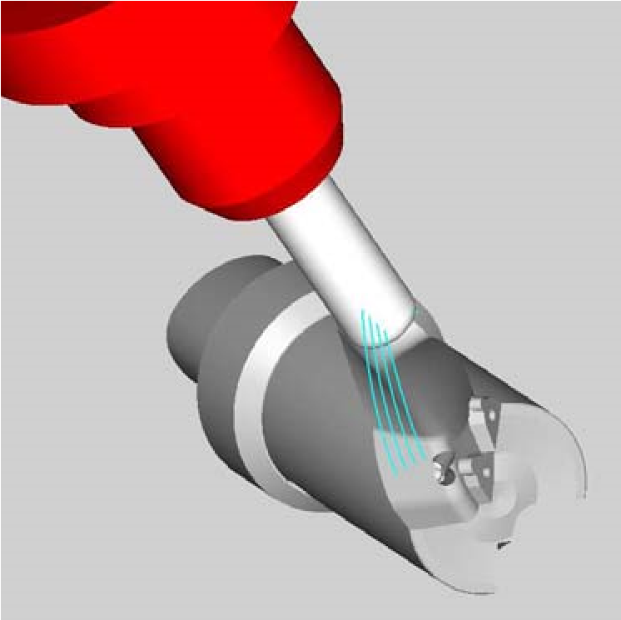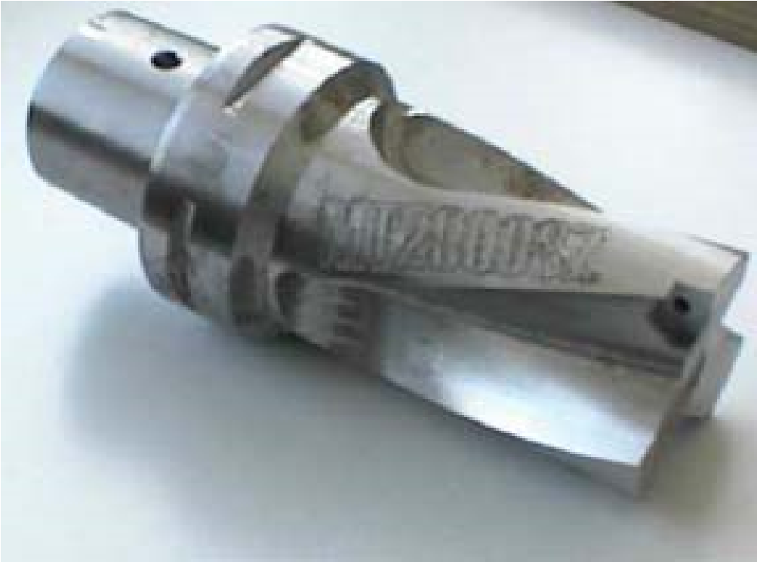

Figure 9: Processing bevel tools[5]

4.3. 5-axis processing of propellers
Propeller processing is one of the most complex tasks for milling process. One of the reasons for that is that a very small space for turning the tool has to be combined with high requirements for the quality of processed surface. Further on there are economic requirements to complete the production quickly in combination with the requirements for smooth passes of tool over the processed item having many processable items.

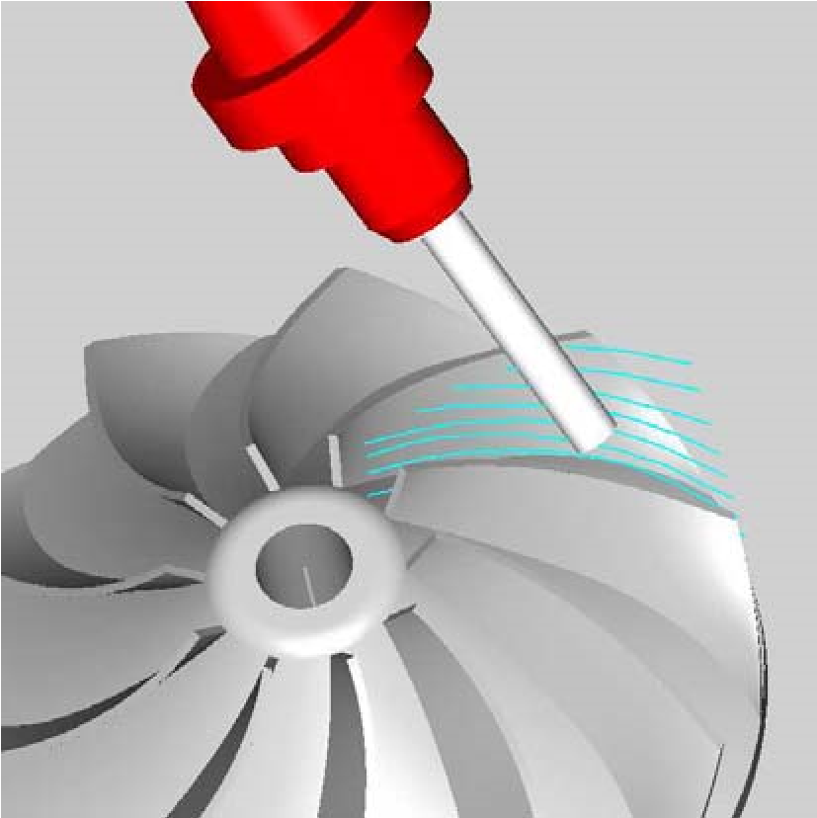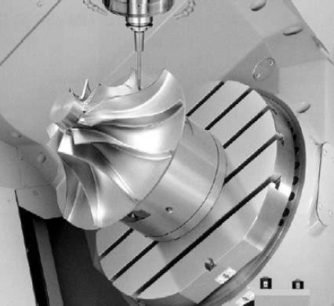

Figure 10: Final processing of propeller blades[5]

4.4. The 5-axis processing of turbine blades

Rough machining of turbine blades – is a classical assignment for 5-axis processing. The 5-axis processing in this case combines the managing and programming of paths for tools with curved processable surfaces. For the processing itself, large face mills are used toghether with a simultaneous 5-axis control. In order to reduce the production time it is crucial to program valid and correct tool paths. Therefore the postprocessors are optimized in order to provide support to the managing computers in the framework of easy management of tool paths.
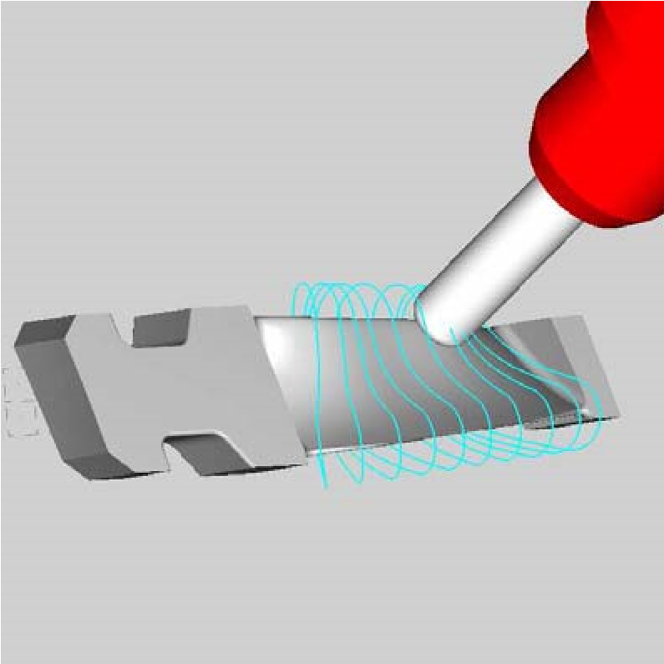

Figure 11: Rough machining of a turbine blade[5]

Final processing of turbine blades – there are two processing strategies for final processing of turbine blades. The first strategy, shown in Figure 9, is a strategy in which the final processing is done by ball end mill and by turning the tool at a specific angle in order to avoid collision and to optimize the conditions of surface cutting. A spiral tool path is used in this strategy in order to avoid traces on the surface caused by path stepover.

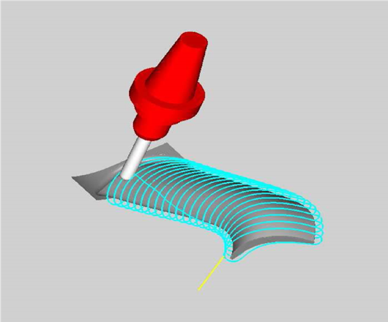

Figure 12: Final processing of a turbine blade[5]

4.5. Kinematics of CNC machines
The number of machine axes relates to the number of degrees of free movement or the number of possible independently controlled auxiliary parts of machine. Five degrees of freedom of movement is the minimum which enables maximum flexibility. That means that the tool and processed item in an operation can be oriented, relativelly, one towards the other at any angle. In the use of translation (T) and rotation (R) axes in the current constructions of 5-axis machines, the following axes combinations were used:
- Three translation and two rotation axes
- Two rotation and two translation axes
- One translation and four rotation axes
- Five rotation axes
The great majority of 5-axes machines falls into the category of machines with three translation and two rotation axes. The groups of machines with two translation and three rotation axes are used in some machines for the production of ship propellers. The other two groups are used in robots, usually in combination with adding some additional axes.

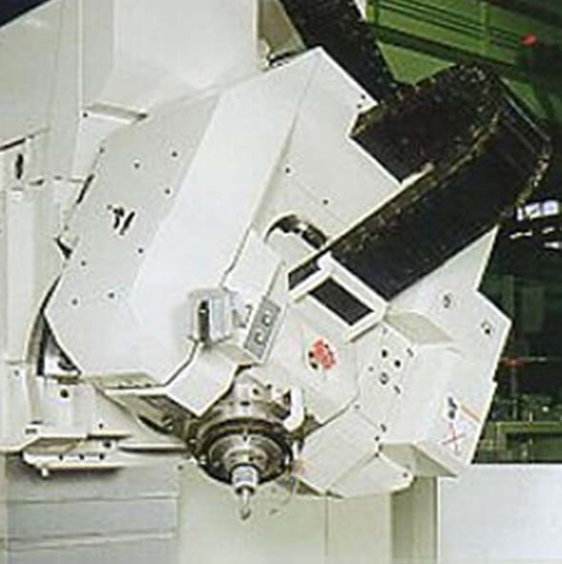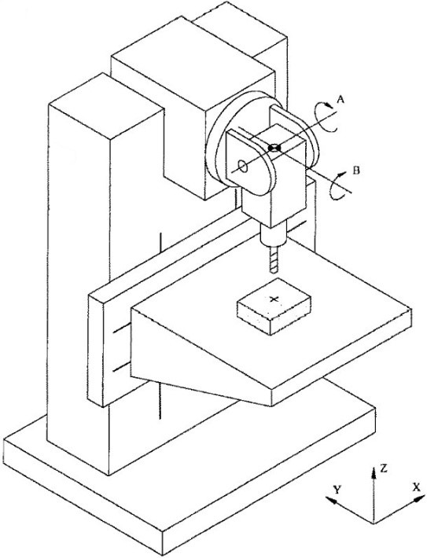

Figure 13: Five-axis mill[5]

5. EXAMPLE OF CAD/CAM PROGRAMMING FOR FIVE-AXIS MILLING
Below is a description of the CAD/CAM programming procedure in the CATIA V5 Program. A similar procedure is used to generate the NC code in other CAD/CAM softwares.

5.1. Assignment description:
According to the laws of fluid theory, the cross-section gauges of steam turbine blade are set every 40 mm, by their appearance, dimensions and cross-section aerodynamic profile.
From this initial data it is necessary to:
- Generate a blade wing by directing the model through the set cross-sections of blade in a CAD program
- Generate the NC code in a CAM program for the production of blade wing on a five-axis CNC mill.
On the basis of the construction obtained, it is necessary to define the prepared item (the raw form of the material) and production technology according to operations:
- Five-axis rough milling
- Five-axis contour milling
- Five-axis smooth (Isoparametric) milling
- Final surface finishing
It is necessary to define the tools, work regimes and work methods for each operation.
- Initiate the processing simulation and (if necessary) perform the NC code corrections
- Generate the technological documentation in a CAM program for the production of blade wind on a five-axis CNC mill.
- Produce the blade on a five-axis CNC mill.

Figure 14: A workshop blade sketch[12]

5.2. Assignment solving procedure

5.2.1. Sketch analysis
In this phase of development it is necessary to study in detail the sketch geometry, all text instructions in the sketch and the header. Special attenction needs to be paid to the surface roughness and tolerances.

5.2.2. 3D model development
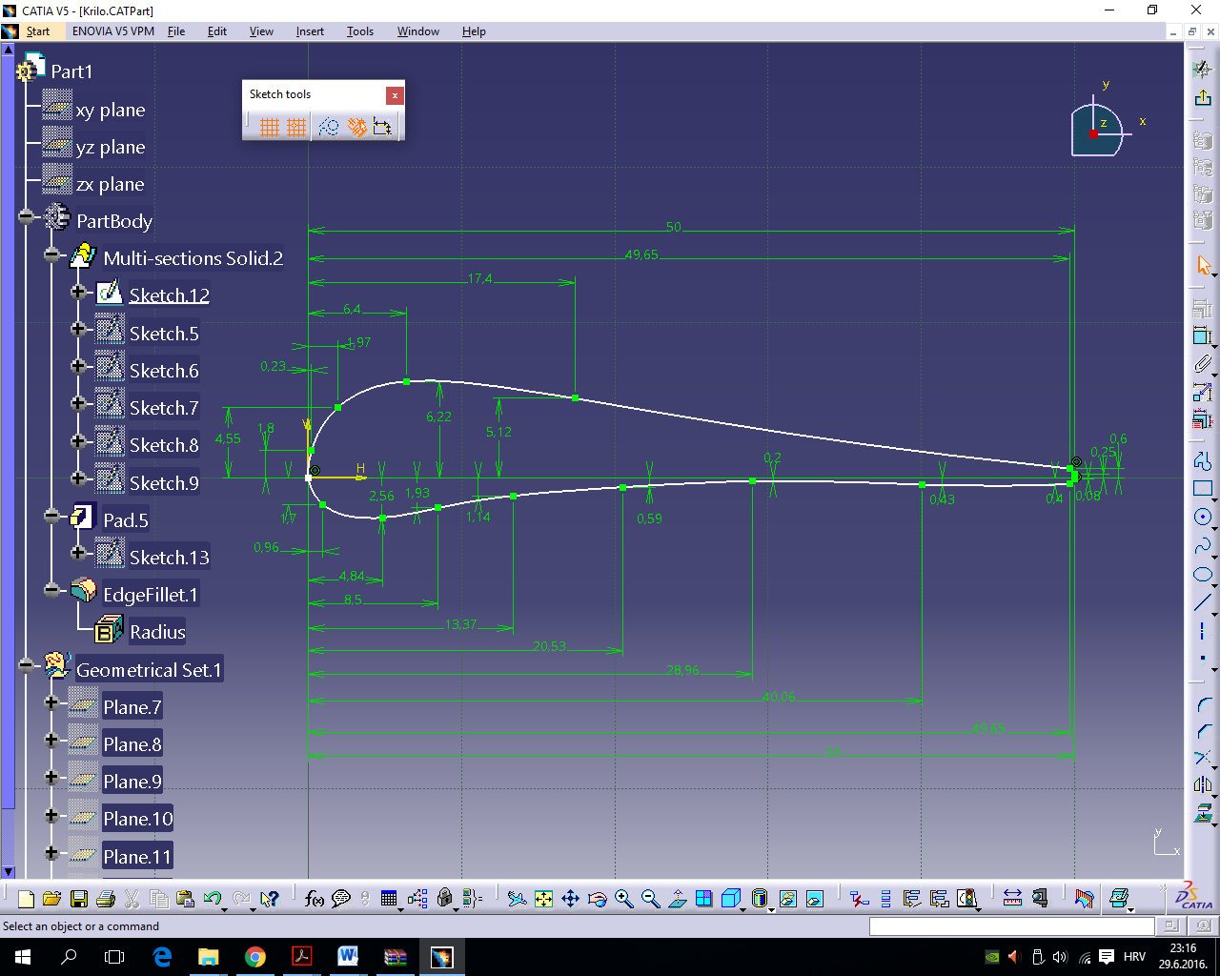
In the Part module of the CATIA V5 program, in Sketch, draw a reference cross-section of the blade as shown in Figure 15.
Figure 15: Blade profile coordinates[12]
The blade itself, i.e. its 3D appearance is obtained by scaling and interpolating the previously obtained referential cross-section of the blade.
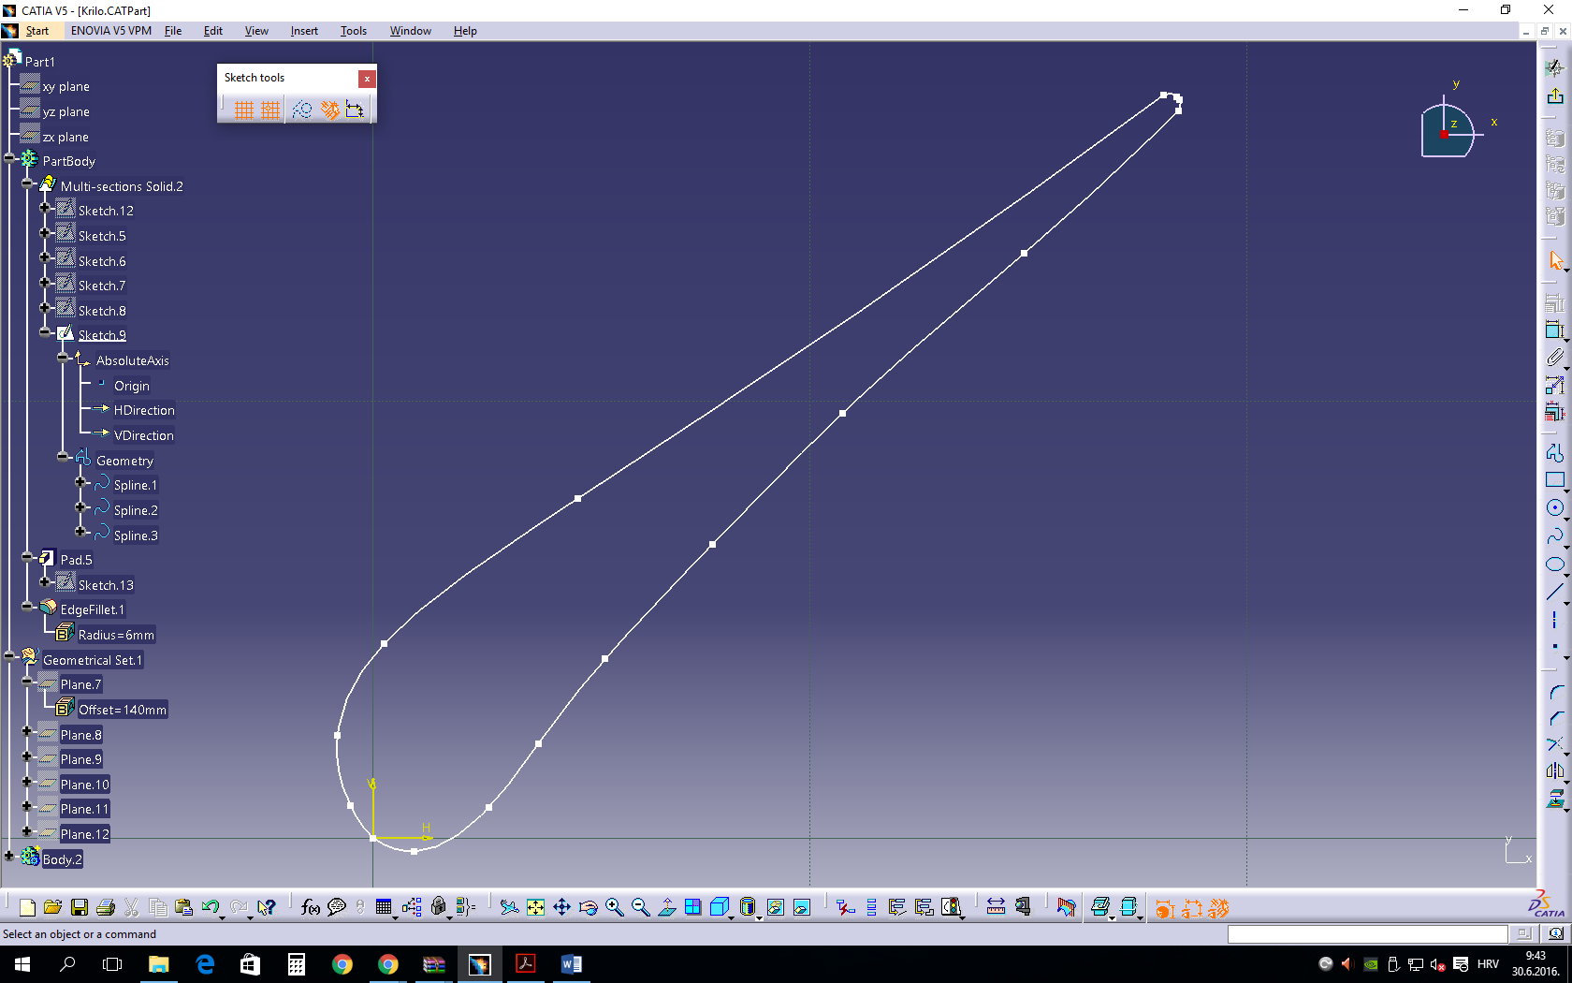
Figure 16: Interpolating the previously obtained referential cross-section of the blade[12]

By passing through multiple profiles of blade segments, as defined in the workshop sketch, the spatial spiral body of blade is formed.

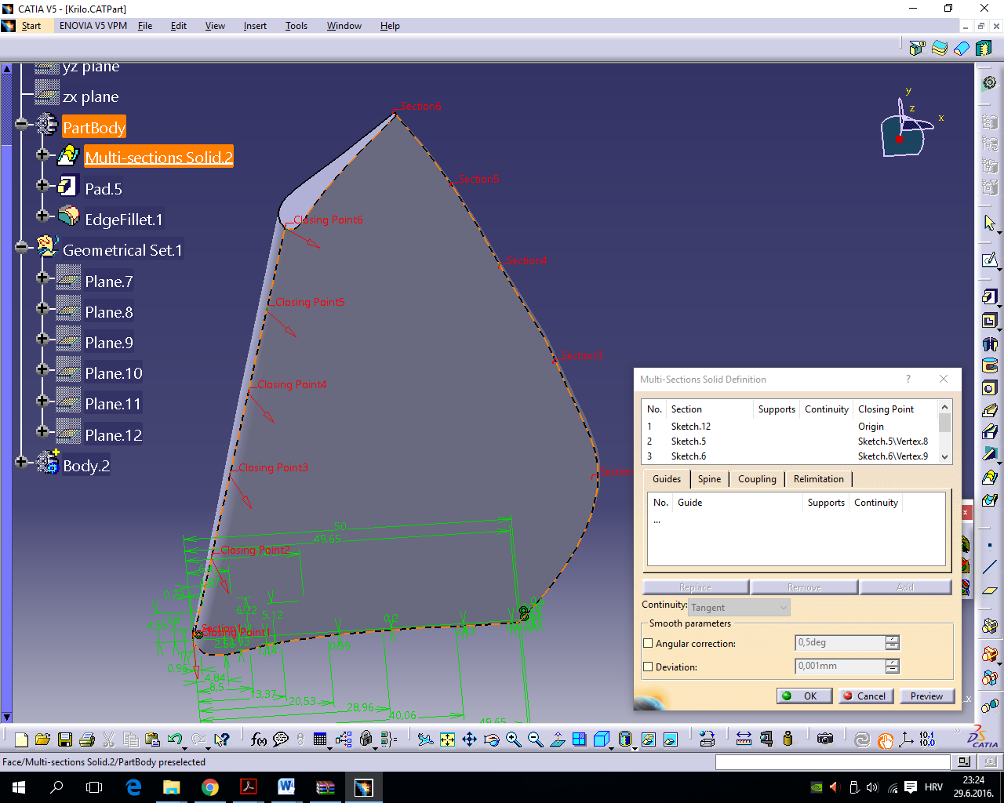
Figure 17: Extracting the body of blade[12]

For the final 3D model, it is necessary to add the blade stand. The final appearance of 3D blade is shown in Figure 18.

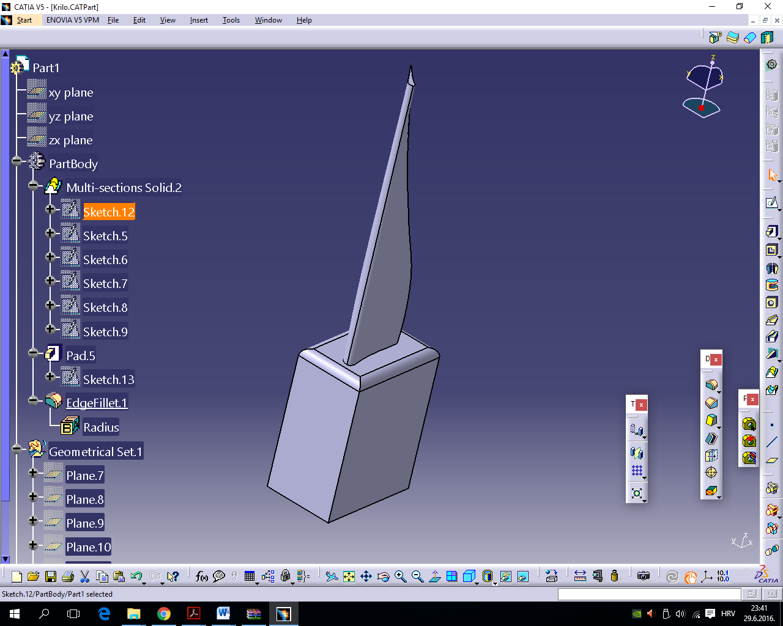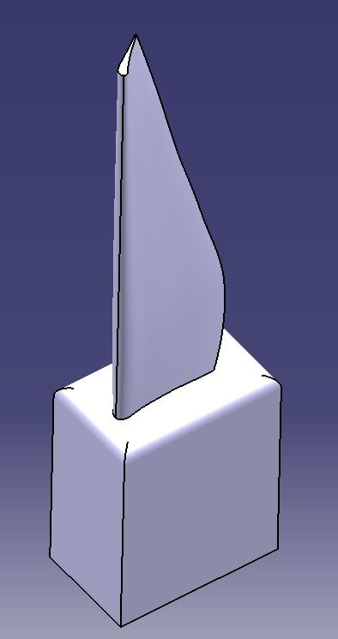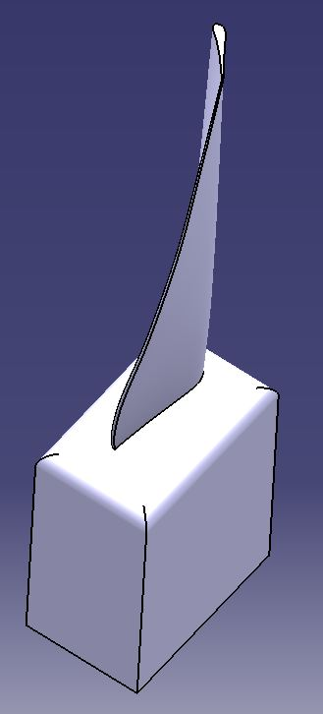
Figure 18: Final 3D model of the blade[12]
Having defined the final form of the blade, also in Part the 3D model of prepared item from which the blade will be produced is added.
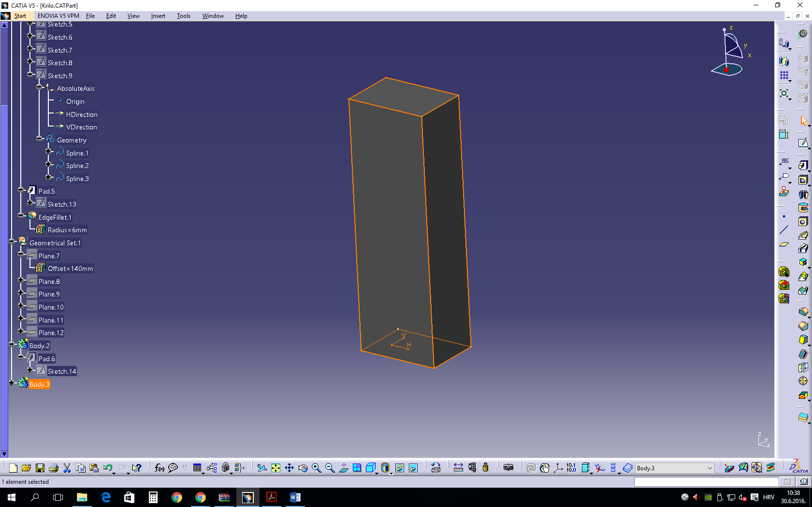

Figure 19: Processed item model[13]

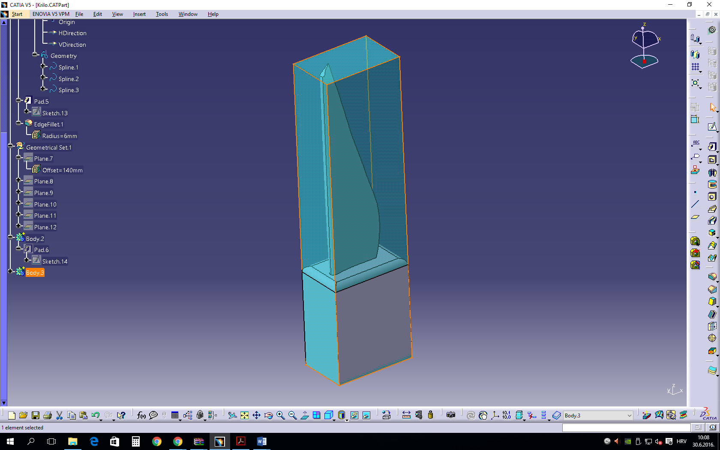

Figure 20: Model of the blade and processed item[13]

5.2.3. Development of blade processing technology
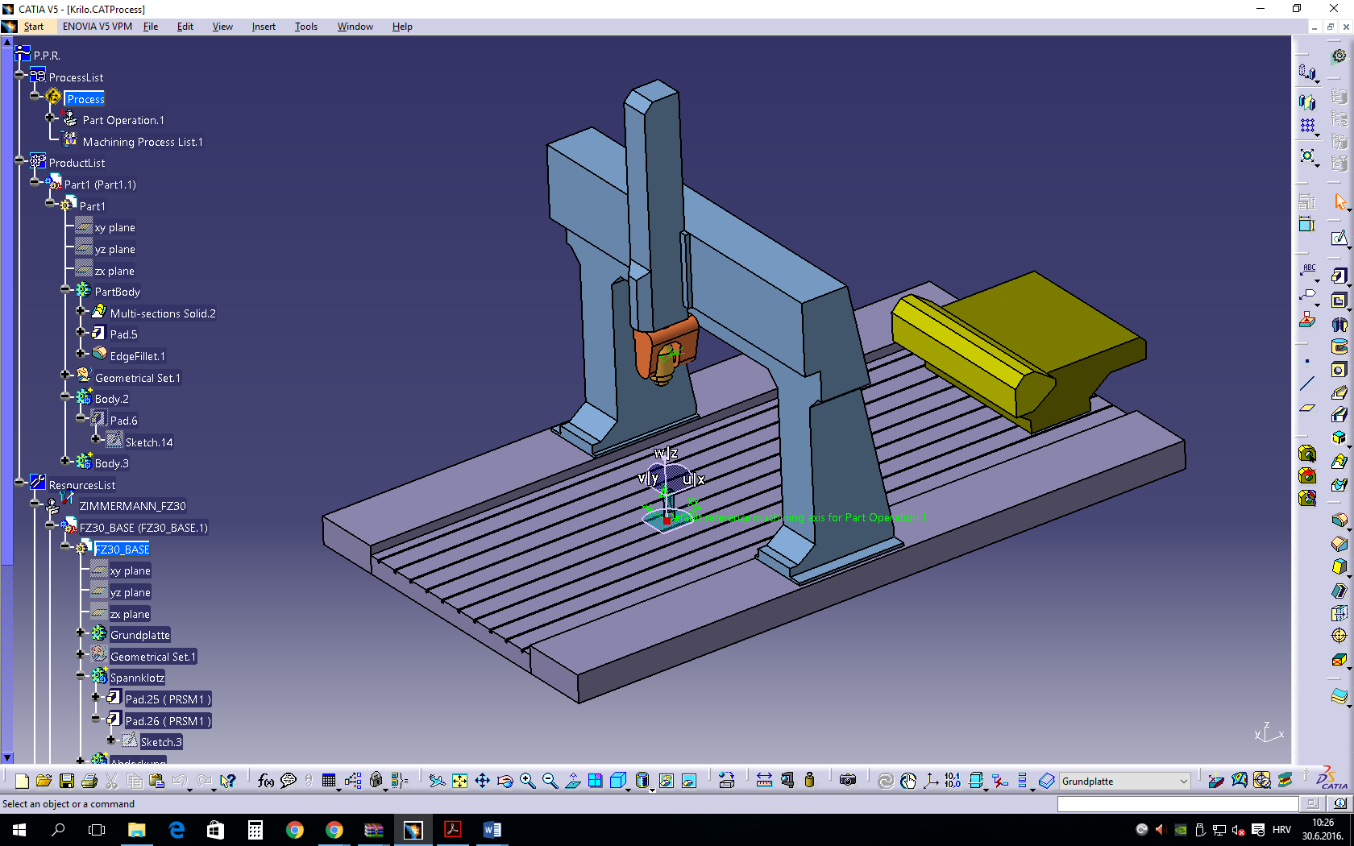
The development of blade processing technology has already started by adding the prepared item in CAD model Part, and the following technology defining is done in the CAM model Machining_Prismatic Machining programa CATIA V5.
Figure 21: CAM module of Machining_Prismatic Machining environment[12]

5.2.3.1. Defining the 5-axis CNC machine for blade production
In order to manufacture the presented blade, it is necessary to have a 5-axis CNC machine in the plant to be able to direct the machine and to enable tool movement simultaneously in all 5 axes (X, Y, Z, A, C). The example of such a machine where the supporting items perform X, Y and Z movements, the tilting cradle enables the turning A movement and the rotation notch table enables the circular C movement, as is shown in Figure 22.
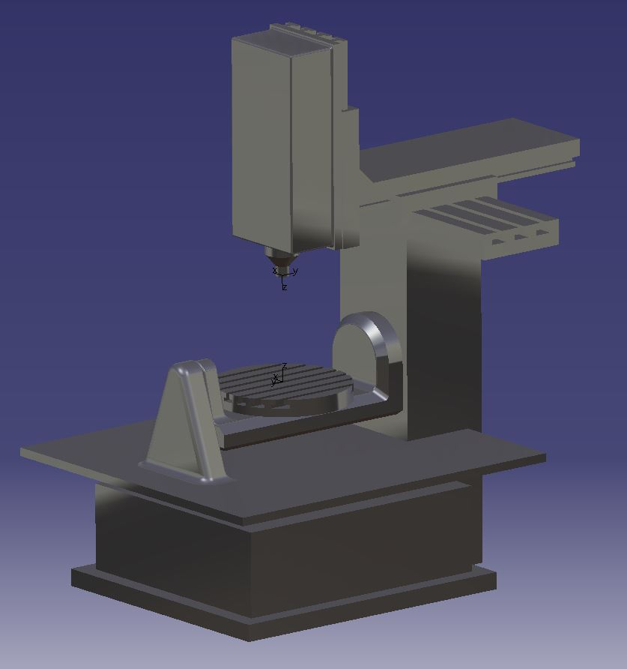

Figure 22: Five-axis CNC machine[12]

It is necessary to fix the prepared item on the table of 5-axis CNC machine, as is shown in Figure 23. The overall blade processing will be performed in one workpiece clamping.

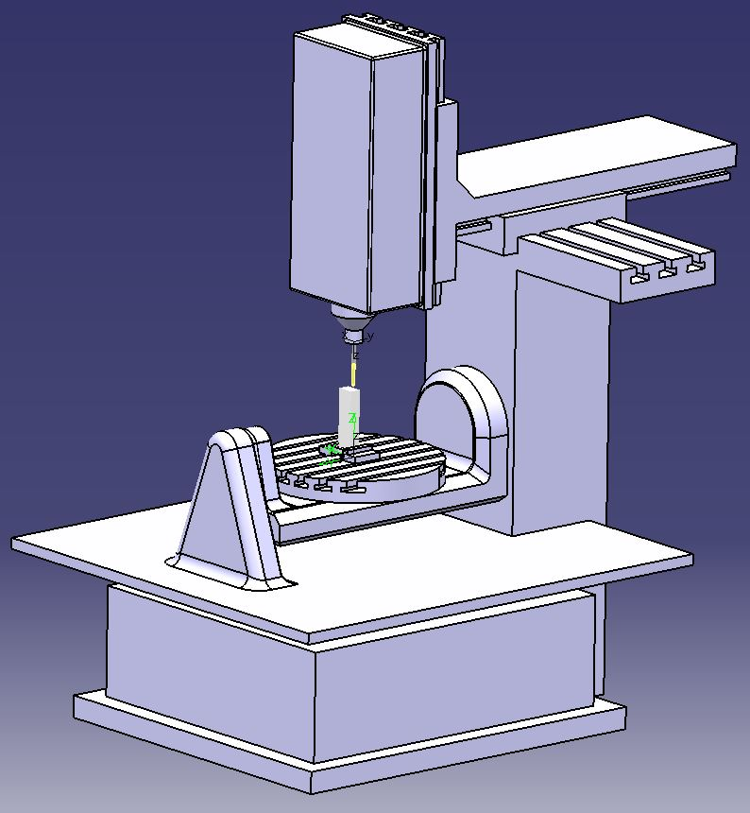

Figure 23: Clamping of the workpiece on the machine[12]

5.2.3.2. Defining the milling operation
The first operation of CNC milling of the blade is Prismatic Roughing. In this process, a large quantity of material is taken off and the objective of processing is to come closer to the final form of the blade, leaving the additional item for final finish. This processing is regularly performed by 3-axis movement at a higher speed.
In the menu for defining the contour processing, the geometry of the body is determined where the processing will be done, as well as the selection of tools, processing work regime level, type of tool entry and tool exit of the machining process. In this operation the additional item remains on the contour for final finishing.

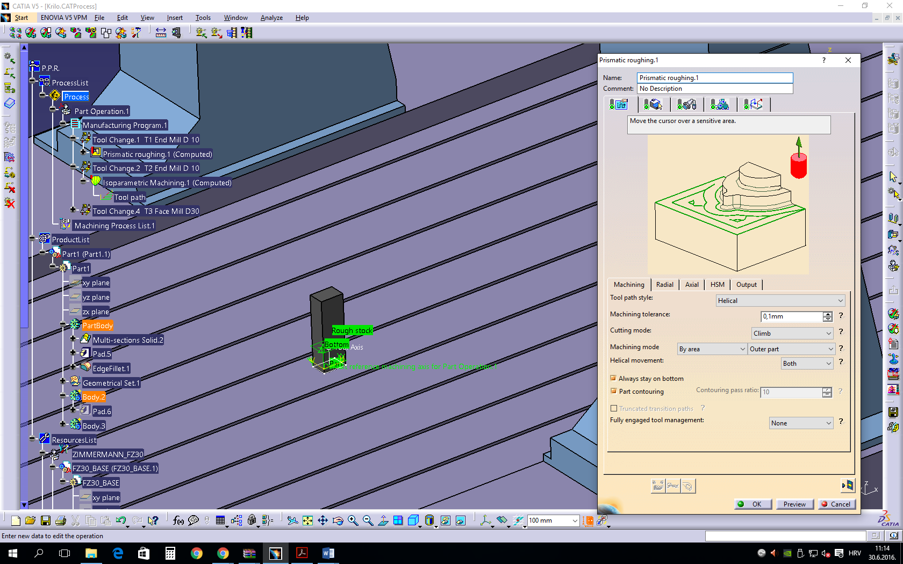
Figure 24: Defining the processing parameters for rough milling of the blade[12]

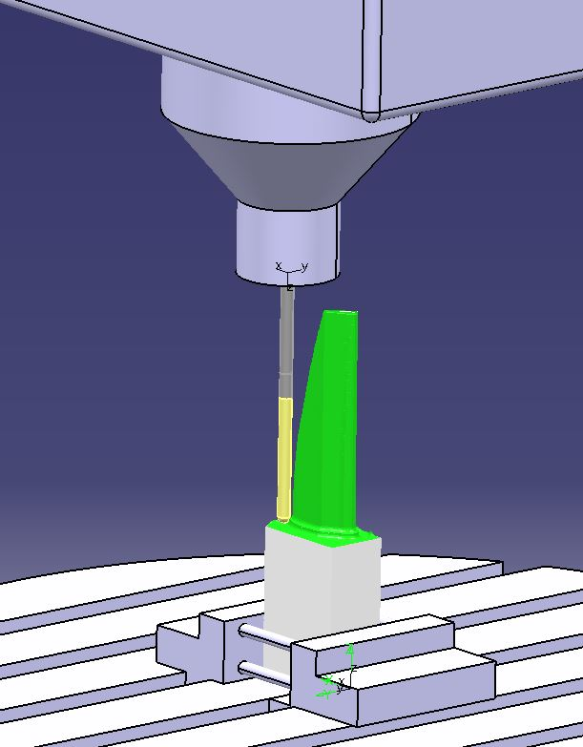

Figure 25: Simulation of the blade profile rough milling on the machine[12]

The second operation in the technology is the 5-axis milling of the blade's external surfaces. This processing is demanding and the main processing in the blade development. The tool is flexible and computer-controlled in 5 axes simultaneously with the objective to process the blade surface up to the final stage. The processing itself is performed by Isoparametric milling (so-called sweeping) - Multi Axis Isoparametric Sweeping Machining.

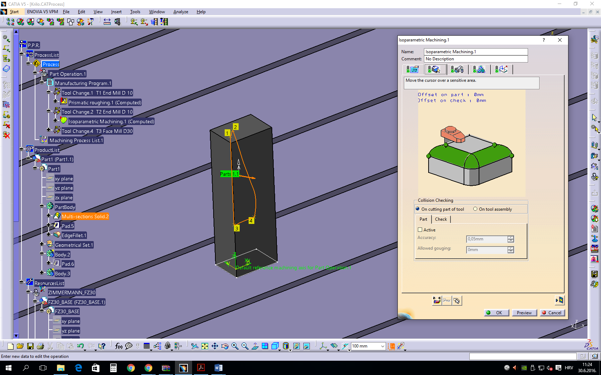
Figure 26: Defining the processing parameters for blade’s external surfaces milling[12]

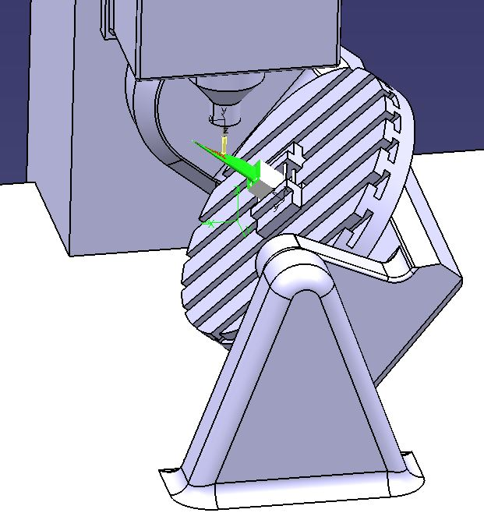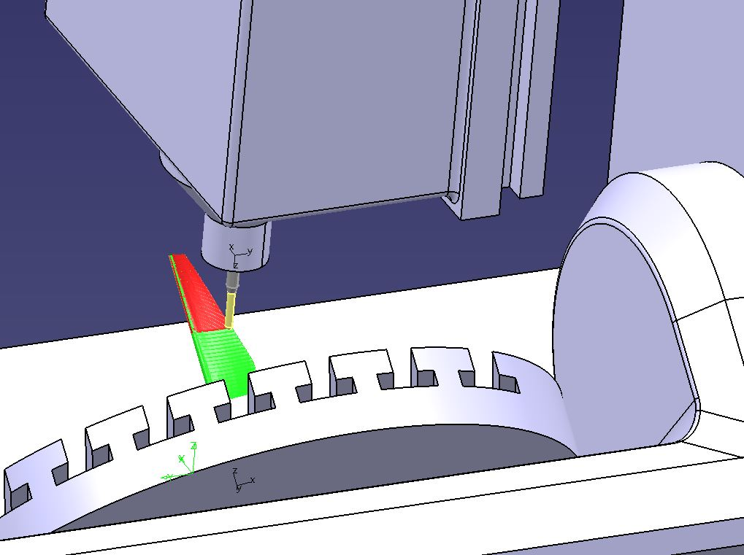

Figure 27: Simulation of milling the blade’s external surfaces on the machine[12]

The third operation in the technology is the 5-axis finishing by blade surface sweeping. This process is the final one in the blade production. This is a repeated previous processing but this time the work regimes are different and slower, the tools are of smaller diameter, with increased movements to finish and polish the curves that remained from the previous processing on the blade’s surface.
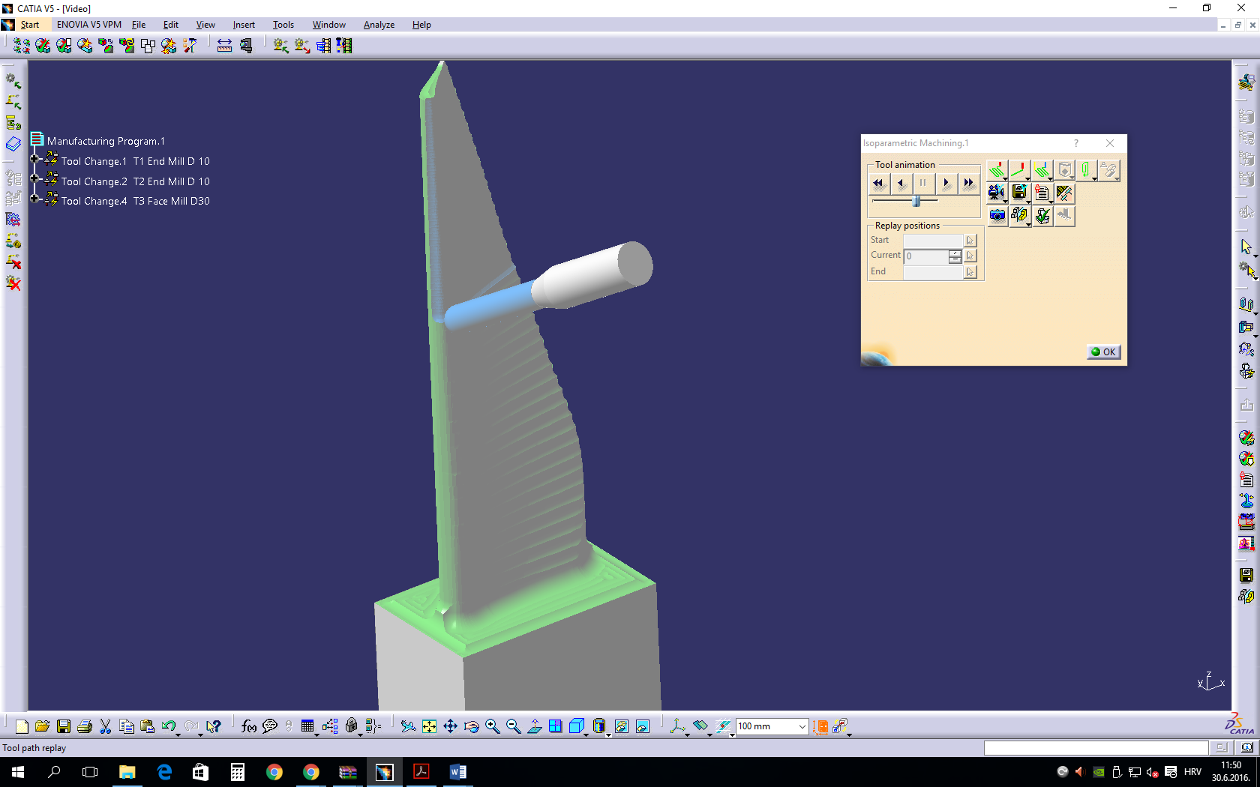
Figure 28: Simulation of final finishing of blade’s external surfaces in CATIA program[12]
What remains is to level out the top of the blade using a face mill.

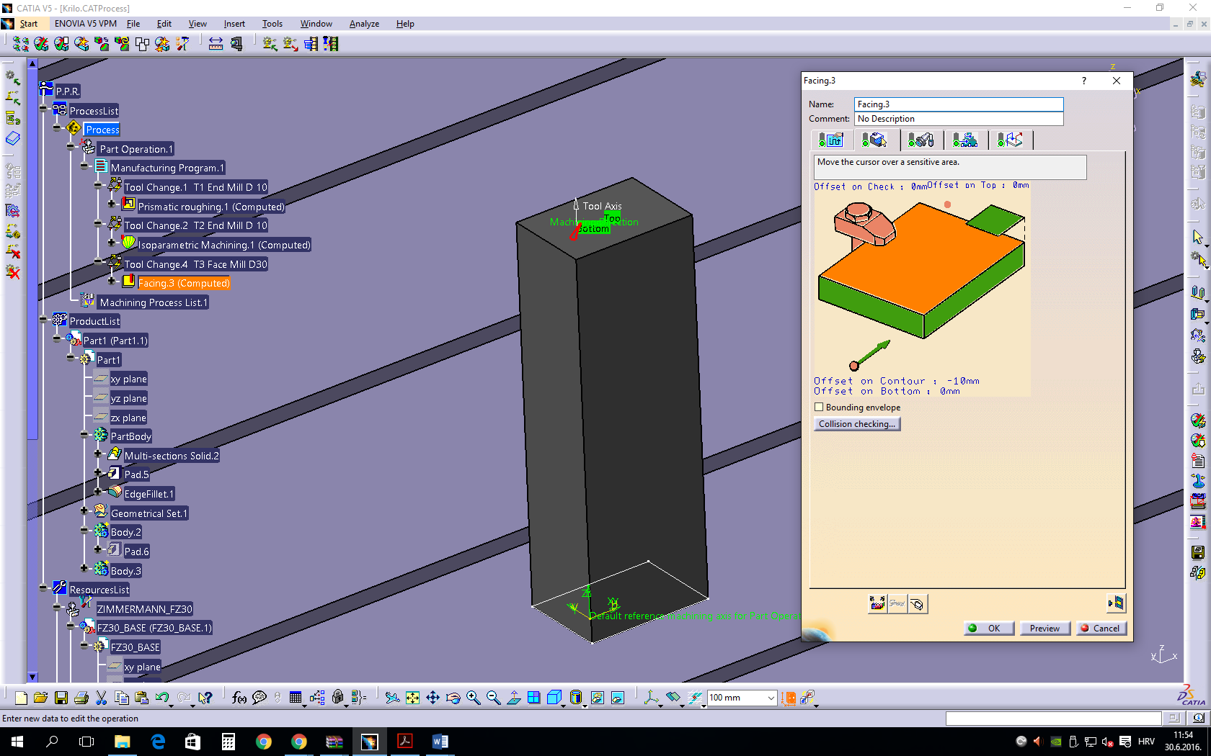
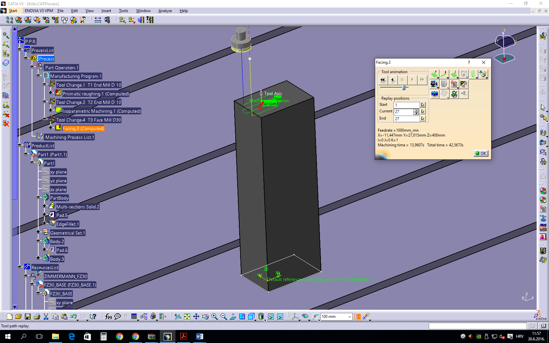
Figure 29: Simulation of face milling of blade top in CATIA program[12]
Figure 30: Defining the processing parameters for face milling of the blade top[12]
With face milling operation the blade processing is completed and the result is the processed blade on the stand as shows Figure 31.
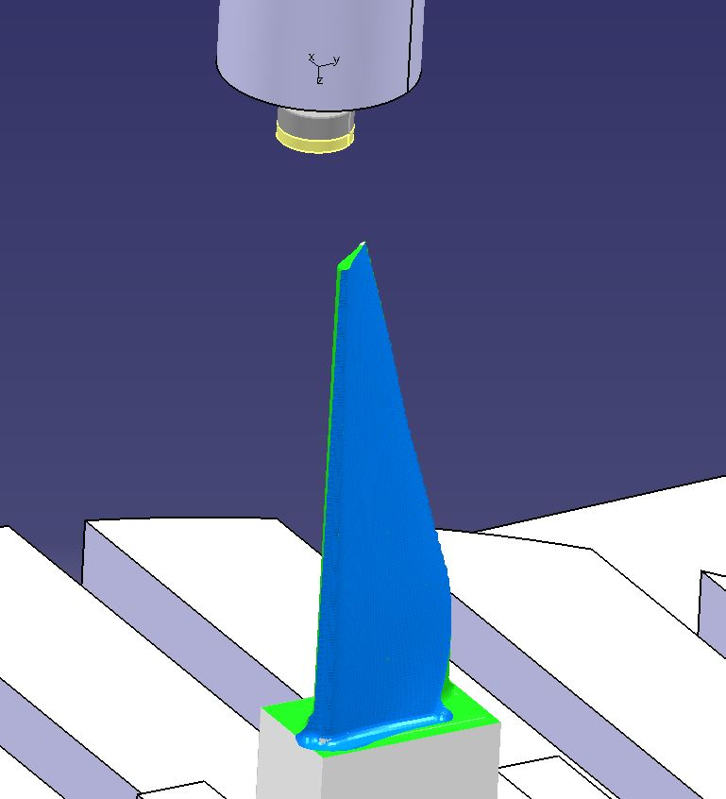

Figure 31: Turbine propeller blade[12]

After having defined the technology and completed the simulation and correction, G code is generated (Annex 1) together with technological documentation (Annex 2).

6. TITLE, REFERENCES
[1] Bošnjaković, Mladen; Stojić, Antun: Programiranje CNC strojeva. Slavonski Brod; Veleuĉilište u Slavonskom Brodu, 2011., 386 str.
[2] Bozdoc, Marian: Marian Bozdoc's history of CAD. Auckland, Novi Zeland URL : http://www.mbdesign.net/mbinfo/CAD-History.htm (21.06.2016)
[3] The best CAD software history on the web, 2004, CAD software – history of CAD CAM, URL: http://www.cadazz.com/cad-software-history.htm (21.06.2016)
[4] Novak-Marcincin, Jozef; Petik, Anton : Computer Aided Manufacturing-Inesparable part of CAD/CAM/CAE systems. Košice, Technical University of Košice, 2002
[5] FSB, Zagreb https://www.fsb.unizg.hr/atlantis/upload/newsboard/29_06_2011__15223_Franic_spec_21.05.11.pdf (22.06.2016)
[6] PTC, The Industry’s Leading 3D CAD Software, 2016, Creo Parametric URL:http://www.ptc.com/cad/creo (22.06.2016)
[7] Dassault Systemes, Company History, 2016, URL: http://www.solidworks.com/sw/183_ENU_HTML.htm (23.06.2016)
[8] Haas Automation, Inc – CNC Machine Tools, About Haas Automation, 2016, HAAS HISTORY URL:http://int.haascnc.com/about_history.asp?intLanguageCode=1033 (23.06.2016)
[9] Haas Automation ®, Inc, Haas VM Series, Prosinac 2015, The Vertical Mold Making Machine URL:http://www.haascnc.com/mt_spec1.asp?id=VM&webID=MOLD_MACHINE_VMC#gsc.tab=0 (23.06.2016)
[10] Haas Automation ®, Inc, CNC Rotaries & Indexers: Rotary Tables, 2016. URL:http://www.haascnc.com/mt_spec1.asp?id=HRT210&webID=ROTARY_TABLE_ROTARY#gsc.tab=0 (21.06.2016)
[11] Haas Automation Inc.: Korisnički priručnik za okomitu glodalicu, 2014 URL:http://diy.haascnc.com/sites/default/files/Locked/Manuals/Operator/2014/Mill/Translated/Mill_Operators_Manual_96-HR8200_Rev_A_Croatian_January_2014.pdf (21.06.2016)
[12] Marijan Abramović , STŠ Fausta Vrančića
[13] STŠ Fausta Vrančića, URL:http://www.stsfv.eu/(21.06.2016)

APPENDIX 1: PART OF G CODE FOR 5-AXIS MILLING OF A TURBINE BLADE
N10 ;===========================================================
N11 ;== Copyright Cenit AG Systemhaus (mr) 2004 ==
N12 ;== ==
N13 ;== For demonstration use only: ==
N14 ;== cPost-Postprocessor for Zimmermann FZ30 ==
N15 ;== with controller SINUMERIK 840 D ==
N16 ;===========================================================
N17 ; PRGNR : Manufacturing Program.1
N18 G0 G90 G40
N19 TRAORI
N20 ;=============== TOOL CHANGE =================
N21 T1 M06 ; T1 End Mill D 10
N22 ;MACHINE OPERATION = Prismatic roughing
N23 ;OPERATION NAME = Prismatic roughing.1
N24 ;TOOL ASSEMBLY = T1 End Mill D 10
N25 ;(---------------------------------------------)
N26 MSG(" MO : Prismatic roughing.1 ")
N27 ;(---------------------------------------------)
N28 TRAORI(1)

N29 D1
N30 G00 X43.411 Y-28.1 Z307.073 A0 C0 S70 M3
N31 G01 Z297.073 F300
N32 Y-20
N33 X-10 F1000
N34 Y30
N35 X-1.461
N36 X-1.458 Y27.625
N37 X-1.455 Y25.25
N38 X11.416
N39 X1.202 Y18.19
N40 X-4.315 Y14.476
N41 X-4.435 Y14.39
N42 X-4.669 Y14.212
N43 X-4.783 Y14.119
N44 X-5.25 Y13.718
N45 Y25.179
N46 X-5.732 Y25.732
N47 X-5.179 Y25.25
N48 X-1.455
N49 X-1.453 Y23.35

APPENDIX 2: TECHNOLOGICAL DOCUMENTATION

Machine : ZIMMERMANN_FZ30

Type : MfgGenericMillMachine
Numerical control attributes
Axial/Radial movement | false
MFG_SPLIT_CIRCLE_STRAT | No split
Helical Interpolation | false
Rapid feedrate | 60000mm_mn
Post Processor words table | CPOST_MILL.pptable
Home point strategy | FROM
NC data format | Axis (X,Y,Z,I,J,K)
NC data type | ISO
Max machining feedrate | 100000mm_mn
Min interpol. radius | 0,01mm
Min discretization step | 1e-004mm
Min discretization angle | 0,1deg
2D circular interpol. | true
3D circular interpol. | true
3D Nurbs interpolation | false
3D linear interpol. | true
Max interpol. radius | 5000mm
Controller Emulator | ZIMMERMANN_FZ30_S840D.ce

Spindle attributes | Tool change attributes
  Home point X | 0mm
  Home point Y | 0mm
  Home point Z | 1469mm
  Orientation K | 1
  Orientation J | 0
  Orientation I | 0
  Tool change point X | 0mm
  Tool change point Y | 0mm
  Tool change point Z | 100mm
  Radius compensation | false

SHOP FLOOR DOCUMENTATION
Krilo.CATProcess
Part operation : Part Operation.1

Manufacturing Program.1

Tool Change.1  Type : Tool Change | 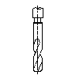 | Tool : T1 End Mill D 10  type : End Mill
Prismatic roughing.1  Type : Prismatic roughing |  | Tool : T1 End Mill D 10  type : End Mill
Tool Change.2  Type : Tool Change |  | Tool : T2 End Mill D 10  type : End Mill
Isoparametric Machining.1  Type : Isoparametric Machining | 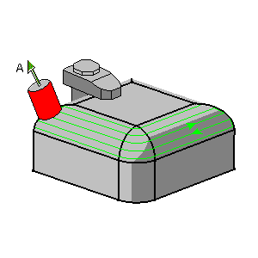 | Tool : T2 End Mill D 10  type : End Mill
Tool Change.4  Type : Tool Change | 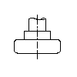 | Tool : T3 Face Mill D30  type : Face Mill
Facing.3  Type : Facing | 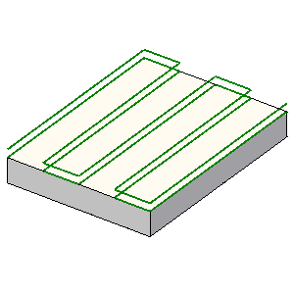 | Tool : T3 Face Mill D30  type : Face Mill

Program cutting time | : | 1h 4' 1''
Program total time | : | 1h 10' 49''

SHOP FLOOR DOCUMENTATION
Krilo.CATProcess
Part operation | : | Part Operation.1
Program | : | Manufacturing Program.1

Prismatic roughing.1

Prismatic roughing
Strategy
IPMGenMode | None
Machining quality | Rough
Nurbs Output | false
Unused | 1mm
Part contouring | true
Drilling tool length | 100mm
Unused | false
Unused | 10deg
Unused | M3xTrochoidParamModeDist
Direction of cut | Climb
Machining mode | Outer part
Offset on bottom plane | 0mm
Unused | 100
Semi finishing thickness on bottom | 0mm
Unused | false
Unused | 1mm
Unused | 10deg
Unused | true
Engagement mode | From outside
Bottom thickness | 1mm
Unused | 0mm
Unused | false
Machining tolerance | 0,1mm
Drilling tool angle | 30deg
High speed machining | false
Tool path style | Helical
Unused | 45deg
Ramping angle | 15deg
Fully engaged tool management | None
Rework threshold | 0,3mm
Helix diameter (% O) | 70
Maximum full material cut depth | 2,5mm
Machine only ordered areas | false
Approach distance | 10mm
Maximum depth of cut | 5mm
Drilling tool diameter | 25mm
M3xIgnoreHoleInt | 2
M3xIgnoreHoleLength | 10mm
Pass overlap (diameter ratio) | 50
Unused | 120deg
Drilling safety distance | 0mm
Pass overlap (length) | 5mm
Unused | 75
Overshoot | true
Unused | true
Unused | -1mm
Radial safety distance | 3mm
M3xIgnoreHole | false
Minimum trochoid radius | 1mm
Unused | true
Unused | true
Engagement mode | Ramping
Part contouring ratio | 10
Unused | true
Unused | 75
Unused | 30mm
Offset on top plane | 0mm
Horizontal areas detection | true
Unused | false
Truncated transition paths | false
Unused | 1mm
Corner radius | 1mm
Tolerance | 0,3mm
Offset | 0mm
Unused | 0,5deg
Pass overlap mode | Overlap ratio
Unused | 0mm
Unused | 0mm
Helical movement | Both
Unused | 25
Axial safety distance | 10mm
Stay on bottom | true
Unused | 45deg
M3xEngageFromExternalZone | false
M3xCircularApproach | false
M3xRadiusCircularApproach | 2mm
M3xAngleCircularApproach | 180mm
M3xHardRampOffset | 0mm
Cutting mode | Climb
M3xTrochoidSurface | 70
M3xTrochoidNonMachiningRadius | 100
M3xTrochoidStep | 0,5mm
M3xTrochoidMode | M3xTrochoidAuto
M3xRadialFirst | false
MfgWorkType | MfgCartesian
M3xFMTrochoidMaxEngagement | 0,5mm
Circular Interpo. | false

Feedrate |  |  | Machining Time
  Feedrate unit | Linear
  Spindle output | true
  Automatic compute from tooling Feeds and Speeds | true
  Spindle unit | Angular
  Automatic compute from tooling Feeds and Speeds | true
  MFG_FEED_SELECT_TRANSITION | false
  MFG_FEED_TYPE_TRANSITION | Machining
  Maximum radius | 1mm
  Distance after corner | 1mm
  Minimum angle | 45deg
  Reduction rate | 80
  Feedrate reduction in corners | false
  SlowdownRate | 100
  Distance before corner | 1mm
  Machining feedrate | 1000mm_mn
  Machining spindle | 70turn_mn
  MFG_LOCAL_FEED_TRANSITION_VALUE | 5000mm_mn
  Approach feedrate | 300mm_mn
  Retract feedrate | 1000mm_mn
  Cutting time | 42' 20''
  Total time | 47' 59'
SHOP FLOOR DOCUMENTATION
Krilo.CATProcess
Part operation | : | Part Operation.1
Program | : | Manufacturing Program.1

Isoparametric Machining.1

Isoparametric Machining

Strategy
IPMGenMode | None
Machining quality | Rough
Nurbs Output | false
Skip path | None
Compensation output | 3D Contact (G29/CAT3Dxx)
Offset on tilting guide | 0mm
Thru a guide mode | Normal to the path
Check allowed gouging | 0mm
Part accuracy | 0,05mm
End extension | 0mm
Machining tolerance | 0,05mm
Radial strategy | Scallop height
Number of paths | 1
Extend tilting guide | true
Side of tilting guide offset | Left
Covering mode | false
Check accuracy | 0,1mm
Unused | true
Unused | true
Collision on part | false
Max discretization step | 10000mm
To / From | To
Tool axis guidance | Fixed lead and tilt
Tilt angle | 25deg
Lead angle | 0deg
Mfg5AxisShortMacroFlag | false
Unused | 0mm
Unused | 0mm
Max distance between paths | 5mm
Tool path style | Zig zag
Max discretization angle | 63deg
Allowed lead | 30deg
Guidance | Lead angle
Min lead angle | -30deg
Allowed tilt | 30deg
Scallop height | 0,05mm
Collision checking mode | Active Part
Max lead angle | 30deg
Start extension | 0mm
Part allowed gouging | 0mm
Minimum heel distance | 1mm
Lead angle | 0deg

Feedrate | Machining Time
  Feedrate unit | Linear
  Spindle output | true
  Automatic compute from tooling Feeds and Speeds | true
  Spindle unit | Angular
  Automatic compute from tooling Feeds and Speeds | true
  MFG_FEED_SELECT_TRANSITION | false
  MFG_FEED_TYPE_TRANSITION | Machining
  Machining feedrate | 1000mm_mn
  Machining spindle | 70turn_mn
  MFG_LOCAL_FEED_TRANSITION_VALUE | 5000mm_mn
  Approach feedrate | 300mm_mn
  Retract feedrate | 1000mm_mn
  Cutting time | 21' 28''
  Total time | 22' 8''

