

ERASMUS+ SECTOR SKILLS ALLIANCE
[TRVANIE PROJEKTU: November 2014 – October 2017]

READING TECHNICAL DOCUMENTATION - METAL

LEARNING MATERIAL

[WORK PACKAGE 3: Designing joint curriculum program]
[OUT 3.2: Learning materials ]
PREPARED BY: P8-SIOV SLOVAKIA

Authors: Alexandra Junaskova
Translated by: SIOV, ZEP

June 2016
The European Commission support for the production of this publication does not constitute endorsement of the contents which reflects the views only of the authors, and the Commission cannot be held responsible for any use which may be made of the information contained therein.

CONTENT
LIST OF PICTURES, TABLES AND CHARTS 2
LIST OF APPENDIXES 3
1 INTRODUCTION 4
2 TECHNICAL DOCUMENTATION 5
2.1 Types of technical documentation 5
2.2 Technical documentation management 6
3 TECHNICAL STANDARDISATION 8
3.1 Types of standards 8
3.2 Technical regulation 9
3.3 Basic standards 9
3.3.1 Lines 9
3.3.2 Material 12
4 IMAGING 13
4.1 Methods of imaging 13
4.2 Views 14
4.3 Methods of projection 15
4.4 Sections, cross-sections, contours 18
4.5 Dimensioning 19
5 TOLERANCE 21
5.1 Tolerance of functional areas size 22
5.2 Geometric tolerance 24
6 SURFACE 27
6.1 Surface profile 27
6.2 Graphical mark of surface properties 30
6.3 Special surface treatment 31
7 WELDED AND SOLDER JOINTS 32
7.1 Drawing sets of welded constructions 33
BIBLIOGRAPHY AND REFERENCES 42

LIST OF PICTURES, TABLES AND CHARTS
Table 1: Overview of used lines 9
Picture 1: Examples of drawing some line types 11
Picture 2: Examples of stops 12
Table 2: Examples of material symbols 13
Picture 3: Object and its axonometric imaging 14
Picture 4: Perspective projection 14
Picture 5: Two-dimensional imaging 14
Picture 6: View in technical drawing. 14
Picture 7: Extreme positions of lever. 15
Picture 8a: Projection in the first quadrant. 16
Pictire 8b: Placing of all views – projection in the first quadrant. 17
Picture 8c: Placing of all views – projection in the third quadrant.. 17
Picture 9: Method of reference arrows 18
Picture 10: Projection of cross-sections 18
Picture 11: Chain dimensioning 19
Picture 12: Ending of dimension line 19
Picture 13: Dimensioning, reference and extension lines 20
Picture 14: Example of dimensioning of bend, cylindrical and spherical areas 20
Picture 15: Examples of holes dimensioning 21
Picture 16: Free and functional surface – examples of tolerance labelling 22
Picture 17: Tolerance 23
Picture 18: Overview of basic deviations 24
Picture 19: Marking the foot 25
Table 4: Tolerated geometric features, their signs 26
Picture 20: Tolerance frames 26
Photo 1: Sensor for laser measuring 27
Picture 21: Steel – usual surface 28
Picture 22: Surface profile 28
Picture 23: Average arithmetic deviation Ra 29
Table 5: Relationship between the medium arithmetic deviation and the methods of surface finish 29
Picture 24: Entry of supplementary requirements 30
Picture 25: Example of surface roughness entry 30
Picture 26: Weld mark 32
Table 6: Overview of some welding technologies 33
Picture 27: Brake drum – dimensioned assembly drawing of the weldment 33

LIST OF APPENDIXES
Appendix 1: Assessment example

1 INTRODUCTION
Technical documentation belongs to key aspects of the production process. Is the carrier of information, which constitute the basis for technological processes in manufacturing, construction, wiring of electrical appliances etc.
The purpose of this module is to master an independent reading of technical documentation which reflects developments in the metalworking and electrical industries. The material is also aimed at the correct treatment (management) of technical documentation. Without this ability it is not possible to properly install wiring and ensure the quality of each step of the manufacturing process.
The submitted guide has an indicative nature and it primarily outlines the main areas which the teachers and learners have to focus on. Its use requires the utilisation of other supportive resources (scientific literature, internet sources) for fixing the subject, depending on national and local circumstances and needs. The document contains links to other websites with educational content, from which teachers and learners shall continue to draw. It also foresees the use of own resources and educational content of educational institute/provider.

2 TECHNICAL DOCUMENTATION
It is necessary to follow certain rules when working with the technical documentation - for example, marking and numbering of the document, document archiving etc. The technical documentation is the property of the company/enterprise and it is necessary to handle it accordingly.
The working method with the documentation depends on what kind of documentation is involved. Firstly, the technical documentation must include a clear specification (label) of the product, part or semi-product. The specification can be:
- full
  - name
  - dimension data
  - material identification (numerical, alpha-numerical, verbal)
  - identification of a document which supplement the requirements on the product, its part or semi-product
- simplified
- We do not understand "drawings" or "scheme" only under the technical documentation. Technical data can also be found in the commercial documentation (advertising materials, catalogues) or in the service documentation (user manuals, service manuals).

2.1 Types of technical documentation
Types of technical documentation in electro-industry can by divided according to:
1) purpose of its use
- production:
  - construction: e. g. drawings, calculations, test results, technical reports, material certificates, certificates of overtaken components etc.
  - technological: e. g. manufacturing drawings of parts adapted for a specific manufacturing technology, material and semi-products specifications, technological processes etc.
  - operational: e. g. instructions for operation and maintenance, spare parts list, quality certificates, special documentation for special technical devices (classification, elements list, revisions plan, revisions book) etc.
- commercial
- patent
2) processing method
- traditional means of drawing: drawing by hand using the drawing tools and drawing paper
- Modern - computer - technology (the result is printed on the printer or plotter), e. g .:
  - CAD – Computer Aided Design, e. g. AutoCAD, AutoDesk, Inventor
  - CAPP – Computer Aided Process Planning
In this material, we will focus on two types of technical documentation: production and commercial. Production documentation for the needs of units of learning outcomes represents drawings:
- draft (display components, their relative positions, sizes - the basis for the final solution)
- components (also called "production", as they are an essential basis for fabrication)
- kits (containing inventory items - BOM, the basis for the interim and final assembly of the product)

Besides this, according to the requirements of the manufacturing process, it is inevitable to read piece lists and other documentation (e. g. reports, tables, lists etc.) for the correct understanding of the content and purpose of the technical documentation.

2.2 Technical documentation management
The technical documentation is part of the company's property. Management (or the administration) of the technical documentation now increasingly depends on the use of modern technologies. The reason and purpose of the use of tools which are computer-assisted is the fact that these systems allow, for example:
- develop a product
- manufacture a product
- modify product
- direct connection to the production cycle
- the direct connection and communication between the different departments within the company but also with suppliers/customers by using the cloud
- monitor product life

One of the trends that meet this requirement, is the PLM (Product Lifecycle). PLM manages the life cycle of the product from planning to its disposal.
Solutions (tools) based on PLM are several:
- systems connected to CAD or directly built on CAD, e. g.:
- PLM 2.0 from IBM (Dassault)
- PDM NX from Siemens
- PLM 360 from Autodesk
- systems not based on CAD
Some tools may be used already by mobile phones (iPad, iPhone, Android) (e. g. 360 Mobile PLM).
Systems ERP (Enterprise Resource Planning) integrate processes related to the production activity of the company: production, logistics, distribution etc.
Currently, however, there does not exist a complete programmes "package" that would address comprehensively the PLM - solutions are provided by programmes (modules) which are often not connected to each other. Another problem is also, for example, that these programs are not able to work with the mutual data. Efforts to interconnect and develop complex, interrelated as well as interdisciplinary instruments, for example, proves. EPLAN-Vault Connector that links ECAD for electrical engineering planning (EPLAN Electric P8) with tools for document management Autodesk Vault and with enterprise ERP application.
The technical documentation must be archived and registered in accordance with the agreed rules. Each document has a designated validity, the author, owner, manager must be known and it must contain additional information:
- identifier
- designation, title or document name
- date of completion, issue
- place of archiving
- the type (assembly drawings, wiring diagrams, management ...) and size (A4, A3 ...)
- status of changes - preliminary edition, final, designation according to the last changes, discarded
- other information, e. g. acknowledgment and approval of inspection bodies, certificates, belonging to the set of documentation, author, language, etc.
- information on users - the number and location of distributed copies.

Original drawings are not stocked. Copies of all formats are made according to STN 01 3111 for A4 format. Copies may be stocked: free, direct binding to files or to bond with a strip.

3 TECHNICAL STANDARDISATION
Technical standardization is a process the purpose of which is to provide solutions that are economical, effective and designed to ensure the quality of the processes and products. According to the Act no. 264/1999 Z. z. on Technical Requirements for Products and on Conformity Assessment and on amendments to certain laws : "Technical Standard contains rules, guidelines, characteristics and results of operations aimed at achieving the most suitable arrangement in the area and in general and repeated use."
The technical standards are based on validated and conventional results of science, as well as practice. The result is a generalization of standardization of species and types of products (products, parts, assemblies, as well as services), their properties and parameters, e. g .:
- materials and their properties
- calculations
- production processes.

3.1 Types of standards
We distinguish:
- basic norms: basic standards related to terminology, conventions, metrology, signs and symbols;
- product standards or standards for services: minimum defined parameters that have the products/services comply with (health, safety or the environment, necessary documentation to the products etc.);
- standards for analysis and methods: the properties are measured towards these standards;
- organisational standards: they describe the functioning of the company/firm/ organization, relationships and activities (e. g. the processes of quality assurance, logistics, management, organisation of production etc.);
- according to the territorial validity:
- international standards by the International Organisation for Standardisation, available to the public,
- European standards adopted by European standardisation body, available to the public,
- Slovak technical standards, publicly available,
- foreign standards adopted by a foreign national standardisation body and made available to the public.

An overview of Slovak, European and international standards is published on the website of the Slovak Office of Standards, Metrology and Testing: Published european and international standards. This office publishes also valid Slovak technical norms STN. European standards are furthermore published by European Committee for Standardisation CEN: http://www.cen.eu/Pages/default.aspx. International norms are published by International Organisation for Standardisation ISO: http://www.iso.org/iso/home.html .
On the lower level there are the so-called corporate standards - these relate to processes within the company/organisation, but they must comply with the higher standards (national, international). An example might be a corporate standard of the company PRE a PREdi for pre hermetically sealed distribution transformers KONČAR.

3.2 Technical regulation
Technical regulation is generally binding regulation which contains :
- technical specifications;
- other requirements;
- rules regarding the services;
- regulation prohibiting the manufacture, import, retail or use of a product or prohibiting the provision or use of a service, or establishment of a service provider.

'Technical specifications' states product characteristics such as size, labelling, packaging, quality standards, compliance assessment procedures etc. This term also includes the methods and processes of production.
'Other requirements' include requirements such as conditions for use, reuse or recycling. These conditions affect the composition or character of the product or its sale.

3.3 Basic standards

3.3.1 Lines
Standard specifies 15 basic types of lines. The following table provides an overview of the types of lines and their numbers:
Table 1: Overview of used lines.
No. | Line | Use
01.1 | continuous thin | .1 imaginary penetration line | .10 diagonal of planes
01.1 | continuous thin | .2 dimension line | .11 hinge line
01.1 | continuous thin | .3 extension line | .12 framing details
01.1 | continuous thin | .4 stop and reference line | .13 recurring details
01.1 | continuous thin | .5 hatching | .14 cross-section of the cone
01.1 | continuous thin | .6 outlines of rotated cross-sections | .15 position of layers
01.1 | continuous thin | .7 short axis | .16 projecting rays
01.1 | continuous thin | .8 root of the thread | .17 grid lines
01.1 | continuous thin | .9 end of dimension lines
01.1 | continuous thin freehand | .18 end of the partial views, cuts and sections
01.1 | continuous thin cranked | .19 end of the partial views, cuts and sections
01.2 | continuous thick | .1 visible edges | .5 main lines of graphs, maps…
01.2 | continuous thick | .2 visible contours | .6 axial length of the partitions
01.2 | continuous thick | .3 backs of thread | .7 dividing lines of forgings and castings in the bottom view
01.2 | continuous thick | .4 borders of useful thread length | .8 line of arrows for cuts and sections
02.1 | dashed thin | .1 covered edges | .2 covered holes
02.2 | dashed bold | .1 surfacing
04.1 | dash-dot thin with a long dash | .1 axes | .3 toothing pitch circle
04.1 | dash-dot thin with a long dash | .2 lines of symmetry | .4 pitch circle of holes
04.2 | dash-dot bold with a long dash | .1 areas with heat and other treatment
04.2 | dash-dot bold with a long dash | .2 position of the plane cuts
05.1 | dash-dot thin with a long dash and two dots | .1 contours of adjacent parts | .6 contours of an alternative construction
05.1 | dash-dot thin with a long dash and two dots | .2 extreme positions of moving parts | .7 contours of the final shape
05.1 | dash-dot thin with a long dash and two dots | .3 centre line | .8 areas with special designation
05.1 | dash-dot thin with a long dash and two dots | .4 initial contours | .9 shifted tolerance zone
05.1 | dash-dot thin with a long dash and two dots | .5 the front of the plane cut

Three categories of line thickness are used to produce technical documentation: thin, thick and very thick. The ratio between the thickness of thin, thick and very thick lines is 1: 2: 4. In the drawings in machinery, thin and thick lines are generally used. The lines are designated by an alphanumeric code x with thickness label.
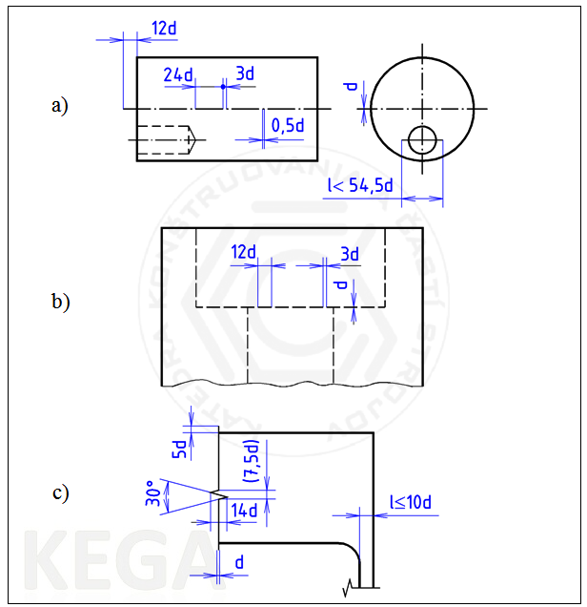
STN ISO 128-21 specifies rules for drawing lines in the CAD system to the processing of documentation by computer, e. g.:

Picture 1: Examples of drawing some line types

Explanation of Picture. 1:
- drawing symmetry axis by a thin dash-dotted line with a long dash (Picture 1a)
- constructing the image of hidden edges and contours by dashed thin line (Picture 1b)
- constructing a line of boundary of partial views with a gable - zig-zag (Picture 1c)

Reference lines and stops
STN ISO 128-22 specifies rules for drawing up the reference lines, stops of the reference lines and their parts, as well as configuration of instructions over the reference line or next to them.
Reference lines are ended by:
- an arrow (open, closed, filled-in) if the lines ends on the line of the contour or edge, pipes or electrical wiring, etc.
- a dot with diameter d = 5 x of the line thickness if it ends in the contour (in the area) of the object,
- without ending when it ends on another line (dimension, lines of symmetry).

Stops:
- may have a fixed length (l = 20 x line thickness), when information (data) are placed centered behind the reference line or they are connected to the graphical symbol
- may have a length adapted to the length of instructions, which are placed above the stop,
- there may be several stops on one reference line.
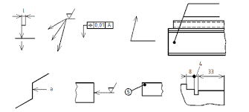

Picture 2: Examples of stops

3.3.2 Material
Understanding of what kind of material the displayed object (component) is made from is a necessary part of the process of production preparation, processing of a product or semi-finished product, its storage etc.
Materials are divided into:
- ferrous metals:
  - malleable (to 2,14% of carbon): e. g. steel
  - inductile (over 2,14% of carbon): e. g. cast iron
- non-ferrous metals:
  - light metals (to 5kg/^{m3} ): e. g. aluminum
  - heavy (over 5kg/^{m3}): e. g. lead, copper
- other materials:
  - plastics, wood, paper
  - lubricants, oils, cooling substances

Table 2 shows an overview of commonly used materials:
Tab. 2: Examples of material symbols.
Graphical symbol | Material | Graphical symbol | Material
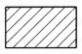 | metals | 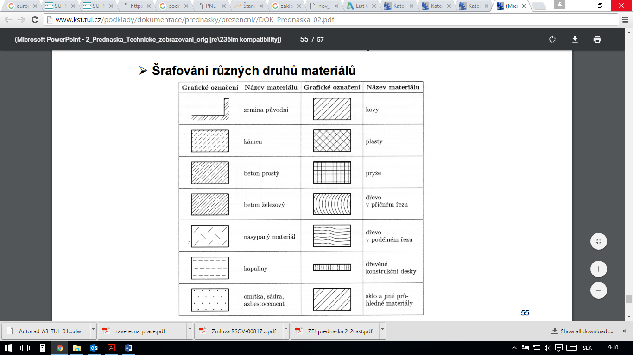 | plastics
 | rubber |  | glass
 | reinforced concrete |  | plaster, gypsum, asbestos

4 IMAGING

4.1 Methods of imaging
These methods can be divided into two basic groups:

- 3D methods – three-dimensional imaging:
- visual projection (an axonometric imaging) - Picture 3:
  - isometric (rectangular)
  - dimeric (rectangular)
  - oblique dimeric
- central projection (and perspective projection) - Picture 4
- 2D methods – projection, perpendicular two-dimensional imaging - Picture 5
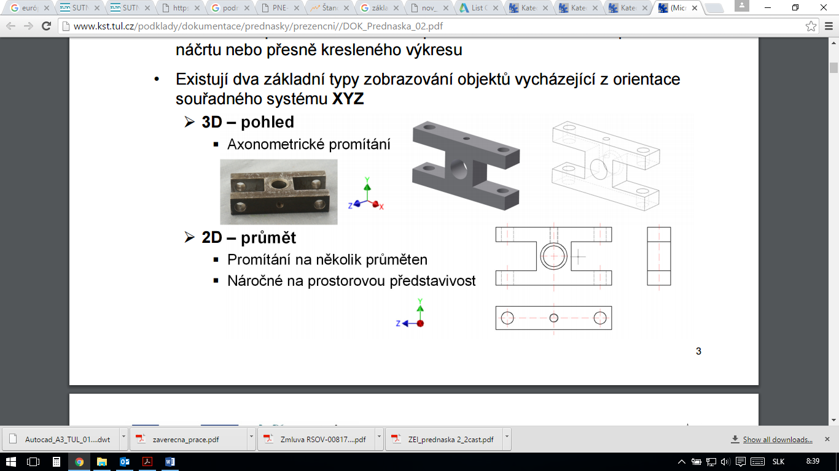

Picture 3: Object and its axonometric imaging

Picture 4: Perspective projection

Picture 5: Two-dimensional imaging

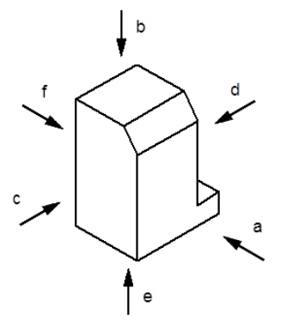
4.2 Views

Picture 6: View in technical drawing.
On the Picture 6 there are basic directions of the views:
- the main view - front view
- top view
- left view
- right view
- bottom view
- rear view

In addition to these views, there can be identified and documented also
a) special views, e. g.:
- partial
- interrupted
- developed
b) simplified view, e. g.:
- repeated elements
- ribbing
- the extreme positions of moving components (Picture 7)
- initial, final contours

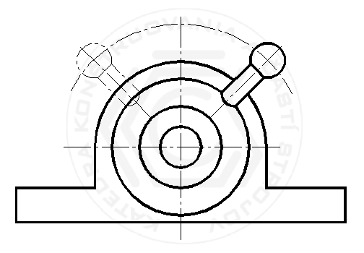

Picture 7: Extreme positions of lever.

4.3 Methods of projection
In Europe, the traditional way of projection is in the first quadrant (Picture 8a and Picture 8b) - ISO E, where the imagined object is situated between the observer and the coordinate plane on which the subject is projected vertically. For America, the typical method of screening is in the third quadrant (Picture 8c) - A ISO.

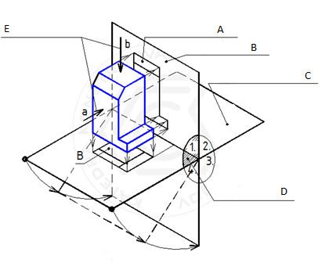

Picture 8a: Projection in the first quadrant.

A – main view
B – vertical plane
C – horizontal plane
D – first quadrant
E – view directions

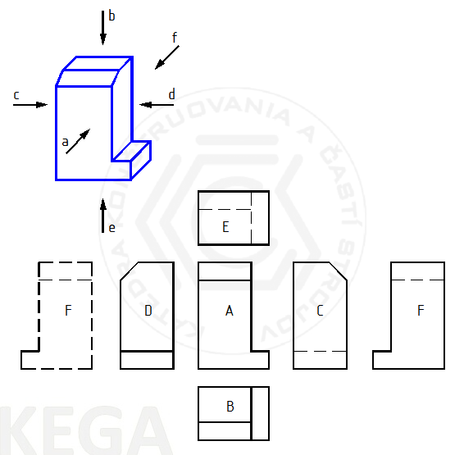

Picture 8b: Placing of all views – projection in the first quadrant.

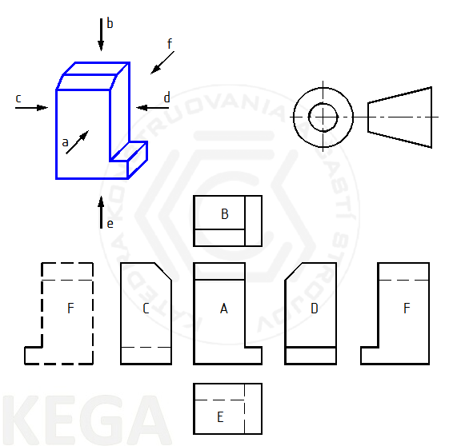

Picture 8c: Placing of all views – projection in the third quadrant.

If it is not - in our case - possible to apply rectangular of projection method ISO E, we can use the method of reference arrows:

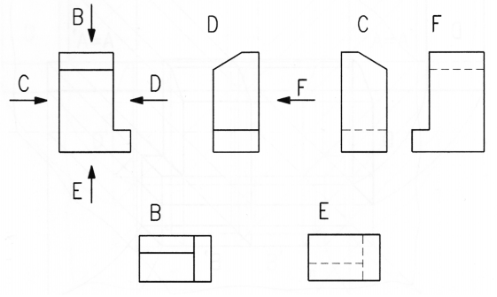
Picture 9: Method of reference arrows

4.4 Sections, cross-sections, contours
Currently, sections or cross sections are not used. Nevertheless, we may find ourselves in a situation where it is necessary to draw/identify for example holes or cavities. Therefore, in order to make clear from the documents what does it concern, it must be displayed (Picture 10):
- viewing direction using the direction arrows
- position of the plane cut by a thick dash-dotted line with a long dash, whereas this component must intersect the component part
- identification of plane cuts

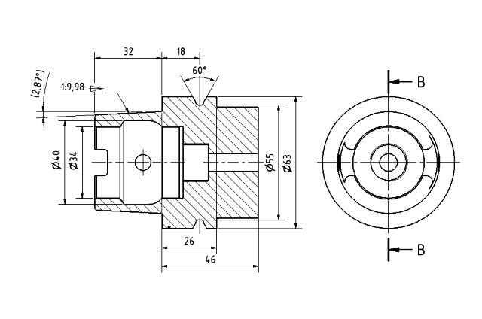
Picture 10: Projection of cross-sections

ISO 128-50 establishes hatching with thin vertical lines (type 01.1.5) at an appropriate angle (45 °) relative to the contours of component parts.

4.5 Dimensioning
We distinguish 3 types of dimensioning:
- functional: essential for function of parts or areas
- non-functional: not essential for function of parts or areas
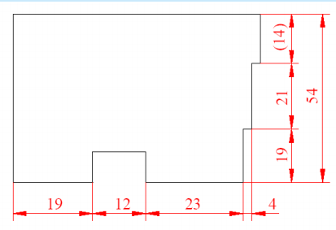
- information: does not influence e. g. production, it is enclosed in parentheses and no tolerance does apply for it (Picture 11)
Picture 11: Chain dimensioning

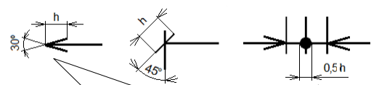
Using a sort, the thickness of the extension lines, arrows or of arrows compensation has strict rules:

Picture 12: Ending of dimension line

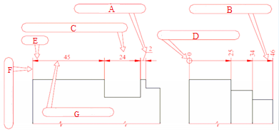

Picture 13: Dimensioning, reference and extension lines

A: Reference line
B: Ending by arrow
C: Value of dimension
D: Mark of beginning
E: Arrow
F: Auxiliary line
G: Dimension line

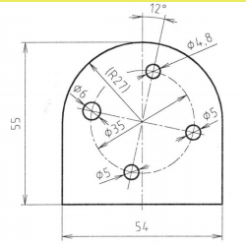
In order to distinguish the geometric shape on the drawing, it is possible to place the following symbols before a numerical value on the dimension (Pictures 14, 15):
R: radius
SR: sphere radius
Ø diameter
SØ sphere diameter
∩ bend
bevel
square

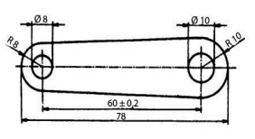
Picture 14: Example of dimensioning of bend, cylindrical and spherical areas

Impassable holes are dimensioned by their diameter and depth of the cylindrical part, wherein the apex angle is usually not dimensioned (Picture 15). Very small holes not dimensioned.
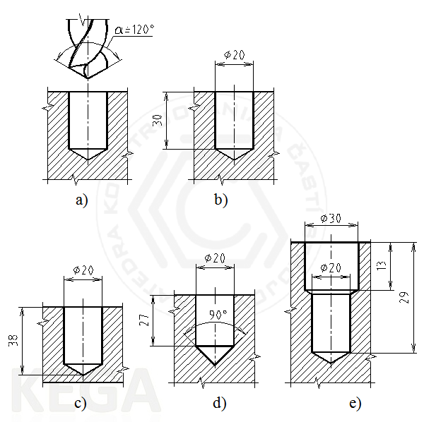
Picture 15: Examples of holes dimensioning

5 TOLERANCE
Parts are produced with so-called tolerance, i. e. by determining the boundary dimensions. The purpose of such production is their interchangeability as well as precision of manufacturing. Such tolerance is specific for length dimensions, angles, cones and coils and others. For the determination of tolerance, good knowledge of a product is required, as well as the component parts, machinery, technology of manufacturing, production economy (cost ratio, efficiency and others.), etc.
We distinguish following surface tolerance
- functional surface: those which touch other surfaces parts - bearings; they allow e. g. installation, define the mutual positions of other surfaces or function parts. They must be tolerated.
- free surface: there are no such requirements imposed on their accuracy comparing to functional surfaces; they are not tolerated.
Tolerances of functional surfaces is entered by:
- prescribed limit dimensions: e. g. ø 10,8 to ø 10,2
- prescribing restrictions on one side: e. g. R5max
- prescribing the numerical values for limit deviations: e. g. ø28±0,1
- prescribing the tolerance class of the system of tolerances and bearings ISO: e. g. 32H7
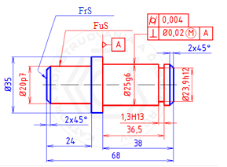

Picture 16: Free (FrS) and functional (FuS) surface – examples of tolerance labelling

5.1 Tolerance of functional areas size
To unify regulations tolerance of functional surfaces, a uniformed system of tolerances and bearings ISO has been developed in tolerances called levels of accuracy and with numerical codes IT 01 0 IT, IT 1 to IT 18. IT Brand (standardized tolerance, Tolerance International) indicates the size of the basic tolerance. In the engineering there are commonly used levels of accuracy IT 5 to 11. This system is also transposed into national standards, which refer to the boundary aberration for established tolerance zones.

Table 3: Application of tolerance levels in manufacturing.
Standardised tolerance level IT | 01 | 0 | 1 | 2 | 3 | 4 | 5 | 6 | 7 | 8 | 9 | 10 | 11 | 12 | 13 | 14 | 15 | 16 | 17 | 18
Ise | Production of gauges and instruments
Ise |  |  |  |  | Production of bearings
Ise |  |  |  |  |  |  | precision and general engineering
Ise |  |  |  |  |  |  |  |  |  |  |  |  | Production of semi-products
Ise |  |  |  |  |  |  |  |  |  |  |  |  |  |  | production of steel structures

In case of bearings, we mark these by association of tolerance mark of the hole and shaft. Tolerance mark for the hole is always comes first (e. g.  50 H8/d9).
By the description of the uniform system of tolerances and bearings ISO, the following terms and definitions are used (Picture 13):
- real size: actually measured dimension of the finished component part; it will always fluctuate between the two limits of sizes
- limit of size: extreme allowed dimensions of an element, whereas we distinguish:
  - upper limit of size ULS – the biggest allowed size
  - lower limit of size LLS – the smallest allowed size
- tolerance: the difference between ULS and LLS
- tolerance interval (TI): interval limited by ULS and LLS (by graphical projection it is bounded by two lines)
- basic deviation: the smallest of the deviations
- nominal size MR: the size of an element with perfect size – defined by drawing

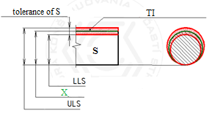
Picture 17: Tolerance of shaft (S)

X: Real size of shaft (S)
Tolerating of functional size by tolerance zone regulations referred to by the ISO standards can only be used for the parts of two types:
- cylinder (e. g. for the tolerance of hole diameter)
- two parallel opposing surfaces (e. g. for the tolerance width of the groove)

Tolerated dimensions components of other types must follow other methods of tolerance, for example, prescription limit deviations (e. g. length dimensions of a recess hole pitch).
ISO standardized system to tolerate linear dimensions determines 28 positions of tolerance zones and 28 shafts positions of tolerance zones of the holes (Picture 18).

Tolerance unit i/I was introduced to calculate the standard tolerance IT1 to IT18 tolerance.

Tolerance Unit is a function of nominal size and includes the impact of production inaccuracy and the uncertainty of measurement. Following relationship is designed for the calculation of the tolerance units:
i = 0,45.D1/3 + 0,001.D for D ≤ 500mm
I = 0,004.D + 2,1 for D > 500mm
whe reas i/I are stated in μm and D in mm.
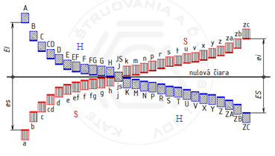
Picture 18: Overview of basic deviations
H: holes
S: shafts
In practice, it is not necessary to carry out calculations for the individual tolerances - the value of the upper and lower deviations for different ranges of nominal dimensions and tolerances.

5.2 Geometric tolerance
Geometric tolerance, as in the previous section, ensures the proper functioning of components or equipment. It concerns the correct shape, profile and orientation (i. e.) of functional surfaces components.
Interrelationships of the tolerances (length / angle measurements and geometric tolerances) are generally considered independent of each other. In the case of interdependence, standardized rules apply:
- envelope surface condition
- material removal rate (MMR)
- mass loss rate (MLR)
- reciprocity rate (RPR)

General geometrical tolerances are distinguished in three classes of accuracy: H - precise; K - mean; L - gross.
We recognize the following terms:
- geometric tolerance: the biggest allowed numerical value of considered deviation which determines the typical dimension of plane or spatial tolerance zone
- shaped element: the characteristic element of an object
- tolerance zone: space in which an object must be situated
- geometric deviation: deviation of the real plane or profile from nominal value of a parameter

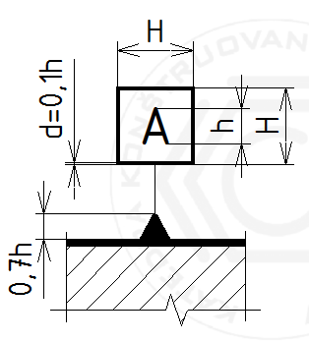
Foots are also such elements of compartment parts that have the relationship to the tolerated object related to the functional or mounting requirements. Most often, the foot is a point (e. e. sphere centre), straight (e. g. shaft axis), plane (e. g. flat surface of the components). In the case of sub-foot, it is a point (marked with a cross), line (two crosses linked by a thin line) and circular or square area (broken line with two dots, hatching). System of foots is a group of two or more foots. The foots are designated by full or empty triangle on the contour line of the element (or its extension), or on an extended dimension line (Picture 19).

Picture 19: Marking the foot

Table 4: Tolerated geometric features, their signs.
Tolerances | Tolerated characteristics | Marks | Base
Shape | Straightness |  | no
Shape | Planness |  | no
Shape | Circularity |  | no
Shape | Cylindricity |  | no
Profile | Any contour profile |  | no/yes
Profile | Any surface profile |  | no/yes
Orientation | Parallelism |  | yes
Orientation | Perpendicularity |  | yes
Orientation | Inclination |  | yes
Position | Location |  | no/yes
Position | Concentricity and alignment |  | yes
Position | Symmetry |  | yes
Whipping | Circular whipping |  | yes
Whipping | Overall whipping |  | yes

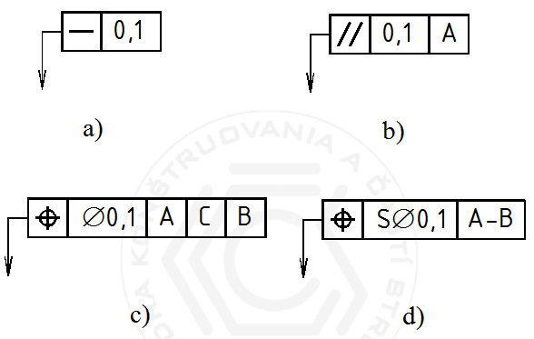
A geometric tolerance is entered in tolerance frames (Picture 20), which (left to right) determine: mark of tolerated characteristics, numerical value, a fundamental element /foot system. Tolerance frame is associated with the element tolerated by the reference line with an arrow.

Picture 20: Tolerance frames

6 SURFACE
Surface texture of components or machine significantly affects the functionality of the parts and equipment, as well as their durability (e. g. the need lubrication due to mutual friction, corrosion resistance and others.). Fatigue damage most often occurs just on the surface of parts. In assessing the work surface we work with the following concepts:
- imperfection: caused during production, handling and storage
- surface texture roughness, waviness and base profile

6.1 Surface profile

A summary of the unevenness of the surface with a small distance from the geometrically ideal surface is called surface roughness. The determination of surface parameters in Slovakia is standardized in ISO international standards. These standards have changed in recent years, for example with regard to the use of new instruments for more accurate measurement of the surface properties of objects (e. g. laser measurement - photo 1).
Photo 1: Sensor for laser measuring

The actual surface or parts of the machine is always different from the geometric - ideal - surface (e. g determined by drawing).

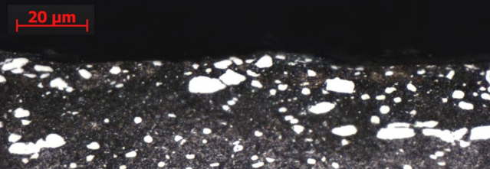
Picture 21: Steel – usual surface

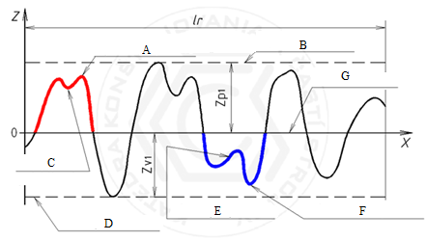
On each profile we can distinguish the prominences and depressions - these two properties together make up the so-called profile element (Picture 21, 22).

Picture 22: Surface profile
A: Protruding peak
B: Line of profile element
C: Protruding valley
D: Valley line
E: Local element
F: Core section
G: Mean line
Given the dominant direction of the surface roughness, the specific profiles can be obtained by cutting:
- cross-section profile: perpendicular to the prevailing inequality
- longitudinal profile: parallel to the prevailing inequalities
On the basis of measurement by measuring devices we distinguish:
- primary profile - P-profile;
- roughness profile - R-profile;
- waviness profile - W-profile.

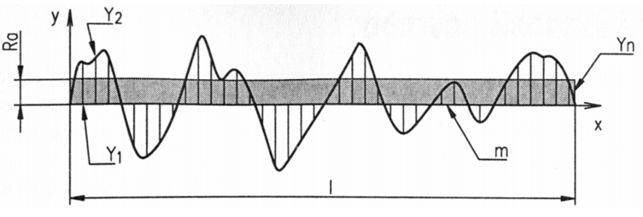
For each of these profiles, so-called medium line of profile is determined. Average arithmetical deviation Ra is the arithmetic average of the absolute deviations of Y within the range of the basic length:
Picture 23: Average arithmetic deviation Ra

Equation: $Ra= \frac{\left|y1\right|+\left|y2\right|+…+\left|yn\right|}{n}$
Ra is stated in μm. Recommended basic lengths are 0,08 mm/0,25 mm/0,8 mm/2,5 mm/8 mm/25 mm.
Surface roughness of components depends primarily on the manufacturing technology of the components (Table 4).

Table 5:
Relationship between the medium arithmetic deviation and the methods of surface finish
Typical method of surface finish | Ra
Finishing: grinding, lapping ... | 0,012 0,025 0,05 0,1 0,2 0,4 0,8
Conventional machining: milling, turning,… | 1,6 3,2 6,3 12,5
Production of semi-products: forgings, castings ... | 25 50 100 200 400

There are three basic groups of surface texture parameters that normalize prescribing requirements for the entire surface of the shape element of the components:
- basic profile parameters: the most commonly used - one for the production processes (eg. for milling, grinding, and for the al.); They are standardized for the all three parameters of the surface profile components:
- motif parameters of surface profiles: they serve to eliminate extreme amplitude values;
- profile parameters based on material share curve: these are designed for demanding functional surface finish treated through two production processes; it stems from material share curve (Abbot-Firestone curve), which is the sum of the lengths of the supporting surface profile I (c) and the location of the place of the cut profile c.

6.2 Graphical mark of surface properties
Surface property is marked by variations of basic mark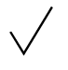 , for example:
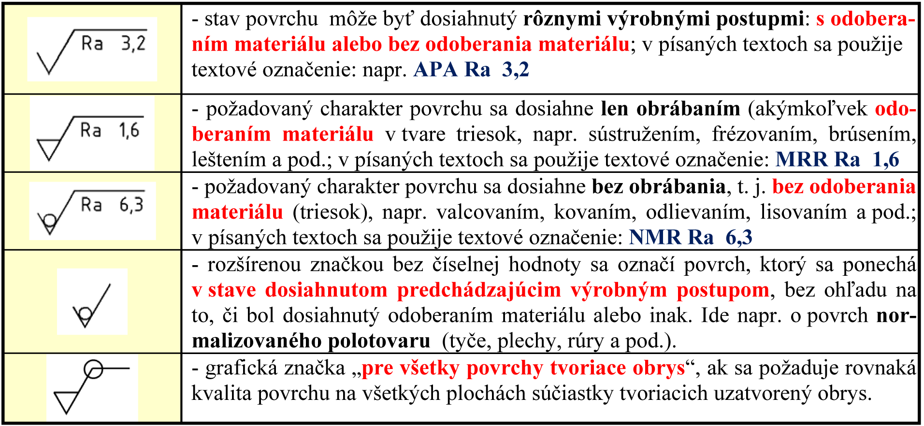 | desired surface texture can be achieved by machining only (take off any material in the form of chips, for example turning, milling, grinding, polishing, etc.); written text in a text label is used: MRR Ra 1,6
 | desired surface texture is achieved without machining, t. j. without removal of material (chips), for example rolling, forging, casting, molding etc.); written text in a text label is used: MRR Ra 6,3
To ensure accuracy and consistency of requirements on the nature of the surface, it is possible to state in the technical documentation other information (Picture 24):
a: the only requirement the character of the surface
b: only in case of two or more requirements
c: production process, surface treatment
d: direction of inequality
e: allowance for machining
Picture 24: Entry of supplementary requirements
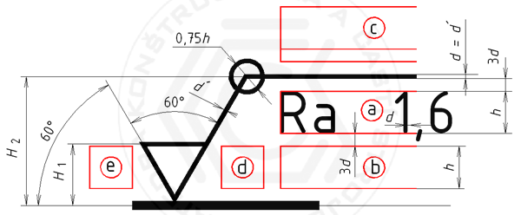
In case that all surfaces of the parts have the same surface character, this information may be given as a joint entry in the block cover page.
On the Picture 25 an example of an entry of surface property can be found:
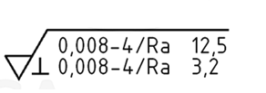

Picture 25: Example of surface roughness entry

From this entry we can identify:
Two requirements on surface property:
upper size limit: 0,008-4/Ra 12,5;
lower size limit: 0,008-4/Ra 3,2;
Parameters of surface property for both requirements:
medium arithmetic deviation of roughness profile Ra;
Upper and lower size limits:
entries are determined by the same parameter, thus marks U and L are left out;
Boundary value of parameter:
upper: Ra = 12,5 µm;
lower: Ra = 3,2 µm;
Data on tolerance limits:
for both applies the rule 16% (ISO 4288);
Type of the filtre to filtre the short and long wave lengths:
not provided – normalised Gauss filter applies;
Bandwidth requirements for both requirements:
0,008-4;
- short wave filter s = 0,008 mm;
- long wave filter c = 4 mm;
Basic length: lr = c = 4 mm;
Assessed length:
common: ln = 5 × lr = 5 × 4 = 20 mm;
Manufacturing technology:
prescribed surface character can only be achieved by milling;
The direction of surface roughness:
perpendicular to the plane of projection view in which a mark used;
The way to achieve the desired parameter:
desired surface texture is achieved only taking of material.

6.3 Special surface treatment
Special surface treatment are represented for example by:
- mechanical processing: e. g. polishing, roller, grooving, notching etc. Prescription of mechanical treatment is indicated by the word on the stop of the reference line.
- application of protective coatings: using mechanical, physical-chemical and electrical processes, for example enamelling, chromate, zinc. The layers are listed in order of base metal, a metal coating, coating thickness in μm, specification of the type of coating. In case of bright sprayed metallic coatings, the met is indicated (all methods of thermal spraying) or elmet (electric arc spraying). Examples
  - Fe/Zn 12c A stands for "zinc coating thickness of 12 μm of chromate (c) of colourless (A) coating on a steel substrate
  - elmet AL 160 means "aluminium coating with a minimum thickness of 160 μm made b electric arc metallization
- thermal and chemical-thermal treatment: for example annealing, tempering, hardening and so on. Written data are entered right at the stop line, such as the method of treatment depth adjustment, the mechanical properties. In case of general definition, the treatment method is entered on the drawing in technical requirements.

7 WELDED AND SOLDER JOINTS
When reading technical documentation, it is essential to have knowledge of basic welding technologies:
- melting: for example. flame, electric arc
- pressure: for example. projection, seam
- special: for example. ultrasound, laser.
We distinguish these types of welds:
- melting: edge flange, butt, fillet, hole punching, grooved
- resistance: spot, seam, projection, butt

The welds are typically not indicated in the technical documentation but the placement of the welds are indicated by bold continuous line or a cross (using thick continuous line) and/or a thick dot-dashed line. In case of asymmetric welds (W, Y, fillet weld), weld mark is placed above and below the double line of the stop of the reference line which is composed of a continuous and a dotted line (the order of these lines determines the position of the weld).
Mounting welds are referred in the drawing set by the stop. Besides the basic weld marks we can determine also the following information:
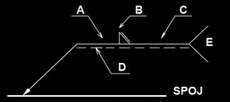

Picture 26: Weld mark

A: dimension of a weld
B: supplementary mark of the weld surface
C: length of the weld
D: supplementary mark of the weld
E: welding technology

Welding technology has the code number (if using a single method of welding, this is indicated in the labelling field):
Table 6: Overview of some welding technologies.
Method according to EN ISO 4063 | European abb. | American abb. | Full title
111 | MMA | SMAW | Manual metal arc welding with consumable electrode
114 | FCAW | FCAW | Flux-cored arc welding without shielding gas
12 | SAW | SAW | Submerged arc welding
131 | MIG | GMAW | Metal arc welding with consumable electrode in metal inert gas MIG
135 | MAG | GMAW | Metal arc welding with consumable electrode in metal active gas MAG
136 | MAG | FCAW | Flux-cored arc welding in active gas
137 | FCAW | FCAW-S | Self-shielded flux-cored welding in inert gas
141 | TIG | GTAW | Tungsten inert gas welding TIG

7.1 Drawing sets of welded constructions
Drawings of welded structures (weldments) have the character the drawing assembly, but also contain elements characteristic for drawing of components. For simple structures only one drawing i sused – for welding and machining (Picture 27); for more complex structures the dimensioned welding drawing set and drawing of machined weldment is used.

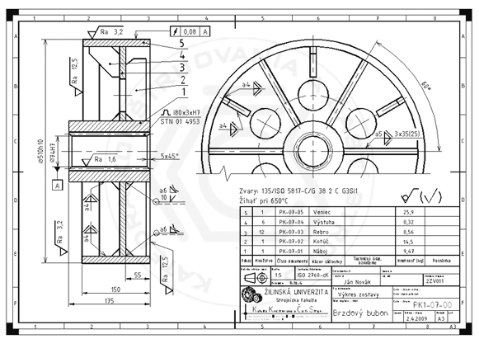
Picture 27: Brake drum – dimensioned assembly drawing of the weldment

REFERENCES

Monograph

REFERENCES

Monograph

[1] BůžeK, M. (2009). Normalisation.
[2] FREIWALD, A. (2012). New norms STN, EN a ISO in technical drawing.

[3] ZEMAN, D. (2015). Technical drawing.

More authors
[1] BAJLA J., BRONČEK J., ANTALA J., SEKEREŠOVÁ D. (2014). Engineering tables.

Electronic sources

[1] Bacics of electrotechnics. http://kem.fei.tuke.sk/~student/Zaklady%20elektrotechnickeho%20inzinierstva/ZEI_prednaska%202_2cast.pdf [23.3.2016].
[2] Basics of forestry technology. http://www.tuzvo.sk/files/3_3/katedry_lf/kltm/Servis_studentom/Servis_studentom/uvodna-prednaska-zlt.pdf [23.3.2016].
[3] Constructing 1. http://www.konstruovanie1.uniza.sk/ [23.3.2016].
[4] Drawing cuts parts. http://www.slideserve.com/aine/kreslenie-rezov-s-iastok [23.3.2016].
[5] European Comittee for Standardization. http://www.cen.eu/Pages/default.aspx [19.5.2016].
[6] European Organisation for Standardization. http://www.iso.org/iso/home.html [19.5.2016].
[7] Mechanisation of machinery. http://www.kst.tul.cz/cz/katedra/vyuka/53/ [5.8.2016].
[8] OMRON – Industry automatisation. https://industrial.omron.cz/cs/products/zx2 [19.5.2016].
[9] Type and thickness of lines. http://www.konstruovanie1.uniza.sk/Subory/2.3.html [23.3.2016].
[10] Welding methods. http://zvaranie.zvaraciatechnika.eu/oznacovanie-zvarov-na-vykresoch/ [19.5.2016].
[11] Welding methods. http://www.welco.sk/library/files/zvaracie_metody_skratky.pdf [19.5.2016].

ANNEX 1: ASSESSMENT EXAMPLE
Reading technical documentation – METAL assesment paper
Learning outcome 1: Using the theoretical knowledge of working with digital pictures

Name and surname: ____________________________ Date: _____________________
Signature: ____________________________________ Points: _____________________

1 point
- Assign the material to each mark.

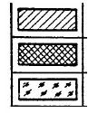

1 point
- Explain the meaning of the surface marks.

a:
b:
c:
d:

- Describe the picture and explain the meaning of dimension 20.
2 points

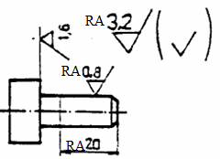
1 point
- What is the meaning of the following entry?

- Name the type of seating on the picture.
1 point

- What information XXX stands for?
1 point

XXX
10 points
- Identify (name) the component part. Describe its characteristics.

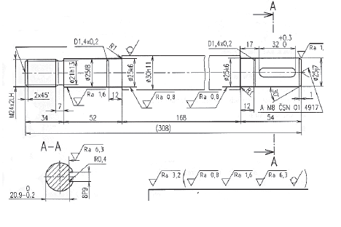
- Identify (name) the component part. Describe its characteristics.
10 points

- Look at the drawing and answer the following questions:
7 points

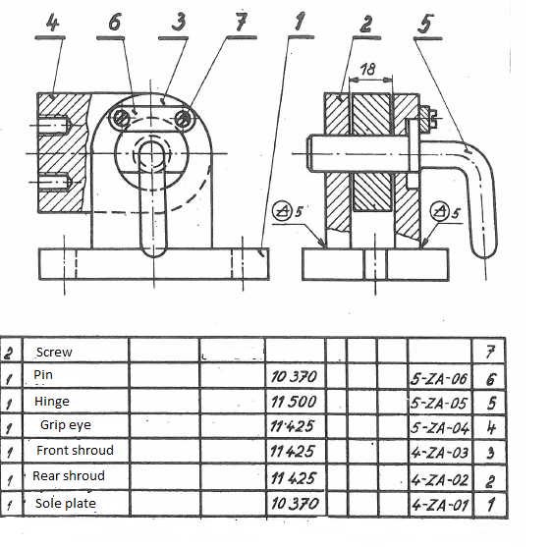
a) What is the name of the fitment no. 6?
b) Which worm is on the screw and of which size?
c) What movements can this part do?
d) Describe the asseblage steps for component parts 5, 7, 4, 6.

- Look at the drawing and answer the following questions:
10 points

a) Enumerate the data in welded joint mark.
b) Find and indicate welded joint(s) in the layout.
c) Explain the data on reference lines.

- What type of scheme is presented on the picture and specify it.
2 points

Oral test:

1 point
- Question………………………………………………………………………………….

1 point
- Question………………………………………………………………………………….

1 point
- Question………………………………………………………………………………….

The term component in electrotechnics in general, means functional element.
Zdroj: http://www.cadstudio.cz/eplan-vault-connector-propojeni-elektro-a-mechanickych-konstrukci-art2220
FREIWALD, A. (2012): New norms STN, EN a ISO in technical drawing.
Detailed analysis of advanced materials is provided through units of learning outcomes "Materials".
Another examples of the differences between ISO E and ISO A: http://www.kst.tul.cz/podklady/dokumentace/prednasky/prezencni//DOK_Prednaska_02.pdf
http://www.konstruovanie1.uniza.sk/

