

ERASMUS+ SECTOR SKILLS ALLIANCE
[PROJECT DURATION: November 2014 – October 2017]

MACHINE VISION SYSTEMS

LEARNING MATERIAL

[WORKPACKAGE 3: Designing joint curriculum]
[OUT 3.2: Learning materials]
PREPARED BY: P3-School Centre Celje, SLOVENIA

Authors: Peter Kuzman, Natalija Klepej, Denis Kač
Translated by: Aleksandra Kotnik, Natalija Klepej, Simona Tadeja Ribič
September 2016
The European Commission support for the production of this publication does not constitute endorsement of the contents which reflects the views only of the authors, and the Commission cannot be held responsible for any use which may be made of the information contained therein.

CONTENTS

1 INTRODUCTION 5
2 MACHINE VISION 5
3 DIGITAL IMAGE CAPTURE 9
3.1 Image resolution 12
3.2 Field of view 17
3.3 Contrast 25
3.4 Depth of Field 28
3.5 Lighting 32
3.6 Frame rate 40
4 TOOLS FOR DIGITAL IMAGE PROCESSING 42
Blob 44
Color 44
Edge 45
Histogram 45
ID 46
Flaw detection 46
Image 46
OCV/OCR 47
Pattern Match 47
5 EXERCISES 48
Theoretical exercises 48
Practical exercises 49
6 REFERENCES 53

LIST OF FIGURES AND TABLES
Figure 1: Counting of products in their packaging.[7] 5
Figure 2: Detection of a foreign object on paper.[7] 6
Figure 3: Measurement of coplanarity of pins on a connector.[7] 6
Figure 4: Positioning of LCD glass substrates.[7] 7
Figure 5: Control of presence of grease in the bearing.[7] 7
Figure 6: Control of luminosity of LED light.[7] 7
Figure 7: Colour inspection of connector wires.[7] 8
Figure 8: Width measurement using two cameras.[7] 8
Figure 9: Colour inspection of connector wires.[7] 8
Figure 10: Width measurement using two cameras.[7] 8
Figure 11: The principle of digital image capture. 9
Figure 12: CCD image sensor. 10
Figure 13: CMOS image sensor. 10
Figure 14: Cine-film with sensitivity ISO 100. 10
Figure 15: Photo with long exposure time and the effect of bright lines caused by moving vehicles. 10
Figure 16: Pixel matrix of the captured image. 11
Figure 17: 8-bit depth or 256 levels of brightness. 11
Table 1: Technical characteristics of the camera.[1] 12
Figure 18: Image capture at different resolutions. 13
Figure 19: Image capture at different resolutions.[3] 13
Figure 20: Capture of two separate black objects on a white background at different resolutions of the sensor.[2] 14
Figure 21: Example of test image to test a camera lens.[4] 14
Figure 22: Example of sampling frequency being too low. 15
Table 2: Values (lp/mm) with different sensor pixel sizes. 15
Figure 23: Example of data for CMOS sensors.[5] 16
Figure 24: Field of view and object distance. 17
Figure 25: Spatially limited mounting of the camera. 18
Figure 26: Observed object in the field of view and object resolution. 18
Figure 27: Field of view being too big and small size of the object in relation to the entire image. 19
Figure 28: Proper field of view and size of the object in the relation to the entire image. 19
Figure 29: Example of supply of lenses with a fixed focal length.[2] 20
Figure 30: The relationship between the field of view and the working distance at resolution 1280 x 1024 pixels.[1] 21
Figure 31: The relationship between the field of view and the working distance at resolution 800 x 600 pixels.[1] 21
Figure 32: Telecentric lens. 22
Figure 33: Light beam with a conventional lens.[6] 22
Figure 34: Light beam with a telecentric lens.[6] 23
Figure 35: Distortion with a telecentric lens on the left and a conventional lens on the right.[6] 23
Figure 36: Image captured with a conventional lens and the visible perspective of the inside of the pipe.[2] 24
Figure 37: Image captured with a telecentric lens, where the perspective of the pipe is not seen.[2] 24
Figure 38: The top images captured with a conventional lens, the bottom ones with a telecentric lens.[2] 24
Figure 39: Different values of contrast, the highest being the transition from black to white.[2] 25
Figure 40: Distinct transition between the objects at the top and blurred transition between the objects at the bottom.[2] 26
Figure 41: High contrast. 27
Figure 42: Low contrast. 27
Figure 43: Comparison between an image captured with a high-resolution lens and an image captured with a standard lens.[7] 27
Figure 44: Left - small depth of field. Right - large depth of field.[11] 28
Figure 45: Depth of field measurement with closed and open aperture.[7] 29
Figure 46: Aperture openness determines the quantity of light flow on a sensor.[9] 29
Figure 47: Different levels of aperture openness at constant exposure time.[10] 30
Figure 48: Aperture openness influence on image sharpness.[10] 30
Figure 49: An example of macro photography and a small depth of field. 31
Figure 50: Illumination by an entire spectrum and using an additional red filter.[12] 32
Figure 51: Change in illumination of the can increases a chance of detecting the inscription on the right.[7] 32
Figure 52: Spectral content of individual lighting sources.[13] 33
Figure 53: Colour Wheel.[13] 34
Figure 54: Candy pieces illuminated by various colours.[13] 34
Figure 55: Left - illuminated with a red 660 nm ring light. Right - illuminated with a 360 nm UV fluorescent light.[13] 35
Figure 56: Left - under diffuse white light. Right - under diffuse IR light.[13] 35
Figure 57: Left - illumination with red light. Right - illumination with IR light.[13] 36
Figure 58: Transparent can holder with additional polarizing filters on the right.[13] 36
Figure 59: Reducing glare with polarizing filters. [1] 37
Figure 60: Polarizing filter.[1] 37
Figure 61: Back lighting illumination technique.[13] 38
Figure 62: An example of flat light source, bright back lighting.[14] 38
Figure 63: Two techniques of diffuse lighting.[13] 38
Figure 64: An example of dome for producing diffuse lighting.[14] 38
Figure 65: Directional lighting or bright field.[13] 39
Figure 66: Examples of directional lighting sources or bright- field lighting.[14] 39
Figure 67: Dark-field illumination technique. [13] 39
Figure 68: Examples of dark-field lighting sources.[14] 39
Figure 69: Left - bright- field image of a mirror. Right - dark-field image of a mirror; note scratch.[13] 40
Figure 70: Left - bright-field illumination technique. Right - dark-field illumination technique.[15] 40
Figure 71: Left: short exposure time. Right: long exposure time.[2] 41
Figure 72: Left - image captured with a global shutter. Right - image captured with rolling shutter.[2] 41
Figure 73: Machine vision system. [1] 42
Figure 74: Compact machine vision camera. [1] 42
Figure 75: An example of an industrial camera communication interface. [16] 43
Figure 76: An example of blob analysis.[1] 44
Figure 77: Color analysis of airbag sensor connection in installation phase.[1] 44
Figure 78: An example of an area of the captured image where the values of the neighbouring pixels vary greatly. [1] 45
Figure 79: Direction of search and search area.[1] 45
Figure 80: An example of histogram.[1] 46
Figure 81: 2D barcode and 1D barcode.[1] 46
Figure 82: Using a digital filter to remove black speckles.(1] 47
Figure 83: Character recognition from a set of the learned text format.[1] 47
Figure 84: Object recognition based on detecting outer edges and comparing them to reference models.[1] 47
Figure 85: Captured images of coins. 49
Figure 86: Software for setting up a camera and a camera emulator. 49
Figure 87: Image editing tool 50
Figure 88: Tool for identifying the coin in the image. 50
Figure 89: An example of pattern recognition despite a different position. 51
Figure 90: Recognition of the damaged coin edge. 51
Figure 91: Foreign object among euro coins. 52

INTRODUCTION
The material is intended for participants attending the course of Machine Vision. Participants will learn how to choose a suitable industrial camera and lens for a given problem. By using special software intended for setting up industrial cameras, they will accordingly set the selected camera and connect it to the system with a pre-programmed programmable logic controller (PLC). In the first chapter the material deals with the principle of digital image capture and explains the basic concepts of digital photography. In the following typical editing tools for digital processing of already captured images are described. The tools are the basic building blocks of special software for setting up of industrial cameras, which are offered in addition to the cameras by manufacturers of industrial cameras. In the end there is a collection of theoretical tasks to consolidate the knowledge plus instructions for carrying out practical tasks.

MACHINE VISION

Machine vision is an optical and electronic system that has the ability to automatically capture a two-dimensional image of an object or details on the object, as well as the ability to process such a captured image. Machine vision is used in four typical control areas. The first control area is counting. Figure 1 shows an example of the use of machine vision for counting of products in their packaging.
Figure 1: Counting of products in their packaging.[7]
CAPTURED
IMAGE
The second control area in which machine vision is used, is detecting anomalies on the object or on the details of the object. Figure 2 shows an example of detection of a foreign object in real-time quality control of paper.
Figure 2: Detection of a foreign object on paper.[7]
CAPTURED
IMAGE
FOREIGN OBJECT

With machine vision we can automate the measurement of dimensions. Figure 3 is an example of measuring the coplanarity of connector pins.
Figure 3: Measurement of coplanarity of pins on a connector.[7]

The fourth control area covers applications of positioning of objects with the help of machine vision. The following picture is a demonstration of positioning of LCD glass substrates.
Figure 4: Positioning of LCD glass substrates.[7]

The majority of industrial applications fall into one of the four above mentioned control areas. The following pictures contain examples of different industrial applications. The bottom left picture displays control of presence of grease in the bearing, and the bottom right picture control of luminosity of LED light.
Figure 5: Control of presence of grease in the bearing.[7]
OK
NOK
Figure 6: Control of luminosity of LED light.[7]

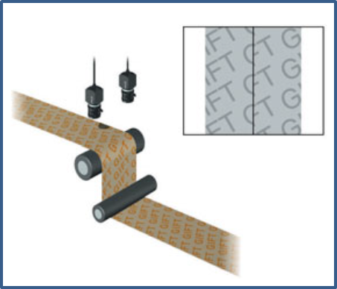 | 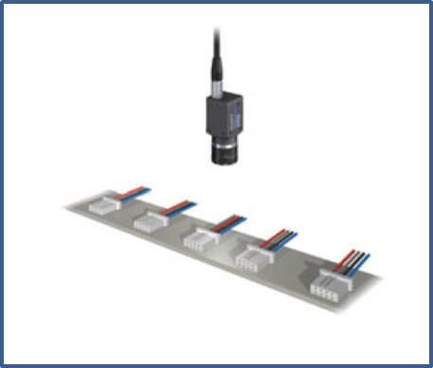
Figure 7: Colour inspection of connector wires.[7] | Figure 8: Width measurement using two cameras.[7]
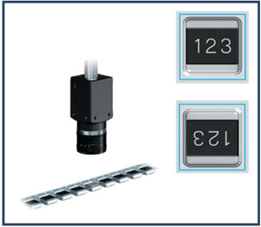 | 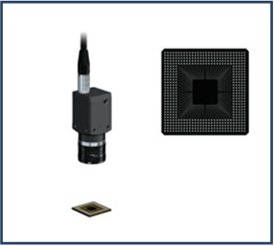
Figure 9: Colour inspection of connector wires.[7] | Figure 10: Width measurement using two cameras.[7]

It is clear from the examples above that these tasks, if performed by human, would take too much time or would be too complex. Machine vision in combination with a control system can perform such tasks 24 hours a day, 7 days a week. An individual task is completed in only 10 miliseconds, which means that controlling, counting, measuring or positioning are carried out at the speed of a production process.

DIGITAL IMAGE CAPTURE

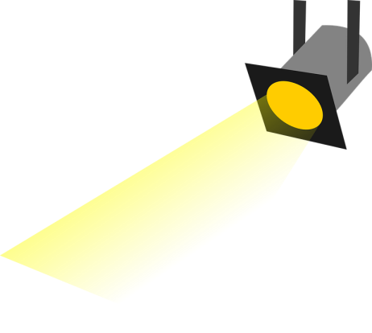
We want to capture, mathematically describe and record the image of an object in the processor and in this way enable the processor to do the required processing of the image. The recording of the image into the processor is influenced by several factors. The size of the object and its distance from the lens system in the camera lens are the basic factors according to which we select the type of the lens. The illumination of the object or the interesting features of the object which we want to emphasize are the basic factors according to which we select the mode of additional illumination of the object.
Figure 11: The principle of digital image capture.
CPU

SENSOR
LENS SYSTEM
ELECTRONICS
OBJECT
INTERFACES
ADDITIONAL OBJECT
ILLUMINATION

The features of the object which we want to capture and then digitaly process, combined with the distance of the object from the lens system in the objective lens and the size of the object itself, determine the choice of the minimum required image resolution. When measuring dimensions with machine vision, resolution of the image determines the minimum possible measured distance. The structure of the digital camera is the same as the one of the classical analog, but instead of a motion picture film, it uses a CCD (Charge Coupled Device) or CMOS (Complementary metal–oxide–semiconductor) sensor. The difference between the sensors is the structure itself. With regard to their properties, the production of CCD sensors is cheaper and less complicated, while CMOS sensors consume less energy and make less noise at poor illumination or when capturing images with higher ISO values.
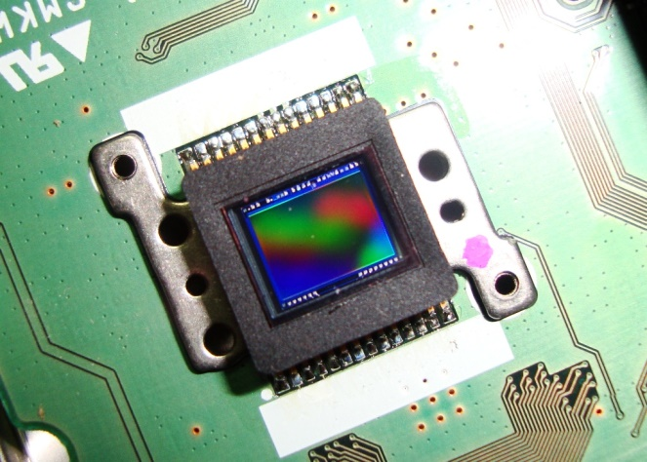  Figure 12: CCD image sensor. | 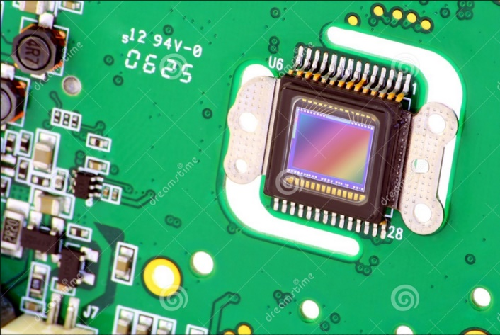  Figure 13: CMOS image sensor.
The ISO value indicates sensitivity. For analog cameras cine-films were marked with ISO value. Higher ISO meant higher sensitivity of the cine-film, but also higher graininess of the captured image. Higher ISO or higher sensitivity enables quicker image capture at low illumination. The aperture can be open for a shorter period of time. This is particularly important when moving objects are less illuminated, where the aperature opened for too long would cause smeared images of the object. The following can be a nice effect in art photography, but in machine vision it is generally undesirable.

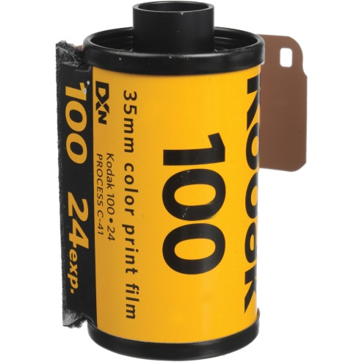  Figure 14: Cine-film with sensitivity ISO 100. | 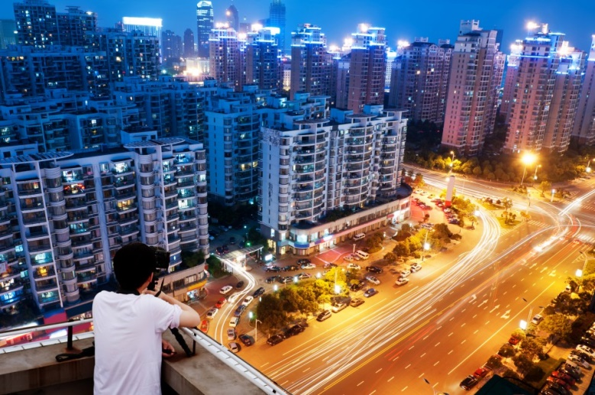  Figure 15: Photo with long exposure time and the effect of bright lines caused by moving vehicles.
An image sensor consists of several independent sensors that detect an individual pixel of an image. Each individual pixel is converted into an electric signal. A sensor the size of approximately one square centimetre is actually a bundle of sensors building a matrix of pixels. Each pixel in such a matrix is converted into an electric signal. On the left below (Fig. 16) there is a picture of a smiley which is displayed within a network of 2500 pixels in the middle. The eyebrow as a detail of the image is enlarged on the right side. Numbers from 0 to 255 indicate the intensity of each individual pixel and in the computer memory they are stored as eight-bit binary combinations. Full black is represented by number 0, clean white on the other hand by number 255. The pixels in the image that are indicated with number 30 represent black color. Number 90 marks the neighboring pixels that are lighter than the ones marked with number 30.
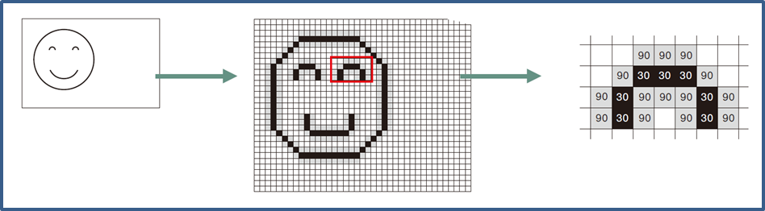
Figure 16: Pixel matrix of the captured image.

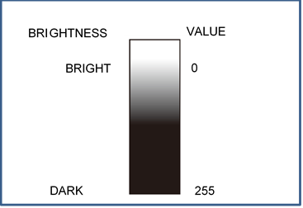
Figure 17: 8-bit depth or 256 levels of brightness.

3.1 Image resolution
A digital camera uses a flat-panel image sensor to capture images. Flat-panel sensors in cameras are different dimensions and have different distributions of pixels on the surface. 800 x 600 pixels indicates the distribution of pixels across the surface of the sensor, meaning 800 pixels are across the width of the sensor or alon the x-axis and 600 pixels across the height of the sensor or along the y-axis. This sort of sensor has 480,000 points on its surface. Table 1 shows technical characteristics of three cameras. From the data we can get the information about the resolution of the sensor and its size.
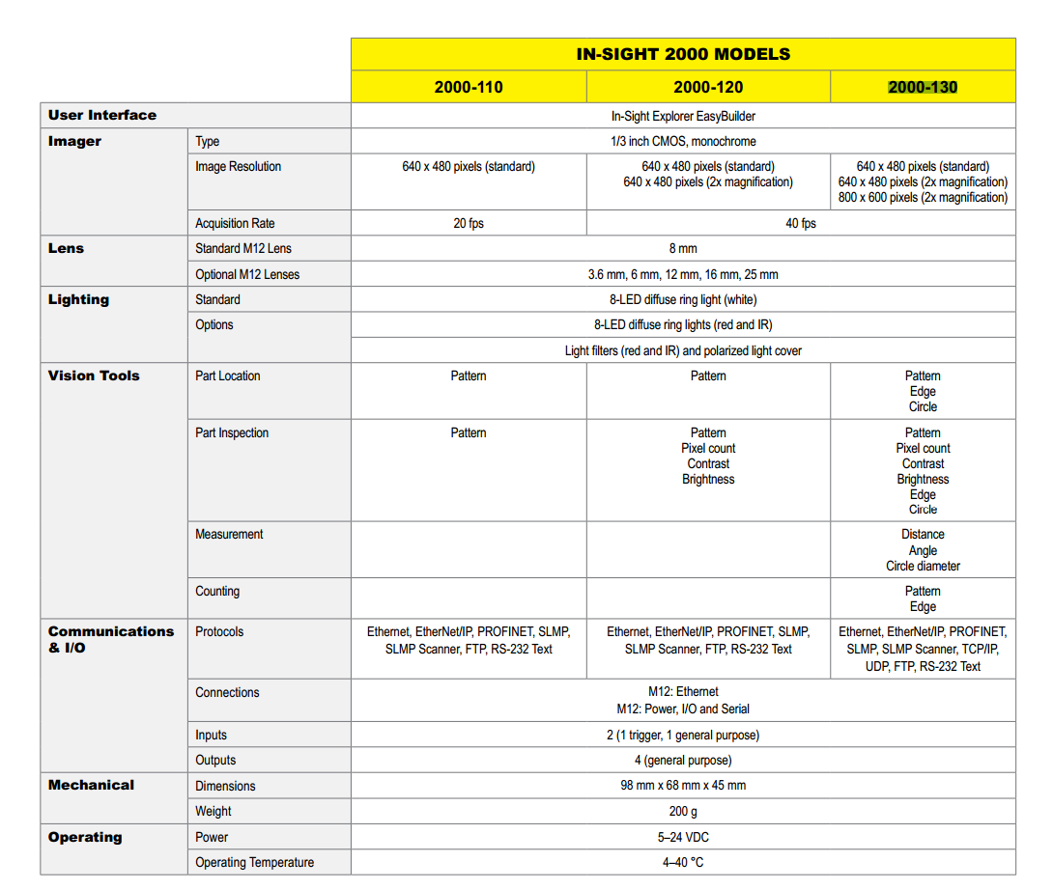
Table 1: Technical characteristics of the camera.[1]
Since the image is stored as points/dots in the memory of the camera, its dimensions are intangible. Its size is determined by the distance to the object and field of visibility.


To distinguish details on objects we must ensure that details of an image consist of a sufficiently large number of pixels. In Fig. 18 we have examples of a higher resolution on the left and lower on the right. The details are harder to discern on the object with a lower resolution. At a lower resolution the bowstring nearly disappears.
Figure 18: Image capture at different resolutions.

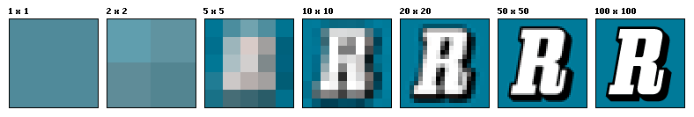
Figure 19 is an example of image capture of capital letter R at different resolutions. The information about the capital R is discerned no sooner than at a resolution of 20 x 20 pixels.
Figure 19: Image capture at different resolutions.[3]

Figure 20 is an example of sensing the distance between two black rectangular objects on a white background. In 'a' the distance between the objects is too small for the in-between white point to activate on the camera sensor. Both black objects are imaged as a larger black rectangle on the sensor and thus the information about the factual image is distorted. During the processing of such an image it is not possible to discern that in reality the two black rectangles
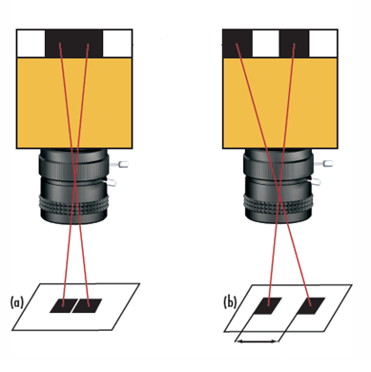
are distant from one another. In 'b' both black rectangles are imaged on the sensor of a higher resolution, where the white area between the scanned rectangles is clearly visible.
Figure 20: Capture of two separate black objects on a white background at different resolutions of the sensor.[2]
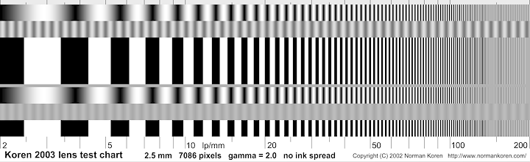
The ability to capture alternating white and black lines in a one-milimeter field of view can be expressed in lp/mm (line pairs per milimeter). The term line frequency is also used and is a useful piece of information when comparing camera lenses and sensors. However, it is not absolute as it depends on the contrast and the field of view.
Figure 21: Example of test image to test a camera lens.[4]
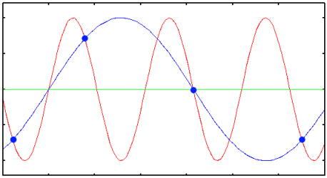
If we want to know what the smallest pixel that can be detected on an object is, the Nyquist criterion should be considered. The frequency of sampling of the signal should be at least twice as high as the highest frequency of the component of the basic signal that we want to faithfully reproduce from the captured points.
Figure 22: Example of sampling frequency being too low.

If we have a look at Figure 22 a period can be defined as a single exchange between a black and a white object or any transition from the black to the white background can be visualised as a single swing/oscillation. If the Nyquist criterion is seen in terms of a period, then this means two samples within one period. In case 'a' in Figure 20 we only have one sample per period and therfore part of the information in the captured image is lost. Both black objects on the captured image are joined. In case 'b' we have two samples per period, which is why the information about two separate black objects is maintained.
Vrednosti (lp/mm) pri različnih velikostih točke na tipalu.
Table 2: Values (lp/mm) with different sensor pixel sizes.
Pixel size on a sensor (µm) | Nyquist limit (lp/mm)
1.67 | 299.4
2.2 | 227.3
3.45 | 144.9
4.54 | 110.1
5.5 | 90.9
n order to determine the minimum spot on an object that a camera can detect, the ratio of the size of the field of view to the sensor size needs to be calculated. The ratio gives the value of the primary magnification (Primary Magnification, PMAG).

$$magnification factor= \frac{sensor size }{field of view size }$$ | (2.1)

If the ratio PMAG, which gives us the primary magnification factor, is multiplied with the resolution of the captured image on a sensor, measured in (lp/mm), the resolution of the object is obtained.

$$object space resolution \left(\frac{lp}{mm}\right)=sensor resolution \left(\frac{lp}{mm}\right) x magnification factor$$ | (2.2)

The required object space resolution is rarely given in lp/mm, but rather in µm. Therefore we can use the equations:

$$object space resolution \left(µm\right)= \frac{1000 (\frac{µm}{mm})}{2 x object space resolution \left(\frac{lp}{mm}\right)}=\frac{pixel size (µm)}{magnification factor}$$ | (2.3)

An example of how object resolution is calculated if:
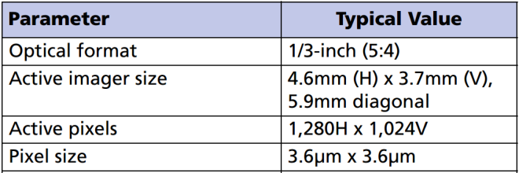
Figure 23: Example of data for CMOS sensors.[5]
- sensor resolution is 800 x 600,
- sensor size is 1/3 inch,
- field of view (FOV) is 100 mm horizontally.

Sensor resolution:
$$sensor resolution \left(lp/mm\right)= \frac{1000 µm/mm}{2 x 4.6 µm} ≈108 lp/mm$$
Sensor dimensions from the table:
$$sensor height \left(H\right)=3.7 mm$$
$$sensor width \left(W\right)=4.6 mm$$
Magnification factor:
$$magnification factor= \frac{4.6 mm}{100 mm}=0.046$$

Object resolution horizontally:
$object resolution \left(lp/mm\right)=108 \frac{lp}{mm}x 0.046 = 4.968 lp/mm$
$$object resolution \left(µm\right)= \frac{1000 µm/mm}{2 x 4.968 lp/mm} ≈100 µm$$

Object resolution 100 µm means that the image of the object will be recorded in such a way that the smallest part of the image will correspond the distance of 100 µm in reality.

3.2 Field of view
The field of view (FOV) is an area that can be captured on the image sensor at a certain distance, measured from the focal point on the lens. The focal length is the distance between the lens focus and the sensor, while the object length is the distance between the object and the focus of the lens.
Figure 24: Field of view and object distance.
L2
L1
FOV 1
FOV 2
L3
IMAGE SENSOR
FOCAL LENGTH
FOV 3
OBJECT LENGTH
FIELD OF VIEW
LENS
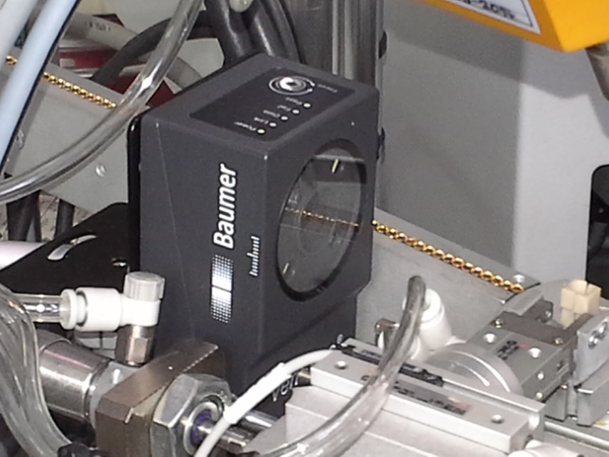
Field of view is in practice related to the size of the observed object or observed detail of an object, plus the distance between the camera and the object. The mounting of the camera is often spatially and/or technologically limited.
Figure 25: Spatially limited mounting of the camera.

In order to take advantage of the maximum possible object resolution, it makes sense for the observed object or one of its details to occupy the whole field of view. The smaller the section that the observed object (or one of its details) occupies in the whole field of view, the lower the object resolution. In the picture below the left side shows an object that occupies a large portion of the field of view, and the right side depicts an object that occupies a small portion of the field of view.
Figure 26: Observed object in the field of view and object resolution.

By selecting a proper lens and a suitable distance to the object we can ensure that the observed object or its detail will occupy the greater portion of the field of view.
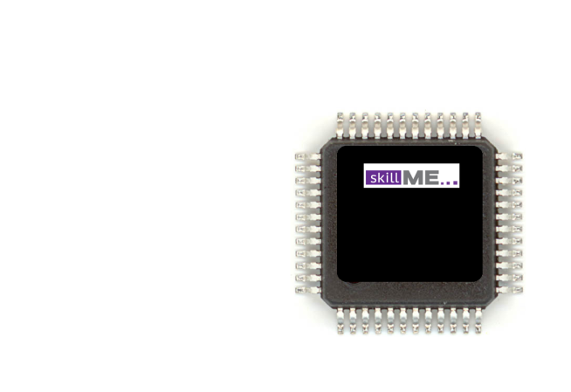  Figure 27: Field of view being too big and small size of the object in relation to the entire image. | 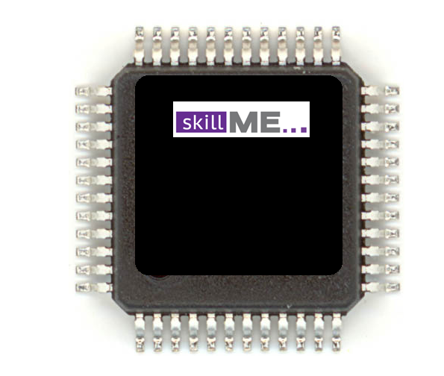  Figure 28: Proper field of view and size of the object in the relation to the entire image.
When choosing a lens we must know the size of the object and the possible distance for mounting the camera. If the observed object or its observed detail is much larger in reality than the size of the camera's sensor, then the field of view can range from 20 mm to a few dozen metres. The lenses for such a field of view can have a variable or a fixed focal length.
When determining the focal length of a lens we should consider the following:
$$magnification factor= \frac{sensor size }{field of view size }$$ | (2.4)
$$focal length= \frac{magnification factor x field of view size }{(1+magnification factor)}$$ | (2.5)
Here we have an example of selection of the focal length of a lens if sensor resolution is 800 x 600, sensor size 4.8 x 3.6 mm, field of view (FOV) 100 mm horizontally and working distance 500 mm:
$$magnification factor= \frac{4.8 mm }{100 mm }=0.048$$

$$focal length= \frac{0.048 x 500 mm }{(1+0.037)}=22.9 mm$$

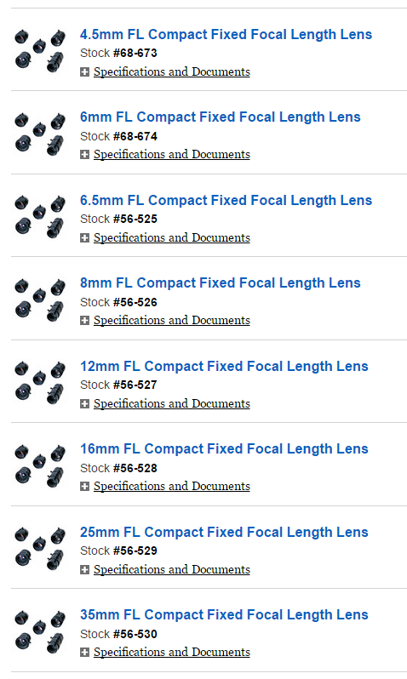
In practice we hardly find a lens with a fixed focal length 22.9 mm. Figure 29 shows a supply of camera lenses with a fixed focal length. From it, we can choose a lens with a focal length 16 mm, which is shorter than the one calculated above. Using this option, we will see some increase in the field of view at distance 500 mm where the camera is mounted, but the object resolution will decrease. Therefore we can choose a 16 mm lens and add a teleconverter. Another option is that we choose a longer focal length and pull the camera away from the object. The last option depends on the space and the equipment technology whose part the camera is.
Figure 29: Example of supply of lenses with a fixed focal length.[2]

There are web accessible applications that enable calculations between the focal length, the field of view and the working distance of a camera. Below we have a few links to such calculators:
http://www.edmundoptics.de/resources/tech-tools/focal-length/
http://www.cognex.com/ExploreLearn/UsefulTools/LensAdvisor/?id=8341
http://www.machinevision.ca/fieldofviewcalculator

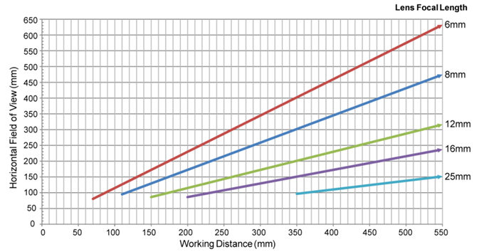
Figure 30: The relationship between the field of view and the working distance at resolution 1280 x 1024 pixels.[1]
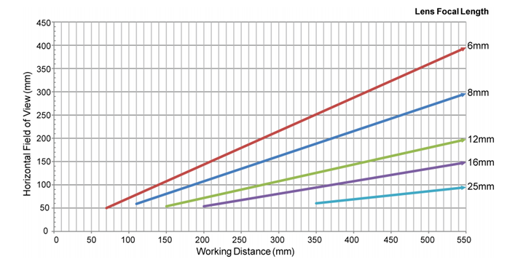
Figure 31: The relationship between the field of view and the working distance at resolution 800 x 600 pixels.[1]
In the figures below we see a relationship between the field of view and the working distance of a camera from the object, for lenses of different focal lengths and two different sensor resolutions.

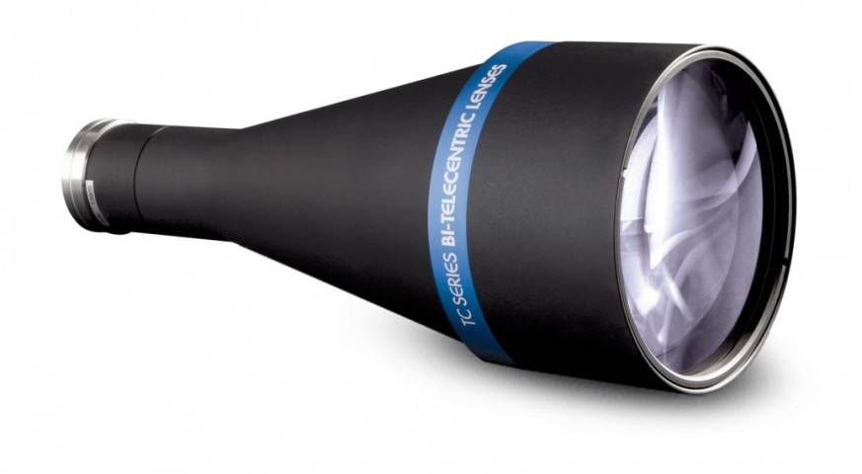
When the observed object or its observed detail is smaller than the size of a sensor in a camera, then it is reasonable to choose a telecentric lens.
Figure 32: Telecentric lens.

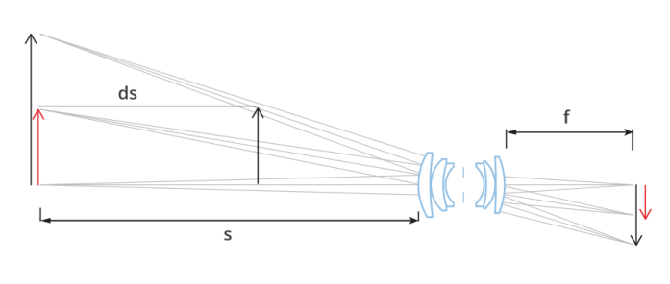
The main feature of a telecentric lens is its constant field of view, regardless of the working distance of a camera. As its imaginary light beams are parallel, such a lens has little distortion and provides greater depth of field.
Figure 33: Light beam with a conventional lens.[6]

Parallel light beams enable a fair comparison of two objects of different sizes, which are located at varying distances from the lens, as shown below. In the previous figure it seems as if both objects are the same size although in reality they are not. This is because light beams fall on the lens at right angles.
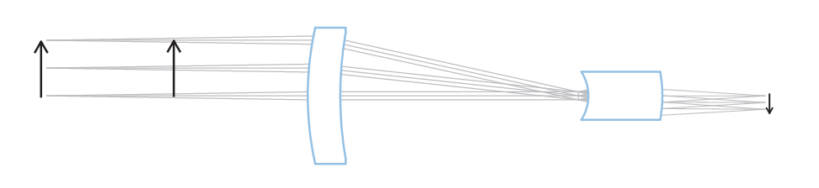
Figure 34: Light beam with a telecentric lens.[6]
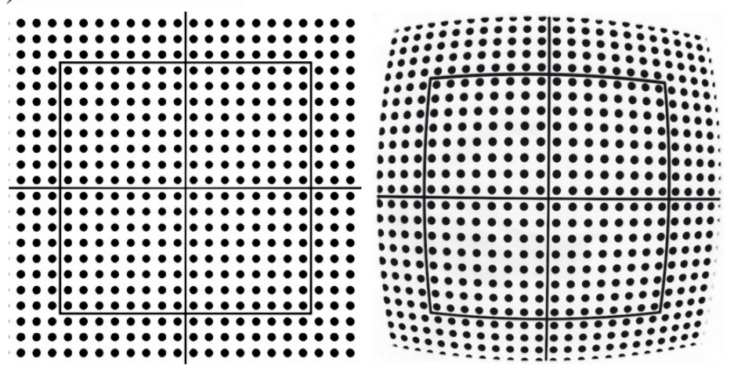
An image taken with a conventional lens exhibits radial distortion on the edges, which we can see on the right below. However, a telecentric lens has no radial distortion, which can be seen on the left below.
Figure 35: Distortion with a telecentric lens on the left and a conventional lens on the right.[6]

In practice there are differences between images taken with a conventional lens and a telecentric lens, which is demonstrated in the two examples that follow. In the first image, captured with a conventional lens, we can see the perspective of the inside of the pipe, which can cause difficulty in perceiving the edge of the pipe that has been cut off. In the image captured with a telecentric lens, the perspective is not seen due to the parallel light beams. The cut-off edge of the pipe is clearly seen.
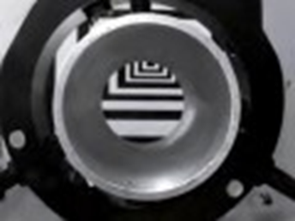
Figure 36: Image captured with a conventional lens and the visible perspective of the inside of the pipe.[2]

Figure 37: Image captured with a telecentric lens, where the perspective of the pipe is not seen.[2]
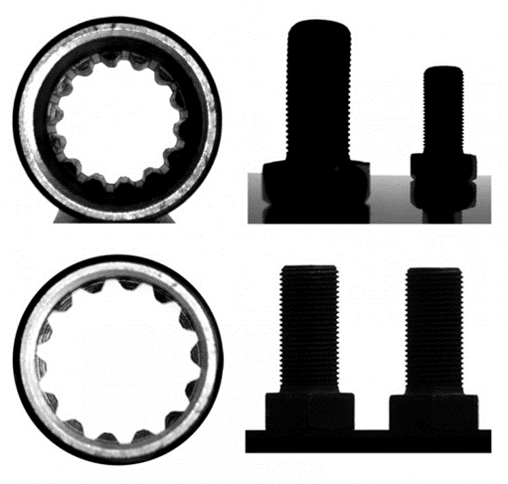
Figure 38: The top images captured with a conventional lens, the bottom ones with a telecentric lens.[2]

The use of a telecentric lens is recommended:
- when measuring dimensions of an object and its dimensions are smaller than 1/10 of the field of depth,
- when measuring dimensions of several objects which are not in the same plain,
- in case of a variable object-to-lens distance, when this distance is not known or cannot be predicted,
- when holes must be inspected or measured,
- when an accurate profile of a piece must be extracted,
- when a great depth of field of a thin object is required,
- when even sensor illumination is required (for example when inspecting LCD, textiles, printing quality).

3.3 Contrast
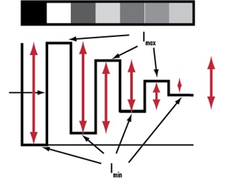
The term contrast describes how well black points can be distinguished from white ones on a captured image. If a captured image consists only of white and black details, the contrast is maximal. However, each captured black and white image consists of a full spectrum of greys. The greater the difference in intensity between a dark and a light point, the better the contrast.
Figure 39: Different values of contrast, the highest being the transition from black to white.[2]
BLACK
WHITE
CONTRAST
SHARP TRANSITION
POINTS OF AN IMAGE
The contrast is defined as a ratio, where l_{max} is the maximum intensity (usually in pixel greyscale values) and l_{min} is the minumum intensity.
$$contrast \left(\%\right)= \frac{\left(lmax-lmin\right)}{\left(lmax+lmin\right)}x100$$ | (2.6)

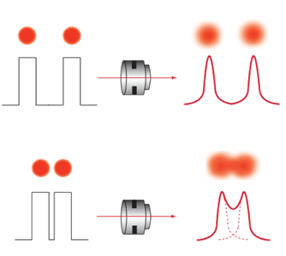
The lens, sensor and illumination all affect the resulting image contrast. They affect the contrast individually and as a whole, as a system. Lens contrast is defined in terms of ideal illumination of an object, but in reality this is rare. In addition to the resolution, information on the object contrast is very important for effective object recognition or recognition of the details on the object. When speaking about the resolution we pointed to the problem of image capture of two objects close to each other (Figure 20). Even though the system is capable of capturing two nearby objects, sampling the space in between, in reality such high contrast as seen in Figure 20 is rare. We are dealing with the maximum contrast here since it is a transition from the black to the white. Often, when one object transitions to another, blurr occurs. This means lack of contrast. In Picture 40 we see that at the top the line frequency is low and therefore the transition from one object to another is clear. However, the image at the bottom was captured at a higher line frequency, which is why the transition from one object to another is blurred and no longer recognizable.
Figure 40: Distinct transition between the objects at the top and blurred transition between the objects at the bottom.[2]
The left picture below (Figure 41) was captured with high contrast and that is why the details on the image are very distinct. The picture on the right (Figure 42) was captured with low contrast. Therefore, the transitions between details are blurred and the details more difficult to distinguish. The factual resolution of a system depends on sensor resolution, lens resolution, contrast capability of a sensor and contrast capability of a lens. Also, in order to effectively and reliably resolve objects and detail an image must possess sufficient contrast.
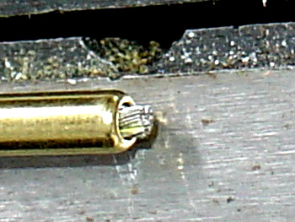  Figure 41: High contrast. | 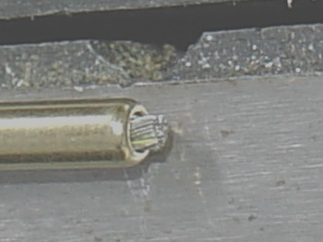  Figure 42: Low contrast.
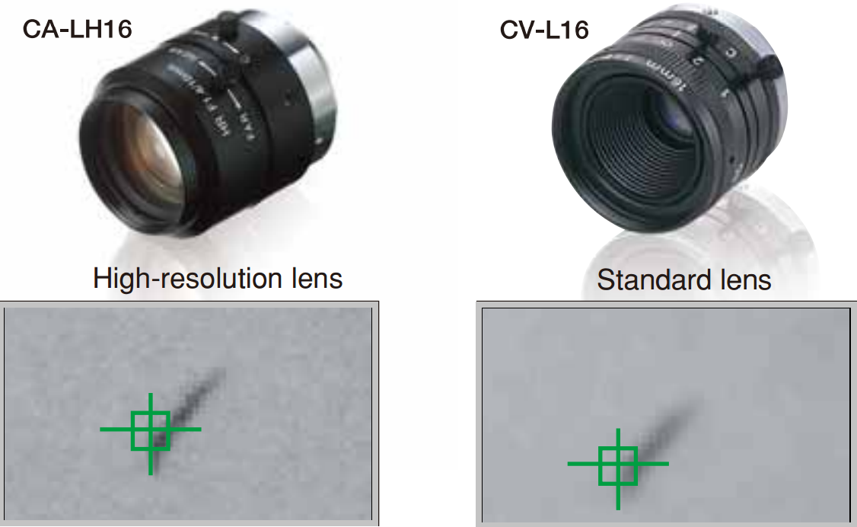
Figure 43: Comparison between an image captured with a high-resolution lens and an image captured with a standard lens.[7]

3.4 Depth of Field
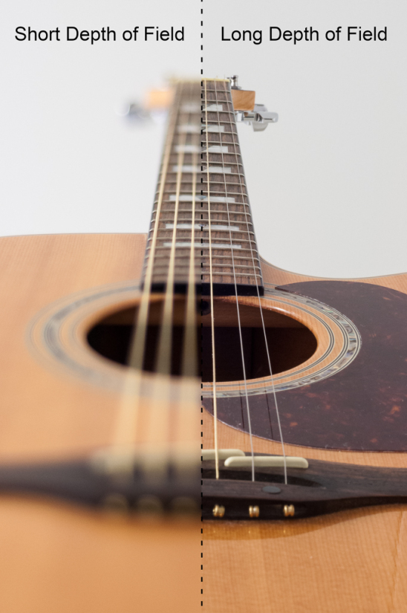
Depth of field is the range of distance in a photo that appears acceptably sharp. Depth of Field varies depending on camera type, focal length of a lens and aperture. The change in sharpness is not abrupt, but occurs gradually. Objects begin to lose sharpness depending on the distance from the focus point. If we look at the picture below, on the left the focus point is in the first third of the guitar neck. Sharpness is gradually lost in the direction of the keel, as well as in the direction of the tuning pegs.
Figure 44: Left - small depth of field. Right - large depth of field.[11]
LARGE DEPTH OF FIELD
SMALL DEPTH OF FIELD

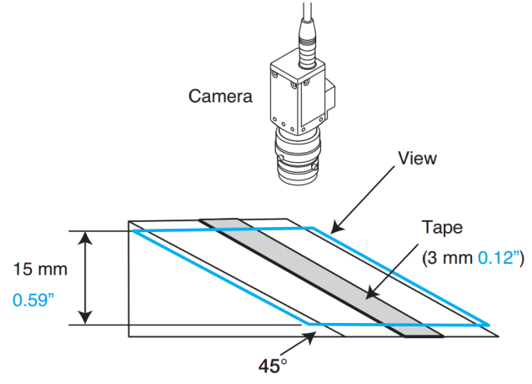
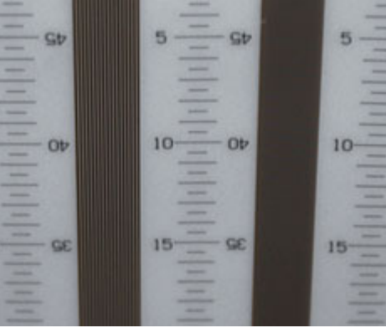
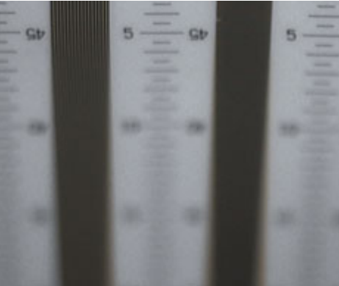
When testing depth of field a camera is placed above a 45-degree slope. Also, a meter is set on the slope in order to measure the range of distance within which the captured image remains sharp.
Figure 45: Depth of field measurement with closed and open aperture.[7]

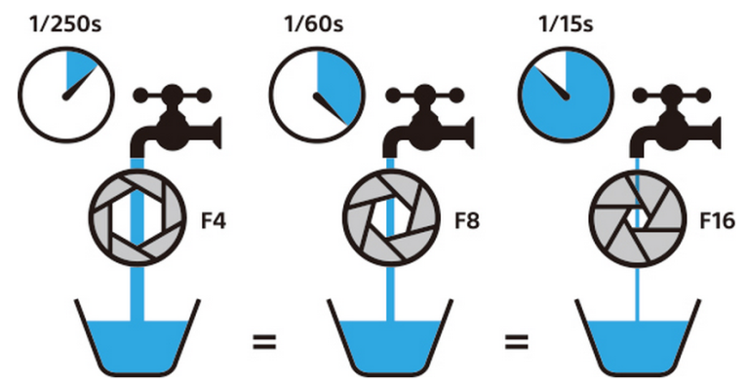
Aperture is a mechanical curtain within a lens that controls the amount of light that reaches the sensor. The following picture shows the analogy of a container being filled with water through a proportional valve. The wider the opening of the aperture, the bigger the light flow and the faster the capture of the image on a sensor.
Figure 46: Aperture openness determines the quantity of light flow on a sensor.[9]

With constant image capture time or constant duration of aperture openness (exposure time) the brightness of the image will vary depending on the level of aperture openness. A wider open aperture will result in a brighter photograph. Figure 47 illustrates an example of a differently illuminated portrait, which was achieved by adjusting the aperture opening.
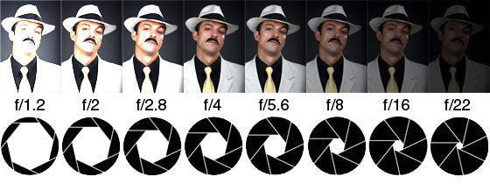
Figure 47: Different levels of aperture openness at constant exposure time.[10]
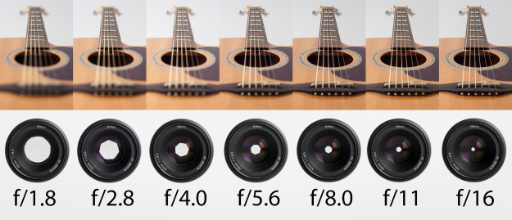
The level of aperture openness has a big influence on the depth of field. The wider the aperture, the shallower the depth of field and vice versa – the smaller the aperture, the larger the depth of field. For an image to be bright enough when the aperture is small, the exposure time needs to be longer, which can lead to blurred images of fast-moving and insufficiently illuminated objects. Figure 48 shows snapshots of strings captured with different apertures. The image on the far left was taken with the widest aperture possible resulting in a very shallow focus while the strings on the far right remain in focus throughout the entire length.
Figure 48: Aperture openness influence on image sharpness.[10]

Depth of field also depends on the focal length of a lens and the size of a sensor, both of which determine the angle under which the light falls from an object to a lens. The shorter the focal length, the greater the depth of field. The longer the distance from an object to a lens, the greater the depth of field. Depth of field can be challenging in machine vision as the photographed objects are usually small and require macro photography but macro extension tubes and macro lenses do not enable a large depth of field. Figure 49 is an example of macro photography clearly lacking depth of field. The ends of the wires are not sharp and only the top edge of the sleeve exhibits acceptable sharpness. When a large depth of field is needed in macro photography we use modern program algorithms that enable photograph composition from several layers, where each layer is captured and sharpened separately. The final image is actually an image made of layers and can have a large depth of field. Such a procedure involving the capture of an object image requires more time as several images must be captured for a single object.
Figure 49: An example of macro photography and a small depth of field.
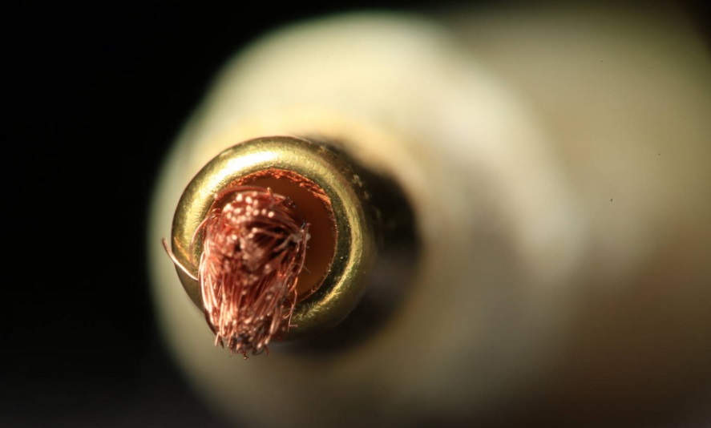
The depth of field can be calculated. Below is the link to a calculator which can help us assess the depth of field:
http://www.vision-doctor.co.uk/optical-calculations/calculation-depth-of-field.html

3.5 Lighting
The success of object inspection with machine vision systems depends primarily on contrast. In order to achieve optimal contrast proper illumination of a captured object is required. Additional illumination of objects guarantees constant adequate level of object illumination. The choice of a lighting source depends on the optical properties of the object whose image we want to capture. Lighting sources differ in terms of technology and geometry of the source. In the picture below on the left (Figure 50) there is a nut illuminated by an entire light spectrum. The sealing ring should also be visible in the picture. However, it is almost indistinguishable from the surrounding area as the contrast in this spot is too low. By using an additional red filter on the lighting source we achieve that the area is illuminated mostly by blue light, which highlights the sealing ring. An image captured in such a way enables automatic recognition of the sealing ring.
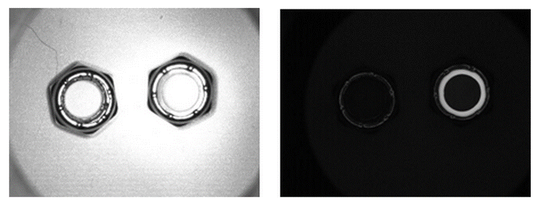
Figure 50: Illumination by an entire spectrum and using an additional red filter.[12]

Figure 51: Change in illumination of the can increases a chance of detecting the inscription on the right.[7]

The following lighting sources are now commonly used for additional lighting:
- Fluorescent
- Quartz Halogen – Fiber Optics
- LED - Light Emitting Diode
- Metal Halide (Mercury)
- Xenon
- High Pressure Sodium
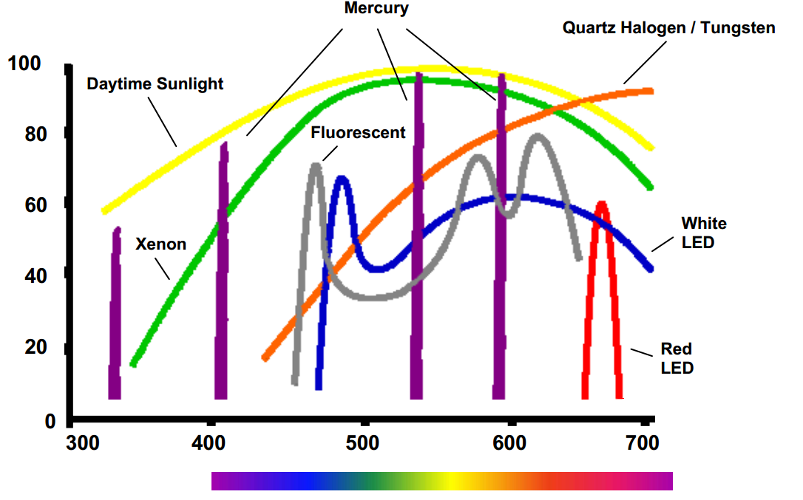
Fluorescent, quartz-halogen, and LED are by far the most widely used lighting types in machine vision, particularly for small to medium scale inspection stations, whereas metal halide, xenon, and high pressure sodium are more typically used in large scale applications, or in areas requiring a very bright source. Depending on special lighting requirements, often more than one source type may be used for illuminating a single object ot its detail. When choosing an appropriate source type, it is important to consider not only a source's brightness, but also its spectral content. Figure 52 illustrates spectral content of individual lighting sources.
Figure 52: Spectral content of individual lighting sources.[13]
Wavelenght (nm)
Relative Intensity(%)

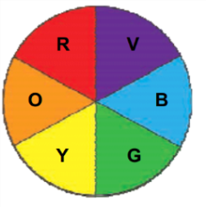
In applications where high light intensity is required, such as high-speed inspections (control of fast-moving objects on a conveyor), it is recommended to match the additional light source with the spectral sensitivity of your camera sensor. For example, CMOS sensor based cameras are more IR sensitive than their CCD sensor counterparts. Materials absorb and/or reflect various wavelengths in different manners. When analysing colours we refer to a colour wheel which distinguishes between warm and cool colors.
Figure 53: Colour Wheel.[13]
WARM COOL

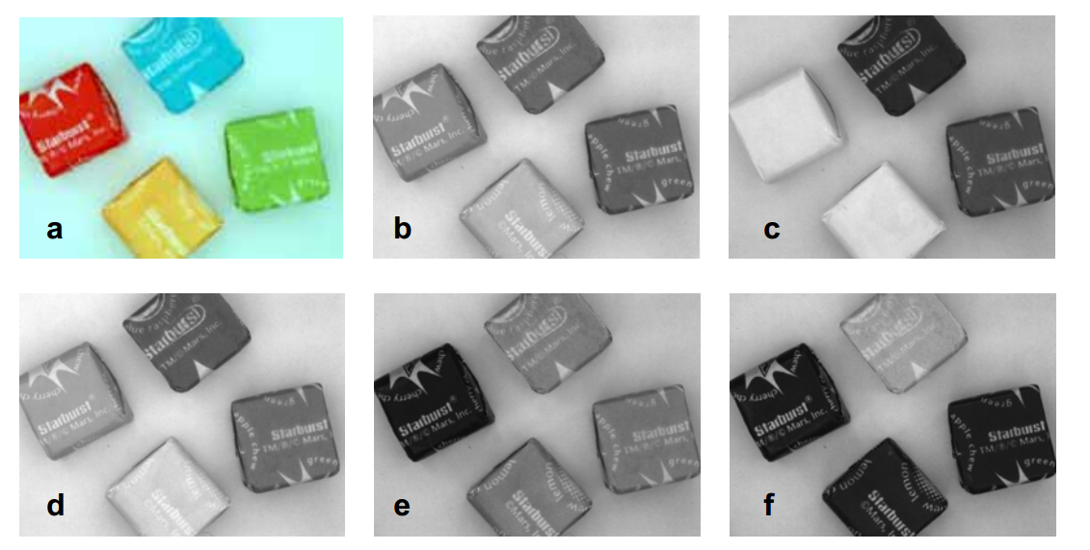
By choosing a source which emphasises a particular colour on an object, we can generate differential contrast between an object and its background. Figure 54 is an illustration of candy pieces illuminated by different colours: in 'a' candy pieces are imaged under white light and a CCD sensor is used, in 'b' they are imaged under white light and a B&W sensor is used, in 'c' they are imaged under red light, lightening both the red & yellow and darkening the blue and green piece, in 'd' they are imaged under red and green light, lightening the yellow piece more than the red, in 'e' green light is used, lightening the green & blue and darkening the red candy, and in 'f' blue light is used, lightening the blue and darkening the others.
Figure 54: Candy pieces illuminated by various colours.[13]

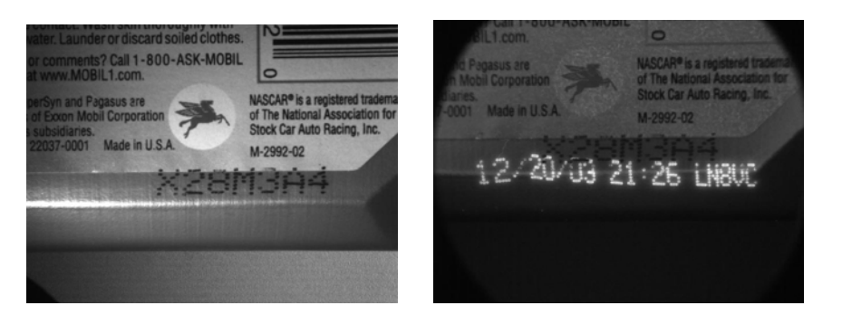
The material that an observed object is composed of, affects the absorption and reflection of particular wavelengths. Different materials respond differently, either reflecting or absorbing a certain wavelength. Figure 55 shows an example of a motor oil bottle, whose fluorescent print is illuminated with with red (left) and UV light (right).
Figure 55: Left - illuminated with a red 660 nm ring light. Right - illuminated with a 360 nm UV fluorescent light.[13]


IR light is a common choice and can be useful in vision inspection for a variety of reasons. IR light is effective at neutralizing contrast differences based on colour, primarily because reflection of IR light is based more on sample composition, rather than colour differences. In Figure 56 (on the right) we have an example of illumination by IR light.
YELLOW

Figure 56: Left - under diffuse white light. Right - under diffuse IR light.[13]
BLACK
RED
WHITE

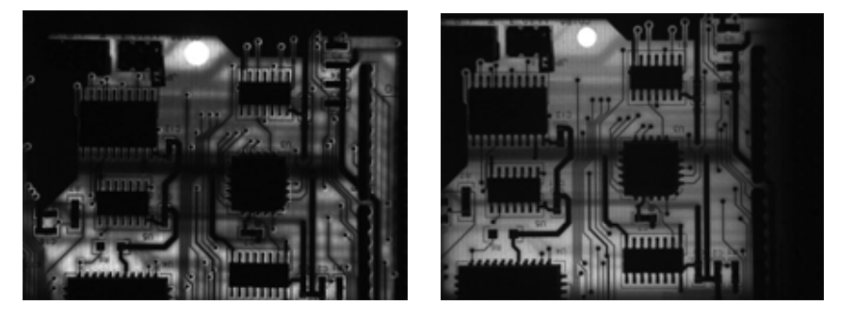
IR light is very effective at penetrating polymer materials. In Figure 57 we see an example of good penetration of IR light (on the right), whereas the penetration of red light (on the left) is poorer. The main difference is seen on the hole in the top center of the printed circuit board. (tiskano vezje)
Figure 57: Left - illumination with red light. Right - illumination with IR light.[13]

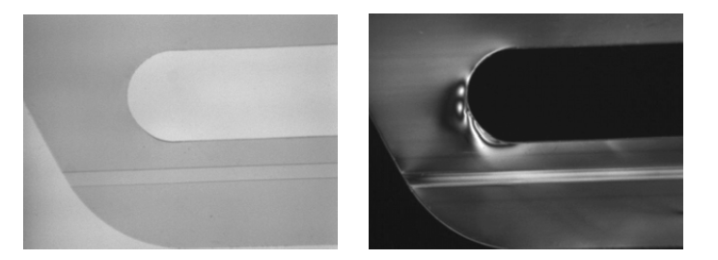
Polarizing filters are used for detecting differences in mechanical damage in otherwise transparent samples (Figure 58) and reducing glare (Figure 59). In case of illumination polarizing filters need to be applied in pairs, one between the light and sample, the other between the sample and camera. Figure 58 shows a noticeable difference in detecting damage on the 6-pack can holder after applying a polarizing filter. We can clearly see stress fields in the polymer in the image on the right. Figure 59 is an illustration of reducing glare.
Figure 58: Transparent can holder with additional polarizing filters on the right.[13]

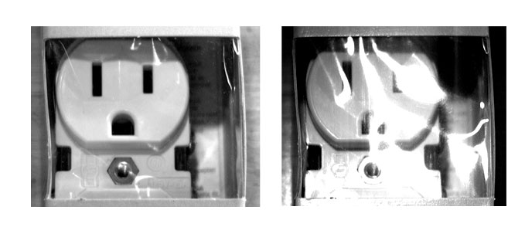
Figure 59: Reducing glare with polarizing filters. [1]
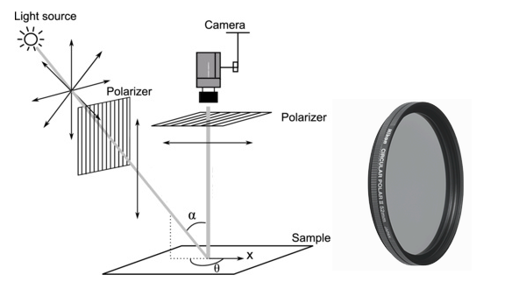
Polarizing filters work by preventing certain wavelegths of light from entering the lens. By means of a polarizing filter we can direct light from its source to the object and then from the object to the camera.
Figure 60: Polarizing filter.[1]
Illumination techniques comprise the following:
  - Back Lighting
  - Diffuse Lighting
  - Directional Lighting or Bright Field
  - Dark Field
The application of some techniques requires a specific light source and light source geometry. Most manufacturers of vision lighting products offer lights with various combinations of illumination techniques available in the same light, and at least in the case of LED-based varieties, each of the techniques is individually addressable. This allows for greater flexibility, since it enables vision inspections on various objects within a single machine vision system. Back lighting generates instant contrast as it creates dark silhouettes against a bright background. The most common uses are detecting presence / absence of an object, hole or gap, part placement or orientation, or measuring objects with machine vision. Often it is useful to use monochrome light. Monochrome light is light of only one wavelength, such as red only, green only, or blue only.
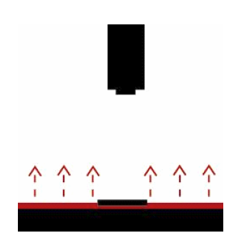  Figure 61: Back lighting illumination technique.[13] | 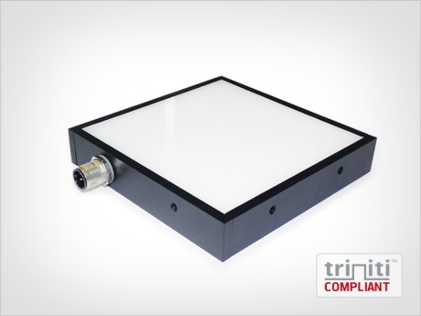  Figure 62: An example of flat light source, bright back lighting.[14]
Diffuse lighting illumination technique is most commonly used on shiny specular samples where we want to inspect their surface, texture or other features on relatively flat surfaces. To be effective, diffuse lights require close proximity to the sample.
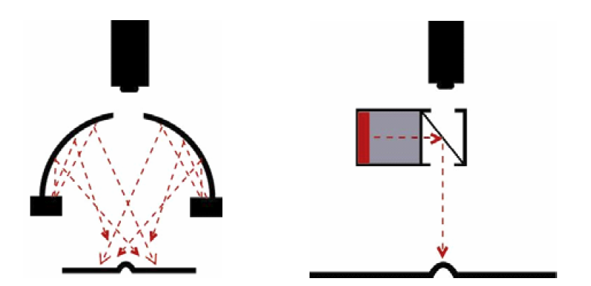  Figure 63: Two techniques of diffuse lighting.[13] | 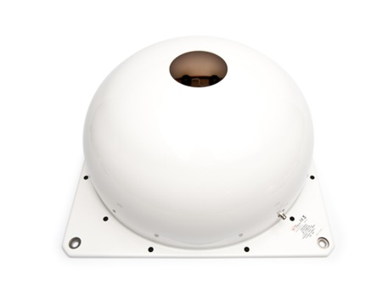  Figure 64: An example of dome for producing diffuse lighting.[14]

Directional lighting is the most commonly used illumination vision lighting technique in machine vision application as well as in everyday life since most of the objects we observe are illuminated in such a way, either by sunlight or, for example, a table light when reading a book. This technique creates a bright field with great contrast and hence enables inspection of topographic characteristics of an object. However, the technique is not appropriate for illuminating shiny surfaces as they reflect light excessively, creating locally an overly bright image.
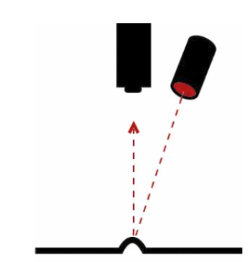  Figure 65: Directional lighting or bright field.[13] | 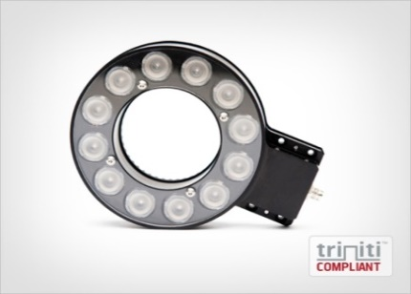  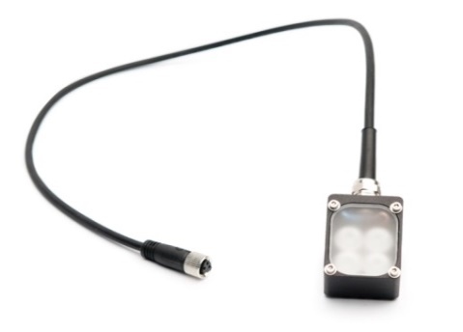  Figure 66: Examples of directional lighting sources or bright- field lighting.[14]
Dark field lighting is a similar principle of illumination as illuminating a road surface with automobile headlights. Light strongly reflects back from every small imperfection on a road. Dark field lighting sources are mostly in the form of a ring with attached LED diodes. This sort of lighting is characterized by low or medium angle of light incidence, typically requiring close proximity. This illumination technique increases the effectiveness for detecting holes, grooves and other surface characteristics.
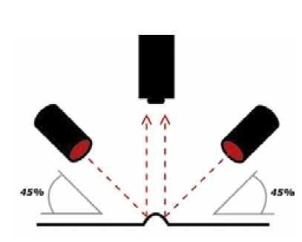  Figure 67: Dark-field illumination technique. [13] | 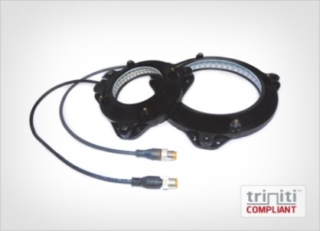  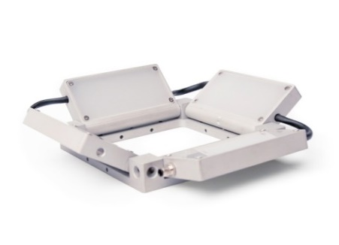  Figure 68: Examples of dark-field lighting sources.[14]
The following figures (Fig. 69) show differences between bright-field and dark-field lighting techniques. An illustration of each technique is followed by a mirrored image of the illuminated surface. Dark-field illumination on the right clearly reveals a scratch on the surface of the illuminated object.
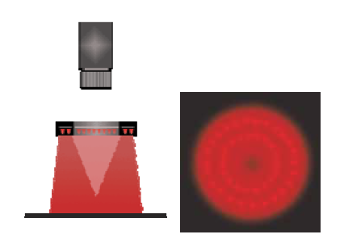
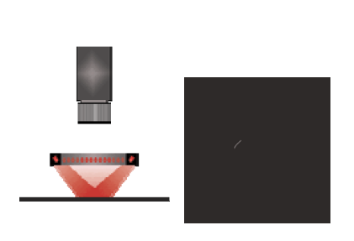
Figure 69: Left - bright- field image of a mirror. Right - dark-field image of a mirror; note scratch.[13]

Fig. 70 shows the use of enhanced contrast to distinguish the inscription as part of the dark- field lighting technique.
Figure 70: Left - bright-field illumination technique. Right - dark-field illumination technique.[15]

3.6 Frame rate
The frame rate refers to a maximum number of images acquired in a second. In case of a rolling shutter it is related to shutter speed. The speed of the frames we can capture in a second is linked to the duration of sensor illumination (exposure time) needed to capture an image. The longer the exposure time for capturing an image, the lower the number of images that can be captured in a second. When capturing moving objects, for example in product inspection on a conveyor, the time required to capture an image is essential. This time needs to be short enough to avoid motion blur, but in order to achieve fast image capture time, an object must be sufficiently illuminated. In Fig. 71 below we have an example of a sensor chip on a slow-moving conveyor, photographed with short and long exposure time.
Figure 71: Left: short exposure time. Right: long exposure time.[2]



The majority of modern digital cameras use electronic or global shutters instead of rolling shutters. A global shutter simultaneously exposes all pixels on a CMOS sensor while a rolling shutter would expose pixels on a sensor serially, in a sequence. As pixels are exposed row by row with a time delay, this can result in a distorted image.
Figure 72: Left - image captured with a global shutter. Right - image captured with rolling shutter.[2]

4 TOOLS FOR DIGITAL IMAGE PROCESSING
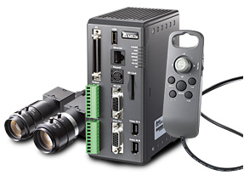
Suppliers of devices in the field of machine vision offer two groups of products. The first group comprises machine vision systems. In machine vision systems the camera and the computer for digital image processing are two independent and separate units, intended primarily for complex image processing in special applications.
Figure 73: Machine vision system. [1]

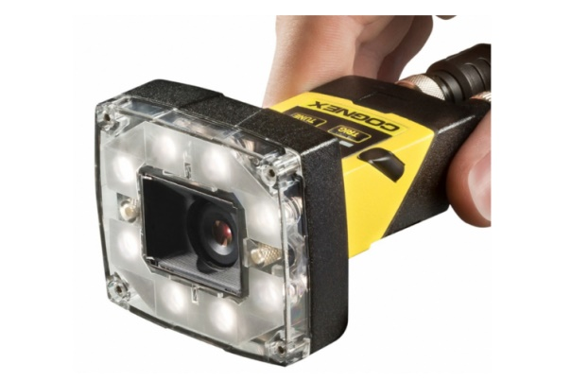
The second group is comprised of compact cameras with an integrated image sensor, a lens, an additional lighting source and a processor for digital image processing.
Figure 74: Compact machine vision camera. [1]

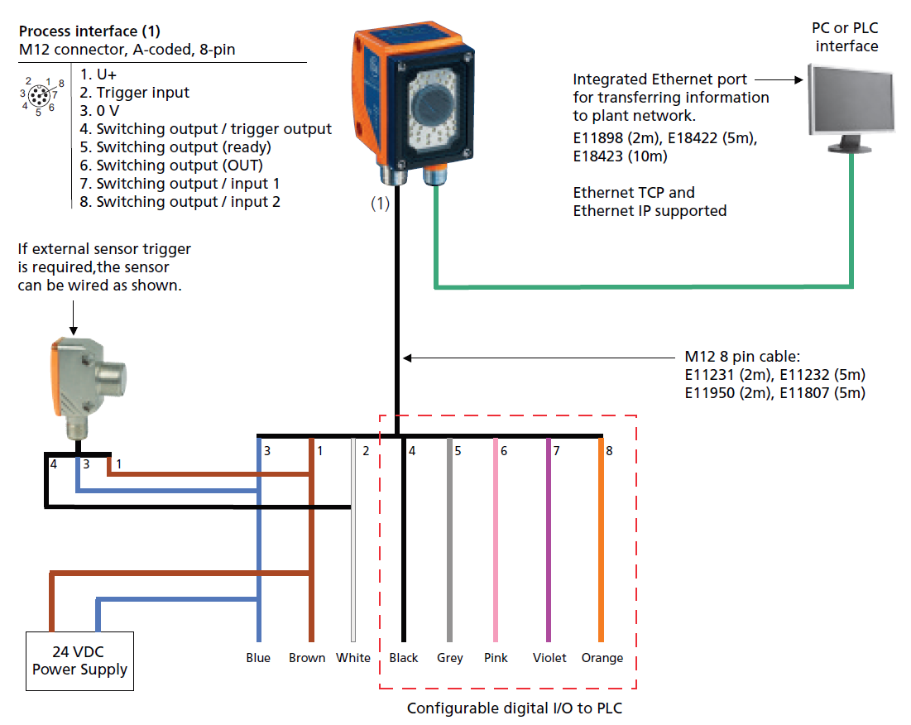
Camera suppliers offer dedicated software for setting compact camera parameters. Various suppliers offer a variety of software but the basic principle is the same. The first thing that must be done is to establish a communication link between a compact camera and a computer with dedicated software installed. Most cameras communicate via an Ethernet connection. The next step is image adjustment, where special attention needs to be given to adequate object illumination and achieving high contrast in the section of the image that will be subject to further processing. The next step is to select and set the appropriate tools for digital image processing embedded in camera software. The last step is to set up a communication interface between a camera and a PLC, a PC or a robot.
Figure 75: An example of an industrial camera communication interface. [16]

Tools for digital image processing that are part of software for setting up a camera are similar, regardless of a supplier. These tools contain functions for processing and filtering certain characteristics that are essential in terms of a tool's decision-making. These functions are: BLOB (Binary Large OBject), Color, Edge, Flaw Detection, Histogram, ID, Image, OCV/OCR and Pattern Match (taken from InSight software [1]).

Blob
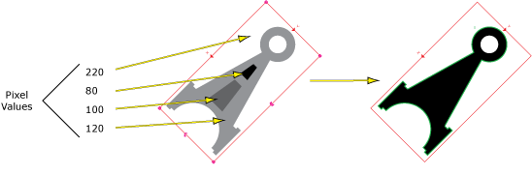
A two-dimensional region where all pixels are of equal value is referred to as blob. Extraction of these regions is called blob analysis. Figure 76 shows blob analysis with the limit value set at 150. All pixels of the value above 150 are coloured white after blob analysis, while those of the value below 150 are coloured black. This is how an object can be discerned from its background.
Figure 76: An example of blob analysis.[1]

Color
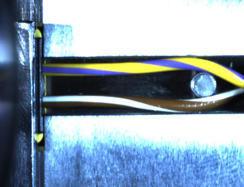
This tool is used for analysing a captured image of an object on the basis of colours. The following image shows an electrical connection to an airbag sensor. By using color function we can analyse the captured image in installation phase and confirm the presence of electrical conductors and ensure their correct connection.
Figure 77: Color analysis of airbag sensor connection in installation phase.[1]

Edge
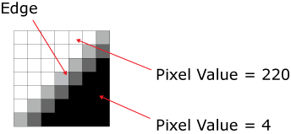
This tool detects the edges of an image. The area where it comes across a sudden change in the value of neigbouring pixels is marked as the edge.
Figure 78: An example of an area of the captured image where the values of the neighbouring pixels vary greatly. [1]

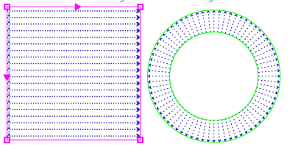
When locating the edges, we can select the area of search in the shape of a rectangle, for example, or in the region between two concentric circumferences. The direction in which we will search for the edges, can also be selected.
Figure 79: Direction of search and search area.[1]

Histogram
A histogram is a graphical representation of the distribution of pixels according to values. Fig. 80 shows the histogram of a picture with pixel value from 0 to 255. The histogram represents two big pixel groups, one being close to the value of 0 and the other close to the value of 255. However, the position of pixels on the captured image is not evident from the histogram. Histogram analysis is useful when detecting damage and dirt on a color homogenous object or a color homogenous area of an object. A histogram also gives information on the illumination of a captured image.
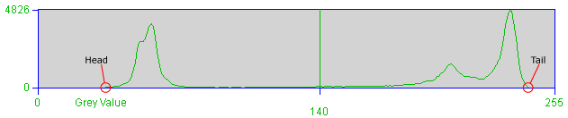
Figure 80: An example of histogram.[1]

ID


ID tool reads and analyses different 1D or 2D barcodes.
Figure 81: 2D barcode and 1D barcode.[1]

Flaw detection
Flaw detection is a tool for detailed pattern analysis of the captured image with the intention of detecting small changes in the appearance of a product that might indicate a defect. Flaw detection looks for pattern changes and compares the captured image with a reference model. Then it gives the value of deviation in percent.

Image
Image is a tool that enables the processing of a captured image. This processing is in most cases related to various filters. The figure below (Fig. 82) shows the procedure of using a digital filter for removing black speckles next to the numbers.The main reason for using filters is contrast enhancement and noise reduction on the captured image.
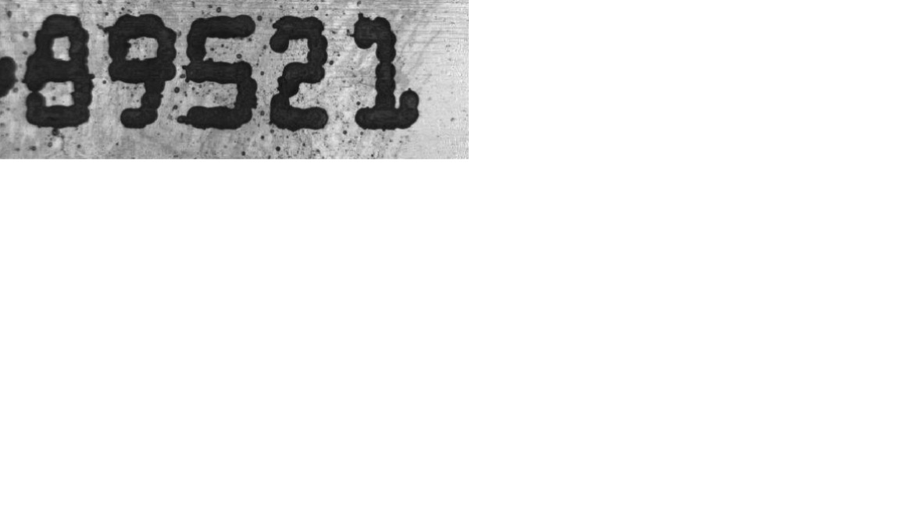
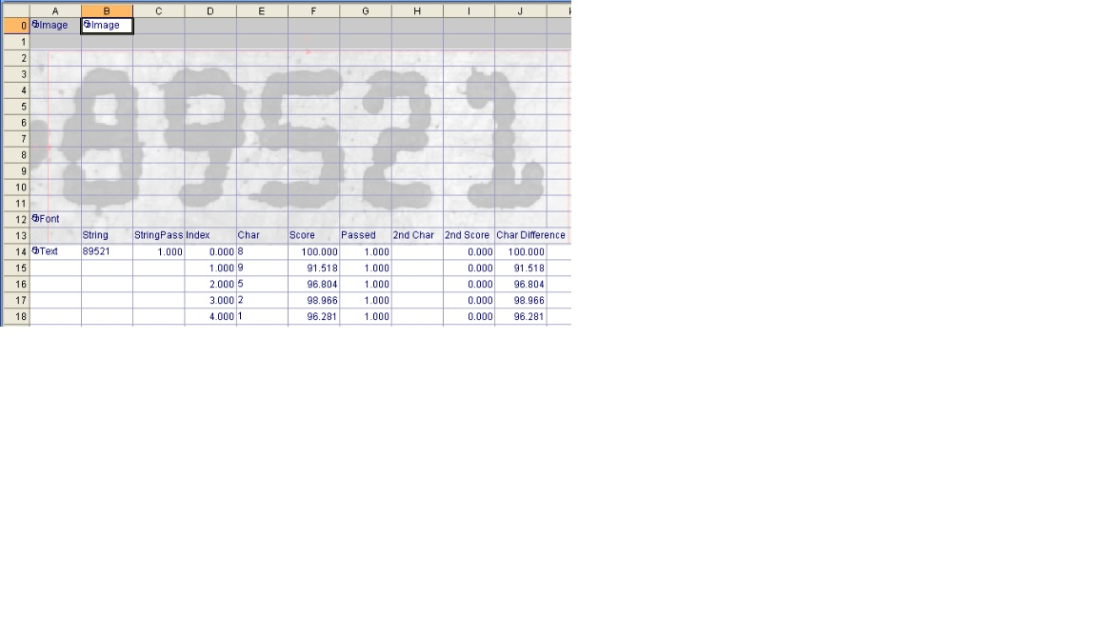
Figure 82: Using a digital filter to remove black speckles.(1]

OCV/OCR
This tool can reads a string of characters according to the learned text format.
Figure 83: Character recognition from a set of the learned text format.[1]
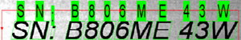

Pattern Match
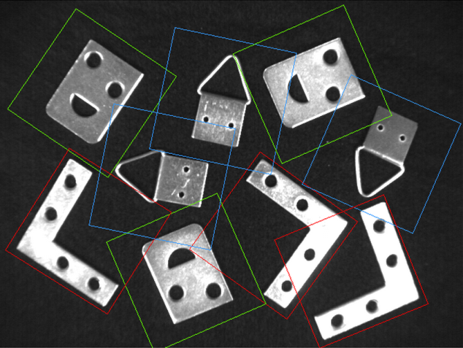
This tool recognizes an object based on its features by comparing it to a reference model. It observes the edges of an object.
Figure 84: Object recognition based on detecting outer edges and comparing them to reference models.[1]

5 EXERCISES

Theoretical exercises
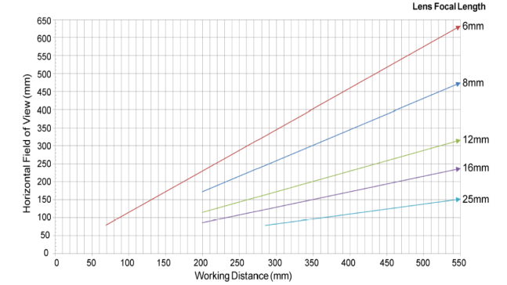
The camera has a lens with a 16-mm focal length and the observed object is 200 mm x 150 mm. What is the working distance at which we have to mount the camera? Use the graph below.

The distance between the object and the camera and is 400 mm and the lens focal length is 12 mm. Specify the horizontal field of view (in mm).
The camera's resolution is 800 x 600 pix and its working distance 700 mm. The observed object has a hole with a diameter of 20 mm. How many pixels are on the length of the diameter?
What is the minimum speed of frame rate if the maximum time of image processing is 37 ms?

Practical exercises

Capture the images of several coins - for two euros, one euro, fifty cents, twenty cents and ten cents with a selected industrial or digital camera.
Figure 85: Captured images of coins.

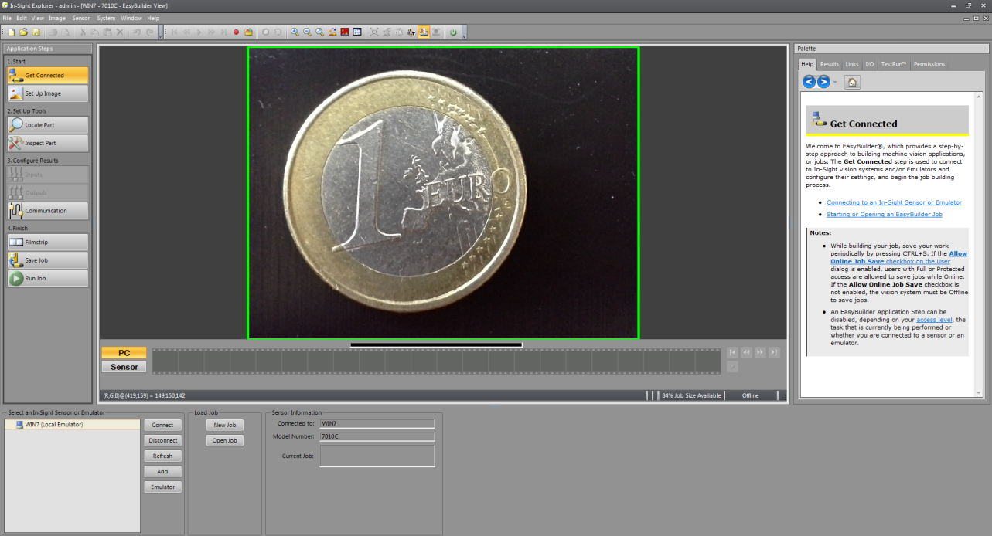
(I)Choose a software tool for setting the parameters of the industrial camera. You can use software that enables work without connection to an industrial camera and with a built-in camera emulator. With such a software tool you can perform all the settings and tests without a connection to the camera.
Figure 86: Software for setting up a camera and a camera emulator.

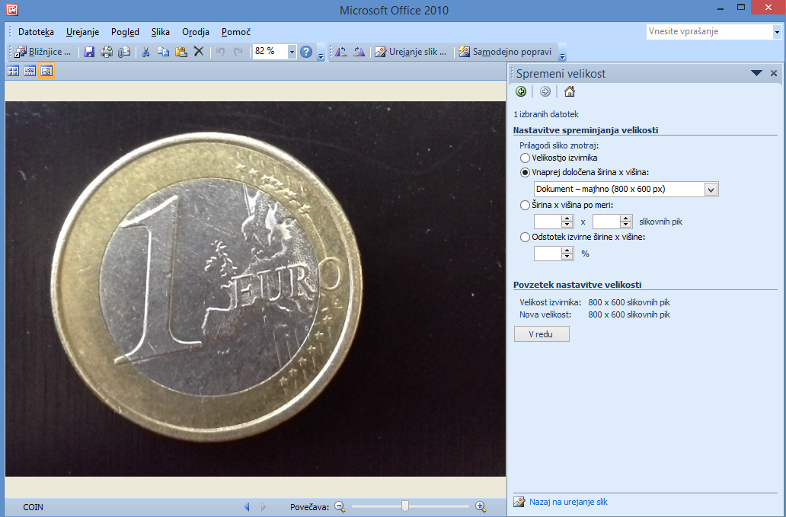
Before inserting images into the software tool the images have to be properly cropped and reduced in size. You can use the image editing tool which is part of the Microsoft Office package.
Figure 87: Image editing tool

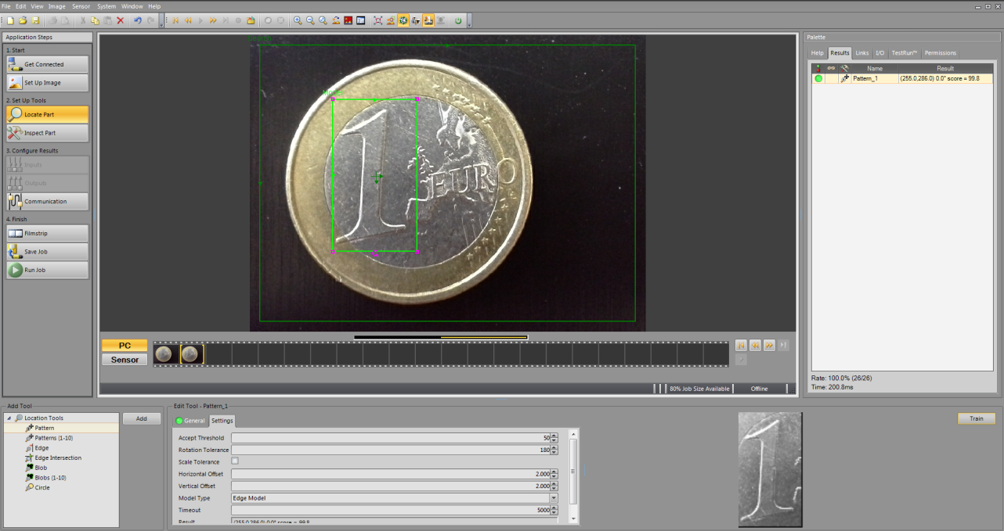
Define the basic features of the coins on the basis of which the machine vision system will identify the value of the coins. You can use the pattern location tool.
Figure 88: Tool for identifying the coin in the image.
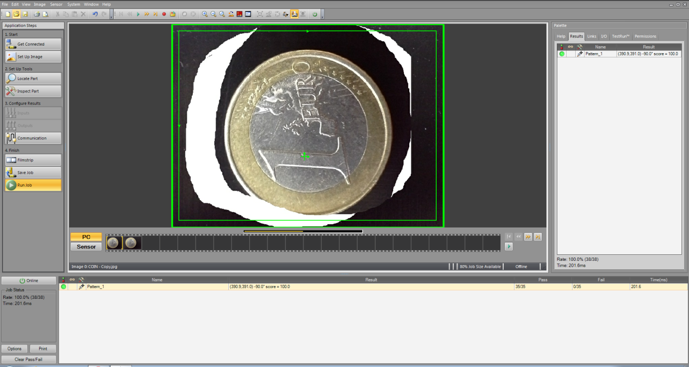
If images have been captured with a digital camera you can capture coin images in other positions or use Paintbrush tool to create a new image of a coin in a different position. Such a redesigned image can then be inserted into an emulator to test the value recognition despite a different position of the coin.
Figure 89: An example of pattern recognition despite a different position.

Define the basic features of the object on the basis of which the system will recognize the damaged coin edge.
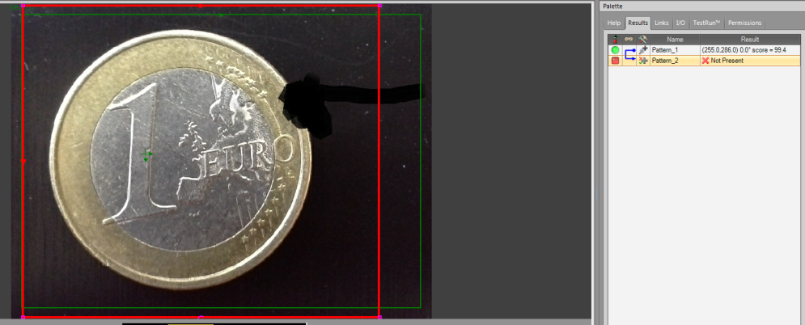
Figure 90: Recognition of the damaged coin edge.
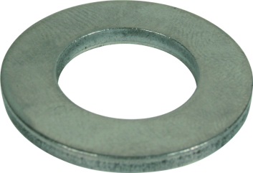
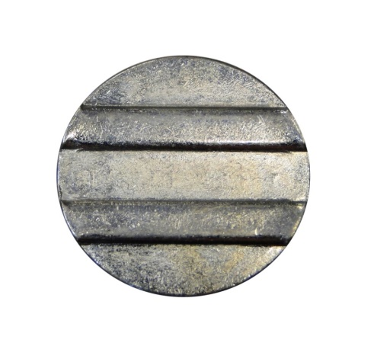

Define the basic features on the basis of which the system will recognize a foreign object among euro coins.The possible foreign objects are a slot machine token, a shopping trolley token, a foreign curreny coin or an M16 washer.
Figure 91: Foreign object among euro coins.

6 REFERENCES
[1] Cognex. http://www.cognex.com [14.4.2016]

[2] Edmund. http://www.edmundoptics.com/ [14.4.2016]

[3] Wikipedia. https://en.wikipedia.org/wiki/Image_resolution [14.4.2016]

[4] Norman Koren. http://www.normankoren.com/Tutorials/MTF5.html [14.4.2016]

[5] Micron. https://www.1stvision.com/cameras/IDS/dataman/MT9M131_PB.pdf [14.4.2016]

[6] Opto-engineering. http://www.opto-engineering.com [18.4.2016]

[7] Keyence http://www.keyence.com/usa.jsp [3.5.2016]

[8] Cambridge in color http://www.cambridgeincolour.com [4.5.2016]

[9] Pinterest https://www.pinterest.com [4.5.2016]

[10] http://www.beginner-photography.com/ [4.5.2016]

[11] https://damienfournier.co/dof-and-aperture/ [4.5.2016]

[12] National Instruments http://www.ni.com/white-paper/6902/en/ [4.5.2016]

[13] Graftek http://www.graftek.com/pdf/Marketing/MachineVisionLighting.pdf [9.5.2016]

[14] Tpl http://www.tpl-vision.com/products/ [12.5.2016]

[15] Microscan http://www.microscan.com [16.5.2016]

[16] Ifm https://www.ifm.com/img/vision_sensors_us.pdf [16.5.2016]

