ERASMUS+ SECTOR SKILLS ALLIANCE
[PROJECT DURATION: November 2014 – October 2017]

Composite Materials

[WORKPACKAGE 3: Designing joint curriculum]
[OUT 3.2: Learning materials]
PREPARED BY: RTK

Authors: Juris Krizbergs, Viktors Gutakovskis
Translated by: Juris Krizbergs

June 2016
The European Commission support for the production of this publication does not constitute endorsement of the contents which reflects the views only of the authors, and the Commission cannot be held responsible for any use which may be made of the information contained therein.

Contents

1. Composites. Overwiew. 1
2. Nanoparticles and Polymer Nanocomposites 6
3. Composite processing methods. 12
4. Composite applications. 18
5. Plastic and Polymer Composite Fabrication Processes 22
6. Composite materials production methods. 49
7. Polymer composites application. 52
8. Production process selection. 57
9. Composites machining 60
10. Summary 63
11. Sources 65

List of tables.
Table 1. Comparison of cost and properties of commercial grade composite materials to aluminium, steel and wood. [6] 4
Table 2. Comparison of costs and mechanical properties [1]. 7
Table 3. Volume resistivity levels for polymer materials [1] 13
Table 4. Room temperature mechanical properties of polymer composites compared with high-strength lightweight metals. [1] 56
Table 5. Room temperature mechanical properties of selected thermoplastics containing 40% chopped glass reinforcement. [1] 56
Table 6. Readily available plastics 59
List of figures.
Figure 1. Comparison of tensile elastic modulus of polypropylene polymers reinforced with conventional fillers (talc and glass fibre) and nanofillers (nanotubes, nanoclay). [1] 9
Figure 2.Typical process for incorporating nanoclay fillers into polymers. In this example, MMT clay is incorporated into nylon polymer. [1] 11
Figure 3. Schematic of a single-walled carbon nanotube. [1] 12
Figure 4. Growth mechanism for carbon nanotubes via a catalytic CVD process. [1] 12
Figure 5. Typical curve showing the volume resistivity as a function of the filler content for a MWCNT-filled polymer composite. [1] 14
Figure 6. Load applications to resins, reinforced plastics, and composites. [2] 15
Figure 7. Moulding sequence.[7] 17
Figure 8. Reinforcing resin with glass fibres in the process of fiberglassing yields extremely durable structures such as boat hulls. [2] 17
Figure 9. Glass fibre application. [2] 17
Figure 10. Smoothing fibreglass-reinforced resin in boat manufacturing. [2] 18
Figure 11. Finishing a fibreglass reinforced boat hull. [2] 18
Figure 12. Manufacturing composites by the pultrusion process. [2] 19
Figure 13. Manufacturing composites by the filament winding process. [2] 19
Figure 14. Manufacturing composites by the lamination process. [2] 20
Figure 15. Aluminium honeycomb sandwiched and bonded between graphite composite skins makes an extremely strong and lightweight structure for the F-18 fighter aircraft. [2] 21
Figure 16. Tooling is all-important to the formation of plastic and composite products. [2] 22
Figure 17. Weight per foot is very important when selecting materials for overhead electrical conductors. [2] 22
Figure 18. A photo of newly developed overhead-valve pushrods made of an aluminium-matrix, continuous alumina fibre-reinforced composite material. [2] 23
Figure 19. Using an aluminium matrix composite for an auto's brake callipers (seen here) can cut their weight in half but gives them equal strength with less. [2] 23
Figure 20. Rotors (or flywheels) for high-speed (-100,000 rpm) applications are subjected to very high stresses. This is a good application for MMCs because they can be fabricated with reinforcements to withstand both hoop and radial stresses. [2] 24
Figure 21. Spectrum of forming processes for thermoplastic materials. [1] 26
Figure 22. Injection moulding. [1] 26
Figure 23. Blow moulding. [1] 27
Figure 24. Calendering. [1] 28
Figure 25. Rotational moulding. [1] 28
Figure 26. Solid-phase forming of drawn plastic shapes. [1] 29
Figure 27. Thermoforming. [1] 29
Figure 28. Stereolithography. [1] 30
Figure 29. Extrusion. [1] 31
Figure 30. Typical VIP setup. [7] 32
Figure 31. VIP moulding.[7] 32
Figure 32. Effect of time and temperature on the curing of thermoset resins. [1] 34
Figure 33. Thermoset fabrication processes. [1] 34
Figure 34. Compression moulding. [1] 35
Figure 35. Cross section of foam-moulded part (×30). Note the dense skin at the surface. [1] 35
Figure 36. Schematic of reaction injection moulding. [1] 36
Figure 37. Transfer moulding. [1] 36
Figure 38. Casting. [1] 37
Figure 39. Schematic of vulcanization of rubber to make a rubber-covered roll.[1] 37
Figure 40. Mould layout. [7] 38
Figure 41. Matrix and reinforcement options for polymer composites. [1] 39
Figure 42. Reinforcements used in polymer composites. [1] 40
Figure 43. Specific strength and stiffness of some cross-ply epoxy matrix polymers.[1] 41
Figure 44. Lightweight composite panels can be made with epoxy bonding of aluminium panels to an aluminium honeycomb core. [1] 47
Figure 45. Common forms of glass fibres for composite reinforcement. [1] 50
Figure 46. Polymer composite forming processes. [1] 51
Figure 47. Techniques for the fabrication of fibre-reinforced composites. [1] 52
Figure 48. Vacuum bag forming. [1] 53
Figure 49. Spectrum of commercially available products for forming polymer composites. [1] 55
Figure 50. Fibre bloom in an FRP street lamp pole after eight years outdoors. [1] 57
Figure 51. Considerations in plastic process specification. [1] 60
Figure 52. Klenk-type drill for drilling Kevlar® [8]. 62
Figure 53. Drilling and cutting tools for composite materials [8]. 63

1. Composites. Overwiew.
Generally speaking any material consisting of two or more components with different properties and distinct boundaries between the components can be referred to as a composite material. The resulting material has characteristics different from the individual components.
Typical engineered composite materials include:
1) Composite building materials such as cements, concrete
2) Reinforced plastics such as fibre-reinforced polymer
3) Metal Composites
4) Ceramic Composites (composite ceramic and metal matrices)
Composite materials are generally used for buildings, bridges and structures such as boat hulls, swimming pool panels, race car bodies, shower stalls, bathtubs, storage tanks, imitation granite and cultured marble sinks and counter tops. The most advanced examples perform routinely on spacecraft in demanding environments.

Table 1. Comparison of cost and properties of commercial grade composite materials to aluminium, steel and wood. [6]
Property | Fiberglass & polyester | Graphite & epoxy | Wood (Douglas fir) | Aluminium Sheets 6061 T-6 | Steel Sheets
Material Cost (€/kg) | 4.00-6.00 | 18.00-40.00+ | 1.60 | 9.00-20.00 | 1.00-2.00
Strength, yield (MPa) | 207 | 414 | 17 | 241 | 414
Stiffness (GPa) | 8.3 | 55 | 12.4 | 69 | 207
Density (g/cm³) | 1.53 | 1.81 | 0.52 | 2.7 | 7.8
Fibre types and Forms
Fibres or reinforcements have many types, here some common types of fibres:
1) Glass fibres.
2) Carbon fibres.
3) Aramid fibres (high strength polymer).
4) Quartz fibres.
5) Mineral fibres.
6) Boron fibres.
7) Organic fibres.
8) Alumina (A1₂O₃) fibres.
9) Metal fibres.
10) Cellulose (wood/paper fibre and straw).
Matrix materials
To utilize high strength and stiffness of fibres in a monolithic composite material suitable for engineering applications, fibres are bound with a matrix material whose strength and stiffness are, naturally, much lower than those of fibres (otherwise, no fibres would be necessary).
Matrix materials provide the final shape of the composite structure and govern the parameters of the manufacturing process.
Because the reinforcements are usually discontinuous, the matrix also helps to transfer load among the reinforcements.
Matrix materials are usually some type of plastic, and these composites are often called reinforced plastics. There are other types of matrices, such as metal or ceramic, but plastics are by far the most common. There are also many types of plastics, but a discussion of them is beyond the scope of this week's column. Suffice it to say for now that the two most common plastic matrices are epoxy resins, phenolic resins and polyester resins.
Depending somewhat on the definition, the use of composites began early in the twentieth century with a phenolic-paper laminate used for electrical insulation, fiberglass boats appeared in the mid-1940s. Until fairly recently, composites were thought of as polymer material surrounding or encasing various strengthening reinforcements. Today the material doing the encasing is termed a matrix, so these types of composites are now termed PMCs, or polymer matrix composites; they take their place alongside two more recently developed composites - MMCs, metal matrix composites, and CMCs, ceramic matrix composites.
Although the three types of composites have some significant differences, they are similar in their general makeup. Each has a polymer, metallic, or ceramic matrix. The reinforcements used inside the matrix can vary, but the same material may be used with each of the matrices. Composites differ from alloys, polymers, and ceramic compounds in that the matrix and reinforcement are separate from each other. A material may be added to a metal, polymer, or ceramic for strengthening purposes, but the material added becomes a part of the original material; reinforcements used in composites do not.
The reinforcements used vary from short or chopped fibres, flakes, and particles to filaments and wires to continuous woven fibres and honeycombs. The short, discontinuous reinforcements will increase mechanical strength, but they are not as effective as the continuous reinforcements that have the ability to transfer or redistribute loads throughout the composite.
Because there are two types of polymers, thermosets and thermoplastics, there are two types of PMCs, and of course, there are a number of polymers within each of the two types.
The metal matrix composites use metal alloys for their matrices with reinforcement provided by particles or filaments of high-performance materials. Examples of discontinuous materials are glass fibres, silicon carbide whiskers, and alumina particles or short polymer fibres; continuous fibres may be of carbon, boron, alumina, or silicon carbide. The metals used in the matrix may be aluminium and magnesium, for their low density; titanium, for strength at higher temperatures; and copper, for electrical and thermal conductivity. Other metals are used for matrices depending on requirements.
The ceramic matrix composites are so far very niche oriented. For example, CMCs are being applied where very special circumstances can take advantage of their ability to withstand high temperatures. Many of these applications are in aerospace. In these composites, the matrix is a ceramic, and the reinforcing materials can be any of the materials already discussed, both continuous and discontinuous.
Smart composites
Smart materials are designed materials that have one or more properties that can be significantly changed in a controlled fashion by external stimuli, such as stress, temperature, moisture, pH, electric or magnetic fields.
Other keywords related to smart material are such as shape memory material (SMM) and shape memory technology (SMT).
Composite skins containing built-in computers and optical-fibre sensors, which enable aerospace systems to detect changes such as pressure, strain, temperature, ice thickness, internal defects and damage. Can be used with UV during fabrication to determine optimum cure. Also called SMART COMPOSITES.
Carbon-Carbon Composites
Carbon-graphite materials can be used for critical structural applications in the form of carbon-carbon composites. This material is like an "all-carbon fibreglass." The matrix is carbon-graphite and the reinforcement is carbon fibres, the same ones that are used to reinforce polymer matrix composites. These composites are used for applications requiring lightweight, coupled with high temperature resistance. In appropriate atmospheres, carbon remains solid at higher temperatures (>3600°C) than any other engineering material. Air is not an appropriate atmosphere for carbon-graphite products, because they burn in air at temperatures above 600°C. Oxidation of carbon-carbon composites is addressed by protective ceramic-type coatings.
Carbon-carbon composites are made from carbon fibre-polymer resin composites such as carbon fibre-phenolic resin. The material is laid up into a part shape in the usual way, and the polymer matrix is converted to carbon by heating in a controlled atmosphere (pyrolysis). There is considerable porosity in the part after this operation, and the porous carbon matrix is densified by intrusion of chemical-vapour-deposited carbon or by resin/pitch impregnation. The part is then heated in a suitable atmosphere to pyrolyze the impregnant. The impregnated part may need multiple impregnation/pyrolysis treatments. If the part is to be used for high-temperature service, the surface is protected from oxidation by surface coatings of ceramics produced by chemical-vapour deposition or other processes. The end result is a carbon-carbon composite that can have a complex three-dimensional shape and specific strength greater than superalloys at temperatures above 1200°C.
Carbon-carbon composites are used for the nosepiece and leading edges of the wings on the space shuttle and on less exotic applications such as brake linings for large aircraft. These materials are very expensive, so they are not used for everyday applications, but they are available for special applications.
Carbon fibre design
The purpose of this design information is to provide general information and specifications on graphite (carbon fibre) composite materials and some guidelines for designing lightweight high performance products with graphite composites.
Graphite composites have exceptional mechanical properties which are unequalled by other materials. The material is strong, stiff, and lightweight. Graphite composite is the material of choice for applications where lightweight & superior performance is paramount, such as components for spacecrafts, fighter aircrafts, and race cars.
Composite materials are made by combining reinforcement (fibre) with matrix (resin), and this combination of the fibre and matrix provide characteristics superior to either of the materials alone. In a composite material, the fibre carry majority of the load, and is the major contributor in the material properties. The resin helps to transfer load between fibres, prevents the fibres from buckling, and binds the materials together.
Graphite fibres (sometimes called carbon fibres) are made from organic polymer such as polyacrylonitrile. The material is drawn into fibres and kept under tension while it is heated under high temperature (> 1000C). Two dimensional carbon-carbon crystals (graphite) are formed when the hydrogen is driven out. The carbon-carbon chain has extremely strong molecular bonds (diamond is a three-dimensional carbon-carbon crystal), and that is what gives the fibres its superior mechanical properties.
Historically, graphite composites have been very expensive, which limited its use to only special applications. However, over the past fifteen years, as the volume of graphite fibre consumption has increased and the manufacturing processes have improved, the price of graphite composites has steadily declined. Today graphite composites are economically viable in many applications such as sporting goods, performance boats, performance vehicles, and high performance industrial machinery.
Applications of Graphite Composite Materials.
Composite materials are extremely versatile. The engineer can choose from a wide variety of fibres and resins to obtain the desired material properties. Also the material thickness and fibre orientations can be optimized for each application.
The advantages of graphite composites are:
1. High specific stiffness (stiffness divided by density)
2. High specific strength (strength divided by density)
3. Extremely low coefficient of thermal expansion (CTE)
4. X-ray transparent (due to its low molecular weight)
Please see Table 2 for a comparison of costs and mechanical properties of graphite composite, fiberglass composite, aluminium, and steel. Due to the wide variety of graphite fibres and resins available, and the numerous combinations of the materials, the properties are listed in ranges.
Table 2. Comparison of costs and mechanical properties [1].
Property | Graphite Composite (aerospace grade) | Graphite Composite (commercial grade) | Fiberglass Composite | Aluminium 6061 T-6 | Steel,  Mild
Cost, €/kg | 40..500+ | 10..40 | 3..6 | 6 | 0.60
Strength, MPa | 620..1380 | 345..620 | 138..241 | 241 | 414
Stiffness, MPa | 69x10⁶ ..345x10⁶ | 55x10⁶ ..69x10⁶ | 7x10⁶ ..10.5x10⁶ | 69x10⁶ | 210x10⁶
Density, g/cm³ | 1.39 | 1.39 | 1.53 | 2.78 | 7.8
Specific Strength | 446x10⁶ ..992x10⁶ | 248x10⁶ ..446x10⁶ | 90x10⁶..157x10⁶ | 86x10⁶ | 53x10⁶
Specific Stiffness | 50x10⁶..248x10⁶ | 39x10⁶..50x10⁶ | 4.5x10⁶..6.7x10⁶ | 25x10⁶ | 27x10⁶
CTE, m/m/°C | -1.8x10⁻⁶ ..1.8x10⁻⁶ | 1.8x10⁻⁶..3.6x10⁻⁶ | 11x10⁻⁶..14x10⁻⁶ | 23x10⁻⁶ | 12.6x10⁻⁶
Applications for High Specific Stiffness
Graphite composites are ideally suited for applications where high stiffness and low weight is required. Most metals used for structural applications have very similar specific stiffness, which is around 100x10⁶ psi. If an application demands high stiffness and lightweight, graphite composites are the only material of choice.
Examples are:
- Spacecraft structure
- Aircraft structure
- Drive shaft for trucks and high performance vehicles
- Machinery rollers
- Sail boat mast and boom
- Bicycle frame
- Machinery components that experience high acceleration & require stiffness & precision
Applications for High Specific Strengths
Graphite composites are widely used for lightweight structures that need to carry extremely high loads.
Examples are:
- Motorcycle components (skid plates, rock guards)
- Fishing pole
- Golf club shaft
- Aircraft structure
- Satellite antenna structures
- Racecar chassis
Applications for Low CTE
Graphite fibre has a negative coefficient of thermal expansion, which means when it is heated it will shrink. When the graphite fibres are put into a resin matrix (positive CTE), the composite can be tailored to have almost zero CTE. Graphite composites are used for high precision and thermally stable applications.
Examples are:
- High precision antennas
- Scanning & imaging machines
- Precision optical devices
- Metrology equipment
Manufacturing Process
Graphite composite components are manufactured utilizing a moulding process. The graphite fibres can be woven into cloth, braided into tubes, or made into unidirectional tapes. The fibres are next coated with resin. This fibre & resin mix can be partially cured then frozen to create a pre-preg, or the fibre & resin mix can be used wet. The graphite fibre & resin mix is then placed into a mould in layers. The number of layers and the orientation of the layers will depend on the mechanical properties desired. The layers of graphite is then compacted and consolidated in the mould by pressure from a press or from a vacuum bag. Depending on the resin system, the part can be cured at room temperature or elevated temperature. Once the part is cured, the part is removed from the mould, and it is ready for finishing operations such as trimming and drilling.

2. Nanoparticles and Polymer Nanocomposites
As presented previously, the mechanical and physical properties of polymers may be modified by the use of fillers such as glass fibres, minerals, graphite, and others. Nanosized fillers now used to reinforce polymers are called polymer nanocomposites. These materials are akin to conventional glass or mineral-reinforced polymers, except that the filler size is on the nanoscale. Nanofillers can provide significant property modification at very low loadings (filler concentration). In this section, we will discuss the two most widely used nanofillers for polymer nanocomposites: nanoclay fillers and carbon nanotube fillers. Figure 1 compares the tensile elastic modulus of polypropylene reinforced with glass fibres, talc, nanoclay, and nanofibers.
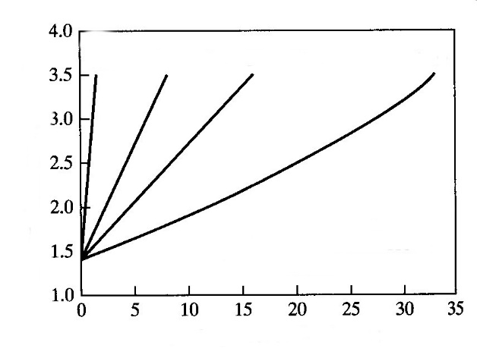
Weight percent filler (wt %)
Tensile elastic modulus (GPa)
Tensile elastic modulus (23°C) of polypropilene reinforced with various fillers
Talc
Glass fibre
Nanoclay
Nano-
tubes
Figure 1. Comparison of tensile elastic modulus of polypropylene polymers reinforced with conventional fillers (talc and glass fibre) and nanofillers (nanotubes, nanoclay). [1]
Note that substantially less nanofiller is needed to give the same effect as the conventional fillers. Significantly less nanoscale filler is required to achieve the same stiffening effect on the tensile elastic modulus as traditional fillers such as glass fibres. There are many advantages to using less filler:
Lower material density (more material per unit mass)
Lower as-moulded and after-baked shrinkage
Smoother as-moulded surface finish (better cosmetics)
Improved impact properties
Higher stiffness
Improved flame retardation
Improved painted impact performance
Improved recyclability
Improved permeation resistance
For example, a polymer filled with 30% glass fibre often has a very rough surface finish due to the presence of subsurface fibres. Often, surface splay, or flow lines, are visible on glass-filled polymer surfaces. Polymer nanocomposites, however, have significantly improved surface finish characteristics, allowing improved cosmetics.
As the use of nanofillers in polymers is still a burgeoning field, the number of polymer systems is limited. Commercially available nanocomposite polymers include the following:
Polyolefin (polypropylene)
Polystyrene
Polyethylene terephthalate
Polyamides (nylon 6)
Epoxides
Polyurethanes
Polyimides
Automobile manufactures commercialized the first large-scale use of polymer nanocomposites about 20 years ago. Based on nylon 6, such materials have been used for various engine covers and fuel lines. Since early 2000, polypropylene nanocomposites have also come into use for large-scale automotive applications. Some vehicles with substantial plastic cladding and fascia use upwards of 25 kg of polypropylene nanocomposite per vehicle, with the largest individual part being a 5 kg front fascia.
Nanoclay Fillers
The most widely used filler for reinforcing nanoclay polymers is a clay called montmorillonite (MMT), from the smectite family - highly expandable silicate clays. MMT clays are based on an aluminosilicate chemistry and have a layered sheet structure. The silicate layers in MMT clays are about 1 nm thick, and cross-sectional areas on the order of 100 nm². They are of high aspect ratio (100-1500) and surface area. The high surface area of MMT clays, coupled with small interparticle distances when dispersed in a polymer matrix, allows for significant property alteration at very low concentrations. These nanosized fillers affect the polymer crystalline morphology and chain mobility. Because nanoclay fillers are on the same order of dimension as the polymer molecules, they interact with the polymer in a much more significant manner than traditional fillers.
Certain steps must be followed to incorporate nanoclay fillers into a polymer. Because the particles are so small, they are not subject to the normal shear stresses encountered when conventional fillers are compounded into a polymer. Often, the particular details of these processing steps are held in close confidence among materials manufacturers. As shown in Figure 2, the nanoclay particles must first be swelled and rendered organophilic (polymer loving) by the use of organic amines and other chemicals.
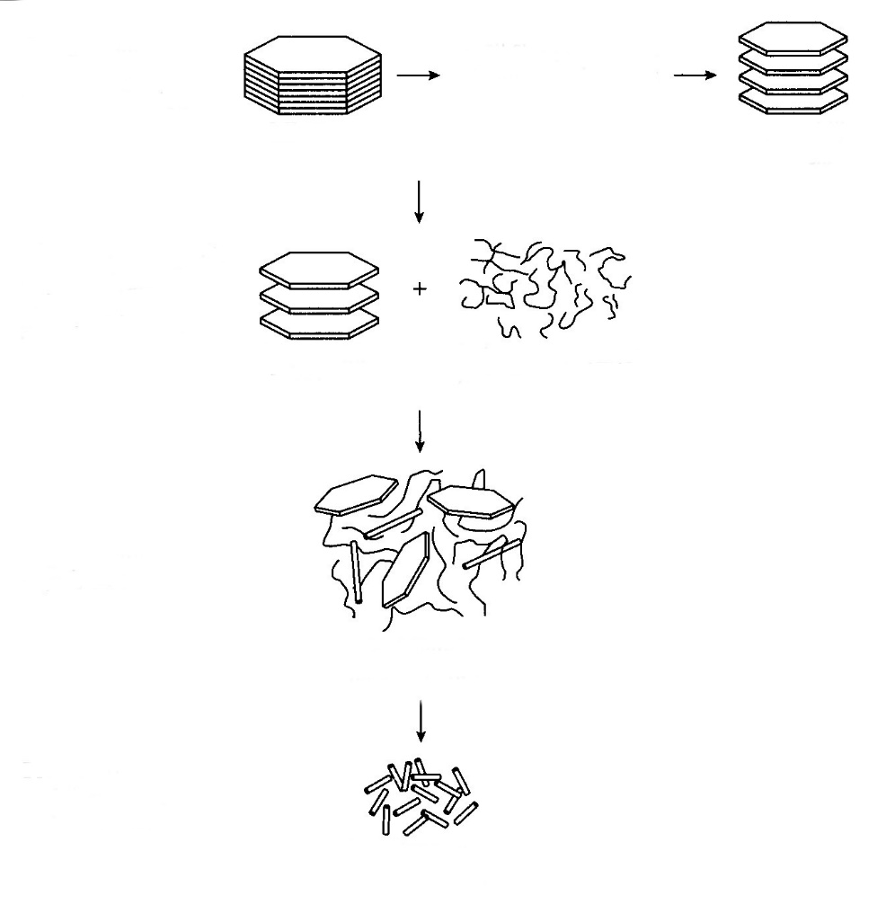
Moulding pellets (masterbatch)
Process to create moulding pellets with clay filler
Exfoliated nanocomposite
In situ polymerization of polymer
Organophilic MMT clay
Polymer monomer (e.g., caprolactam)
Organophilic MMT clay
MMT clay particles
Organophilic treatment and compatibilization
Swell clay particles in 12-aminododecanoic acid
Disperse organophilic clay in polymer monomer such as caprolactam (nylon)
Figure 2.Typical process for incorporating nanoclay fillers into polymers. In this example, MMT clay is incorporated into nylon polymer. [1]
This step allows the individual nanoclay platelets to interact more readily with the polymer. Typically, the organophilic clay particles are then dispersed in a polymer monomer. Once the particles are well dispersed in the monomer (a key technology itself), the dispersion is then polymerized by suitable catalysts or initiators. At this point, the nanoclay-filled polymer can be processed into pellets or beads. Usually, such pellets contain 20% to 40% nanoclay filler and are called a masterbatch. The nanoclay masterbatch pellets may then be mixed with unfilled resin pellets from the same polymer family to bring the blended nanoclay concentration into the 2% to 5% weight range. The blended pellets are then processed in conventional polymer processing equipment such as moulding machines, to render a final product. The primary goal in incorporating nanoclay fillers into the polymer is to develop a fully exfoliated distribution of nanoclay platelets (e.g., all particles are delaminated and platelets are uniformly dispersed).
Carbon Nanotube Reinforcement
Carbon nanotubes (CNTs) are another type of filler nanotechnology used to modify the properties of polymers. Although there are many variants of the carbon nanotubes, there are two general classes: single-wall carbon nanotubes (SWCNT) and multi-wall carbon nanotubes (MWCNTs). What is unique about carbon nanotubes is that the carbon is in its hexagonal graphitic form, where the basal planes are oriented radially around the tube, as shown in Figure 3.
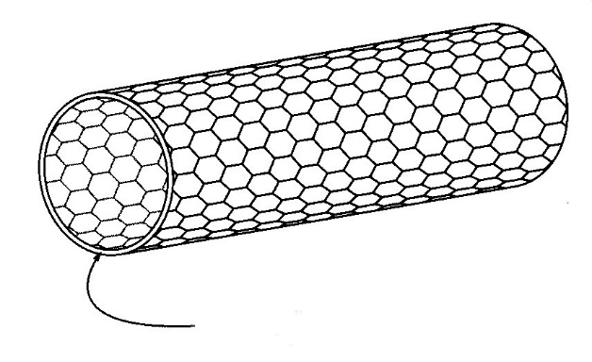
Continuous, cylindrical graphene plane
Figure 3. Schematic of a single-walled carbon nanotube. [1]
This preferential crystallographic orientation enhances the axial mechanical, electrical, and thermal properties of the nanotubes. In many commercial applications, MWCNTs are the preferred filler for nanotube-filled polymers, as they are lower cost than the single-wall carbon nanotubes (SWCNTs) and offer similar performance.
Carbon nanotubes classically are grown via the chemical vapour deposition (CVD) of a hydrocarbon such as acetylene in the presence of nanosize metal catalyst particles such as iron, supported on a substrate such as silica, as shown in Figure 4.
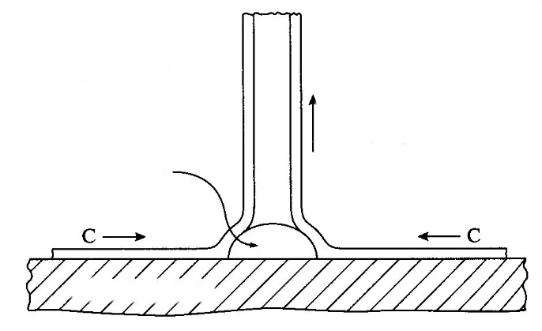
Silicon substrate
Extrusion or root growth process
Fe particle
CVD reaction of C_{n}H_{m}→C+H₂
Figure 4. Growth mechanism for carbon nanotubes via a catalytic CVD process. [1]
Newer processes are being refined and developed to enable ever higher production rates. Many high-volume processes, though, still rely on a metallic catalyst. Once grown, CNTs must be purified. The metal catalyst particles must be removed, typically by acid washing. Lower-grade nanotubes and malformed carbon particles (e.g. soot, amorphous particles) are removed by thermal or chemical oxidation of the material in a controlled furnace or by another method. The tubes with lower graphitization burn off at lower temperatures, leaving only the highly graphitized tubes.
Generally, MWCNTs are 10-15 nm in outside diameter, 2-4 nm in inside diameter, and about 10-20 μm long. The walls contain about 15 graphene layers (a single-atom layer of carbon atoms in hexagonal arrangement). The high aspect ratio, the tubular geometry, the defect-free structure, and the highly graphitic nature of the nanotubes give them extraordinarily high mechanical properties. For example, tensile strengths of 150 GPa and elastic moduli of 800-900 GPa are possible for MWCNTs. The highly graphitized structure of the CNTs allows for thermal and electrical conductivity benefits. Similar to nanoclay-filled polymers, nanotube-filled polymers have enhanced mechanical, electrical, thermal, and flammability properties at filler loadings well below those used for conventional reinforcing fillers such as PAN carbon fibres, carbon black particles, and expanded graphite.
Carbon nanotubes (CNTs) have been in volume production for more than 25 years. However, CNTs have been relatively expensive, with prices hovering around $1320/kg (in 2008), and the product quality is highly variable. For example, a $l/kg polymer would cost more than $6,5/kg when filled with 5% CNT. Such economics would be prohibitive for even the lowest-cost polymer binder such as polypropylene. Recently, more industrial capacity, process efficiencies, and higher yields have driven down the cost of CNTs.
One key aspect of using CNTs for polymer reinforcement is that the surfaces of the CNTs must be chemically treated or functionalized (the surface chemical composition altered to enhance compatibility) in order for them to be incorporated and uniformly dispersed into any polymer matrix. In their native state, CNTs tend to intertwine easily, and, because of their small size, they are insensitive to the shear forces of various blending or mixing processes. The functionalization of CNTs is a nanotechnology in itself and is subject to many proprietary processes. Once the CNTs are functionalized, they need to be incorporated into the polymer matrix. The polymers can be thermosetting or thermoplastic, and they can be rigid or elastomeric. Similar to nanoclays, CNTs may be incorporated by melt impregnation, solvent impregnation, or in situ polymerization. In most instances, polymer master-batches are sold with CNT concentrations as high as 15% to 20%. These masterbatches are then blended with virgin resin at the point of use, such as a moulding machine, to reduce the filler loading to the typical levels of 0.5% to 5% weight.
Table 3. Volume resistivity levels for polymer materials [1]
Application | Volume resistivity (Ω/cm) | Polymer class
Electrical insulation | 10¹⁷…10¹³ | Insulating polymers
Antistatic | 10¹¹ | Antistatic polymers
Electrostatic painting | 10⁹
Electrical charge dissipation | 10⁷…10³ | Statically dissipative polymers
Electromagnetic interference (EMI) shielding | 10…0,1 | Conductive polymers
Metal-like electrical conduction | 10⁻³
In 2008, MWCNT fillers were primarily used for improved static dissipation of polymers. Due to the high electrical resistance of most commercial polymers, they are quite notorious for storing electrical charge (e.g., static electricity), which can be harmful in certain electronic applications. Table 2 compares the relative volume resistivity of various polymer classes. Conductive MWCNT fillers may be added to polymers to increase the electrical conductivity and reduce their propensity to store electrical charge. (See Figure 5) In general, a polymer is considered to be statically dissipative if its surface electrical resistance is less than 1 MΩ/cm (10⁶ Ω/cm). The electronics industry uses statically dissipative polymers for hard disk drives and chips.
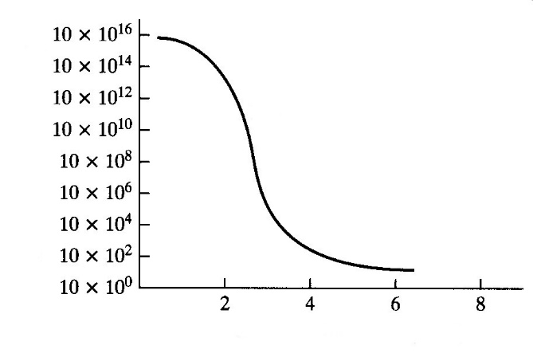
MWCNT nanotube filler (wt%)
Volume resistivity (Ω-cm)
Percolation curve
Figure 5. Typical curve showing the volume resistivity as a function of the filler content for a MWCNT-filled polymer composite. [1]
The automotive industry uses statically dissipative polymers in components for fuel delivery. One benefit of using MWCNT for nylon fuel lines is that due to the low loading, the high permeation resistance of the nylon 12 can be maintained to minimize fuel vapour release into the environment.
Traditionally, carbon blacks, graphite, and carbon fibres are used to increase the electrical conductivity of polymers. The high filler loadings of traditional conductive fillers adversely affect mechanical properties such as toughness. Additionally, the fillers have a tendency to slough (rub) off the surface. Static dissipation in polymers using MWCNTs may be achieved with much lower loading levels and no loss in mechanical properties.
The statically dissipative properties of MWCNT-filled polymers is a prime benefit for automotive manufacturers because of the improved paintability. Traditionally, polymers must be pre-treated to enhance surface conductivity to allow electrostatic painting. With MWCNT-filled polymers components, pre-treatment is not required.

3. Composite processing methods.
Many composites require two processes before they are able to meet a material need - the first one to create the composite itself and the second to shape and/or fit the composite material to the final application. In other cases, a composite may be prepared and shaped to meet final requirements in one-step.
In this section, we will briefly explore the methods used to create and/or form the three types of composites - polymer matrix composites (PMCs), metal matrix composites (MMCs) and ceramic matrix composites (CMCs).
Polymer Matrix Composites (PMCs)
PMCs consist of the plastic material reinforced with some type of stranded fibre material. The fibre reinforcement material usually makes up about half of the total material weight. Examples of the fibre materials used in composites are graphite and glass. The fibre functioning as a structural component of the composite and is designed to take the load stresses applied to the composite structure. Were it not for the fibre portion of the composite material, only the resin portion of the material would be subjected to the applied loads. This structure alone would not be able to withstand the forces applied and would fail in service (Figure 6).
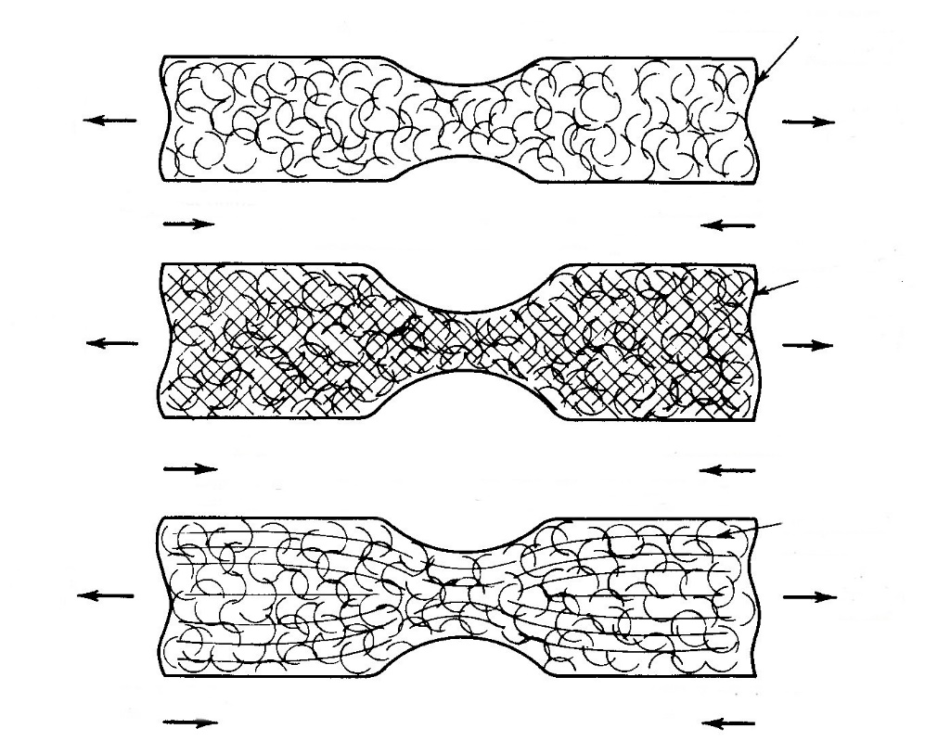
Tensile load
Tensile load
Tensile load
Tensile load
Tensile load
Tensile load
Compression load
Compression load
Compression load
Compression load
Compression load
Compression load
Composite-resin matrix with fibers resin unbroken - strongest
Random reinforced resin matrix- stronger
Resin matrix only - strong

Figure 6. Load applications to resins, reinforced plastics, and composites. [2]
We begin with a discussion of prepregs and sheet-moulding compound, both materials from which PMC products might be made.
Three other processes for manufacturing PMC products will then be described - pultrusion, filament winding, and lamination.
Prepregs. In producing prepregs, an intermediate (preimpregnated) product, many continuous strands of fibre are carefully aligned and then coated with the appropriate thermoplastic or thermoset resin and made into a sheet or tape. Individual pieces of the tape or sheet are used to form the laminated product and then heated for curing.
Sheet-Moulding Compound. Instead of the continuous fibres used in the prepregs just described, sheet-moulding compound is made from chopped fibres that are deposited, with random orientation, on a resin-covered carrier film, such as polyethylene. Another layer of resin covers the fibres, and then a top sheet or film (e.g., polyethylene) covers the resin. The resulting sandwich is pressed between rollers and coiled up or kept as flat sheets. The moulding compound is stored in a controlled environment through a maturation process that lasts about 24 hours. It must then be kept at a temperature low enough to delay curing; the shelf life is about 30 days.
Moulding. Some of the moulding methods can take advantage of the prepregs and moulding compounds are compression and transfer moulding. In these cases the reinforcements are placed into the mould cavity before or during the application of the polymer material.
Hand Layup. A process with wide application that provides a good illustration of the hand layup method is the use of fiberglass. In this process alternating layers of glass fibre fabric and resin are coated over a mould or form built in the shape of the desired end product. Short pieces of glass fibre may also be mixed with the resin while it is still in a liquid state. A popular application of this method is in manufacturing for boats (Figure 8) and other large hollow fabrications such as swimming pools.
The most common manufacturing process for fiberglass is the wet lay-up or chopper gun spray process using an open mould. The shape of the part is determined by the shape of the mould, and the mould surface is typically in contact with the exterior of the part. Mould release is first applied to the mould to prevent the fiberglass part from adhering to the mould. Gel coat, which is pigmented resin, is applied to the mould to give the part colour. Fiberglass and resin are then deposited onto the mould and rollers compress the fiberglass, which evenly distributes the resin and removes air pockets. Multiple layers of fiberglass are deposited until the desired thickness is achieved. Once the resin is cured, the part is removed from the mould. Excess material is trimmed off, and the part is ready for paint and assembly. There are also closed mould processes for making fiberglass parts.
After curing, the part is
removed from the mould
Excess material is trimmed
and it is ready for assembly
Fiberglass, resin & catalyst is applied in layers and rolled out
Mould
Wax is applied as mould release
Gel coat is applied to provide color
Roller
Figure 7. Moulding sequence.[7]
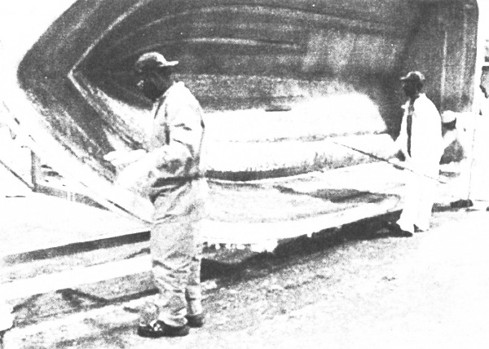
Figure 8. Reinforcing resin with glass fibres in the process of fiberglassing yields extremely durable structures such as boat hulls. [2]
The process is accomplished by building up layers of fibre strands or sheet fabric (Figure 9) and resin.
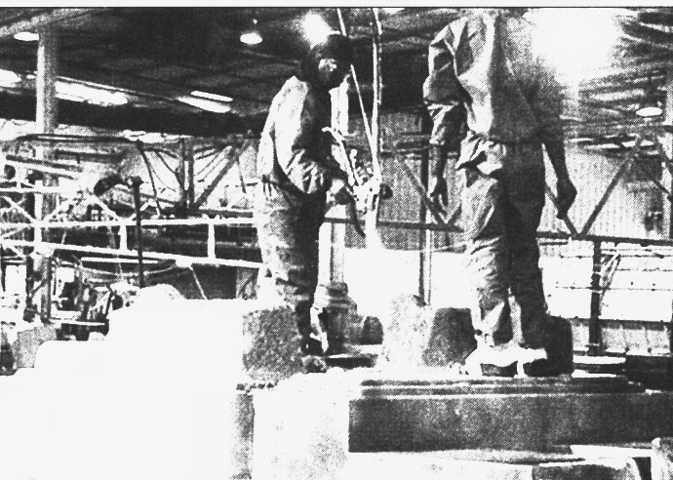
Figure 9. Glass fibre application. [2]
Pieces of glass fibre are laid over the desired form, and the resin is applied by spray application or hand spreading (Figure 10).
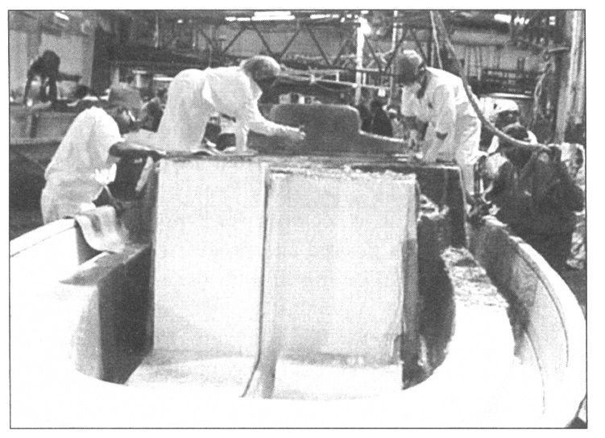
Figure 10. Smoothing fibreglass-reinforced resin in boat manufacturing. [2]
The liquid resin and fibre mixture may be trowelled and smoothed while it is still in a liquid state. After hardening, the fiberglass fabrication may be refinished by mechanical abrasive processes such as sanding and buffing (Figure 11).
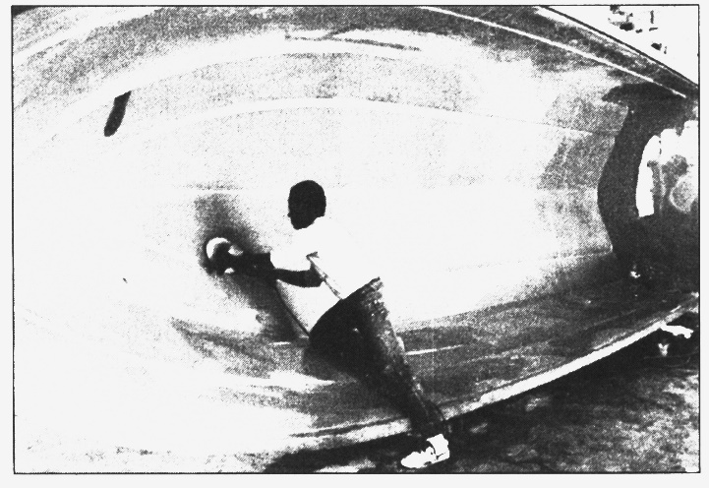
Figure 11. Finishing a fibreglass reinforced boat hull. [2]
The end product is extremely strong, durable, and lightweight. It is also impact resistant and not subject to corrosion, and almost any shape can be fabricated given the proper tooling.
Pultrusion. Pultrusion is illustrated in Figure 12.
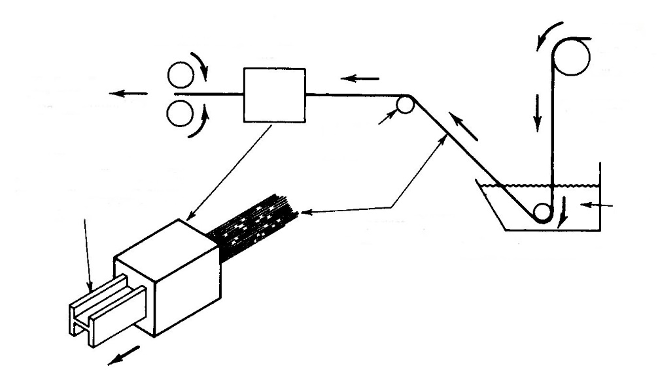
Resin coated fibres pulled through die emerge formed into desired end product shape
Die formed end product
Resin coated fibre
Rollers
Liquid resin tank
Resin
Dry fibre
Fibre supply roll
Heated pultrusion die
Pull rollers
Figure 12. Manufacturing composites by the pultrusion process. [2]
Fibres are pulled or drawn through a liquid resin and then through a heated die that forms the desired shape. Pultrusion is much like extrusion except for the pulling rather than pushing of the material through the extrusion die. Composite products manufactured by pultrusion methods include structural members and tube.
Filament Winding. In the technique of filament winding (Figure 13), the fibre is wound back and forth on a cylindrical form.
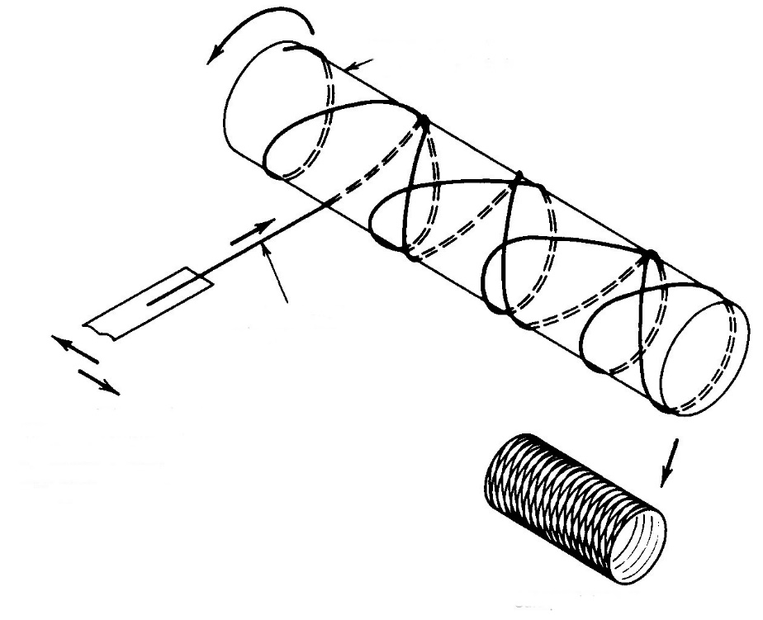
End product
Alternating feed direction lays down criss cross filament pattern
Fiber strand (filament)
Rotating form (mandrel)
Figure 13. Manufacturing composites by the filament winding process. [2]
This method is used to produce cylindrically shaped products such as tanks or other pressure vessels. After curing, the form is removed, leaving the hollow composite product.
Lamination. Laminating alternating layers of resin containing the structural fibre is the third major method of composite manufacturing (Figure 14).
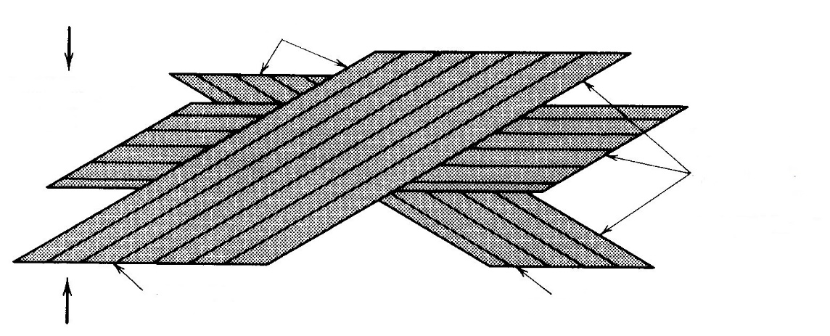
Fibres run in different directions so that leads are evenly distributed
Fibres
Resin
Resin matrix
Figure 14. Manufacturing composites by the lamination process. [2]
This process is similar to the technique used with fiberglass; however, the composite fibres are continuous throughout the material, whereas in fiberglass short pieces of glass fibre are randomly distributed throughout the resin structure.
Metal Matrix Composites (MMCs).
Liquid Matrix. The most straightforward of the MMC methods involves casting the molten matrix metal around solid reinforcements, using either conventional casting techniques or a pressurized gas on the liquid matrix to force it into and around a preformed reinforcement, which is often made of metal sheet or wire, or ceramic fibre.
Powder-Metallurgy Techniques. The reinforcement fibres, whiskers, or particles are carefully mixed with the powdered metallic matrix so they are uniformly distributed in the mixture. This mixture of powdered metal and reinforcements is then compacted to form the desired part. An initial compaction may be done cold, followed by sintering, or all the compacting may be done at the sintering temperature. The sintering fuses the various particles together into a shape and size that should be very close to the desired dimensions.
Liquid-Solid Processing. This is a casting technology in which the reinforcement being added to the metallic matrix is in its mushy stage: that is, it is partly frozen, partly liquid.
Ceramic Matrix Composites (CMCs)
The most common process used in producing CMCs is slurry infiltration, in which the slurry contains the ceramic matrix powder. A fibre preform of the desired product is hot pressed and impregnated with the slurry, then sintered.

4. Composite applications.
As composite materials undergo further development, their uses will extend to a larger line of products. Above the applications in aircraft were mentioned briefly. In this application, the aircraft design engineer seeks materials with favourable strength-to-weight ratios. Strength coupled with light weight can result in products that require less fuel to propel them. This consideration is extremely important in the production of aircraft, spacecraft, and automobiles of today and tomorrow.
The honeycomb composite structure creates a product that demonstrates these highly desirable characteristics of light weight and strength. In Figure 15 aerospace technicians lay an aluminium honeycomb core on a graphite composite skin. The metal honeycomb, which is in itself a high-strength lightweight material, will be sandwiched between two layers of the graphite composite. The entire assembly will then be cured by heat and pressure, thus making a durable aircraft structural component.
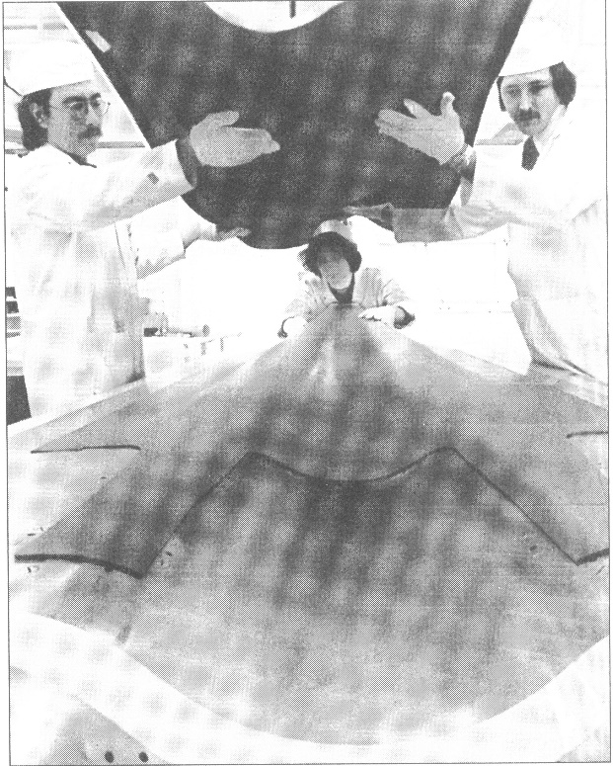
Figure 15. Aluminium honeycomb sandwiched and bonded between graphite composite skins makes an extremely strong and lightweight structure for the F-18 fighter aircraft. [2]
Large components can more easily be made from composite materials than from metals. Figure 16 shows a large graphite composite component for a jet aircraft. The technician is seen applying graphite-epoxy prepregs to a precision bonding fixture. When 50 to 60 plies have been built up, a vacuum will be applied to the bonding fixture so the part will closely adopt the shape and size of the fixture. The fixture and part will then be placed in an autoclave (a controlled heating chamber), curing the prepreg.
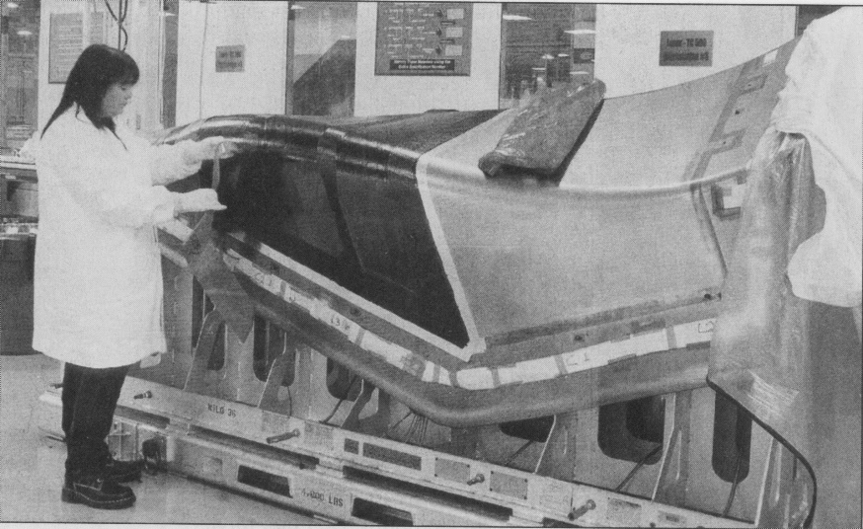
Figure 16. Tooling is all-important to the formation of plastic and composite products. [2]
A technician lays up graphite composite material on a large precision bonding fixture.
Air and land vehicles are not the only applications that benefit from an improved strength-to-weight ratio. Overhead electrical conductors must be strong enough to support the weight of wire strung between transmission towers that are spaced many feet apart. If the normal methods of strengthening are used on the conductor itself (heat treating or cold working) its conductivity suffers greatly. Instead, a typical method of strengthening is to put steel strands in the core of the cable. Figure 17 shows strands of an aluminium conductor with a core of strands of an MMC - an aluminium matrix with alumina reinforcement fibres. This combination can yield higher conductivity at the same weight per foot.
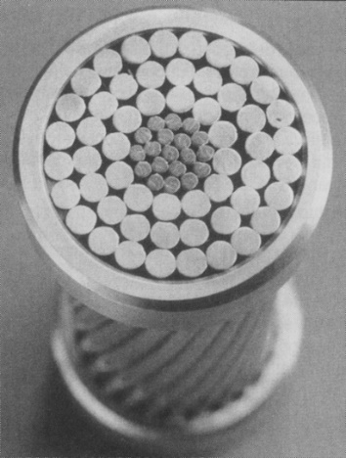
Figure 17. Weight per foot is very important when selecting materials for overhead electrical conductors. [2]
This picture shows the cross section of a conductor being developed by 3M and a foreign partner. The aluminium conducting strands can be seen on the outside, surrounding a core of aluminium matrix composite (AMC) strands. The AMC provides the strength typically provided by much heavier steel wires. The rings that can be seen around the conductor are there only to keep this section of cable from unwinding.
Figure 18 is a photo of an improved overhead-valve pushrod for a high-performance automobile engine. It is made of an MMC with aluminium as the matrix and alumina (A1₂O₃) fibres as the reinforcement. Combining a ductile, light metal with a strong reinforcement that is almost as light yields a light, strong composite. The alumina reinforcement, which has a very high modulus of elasticity, improves the stiffness of the composite. When the performance of the composite pushrod is compared with that of a 4340 heat-treated steel pushrod, it is found that the composite is stronger, stiffer, and has better damping capability.
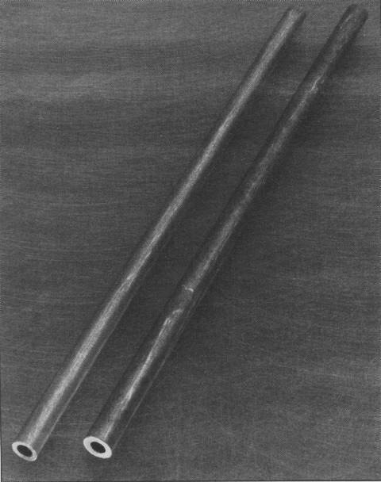
Figure 18. A photo of newly developed overhead-valve pushrods made of an aluminium-matrix, continuous alumina fibre-reinforced composite material. [2]
The tensile and compressive strengths, stiffness in bending, and damping capability of the composite are a significant improvement over a 4340 steel pushrod and can result in improved engine.
Figures 19 and 20 illustrate applications that take advantage of the high strength and low weight of the ceramic-reinforced aluminium-matrix composite material. The alumina used in these composites is rods or fibres of 10 to 12 μm (microns), or 0.010 to 0.012 mm in diameter - very small. Although we think of alumina as being very brittle, it is very strong (tensile strength about six times that of heat-treated aluminium alloys) and stiff (modulus of elasticity about five times that of aluminium). When the composite material is 40 percent aluminium and 60 percent alumina the resulting tensile strength and modulus of elasticity are about three and a half times that of heat-treated aluminium, or the composite material has properties that are higher than those of steel, but at 45 percent the weight!
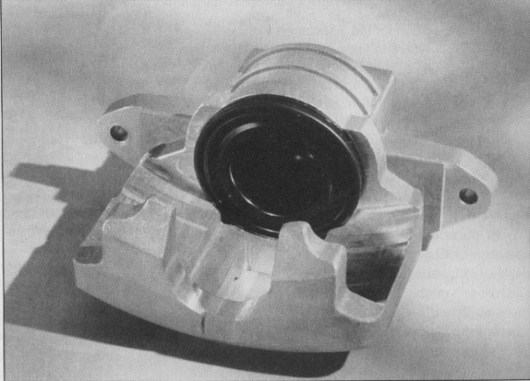
Figure 19. Using an aluminium matrix composite for an auto's brake callipers (seen here) can cut their weight in half but gives them equal strength with less. [2]
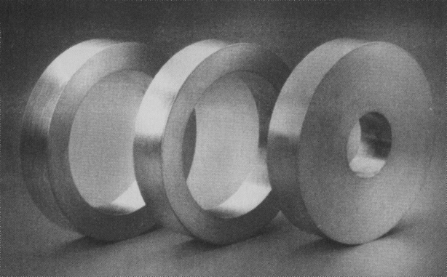
Figure 20. Rotors (or flywheels) for high-speed (-100,000 rpm) applications are subjected to very high stresses. This is a good application for MMCs because they can be fabricated with reinforcements to withstand both hoop and radial stresses. [2]
Tool and die making for plastics and composite processing
As is the case in processing most raw materials into useful products, special tooling is required in the plastics and composite processing industry. Here the raw material is often in a liquid or flexible state prior to its formation into the end product. Therefore, considerable tooling is required to hold or form the material until steps are taken in the process that alters the state of the material to make it rigid.
In processing plastics and composites, much of the tooling appears in the form of moulds or forms. Most of this tooling is made from metal and is manufactured to exact dimensional specifications.
Tool and die making is therefore an integral and indispensable part of any manufacturing industry. The tool and die maker, who represents the upper end of the skilled machinist trade, will always be needed to build the tooling that makes mass production possible. The toolmakers of today and tomorrow have at their disposal all the modern improvements that an advancing technology makes possible. Among these are computer-aided design (CAD) and the versatility of computer numerical control machining (CNC) for making the high-precision tooling required by space-age manufacturing.
Modern methods of high-production plastic and composite part production will yield parts at very low cost; however, the tool and die cost must be included in the product price. Each plastic part produced includes a portion of the tooling price. The first part produced represents the full cost of tooling plus the material consumed in making the part. As each successive part is produced the cost of tooling is spread out further and further. Eventually, enough parts are produced to underwrite the tooling cost, and from then on, the only cost is for material and production overhead expenses. If a large number of production parts are further produced, a good return is received on the tooling investment.
Production tooling, once manufactured, can be stored and reused later. If a manufacturer receives an additional order for the same product, it is not necessary to remanufacture the tooling. Moreover, the customer may be able to purchase the manufactured product at a more reasonable price.

5. Plastic and Polymer Composite Fabrication Processes
Chapter goals:
- To achieve an understanding of how thermoplastic and thermoset plastics and polymer composites are shaped into parts.
- To gain enough knowledge of plastic fabrication processes to allow a designer to select a process for a proposed design.
- To achieve an understanding of how to specify a plastic fabrication process.
- To achieve an understanding of recycling importance and recycling codes on plastics.
P
robably the most limiting factor in the application of plastics to a new design is their fabricability. Polytetrafluoroethylene (PTFE; Teflon®) is a great plastic for applications for which chemical resistance is a priority, but not many consumer products are made from this plastic. Why not? It cannot be injection moulded, blow moulded, cast, or made by any of the processes that prevail in commodity plastics. Parts are made from PTFE only by sintering particles together under significant pressure. This fabricability problem (along with the high cost) limits its application. Continuous fibre-reinforced plastics usually have higher stiffness and strength than unreinforced plastics, but similar to PTFE, the processes that are available for adding continuous fibre reinforcement to plastics are limited in number and none is as low cost as injection moulding for making many parts.
If it looks as if a particular plastic has properties that will fit your application, you must also consider the fabrication options that exist with this plastic. Is the plastic injection mouldable? Does it have a high or a low shrinkage rate in moulding? Is it stable in moulding? What kind of tooling investment is necessary? What kind of lead-time does the fabrication process require? How available is the fabrication capability?
These are the types of questions that need to be answered before finalizing a plastic selection. In addition, what will it take to make the part that you want from the plastic that you selected? An understanding of available plastic fabrication processes and how they apply to different plastics is a necessary requirement for proper selection of plastics for design engineering. What does it take to make a part from polyethylene? What does it take to make the same part from polybenzimidizole? You will benefit from knowing the answers.
5.1. Thermoplastic Fabrication Processes
This chapter is intended to introduce the various processes that are used to make thermoplastic plastics, thermosetting plastics, and polymer composites. It will be a review for experienced plastic users. The next chapter will cover how to select one plastic for a particular part under design, but one aspect of selecting a plastic is knowing what form you want the plastic to be in. In metals, the designer has the option of machining the part from a stock shape and casting, extruding, or forging to a near-net shape, followed by finish machining or the part may be shaped to final form by a process such as powder metallurgy or die-casting. There are similar options in plastics and composites, but with more choices. Shaping into final form is more common for plastics than it is for metals. The reason for this is mainly that plastic fabrication processes often include clever techniques to break plastic flow paths (sprues, runners, risers, and scrim) from parts. Injection moulded plastics are often separated from feeders at ejection from the mould. The plastic feeders go off to get recycled, and the parts are conveyed to the next operation. Die-cast metal parts often require a secondary operation to remove feeders. Parts are not easily broken free from the shot. A trim press is used to perform this function.
This section is dedicated to thermoplastic materials, those plastics that can be remelted and reused. Thermoplastics include commodity plastics such as polystyrene and polyethylene as well as engineering plastics such as nylon 6/6 and polyphenylene sulphide Thermoplastic part shapes range from 3-mm-diameter buttons to automobile dashboards. The fabrication processes used (Figure 21) range from injection moulding, which can produce hundreds of parts per minute, to casting acrylics, which may take an overnight cure for one part. There are entire book on each process, and we do not have space to go into detail on each of these processes, so we will present a word description and, in some cases, a sketch) in hopes of gaining some familiarity with the various processes.
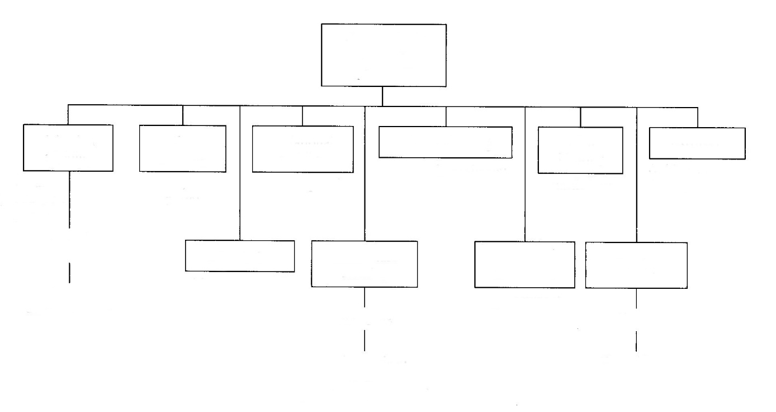
(shapes from sheets)
(tubing, moulding, etc.)
(plastic bags)
Bulk and sheet moulding (mostly simple shapes)
(prototypes)
Sheet materials
Webs (films)
Shapes
Stamping
Casting
Free form fabrication
Solid phase forming
Calendering
(hollow parts)
Rotational moulding
(bottles, hollow parts)
Forming during moulding
(high
production
parts)
Coinjection moulding
Extrusion
Film blowing
Thermoforming
Blow moulding
Injection moulding
Thermoplastic forming processes

Figure 21. Spectrum of forming processes for thermoplastic materials. [1]
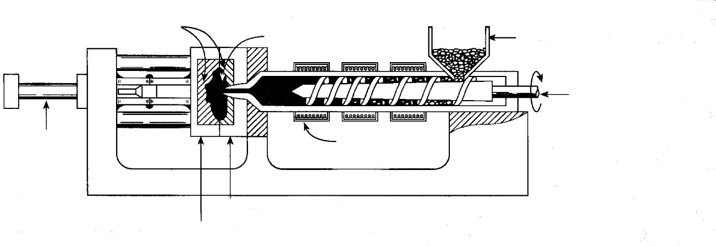
Hopper to feed polymer pellets
Part
Cavities
Movable half of mould
Heaters for melting
Stationary half of mould
Screw and ram
Hydraulic cylinder or electric actuator for mould clamp and opening
Figure 22. Injection moulding. [1]
Injection moulding (Figure 22). A process in which granular polymer - usually, thermoplastic - is fed from a hopper into a heated barrel where it is melted, after which a screw or ram forces the material into a mould. Pressure is maintained until the part has solidified. The mould is opened, and the part is ejected by some mechanism. This is by far the most important technique for mass production. The major disadvantages of the process are that not all polymers can be processed (some thermosets cannot) and the metal moulds are very expensive.
This basic process is also used for coinjection moulding of two different polymers. There are two extrusion barrels and injection systems. A shot is made with one polymer, and a second shot with a second polymer can be used to surround or surface the part made in the first shot. Coinjection is often done to achieve a cosmetic effect or to alter use properties. For example, a thermoplastic elastomer (TPE) can be injection moulded just on the grip area of a plastic drill body after the rigid plastic body is moulded.
Another variation of injection moulding is structural foam moulding. The mould is only partially filled, and the injected plastic expands to fill the mould to produce a part that is lightweight because of the entrapped porosity, but with an integral skin. Foamed polymers have lower weight (and cost) than their no foamed counterparts, and the mechanical properties are often comparable. This process frequently is used on polyphenylene oxide, olefins, vinyls, nylons, and thermoplastic elastomers.
Blow moulding (Figure 23). A process of forming hollow articles by blowing hot polymer against internal surfaces of a split mould. Usually, a tube (parison) of heated polymer is extruded down the centre of the closed mould. Air is then injected, and the heated polymer expands in a uniform thickness to form the desired shape. This is the process used to make plastic bottles and containers. It is fast and typically used only on thermoplastic materials.
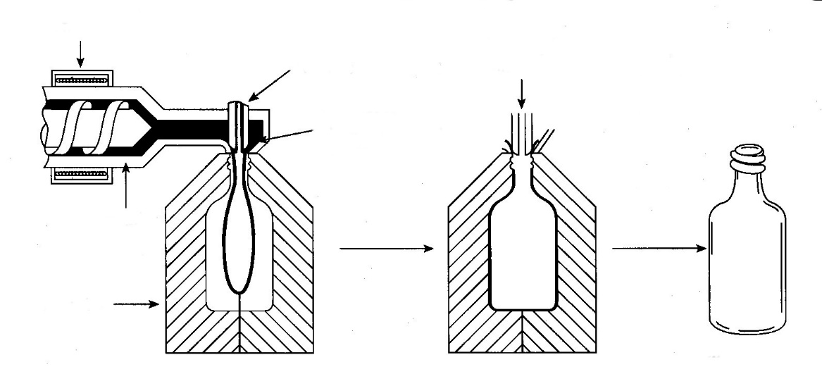
End product
Blowing is initiated
Polymer is extruded around the air annulus
Air tube
Split mould
Extruder
Heater
Figure 23. Blow moulding. [1]
Calendaring (Figure 24) The process of forming thermoplastic or thermosetting sheet or film by passing the material through a series of heated rolls. The gap between the last pair of heated rolls determines the sheet thickness. The material usually is blended and plasticated on separate equipment. Elastomer sheets, gaskets, and vinyl flooring tiles often are formed with this process.
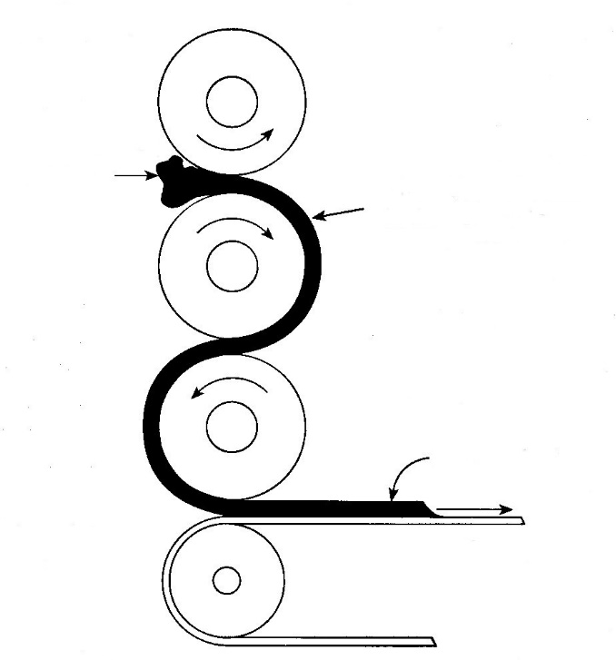
Unvulcanized rubber
The rubber is heated in the working to cause vulcanization
Rubber sheet
Conveyor
Figure 24. Calendering. [1]
Rotational moulding (Figure 25). This process usually is used for making large hollow containers such as fuel tanks, water tanks, floats, and so on. A pre-measured quantity of thermoplastic pellets is charged into a closed metal mould. The mould is clamped closed and put into a device capable of rotating the mould about two axes. The rotating mould is heated to melt the charge. The molten polymer forms a skin against the mould wall to make the part. Mould heating is stopped, and the mould is air or water cooled to allow part removal. A significant advantage of this process is that it uses relatively low-cost tooling, compared with injection moulding and other capital-intensive processes.

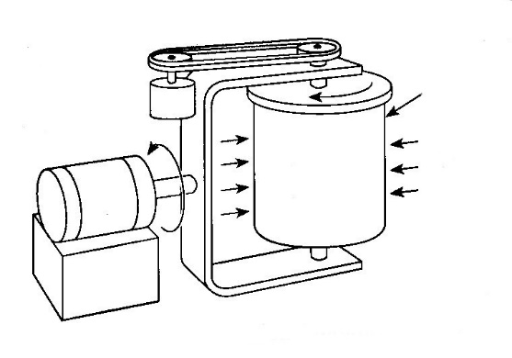
Heat
Mould
Figure 25. Rotational moulding. [1]
Solid-phase forming. A process employed with thermoplastic materials in which a sheet or similar preform is heated to the softening point, but below the melting point, and forged into a drawing ring by a heated die set. The still-warm preform is transferred in the draw ring into a cooled draw die, and a plug draws the part to the finished shape. The steps in this process are illustrated in Figure 26. A lubricant is applied to both sides of the preform to assist the draw. Depth-of-draw ratios can be 1:5 or higher, and the forming in the solid phase is said to enhance strength over parts formed by melting techniques.
Simpler shapes can be made by heating and stamping a sheet to make a form such as an arch support for a shoe. Filled or reinforced thermoplastics, called sheet or bulk moulding compounds, can also be formed by press shaping of the preheated material.
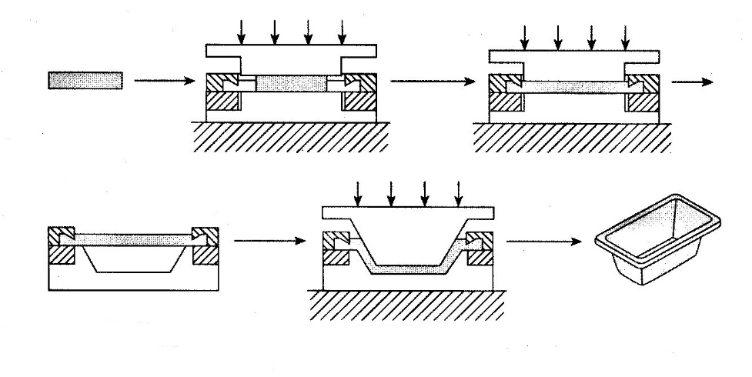
Draw to shape
Transfer to forming die
Figure 26. Solid-phase forming of drawn plastic shapes. [1]
Thermoforming (Figure 27). A method of forming polymer sheets or films into three-dimensional shapes, in which the sheet is clamped on the edge, heated until it softens and sags, drawn in contact with the mould by vacuum, and cooled while still in contact with the mould. Vacuum is not always necessary. Sometimes the sheet is simply draped over a mandrel. Sometimes matched metal moulds are used. Thermo-forming is ideal for low-volume production of containers, machine guards, and other parts with suitable shape.
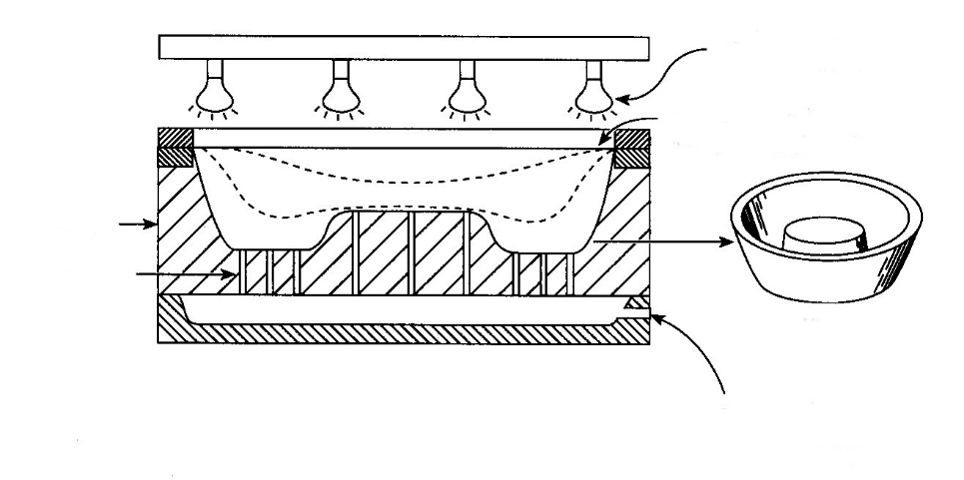
Part
Mould
Vacuum port
Vacuum manifold; vacuum pulls sheet into intimate mould contact after sheet is heated to sufficient sag
Polymer sheet clamped on the edge
Heat lamps cause sheet to soften
Figure 27. Thermoforming. [1]
Free-form fabrication. Stereolithography is one process in a category of fabrication processes that are termed free-form fabrication processes. In this process, illustrated in Figure 28, a computer-controlled laser is used to selectively polymerize a liquid resin to form a part.
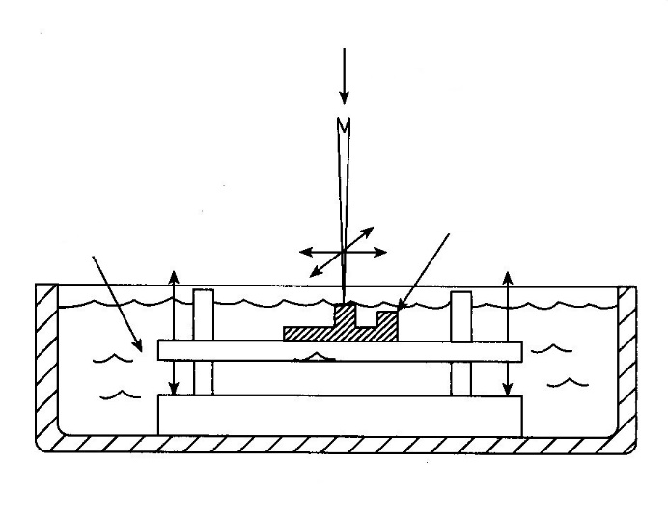
Resin
Part
UV laser
Figure 28. Stereolithography. [1]

A platen is given a thin coating of liquid resin by dipping or spraying; the laser traces the shape of the part at a vertical-slice height of a few microns. This action polymerizes the resin. The part is recoated, and the process is repeated at another slice height. This process is repeated until a three-dimensional part emerges.
Another variation of this process is the laser fusing of powder. A platen is coated with a thin layer of powder, and the laser fuses the powder in the shape of the part. The emerging shape is given another coating of powder, and the process is repeated.
The usual material for stereo lithography is a UV-curable polyurethane resin (rigid). The powder process can use nylons, polycarbonate, and a wide variety of thermoplastic materials. Both techniques are used to produce plastic prototypes without hard tools or even drawings. The part can be made from computer data files (computer-aided design, CAD). Functional tests can be made on the part before any capital is invested in tooling. The process is also used to produce short-run tools from thermoplastics. A process variation for rapid prototypes is called three-dimensional (3D) printing. An array of dot print heads deposit wax or low-melt thermoplastics to form a part from CAD drawings. These devices are intended for use in engineering offices.
Extrusion (Figure 29). The process of forming continuous shapes by forcing a molten polymer through a metal die. Extrusion is used to make structural forms such as channels, bars, rounds, angles, tracks, hose, tubing, fibres, films, and countless other forms. It is very fast and usually applied only to thermoplastics. With special techniques, two different polymers or different colours of the same polymer can be coextruded, and plastics can also be foamed during the extrusion process. This process is often used to make specially shaped weather stripping. A variation (blowing) is used to make plastic bags.
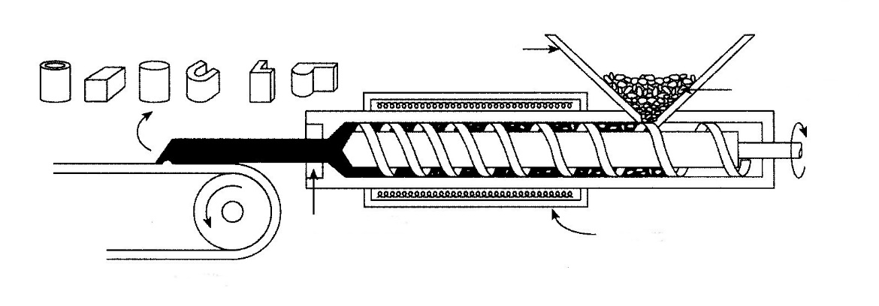
Hopper
Typical shapes
Polymer pellets
Heaters
Changeable die
Conveyor
Figure 29. Extrusion. [1]
Vacuum Infusion Process (light RTM)
The Vacuum Infusion Process (VIP) is a cost effective process for making high quality composite parts. Advantages of VIP include higher quality, better consistency, higher glass content (higher specific strength and stiffness), good interior finish, faster cycle time and lower cost.
The Vacuum Infusion Process (VIP) utilizes vacuum to infuse resin into the laminate. The first step is to load the fabric fibres and core materials into the mould. Also ribs, inserts and any other components can be added, and this is done without resin. Next the dry material is seal closed using a vacuum bag or a counter mould. High vacuum pump (25 in Hg or more) is used to remove all of the air in the cavity and consolidate the fibre and core materials. Still under vacuum, resin is infused into the mould cavity to wet out the fabric fibres and core. The vacuum infusion process is very simple in concept; however, it requires detail planning and process design so the parts can be infused in a reasonable amount of time without any dry spots. The rate of infusion depends on the viscosity of the resin, the distance the resin has to flow, the permeability of the media, and the amount of vacuum. Therefore, the choice of materials, flow media, resin flow layout, and location of vacuum ports are critical in making good parts. The advantage of the vacuum infusion process is to create a laminate with very high fibre content (up to 70% fibres by weight), thereby creating a very high strength and stiff part at minimum weight. Vacuum Infusion is also an efficient manufacturing process for complex laminate with many plies of fibres and core materials.
Benefits of VIP:
- Higher fibre-to-resin ratio (up to 70% fibres by weight)
- Higher strength and stiffness
- No resin entrapped air/ very low voids
- Very consistent laminate with great process control (less human errors)
- Minimal part shrinkage with good surface profile and accuracy
- Can have good outside and inside surfaces
- Efficient to laminate complex fibre layers, ribs, inserts and cores
- Cleaner process with no VOC air pollution
- Faster cycle time
Short coming of VIP:
- Complicated set-up and need to develop the optimal vacuum ports and resin injection locations
- If there is a vacuum leak, the part can be scrapped
- Cosmetic finish on the surface is not as good as open mould process due to fabric print through; however, a barrier coat can be used to improve the finish.
- Tooling cost is higher
- VIP materials cost more than standard resins and fabric
- Will consume some disposable supplies
Vacuum Outlet
Resin Inlet
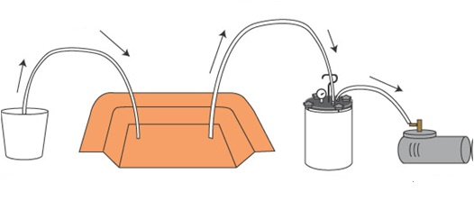
Vacuum Pump
Resin Trap
Mould
Resin
Figure 30. Typical VIP setup. [7]
Typically vacuum ports or channels are created around the perimeter of the part and the resin insertion is at the centre of the part. The goal is to have the resin wet out the entire part as quickly as possible without any dry areas. For large or complex parts, additional resin inlet lines can be added.
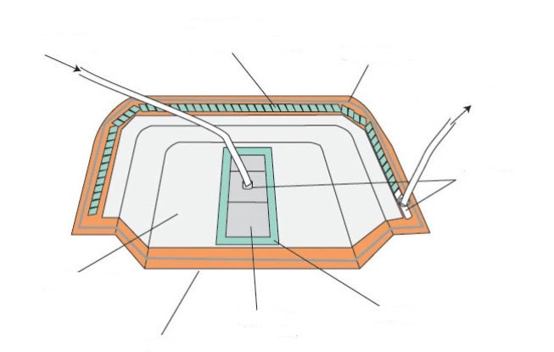
T-Fittings
Peel Ply
Enka Fusion Filter Jacket
Mould
Reinforcement
Vacuum Outlet
Sealant Tape
Spiral Tubing
(wrapped in peel ply)
Resin Inlet
Figure 31. VIP moulding.[7]
A good quality mould is required for vacuum infusion. It needs to be vacuum tight and can sustain the high exothermic temperatures from the part curing.
Select your fibre reinforcement, core and resin.
Choosing the correct fibre reinforcement, resin and core materials are important decisions for VIP. Any types of fibres can be used, but the proper fibre size, the type of weave and style will allow for VIP. The resin used for VIP need to have low viscosity (ideally less than 400 centipoise) to ensure the infusion can be completed prior to the resin cure. There are numerous polyester, vinyl ester and epoxy resins formulated for VIP. For sandwich construction utilizing a core (such as balsa or foam), resin grooves can be added to the core to improve the resin flow. Flow media, which is a plastic mesh, can be added to the laminate to improve the resin flow and speed up the infusion process. The flow media is removed after the part is demoulded. The engineers at Performance Composites can help you choose the correct materials and develop a VIP process that will meet your criteria and cost target.
Summary: Thermoplastic Processes.
Many other processes are used to form thermoplastics, but the ones that we have illustrated are the most widely used. Most of these processes require very expensive equipment. An injection moulding, blow moulding, or film-blowing machine easily can cost in excess of $200,000. Extruders, calenders, and stereo lithography machines are similar in cost. Thermo-forming can be done with very simple equipment (such as wooden forms, a vacuum cleaner, and an oven). Rotational moulding and some types of solid-phase forming can also be performed without expensive equipment. The high equipment costs associated with many of these forming processes can be dealt with by using vendors who specialize in particular processes.
5.2. Thermoset Fabrication Processes.
Thermoset polymers typically are available as liquid resins or as solid particles, powders, or beads. Many liquid resin systems require two or more components to be mixed together to initiate cross-linking or curing. For example, liquid epoxy often requires a polymer resin (for example, based on bisphenol A and epichlorohydrin) and a hardener such as a polyamide. The resin and the hardener must be mixed together to initiate the cross-linking reaction.
Similar to thermoplastic resins, some thermoset resins are commercially available as solid granules, beads, or pellets containing the necessary additives and fillers for the application at hand. For example, phenolic moulding compounds are made by reacting phenol resin, formaldehyde, and an alkaline catalyst in a vessel under temperature-controlled conditions (i.e., heat generated from the reaction must be removed). The reaction is allowed to progress until the viscosity of the resin increases. At this point, excess water from the reaction is driven off by vacuum - yielding a viscous resin that is soluble in solvents (known as A-stage resin). The A-stage resin is cooled to a solid and ground into a fine powder. Additives such as fillers, colorants, and lubricants are mixed with the powder. The powder is then processed on heated mixing rollers, where some cross-linking begins to occur. When the polymer is nearly insoluble in solvent, but still fusible with heat and pressure, the reaction is terminated - yielding a B-stage resin. The B-stage resin is cooled and rough-ground into granules, or pellets. To mould a part from granulated B-stage resin, the resin is heated until it liquefies and then it is consolidated in a mould by injection or compressing (for example). With time and temperature, the liquefied B-stage cross-links to a rigid solid. The liquefaction and curing process is shown graphically in Figure 32a. Likewise, when a liquid resin is cured under temperature-controlled conditions, the viscosity rises with time, as shown in Figure 32b.
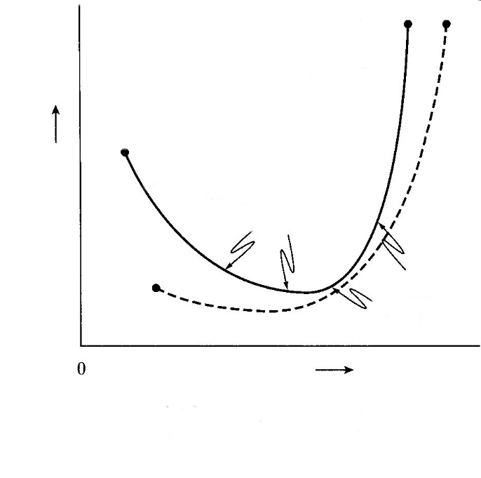
(b)
(a)
(b) Curing of a liquid resin at a controlled temperature
- Curing of a B-stage polymer
Log η (viscosity)
Temperature
Solid resin
(B-stage)
Cross-linked polymer
(C-stage)
Cross-linking increases viscosity
Resin softens to low viscosity liquid
Figure 32. Effect of time and temperature on the curing of thermoset resins. [1]
Once thermosets are formed, they cannot be remelted. This makes moulding machine cleanout very difficult, which is the major reason thermosets are often moulded in equipment that is simpler than that used on thermoplastics. Injection moulding and extrusion processes are used on thermosets, but the process is complicated by the need to completely remove the polymer from the barrel and runner system at shutdown. If, for example, an extruder is shut down with a thermoset in the barrel that heats and conveys the material, the screw may become an integral part of the barrel. Screws can cost $50,000, barrels twice that. Thus, thermosets can be formed by some of the thermoplastic processes, but special techniques must be used to deal with the irreversible nature of these materials. Most composites are made with thermoset-ting resins. These will be addressed in the next section. This section will cover the processes that are used for thermosets that do not contain continuous reinforcement (Figure 33).
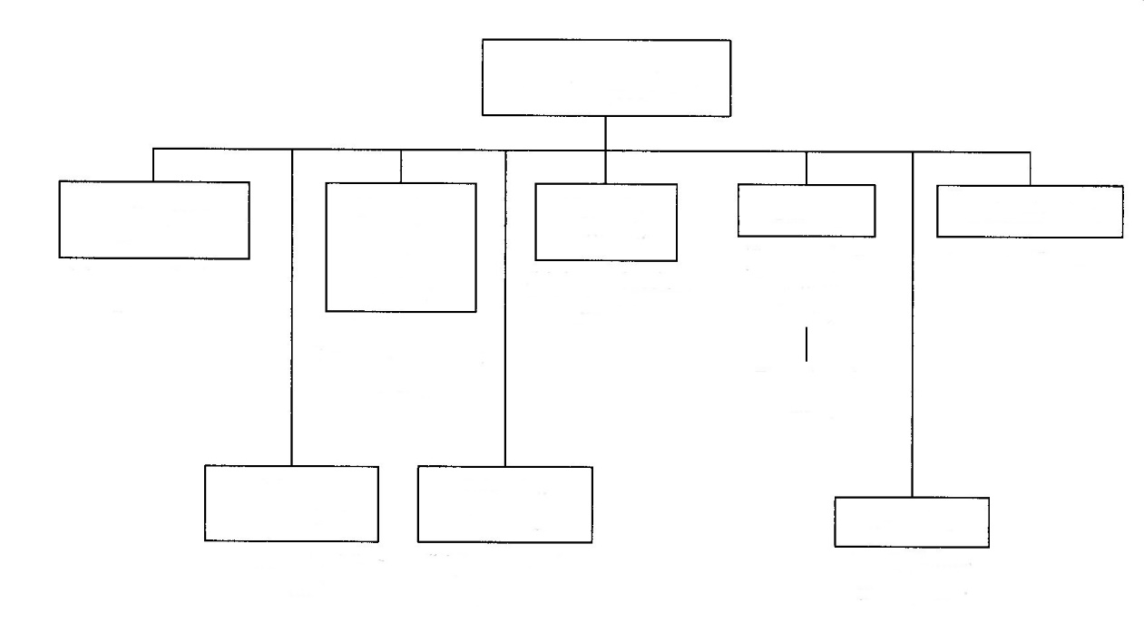
Thermoset forming processes
Foam processing
(electrical devices, small parts)
(rubber products)
(auto parts, business machine parts)
Sintering
(stock shapes, small parts)
(high-production parts)
(insulatin, bedding, auto parts)
Rotational casting (vessels)

(fixtures, low-production
parts)

(high-production parts)
Injection moulding
Vulcanization
Casting
Transfer moulding
Reaction
injection
moulding
(RIM)
Compression moulding
Figure 33. Thermoset fabrication processes. [1]
Compression moulding (Figure 34). The moulding material, usually preheated and premeasured, is placed in an open mould cavity, the mould is closed with a cover half or plug, and heat and pressure are applied and maintained until the material has filled the cavity and cures. This is the most widely used process for thermosetting materials. Because curing of thermosetting polymers is a time-dependent reaction, cycle times usually are much longer than those in injection moulding are.
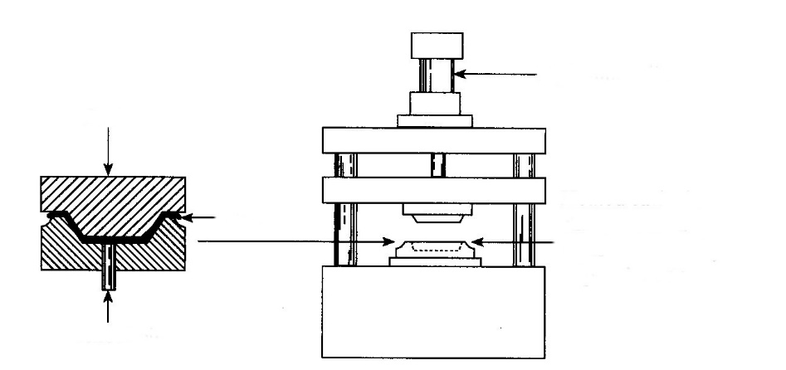
Knockout pin
Flash
Heated cavity is charged with a measured quantity of powder or a preform
Hydraulic cylinder
Part
Figure 34. Compression moulding. [1]
Injection moulding. Thermoset materials may be injection moulded in high-production applications. Thermoset injection moulding cycles typically are two to three times faster than compression-moulding cycles - yielding lower-cost parts. Much the same as with thermoplastic materials, a screw or plunger is used to feed the polymer (typically, B-stage pellets or beads) through a heated barrel. With heat, the viscosity of a thermoset polymer initially decreases. However, over time, the viscosity increases as the polymer crosslinks. The intent is to inject the liquid polymer in the mould while it is at its lowest viscosity level. Once in the mould, the polymer is heated long enough to cross-link the resin and form a solid part. The part is then ejected from the mould. It is not uncommon to heat the parts in an oven off-line to further cure the polymer (this is known as post curing) to ensure required properties and dimensional stability.
Foam moulding. Various techniques are used to produce moulded plastic parts with dense skins and high porosity in the core (Figure 35). The simplest process involves charging a metal mould with resins that foam and expand during reaction. The expansion of the foaming resin causes the mould to be filled. A variety of similar processes are used for large parts, with the exception that the polymer is injected into the cavity rather than charged into the mould.
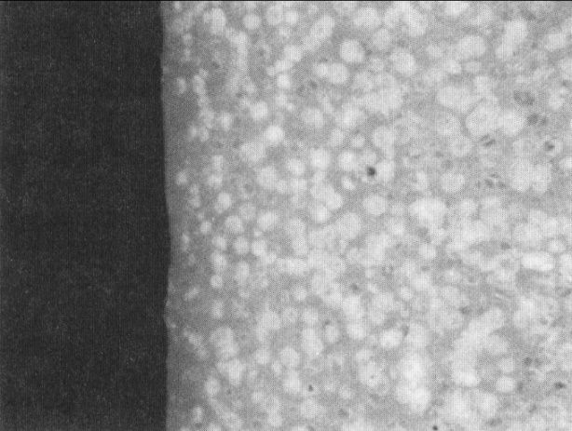
Figure 35. Cross section of foam-moulded part (×30). Note the dense skin at the surface. [1]
Standard injection moulding machines can be adapted to produce foamed parts by adding equipment to inject a metered amount of gas or a chemical blowing agent into the polymer near the exit end of the extruder barrel of the injection-moulding machine. The advantage of foam moulding is the ability to increase section sizes and part stiffness without using significantly greater amounts of material. Side effects often are less shrinkage and better part tolerances.
Foams such as those used in furniture, bedding, auto seats, and the like usually are made from thermosets that are allowed to foam outside of a mould.
The most common foams are polyether or polyester polyurethanes. Components are reacted and applied to a long conveyor belt. The reactants form a huge foam "bun." The bun is sliced to make slabs or cut with a veneer knife to make sheet goods.
Reaction injection moulding (RIM). Polymer reactants are pumped under high pressure into a mixing chamber and then flow into a mould at atmospheric pressure. The chemicals expand to fill the mould and to form the polymer. The foaming action of the reactant produces the pressure for replication of mould details [about 207 to 483 kPa)], and the reaction heat speeds the polymer cure. (Cycle times usually are less than two minutes.) A schematic of the RIM process is shown in Figure 36 .
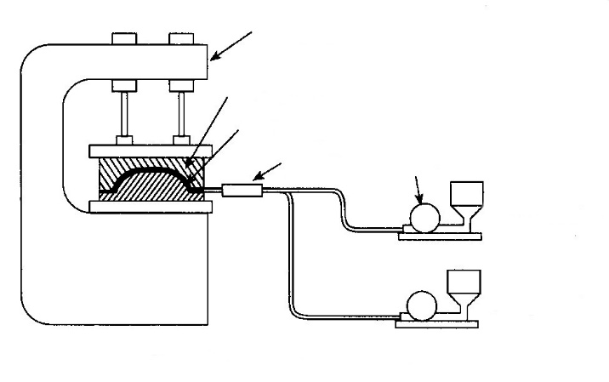
Mixing
chamber
Component B
Pump
Component A
Part
Metal mould
Clamping press
Figure 36. Schematic of reaction injection moulding. [1]
This process is most often applied to large parts (over 1 kg), and polyurethane foams are the most popular moulding materials. Many large auto parts such as bezels, dashboards, and fenders are made with this process. Fillers can be added to the reactants to improve the mechanical properties of moulded parts.
Transfer moulding (Figure 37). This process usually is applied to thermosetting materials. The moulding material is put into an open cylinder, heated, and transferred under pressure into the part cavity. It is modification of compression moulding.
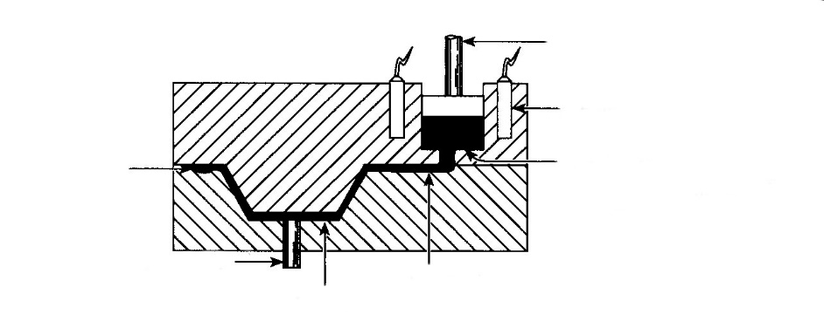
Powder or preform is melted before application of pressure
Heater
Ram
Runner
Cavity
Knockout pin
Overflow
Figure 37. Transfer moulding. [1]
Casting (Figure 38). This process forms solid or hollow shapes from molten polymer or from catalysed resins by pouring the liquid material into a mould, without significant pressure, followed by solidification or curing. The mould is usually open at the top. The polymer casting process is widely used on urethane and silicone elastomers to make roll covers, die springs, sheets, and the like. It is also suitable for making jigs and fixtures from filled epoxy or polyester resins.
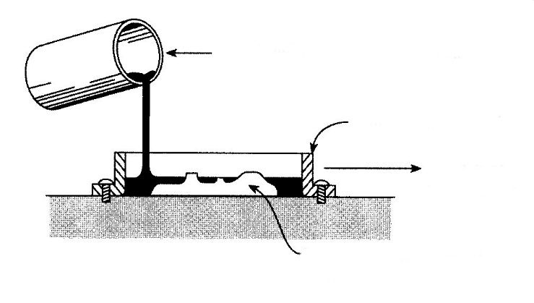
Make shape from metal,
wood, plaster, etc.
Oven cure, if necessary
Simple metal mould
Catalyzed thermosetting polymer
Figure 38. Casting. [1]
Rotational casting can be done in tools similar to those used for rotational moulding of thermoplastics. Liquid reactants are poured into a closed mould and rotated in two axes until the resins cure. It is not necessary to heat the mould as in rotational moulding of thermoplastics.
Sintering. Used on some of the fluorocarbons, polyimides, and similar high-temperature plastics, sintering is the bonding of adjacent surfaces of powder particles. Some of the high-temperature polymers are made into shapes by compressing polymer particles, as in compression moulding, and heating them until the particles join by coalescence. They do not melt and flow as in normal compression and transfer moulding.
Vulcanization (Figure 39). Most rubbers are vulcanized to form a shape. Vulcanization is the application of heat and pressure to cause polymer cross-linking and branching, the process that makes rubber rubbery. Before vulcanization, rubber is sticky. Figure 39 illustrates the making of a rubber-covered roll.
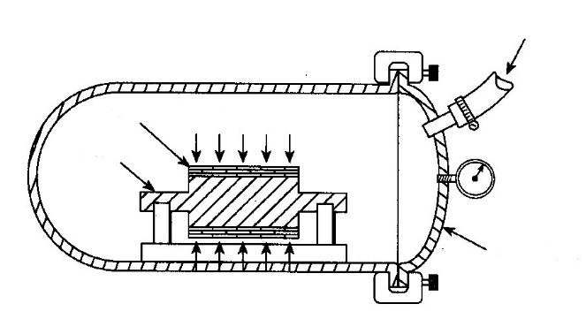
Steal
roll
Rubber ‘tape’
Autoclave
Steam
Figure 39. Schematic of vulcanization of rubber to make a rubber-covered roll.[1]
A tape of partially reacted rubber is wrapped around the roll to the thickness of rubber desired. The taped rubber is shrink-wrapped with a plastic film (to protect the rubber from oxidation) and placed in an autoclave. The steam-heated autoclave produces both the heat and the pressure needed to complete the consolidation of the tape into a solid rubber coating on the roll. The vulcanized rubber coating is then ground to the customer's specified diameter. This process is also used for automobile tires and the other rubber items that we take for granted.

Tooling
Tooling or moulds are used to define the shape of the fiberglass parts. The fiberglass part will pick up all shapes and features of the moulds; therefore the quality of the part is heavily influenced by the quality of the mould. The moulds can be either male or female. The female moulds are the most common and they will produce a part with a smooth exterior surface while a male mould will produce a smooth interior surface (please see drawing below).

Smooth gel coat surface | Smooth gel coat surface  Male mould
Figure 40. Mould layout. [7]
Rough surface
Rough surface
Female mould
For very short production runs (less than 10 parts), temporary moulds can be made from wood, foam, clay or plaster. These moulds are economical and can be fabricated quickly, which will allow inexpensive prototype parts to be fabricated. For larger volume production, moulds are typically made with fiberglass. These moulds have a life expectancy of 10+ years and 1000+ cycles. Fiberglass moulds are inexpensive and usually only cost 6 to 10 times the price of the part.
The mould is a mirror image of the part. To create a mould, a master (plug) is required. The master can be an actual part, or can be fabricated out of wood, foam, plaster, or clay. The exact shape and finish of the master will be transferred to the mould. Once the master is completed, it is polished, waxed and the mould is built up on the master. The fabrication technique of the mould is similar to fabricating a fiberglass part except that tooling materials (gel coat, resins, and cloth) are used to provide a durable mould that has low shrinkage and good dimensional stability. Once the mould is laminated, it is reinforced with wood, fiberglass or a metal structure to ensure that it retains the proper shape. The mould is then removed from the master and put into production.
Summary: Thermoset Forming Processes
Our discussion has omitted thermoset forming processes such as making plywood, flake board, and related construction products, which make up the largest fraction of use of thermosetting polymers. There are two reasons for this omission: first, they are really composites and thus belong in the next section; second, they are not used by most material users, only those in the wood composite industry. An important concept to keep in mind with regard to thermoset fabrication processes is that forming/ moulding cycle times are usually longer than those for making thermoplastic parts are. This is why thermoplastics are used more on a tonnage basis. However, when it comes to heat resistance, the thermosets usually excel. Some thermoplastics have higher use temperatures than thermosets, but they really have little strength at temperatures in excess of 500°F (260°C), and they melt when overheated. Thermosets do not melt. When overheated, they char and often are still usable. Therefore, thermosets are somewhat more difficult to form than thermoplastics, but the moulding equipment usually is cheaper and thermoset materials simply perform better than thermoplastic materials in many applications.
5.3. Polymer Composites.
Reinforcement Types. Previously we defined a composite as a material composed of two or more different materials, with the properties of the resultant material being superior to the properties of the individual materials that make up the composite. By this definition, an alloy or blend could be a composite, but the accepted meaning of "polymer" is "a material with a continuous resin matrix and a controlled distribution of a reinforcing material." Even some polymer materials, such as liquid crystal polymers, that meet this definition are not normally considered composites. From the commercial standpoint, composites are made from matrices of epoxy, unsaturated polyester, some other thermosets, and a few thermoplastics. The reinforcements are glass, graphite, aramid, thermoplastic fibres, metal, and ceramic. The combination of the two materials makes a composite (Figure 41).
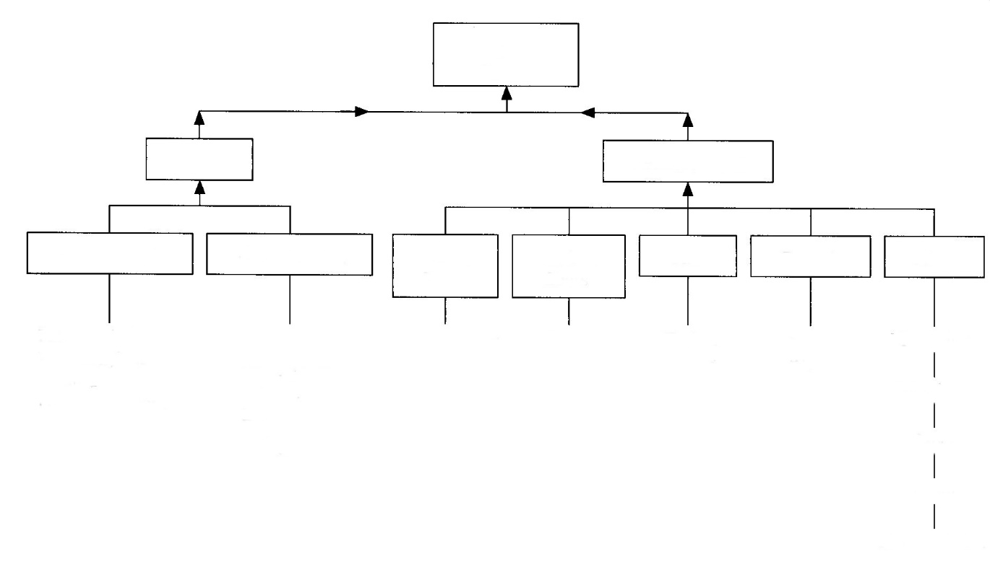
SiC
Al₂O₃
E-glass
S-glass
Lo E
Hi E
Polypropilene Aramid
Epoxy
Unsaturated polyester
Phenolic
Polyimide
Etc.
Polyetherimide Polyphenilene
sulfide
Polyether sulfone
etc.
Thermosetting
Reinforcement
Metal sheet
Metal foil
Nanomaterials
Cloth
Paper
Others
Ceramic
Glass
Matrix
Thermoplastic
Carbon fibres
Plastic fibres
Polymer composites
Figure 41. Matrix and reinforcement options for polymer composites. [1]

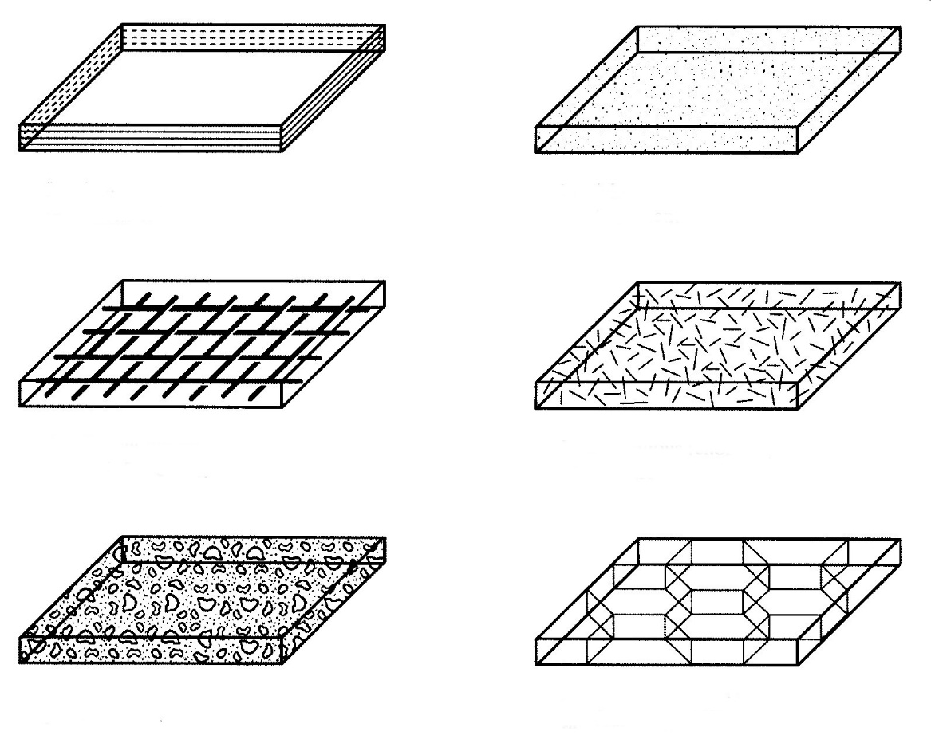
Particle reinforcement
Laminar reinforcement
Discontinuous (chopped) fibre reinforcement
Continuou woven fibre reinforcement
Skeletal (honeycomb) reinforcement
Flake reinforcement
Figure 42. Reinforcements used in polymer composites. [1]
The reinforcement can be continuous, woven, or chopped fibre; conventional composites contain from 20% to 50% by weight of glass or other reinforcement. The percentage of reinforcement in advanced composites can be as high as 70%; these materials usually use epoxy as the matrix material, and graphite fibres are the most common reinforcement. Some reinforcement schemes used in polymer composites are shown in Figure 42.
The purpose of adding reinforcements to polymers usually is to enhance mechanical properties. Chopped fibres, flakes, particles, and similar discontinuous reinforcements may enhance short-term mechanical properties, but these types of reinforcements usually are not as effective as continuous reinforcements in increasing creep strength and similar long-term strength characteristics. Continuous reinforcements serve to distribute applied loads and strains throughout the entire structure. These latter types of composites offer the most potential for making polymer-based composites competitive with metals for structural applications.
Cellulose fibres reinforce plants, and they are responsible for the remarkable mechanical properties that are available from wood. Woods are natural composites. The first commercial synthetic polymer composites were phenolic-paper laminates intended for electrical insulation (circa 1915).
Probably the most important events in the use of reinforced plastics (RPs) were the development of epoxies, polyester resins, and glass fibres. These developments allowed the use of composites for structural items such as boats, piping, and containment vessels. There are many reasons for the use of polymer composites, but most centre on their strength and environmental resistance characteristics. As shown in Figure 43, the high-performance grades of polymer composites - those with the stronger matrix materials and continuous reinforcements - have specific strengths and specific stiffness ratios superior to those of steels and aluminium alloys.
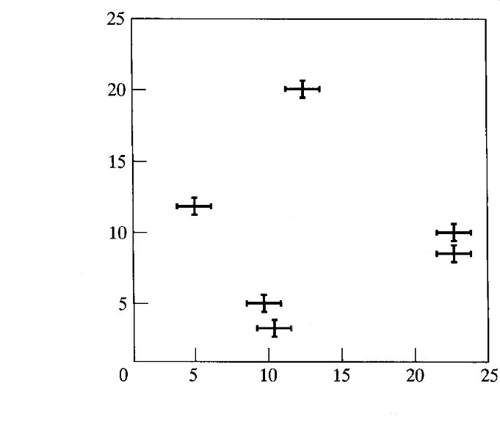
Steels
Aluminium alloys
Boron/epoxy
Graphite/epoxy
E-glass/epoxy
Aramid/epoxy
Specific strength, 2,5x10⁻⁴ mm
Specific stiffness, 2,5x10⁻⁶ mm
Figure 43. Specific strength and stiffness of some cross-ply epoxy matrix polymers.[1]
Specific strength is the tensile strength of a material divided by the density, and specific stiffness is the tensile modulus divided by the density. These ratios are used by designers to decide which structural material will provide a desired strength or stiffness with the lowest mass. For example, an I-beam of steel will weigh more than two times as much as a composite I-beam of boron-epoxy, with an equivalent stiffness. Similarly, an aramid-epoxy lifting device will be four times as strong as a steel device of the same mass. Advanced composites are taking over for aluminium, steel, and titanium for structural components on aircraft for these reasons, and the lower-strength and less costly polymer composites are replacing metals on automobiles because of their lower weight and resistance to atmospheric rusting and road-salt corrosion.
The use characteristics of composites depend on the nature of the polymer resin matrix, the nature of the reinforcement, the ratio of resin to reinforcement, and the mode of fabrication. The high-performance composites usually contain over 50% reinforcement. In the remainder of this discussion, we shall describe the common matrix materials, reinforcements, fabrication techniques, and application guidelines.
Matrix Materials.
Thermoplastics. There are two main types of polymer composite matrix materials: thermoplastic and thermosetting. In 2008, about 90% of the composite market used the thermosetting materials. Up to the late twentieth century, thermoplastic materials were reinforced primarily with chopped glass fibres. The glass reinforcement usually was in the form of short-length fibres (a few millimetres) blended into moulding pellets, and parts were injection moulded or formed in the conventional techniques. This type of reinforcement does not produce a composite with the degrees of strength that can be obtained with the same reinforcements in continuous form. Continuous reinforcement of thermoplastics is a technology that reached commercial importance in the 1990s, but the market is growing as the available reinforcement and matrix products improve.
The technical problem that had to be overcome to make the concept work was to develop the technology to coat continuous reinforcement fibres with a layer of thermoplastic material. The earliest systems drew reinforcement material such as glass through a bath of molten polymer and then wove the polymer-coated filament into cloth or tape for reinforcement of shapes. Tapes of prewoven material also could be dipped in molten polymer for coating, but the wetting problem was more formidable.
If the product to be made is a simple shape such as a cafeteria tray, the thermoplastic-coated reinforcement is placed as a sheet between a matched set of compression moulding dies. Heat and pressure are applied, and the part is ejected after it is subjected to a suitable heating and cooling cycle in the mould. Thus, the raw material for making a thermoplastic composite is a prepreg, or previously impregnated, cloth that was saturated by the vendor with the matrix material of interest. Making the part from this material involves heating it (by any technique) and then restraining it in the desired shape until it becomes rigid (cools) enough to handle. The term prepreg also applies to reinforcement that is impregnated with partially reacted thermosetting matrix resins.
Drawing fibres through molten polymer to coat them is not without problems. Molten plastics have the consistency of honey. Visualize pulling a piece of string out of a jar of honey and trying to get the honey to wet and to coat the string with a thin, uniform coating. Another problem that has had to be reckoned with is the high temperatures needed to get reasonable viscosities out of polymers of interest. For example, some thermoplastics for matrix materials do not develop low enough viscosity for fibre coating until the molten bath is at 343°C. A temperature this high produces other problems, such as oxidation of the melt polymer, fume emission, and related issues. In other words, coating fibres from molten baths is not without problems, but it is one of the techniques used to create thermoplastic prepregs for making composites.
A second system that has been developed for coating reinforcements with thermoplastics is to use polymers that can be dissolved in a solvent. The fibres are drawn through a bath of the polymer-solvent solution. The solvent is allowed to volatilize, and the reinforcement coating is reduced to only polymer. This system produces better fibre wetting, but the problem of solvent evaporation must be dealt with. This technique often is used with the amorphous thermoplastics such as polyamide-imide, poly-sulfone, polyetherimide, and similar materials. One advantage of solution-impregnated prepregs over melt-impregnated prepregs is better conformability and tack. The melt-coated reinforcements normally are quite stiff, and this produces problems in making shapes. In our cafeteria tray example, a stiff reinforcement would lie on the open mould like a piece of cardboard; when the mould is closed, the stiff, card-board like material may move out of position and an incomplete part may result. Solution-coated materials can have better flexibility as well as some tack that will allow them to conform to a mould and keep their position during the mould closing cycle.
In summary, thermoplastic composites can be made from any of the common reinforcements and from many thermoplastic matrix materials. The most common reinforcements are glass, carbon fibre, and aramid fibre, and the most common thermoplastics for matrices are polysulfone, polyetherimide, polyamide-imide, polyetherether ketone, polyethersulfone, and polyphenylene sulphide. Composites made from these materials have strength and stiffness approaching that of thermoset composites, and often, much better toughness. They can have process economies if used properly. For example, parts can be warm stamped with speeds not possible with thermoset processes that require heating for curing or a long mould cure time. Suppliers are continuously working to make this material easier and more cost effective to work with.
Thermosetting Resins. Thermosetting polymer matrices usually are formed from low-viscosity liquids that become cross-linked by combination with a catalyst or by the application of some external form of energy, such as heat or radiation (UV and other types). The earliest composites were made with a phenolic thermosetting matrix. The epoxides followed, then the ureas, the unsaturated polyesters, and the silicones; now there are considerably more. From the usage standpoint, the most important are the first three materials: phenolics, epoxies, and unsaturated polyesters.
Phenolics (PFs). Hard and rigid, these have one of the highest moduli of elasticity of common plastics, and they have good electrical properties. All the normal reinforcements can be used with phenolic resins, but because a major application of these materials is for circuit boards, there is a variety of reinforcements specific to the needs of the electrical industry. These are called NEMA (National Electrical Manufacturers Association) laminates in the United States, but these grades are available worldwide. There are grades with paper, cloth, and glass reinforcement, and some companies offer grades with aramid fibres as reinforcement. Many automotive brake and clutch pads are moulded from phenolics that are reinforced with asbestos, powdered metals, and friction modifiers, such as molybdenum disulphide and graphite. Phenolics are extremely useful in machine design in that they are available in standard shapes (rods, plates, strips, and sheets) that can be machined into all sorts of machine components, gears, cams, and structural parts. These laminates have one of the highest compressive strengths of any composite (flatwise). The strength can be in excess of 215 MPa, and they have good stability and machinability.
Phenolic resins are widely used in decorative laminates. A familiar trade name for one of these laminates is Formica®, and they are used for kitchen counters and similar work counters in all sorts of applications. These laminates are layers of paper-type products and decorated paper that are compression laminated into sheet goods. Urea and melamine formaldehydes are similar to phenolic resins in applications and properties, and they are also used for these types of composite laminates. Ureas are the resins used in particle boards that are widely used in furniture and the construction trades.
One useful aspect of phenolic resins in manufacture is that they can be purchased as B-stage resins. This means that they will behave as thermoplastics until they are heated to a particular temperature under compression. They then set to final form, and from then on, they are thermosetting; they can never be melted again. B-stage resins are only partially catalysed; consequently, they are only partially cross-linked. The heat and pressure cycle completes the reaction. This means that users can buy phenolic resins in pellet form, mix the pellets with reinforcements of their choosing, and then compression mould the powder-reinforcement blend to make a desired shape.
Epoxies. Their name derives from the epoxy functional group that terminates molecules or that is internal to the structure, cyclically or not. Epoxies are really polyethers, because the monomer units have an ether type of structure with oxygen bonds, or R - O - R. The general structure of epoxy types of polymers is shown here:
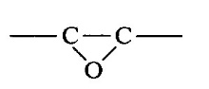
Epoxide functional group
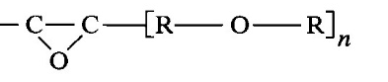
General formula for an epoxy resin
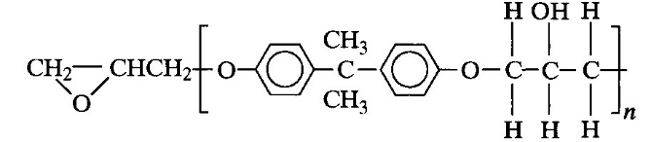
Epoxy formed from bisphenol A and epichlorohydrin
The chain length of the molecules of epoxy before cross-linking is relatively short - as short as 10 molecules. When cured, these molecules crosslink to form a three-dimensional network, and the catalyst or reacting species becomes part of the structure. This incorporation of the catalysing agent in the structure is responsible for one of the unique characteristics of epoxies: minimal physical size change on polymerization. Solvents and condensation products are not emitted. The shrink rate can be as low as 0.01% of dimension. Low shrink rates make epoxies ideal for adhering to other surfaces and reinforcements. If a material has a strong tendency to shrink on formation, there will be a tendency for its bond to other surfaces to be under a significant shear stress.
Many grades of epoxy matrix resins are commercially available; they differ in molecular structure and the nature of the curing agent. Epoxies used in polymer composites usually have two components, and polymerization commences on mixing.
The actual mechanism of polymerization can be direct linkages of epoxide groups, linkages between epoxide groups and other chain molecules, and epoxy-to-epoxy linkages. Some reactions are caused by catalysis, and some are caused by chemical reaction of the mixed species, but the net result is a three-dimensional macromolecule with chemical bonds throughout. The properties of epoxy resins vary with the type of epoxy and the type of curing agent. In fact, it is possible to obtain a fairly wide range of properties with a given resin, depending on the mixture of resin to curing agent and the type of curing agent.
Epoxy resins are probably the most important matrix material for high-performance structural composites. Epoxy is the matrix material that produces the highest strength and stiffness, with the stronger reinforcements such as boron and graphite. Its importance in polymer composites is mostly due to its high strength, low viscosity for wetting, and low shrinkage tendencies. There are special grades of epoxy for elevated-temperature service to about 176°C, but more expensive matrix resins such as polyimides, silicones, and bismaleimides (BMIs) replace epoxies for service temperatures over 176°C.
Unsaturated Polyesters. These styrene-polyester copolymer resins usually contain inhibitors that allow their storage as liquids for a year or more. Once catalysed, the resins become rigid in times as short as one minute or as long as several hours. Several other polyester resins are used for reinforced thermosetting plastics (RTPs) and RTP composites: bisphenols, Het acid, and vinyl esters. The last are used for chemical-resistant piping and tanks. They have better corrosion resistance than the general-purpose resin. Bisphenol resins can be modified to impart some resilience to a composite. The Het acid resins are heat stabilized and flame retardant. The vinyl esters are really epoxy based and differ chemically from the other polyesters, but they are usually classified in the polyester resin family. They are used for aggressive chemical environments.
Unsaturated polyester resins are by far the most important materials for general-purpose composite structures and parts. They are the materials used for the familiar fiberglass boat, the Corvette automobile, recreational vehicles, all sorts of storage tanks, pultruded piping, portable toilets, and countless commercial and military applications. These materials are much lower in cost than the epoxies (about 6.6$/kg vs. 13.2 $/kg for the lowest-cost resins). They also have slightly lower strength than the epoxies.
Polyester matrix materials are used with all the reinforcements, but glass is by far the most common. These resins are used for all the manufacturing processes that are used on composites. Big boats often are made by hand layup; small boats are made by combining polyester with chopped fibre in a special spray gun, and the hull is formed by simply spraying the mould to the desired hull thickness. Fillers can be added to unsaturated polyesters (UPs) to make a gel coat, which is the smooth, pigmented outer skin on boats and the like. Tanks and similar structures are made by filament winding or by layup techniques for large items. Pipe and structural shapes are pultruded; fibre reinforcement and resin are coextruded from a die. Parts can be stamped from UP matrix materials when these are supplied as sheet and bulk moulding materials. Partially reacted polyester (B stage) comes as a prepreg that is set up by heat when forming is done.
In their simplest form, unsaturated polyesters are supplied as a fairly low-viscosity fluid (similar to cheap maple syrup) that can be clear or pigmented. The resin cures after it is mixed with a catalyst. The catalyst ratio can be as low as 50 millilitres per litre of resin, depending on the degree of mixing and temperature. To make something by hand layup, the mould surface is coated with a layer of catalysed resin, the reinforcing cloth is applied to the sticky resin on the mould, the reinforcement is then saturated with more resin, and the part is allowed to cure. The part will set up in anywhere from one hour to overnight (depending on the amount of catalyst added and the temperature). This process description should explain why this matrix material is so widely used. It is extremely easy to perform the basic process steps. Low-skill help can be used.
A high degree of technology applies to the design of the reinforcement if you are to optimize a design, but if you are building simple portable toilets, rigorous calculations on the number of layers and orientation of the reinforcement are not necessary. If a spar for an aircraft is the part under design, calculations probably will be necessary. Whatever the composite application, unsaturated polyesters are usually the candidates of first choice because they are the lowest cost. If they do not satisfy the design criteria, the more expensive epoxies, polyimides, and so on can be considered.
Silicones. Used as a composite matrix resin for special applications, silicones can withstand service temperatures as high as 315°C; when used in the form of a low-durometer elastomer, they can have unusual release characteristics. Printing blankets are made from silicones because they will transfer ink completely to other surfaces. Nothing sticks to silicone elastomers. Silicones are also available as rigid thermosets. The high-temperature resistance of these materials is probably the result of the silicon-to-oxygen linkages that make up the backbone of these polymers.
Polyimides. Like silicones, polyimides are used for special applications - usually, high-temperature composites. Polyimide prepregs are available that can be handled and fabricated like other partially polymerized matrix resins. Prepregs can be placed in moulds and cured to final form with the application of heat. Service temperatures can be as high as 260°C. These resins are much more expensive than epoxies and unsaturated polyesters, so their use usually is confined to aerospace and similar applications where there may be more tolerance for the higher cost.
There are no technical limits on the variety of resins that can be used as a matrix for polymer composites. The major criteria for suitability for use are that they have the ability to wet the reinforcement and adhere to the reinforcement. The important matrix materials, from the standpoint of commercial availability and desirable properties, are unsaturated polyester, epoxies, and phenolics. Other thermosetting matrix materials include polyimides, urea, melamine formaldehydes, furans, and allyls such as diallyl phthalates (DAPs). Melamines are widely used with fillers for the familiar unbreakable dinnerware. Ureas are used for laminating resins, but the largest tonnage is used for laminating wood products such as plywood. Furans are useful in the chemical process industry for tankage to hold aggressive chemicals. Diallyl phthalate moulding resins are often used with glass reinforcing for compression-moulded electrical components. They can have better compression properties than the phenolics. Composites for elevated temperature service usually use polyimide, silicone, or BMI matrix resins.
Most of the thermoplastics are available in glass-reinforced form. Glass contents typically are in the range of 10% to 40%. Any thermoplastic can be used, but some of the commonly reinforced thermoplastics are polyamides, polycarbonate, polystyrene, acetals, ABS, acrylics, polyethers, polyphenylene oxide, and the fluorocarbons. They are not widely used for matrices with continuous fibre reinforcement because of the problem of reinforcement wetting. If the goal of an application is a high-performance composite, the most suitable matrices will be unsaturated polyester or epoxy.
The common matrices for continuous fibre-reinforced thermoplastic composites include polyetherimide (PEI), polyphenylene sulphide (PPS), and thermoplastic polyimides (PIs). If an application involves service temperatures below 93°C, the most suitable matrices usually are unsaturated polyester or epoxy.
Reinforcements.
The spectrum of materials used in polymer composites for reinforcements is shown in Figure 41. The first composites were laminates of paper saturated with phenolic resin and compression moulded into sheets for electrical applications. Paper reinforcement is still used, mostly for phenolic laminates and electrical applications because of favourable heat resistance and electrical insulation characteristics. Rod shapes are made by coiling resin-saturated paper like a roll of wallpaper. Cotton fabrics evolved as the next important reinforcement. Canvas-phenolic composites emerged in the 1930s, and woven cotton fabrics are still widely used as continuous reinforcements in phenolic laminates. A variety of weaves and fibre diameters are used, and these differences translate into different properties in the finished composite. The biggest advantages of paper and cotton reinforcements are low cost and the ease of machining. Hard, inorganic reinforcements such as glass and metal cause excessive tool wear in secondary operations and mating material wear in sliding systems. Paper and cotton are less abrasive reinforcements.
Metals. An important technique in the use of metals in polymer composites is the use of metal skeletal structures in the form of honeycomb panels. Beehive pattern honeycombs are often made from aluminium in foil thicknesses. These honeycombs form the core of laminates, with metals or fabric-reinforced polymers on the facing of the laminate (Figure 44).
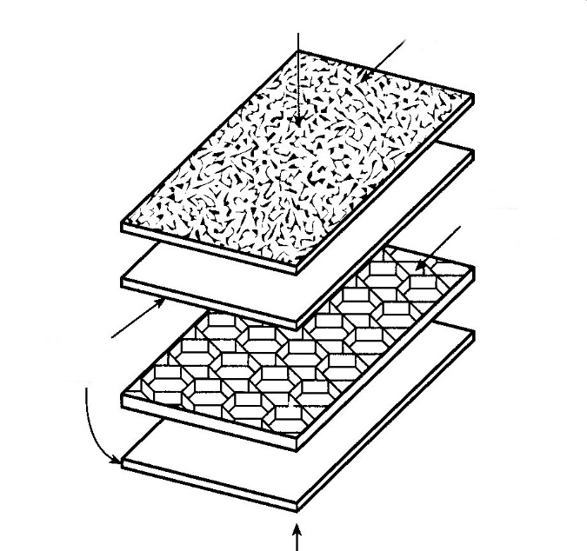
Textured vinyl
Aluminium honeycomb
Aluminium sheet
Figure 44. Lightweight composite panels can be made with epoxy bonding of aluminium panels to an aluminium honeycomb core. [1]
These types of structures have long been important in the aircraft industry, sometimes for structural members of the aircraft, sometimes for interior panels such as doors, seats, headliners, and the like. They can be extremely light for a given section modulus. In fact, the use of metal honeycomb laminate cores may be the most commercially important use of a metal reinforcement in polymer composites. Metal wires or other shapes are not widely used. Metal/plastic/metal laminates have become commercially available. These laminates function much like honeycomb panels, but are easier to manufacture and are less expensive. European automobile manufacturers are developing metal/plastic/metal laminates for auto body panels such as hoods because they may be stamped and deep drawn much like steel sheet.
Asbestos. The asbestos that is used as a reinforcement in polymer composites usually is chrysotile asbestos, which is a hydrated magnesium silicate (3MgO • 2SiO • 2H₂O). It is a naturally occurring mineral with a fibrous structure that makes it ideal for wetting with low-viscosity resin matrices. Synthetic fibres do not have the leafy structure of these materials. Asbestos can be wet in water and made into fibres that, in turn, can be woven into fabrics for reinforcements; these can be used either as single-strand filaments or as particles or flakes. They are considered non-flammable and are relatively inert, from the standpoint of chemical attack. In the 1970s, asbestos-reinforced phenolics accounted for about 35% of the entire production of polymer composites in the United States (about 3.5 million tons), with much of the usage in automobile brake pads and clutch facings. In the 1980s, a trend started to eliminate asbestos from all products because of a possible link between asbestos and lung cancer. The net result has been a global replacement wherever possible. Glass in chopped fibre form is the usual substitute.
Ceramics. Ceramics such as silicon carbide, aluminium oxide, and silicon nitride can be made into small-diameter fibres, whiskers, or particles that can be used for polymer composite reinforcements. Whiskers are really single crystals with lengths up to 10,000 times their diameter. The whiskers can have extremely high tensile strengths, but their length usually is less than 10 mm, which makes them unsuitable for continuous reinforcement. Ceramic reinforcements are not widely used in polymer composites, but they are popular in metal matrix composites.
Polymers. In our discussions on polymer crystallinity, we mentioned that many research programs are aimed at developing liquid crystal polymers with extremely high strength. A number of these materials, including a number of the olefins, have been used as reinforcements for thermoset and thermoplastic composites. A system of commercial importance is Kevlar®, an aramid fibre with a tensile strength of about 3102 MPa. It is available in continuous fibres, as woven fabrics, and as chopped fibre. These forms can be used for reinforcement of thermoplastics and thermosets; their main advantages over glass are greater toughness and lighter weight. A 5 m long canoe made from a laminate of Kevlar and vinyl ester weighs only 7,2 kg. A companion polymer reinforcement material is Nomex, a high-temperature nylon. It is not as strong as Kevlar, but it is easier to process and lower in cost.
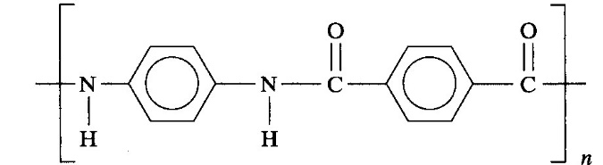
Kevlar
An older form of polymeric reinforcement is polypropylene in the form of continuous fibres for woven reinforcement cloth for unsaturated polyester and epoxy composites. Like Kevlar, this type of material has the advantage over glass in that it is of lighter weight and toughness; its strength is comparable to that of glass, but its use as a replacement for glass has not occurred. Polymer reinforcements do not machine like the glass-reinforced composites. The reinforcing fibres tend to melt in sanding and other operations. Finally, polymer reinforcements can be porous foams that can be resin impregnated. A common composite technique used in boat building is the use of layers of glass and resin separated by end-grain balsa wood that has been saturated in the matrix resin. This system produces a high section modulus and lighter weight than a solid build-up of woven glass layers. End-grain balsa is very expensive, and foamed olefins and other plastics are moulded into shapes that are used to replace the end-grain balsa.
Boron. Continuous filaments for reinforcement of composites are made by chemical vapour deposition of boron from a boron-rich gas. These boron fibre reinforcements have a higher tensile modulus than most other reinforcements, but their high cost has restricted their use to aerospace and military applications.
Carbon-Graphite. Amorphous carbon is obtained by heating organic materials, usually in the absence of air. This kind of carbon (carbon black) is used to pigment plastics and to aid in the vulcanization of rubber. The carbon fibres that are used as reinforcement in polymer composites are obtained by heating precursor fibres of organic materials to very high temperatures in the absence of air and usually under tension. The starting materials are fibres made from rayon, pitch, or polyacrylonitrile (PAN). Pyrolyzing temperatures can range from about 1093°C to as high as 2926°C. At the higher temperatures, the fibre takes on a graphitic structure. Graphite crystals have a hexagonal structure with the basal (base) plane aligned parallel to the fibre axis. When fibres have significant graphitic structure, they can have extremely high strength and modulus. The tensile modulus of elasticity (stiffness) for PAN carbon fibres can be in excess of 758000 MPa. The highest-stiffness fibres have smoother surfaces than the lower-stiffness fibres, and this means that fibres must be treated to help them bond to the polymer matrix. The lower-stiffness fibres have rougher surfaces and bond better to the matrix. For these reasons, it is common practice to use the lower-modulus fibres unless the application absolutely requires the high-modulus fibres.
Carbon fibres (CFs) are grown in diameters smaller than 5 μm. They are made into strands for weaving or winding, and they are available as chopped strand for use in injection moulding resins. The cost of these reinforcements in 2008 ranged from as low as 22$/kg, to as high as 440$/kg for the super high-modulus variety. Chopped fibres are the lowest-cost form. Carbon fibres are used where glass reinforcement will not provide the desired stiffness or weight reduction.
Carbon nanotubes (CNTs) are becoming commercially available for reinforcement in thermoplastic and thermosetting resins. A carbon nanotube is a single-atom-thick sheet of carbon atoms formed into a tube. The tubes usually are less than 10 nm in diameter, with lengths that can be hundreds of microns long. The tubes have desirable mechanical properties and are added to polymers as reinforcement There are many techniques for making CNT’s, but a good number of them involve subjecting carbonaceous gases to a plasma field, where the CNTs crystallize on silicon or other substrates. The use of these materials and other nanometre-sized reinforcements has created a category of plastics termed nanocomposites. In 2008, there were no rules on what qualifies as a nanocomposite. If nanomaterials are added to any solid, the product may be called a nanocomposite. Carbon nanotubes and the like, however, will be important composite reinforcement for the near future.
Glass. The most common reinforcement for polymer composites is glass fibres. The first important structural composites were often improperly termed Fiberglas®, which is a trade name. The acronym FRP, for fibrous-glass-reinforced plastic, was established to prevent the misuse of the Fiberglas trade name, and this acronym was replaced by RTP, for reinforced thermosetting plastic. The latest acronym to appear in the literature, RP, for reinforced plastic, is the most current.
Glass fibres are made essentially by flowing molten glass through tiny holes in dies. Two important types of glass are in wide use for reinforcements: E glass, which is a borosilicate glass named for electrical applications; and S glass (high strength), which is a magnesia/alumina/silica material with higher tensile strength than E glass. Fibre diameters usually are in the range of 5 to 25 μm). Both are used for the same types of applications, but the E glass is lower in cost; it can be fabricated at lower temperatures.
Glass reinforcements are available in every imaginable form. The most common forms of glass reinforcement are shown in Figure 45.
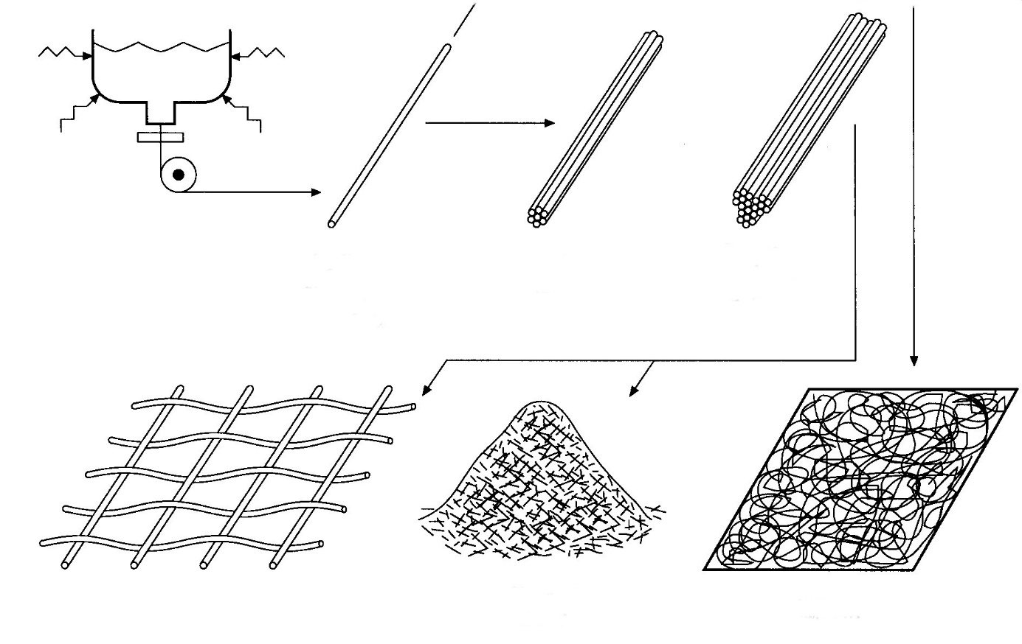
Melt
Chopped strand
Weaves
Mat (nonwoven)
Trand or tow
Rowing (called yarn when twisted)
Fiber or filament (continuous)
Figure 45. Common forms of glass fibres for composite reinforcement. [1]
Chopped strand is widely used for reinforcement of thermoplastics and for bulk moulding compounds, but the other forms typically are used in large structural composites. Strands usually consist of many individual filaments for use in filament winding or in making weaves. Woven glass reinforcements can be obtained in about as many different weaving patterns as are available in clothing. Most are two-dimensional in nature, and new weaving techniques are constantly being investigated. The use of two-dimensional weaves in laminates produces anisotropic strength characteristics. One direction will always be weaker than the others will. Making isotropic three-dimensional weaves is a current area of composite research.
Mat cloths are made from randomly intertwined discontinuous fibres of moderate length, not unlike felt. Glass fibre mats require more resin for saturation than do the weaves, but they produce a better surface texture after moulding. When bundles of strands are formed into a large, continuous strand, the product is called roving, and heavy composites are often made from cloths that are woven from roving.
The bond between the glass reinforcement and the resin matrix is an important part of making a composite that has good mechanical properties. Glasses often are treated by compounds that tend to enhance this adhesion. Silane compounds have the general formula A₃SiB, where A may be a halogen such as chlorine and B is preferably some functional group that will tend to bond to the matrix material. Essentially, the goal in using the silane coupling agents is to have a Si - O type of bond to the glass, with the other end of the molecule having an organic molecule that likes to bond to the organic resin matrix. There are other types of coupling agents in commercial use, but from the user's standpoint, this can be a design factor if the goal is a high-performance composite. In fact, coupling agents apply to other types of reinforcements as well. The reinforcement cannot distribute operating stresses and strains if it does not bond well with the matrix.

6. Composite materials production methods.
The various techniques used to reinforce resins to make a polymer-glass composite are shown in Figures 46 and 47. Contact moulding or hand layup involves coating a mould or form with a layer of resin; a layer of glass reinforcement is applied, and the reinforcement is thoroughly saturated with resin. The process is repeated until the desired composite thickness is achieved. (The maximum thickness usually is about 9 mm.) The polymer matrix typically is a polyester or epoxide.
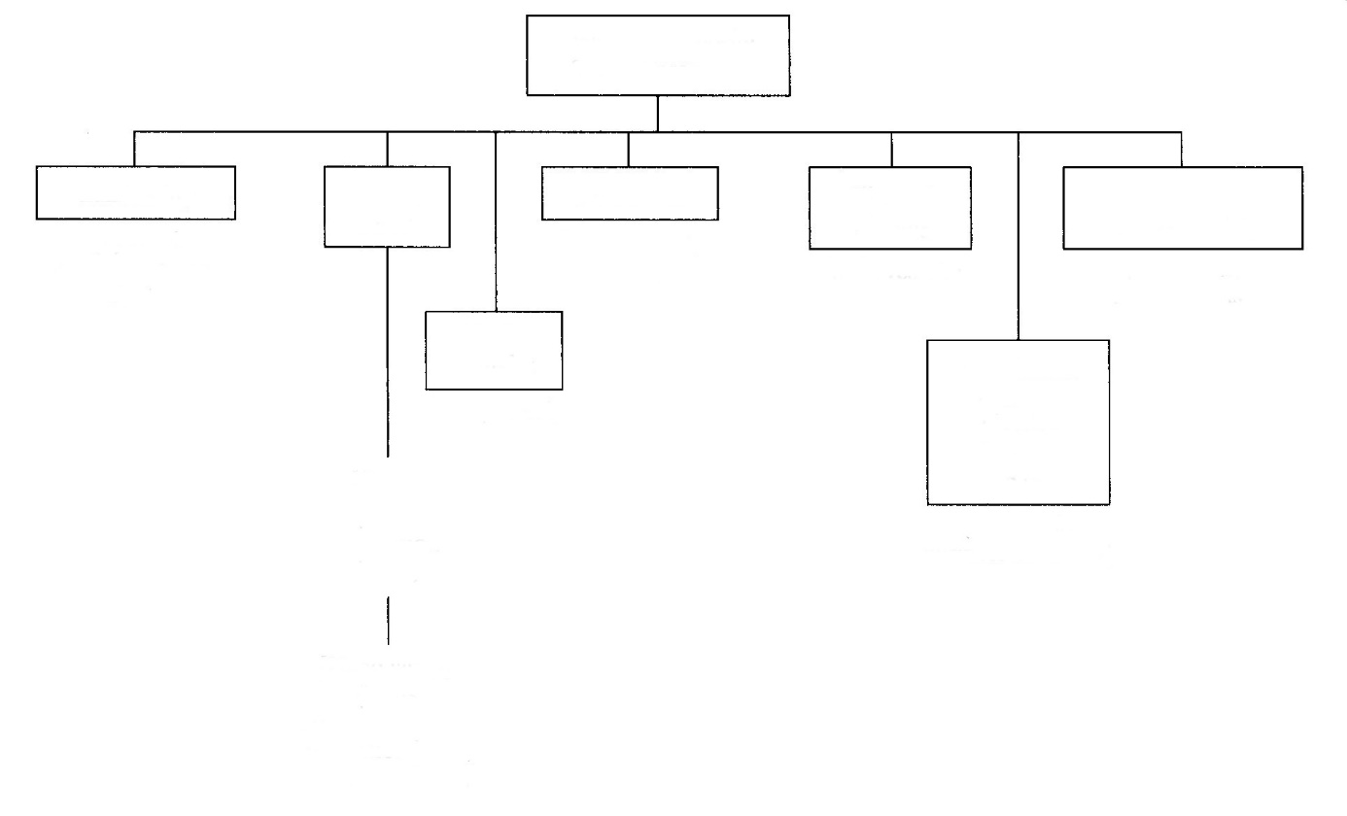
(plywood, structural members, countertops)
(grates, tubes, pipes)
(rolls, vessels)
(auto parts, smaller parts)
(auto parts, business machines)
Reinforced reaction injection moulding (RRIM)
[Hand layup]
(boats,
structural shapes,
recreation items,
large structures)
[Spray]
(boats,
recreation
items)
Resin transfer
Bulk and
sheet moulding
Filament
winding
Pultrusion
Open mould
Laminating
Polymer composite
forming processes
Figure 46. Polymer composite forming processes. [1]
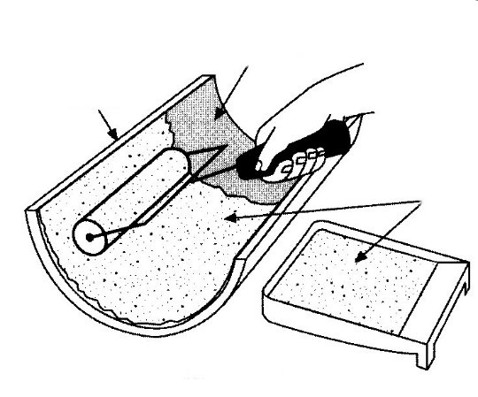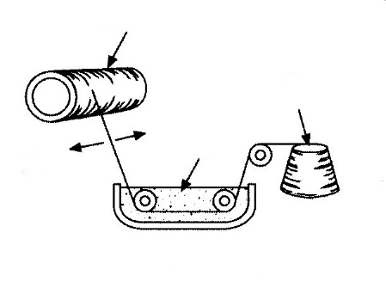
Resin
Shuttle
Filament winding
Glass
filament
Mandrel
Hand layup
Mould
Resin
Glass reinforcement
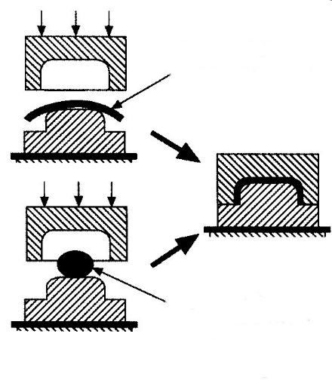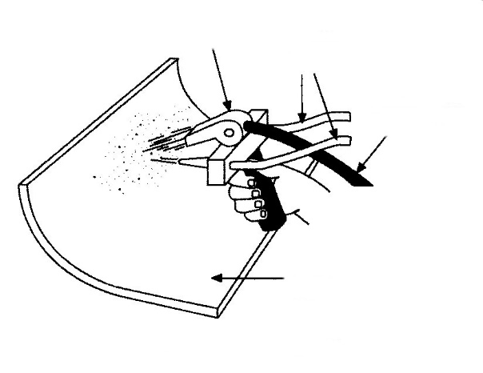
Open
form
Continuous
strand fibre
Resin
lines
Fiber chopper
Bulk moulding
compound, BMC
Sheet moulding
compound, SMC
Chopped fibre sprayer
Compression moulding
Pump
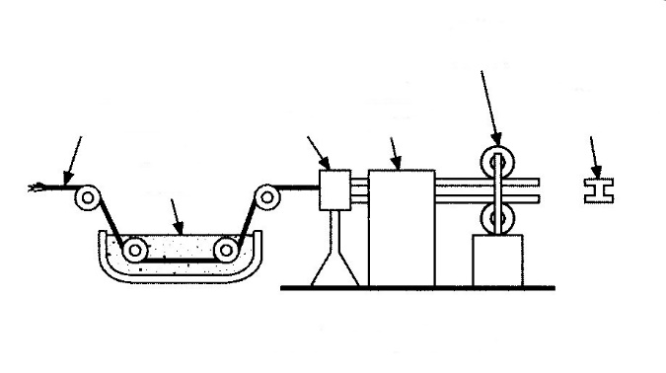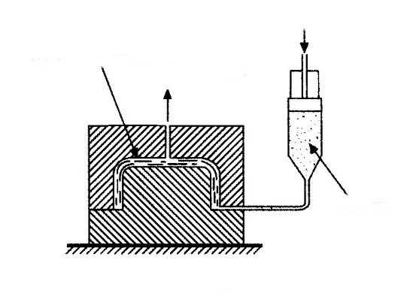
Resin transfer moulding
Continuous pultrusion
Catalyzed
resin
Vent and
vacuum
Dry
reinforcement
Typical
shape formed
Pulling
device
Curing
oven
Die
Resin
bath
Glass
reinforcement
Figure 47. Techniques for the fabrication of fibre-reinforced composites. [1]
Filament winding reinforcing uses special machines to wind the glass reinforcement around a mandrel. The reinforcement is a continuous strand, and the strand is saturated with resin in an in-line bath. The winding pattern can be varied to control the strength characteristics of the composite. This process is widely used for making pipes and tanks to handle chemicals.
Compression moulding is similar to the process described previously for unreinforced thermosets, except that special techniques are required to introduce the glass reinforcement into resins that have to be catalysed and have a limited pot life after catalyzation. In the sheet moulding process, catalysed polyester or epoxy resin is kneaded into the glass reinforcement by rollers. Special fillers are added to keep the resin from being tacky, and inhibitors are added to increase the pot life of the catalysed resin. The finished sheet, called sheet moulding compound (SMC), consists of resin and reinforcement, and this sheet can be cut to an appropriate size and pressed in a matched mould to make the finished part. The moulds are heated to complete the cross-linking of the resin.
A similar product, called bulk moulding compound (BMC), is produced by adding thickeners to the resin; it is kneaded like dough with chopped fibres to make a compression moulding charge that resembles a glob of dough. The heating and pressing are the same as in sheet moulding. Both processes can be used for large mouldings such as automobile fenders.
Continuous pultrusion is a process for making glass-reinforced shapes that can be generated by pulling resin-impregnated glass strands through a die. The glass is pulled through a resin bath; it is shaped as it goes through a heated bath, and the resin crosslinks in the heated die and combined curing section. Pipes, channels, I-beams, and similar shapes can be generated. Pultrusion structural shapes are frequently used for decking and structural members around corrosive chemical tanks.
Chopped fibre spraying performs the same job as hand layup, but it is much faster. Two component resins are mixed in a handheld gun and sprayed at a mould surface. A chopper is incorporated in the gun. It chops continuous strands of glass into short lengths to act as reinforcement in the composites. This process can be used to make large reinforced composites such as boats, shower stalls, and bathtubs. Chopped fibre reinforcements, however, are not as strong as the hand lay-ups that are reinforced with mat or woven roving.
Resin transfer moulding has evolved as a way to speed up contact and to improve the part by having two finished surfaces instead of one. This process requires a close-fitting mould. Glass reinforcement is cut and shaped to the desired thickness in the open mould. The mould is then closed and evacuated, and catalysed resin is pumped into the bottom of the mould. When the mould is filled, the pump is shut off, the resin line is stopped off, and the part is allowed to cure. This is becoming an important process for the production of large RTP boats. It is replacing hand layup.
The use of computers to control filament winding is increasing the complexity of parts that can be wound and the performance characteristics of these parts. For example, computer control can add extra layers of reinforcement or change the pattern in high-stress areas. Advanced systems couple finite-element stress analysis with reinforcement patterns.
Vacuum bag forming (Figure 48) is used to shape sheet-moulding compounds to complex shapes. This process uses atmospheric pressure to do the forming, thus eliminating the high cost of matched metal moulds. It is possible to cure the SMC in the vacuum bag rig by using temperature-resistant silicone rubbers for the forming bladder; but the more common practice is to use vacuum-bag forming to make a preform and then cure the preform in another mould.
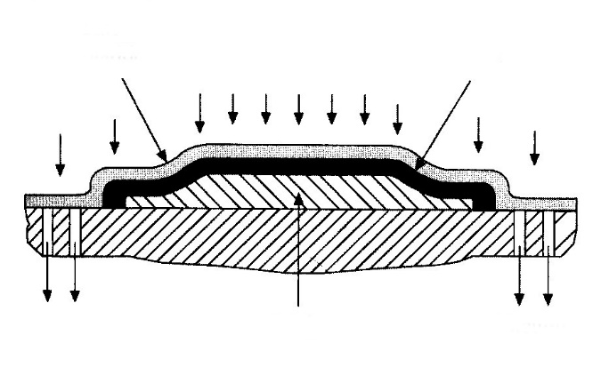
Vacuum
Vacuum
Male
mould
SMC
Rubber
bladder
Figure 48. Vacuum bag forming. [1]
The practice of reinforcing thermoplastic materials means that all the processes that use moulding pellets (injection moulding and others) can be considered composite fabrication techniques; chopped fibres and particulate reinforcements could be blended into these moulding pellets. Filament winding is also done with thermoplastics; a reinforced strip is heated, wrapped on a heated mandrel, and, subsequently, cooled. Thus, just about any thermoplastic or thermosetting plastic fabrication technique can be used to make polymer composites, but the high-performance composites are more likely to be made from thermosetting resins by one of the techniques shown in Figure 46.

7. Polymer composites application.
We have discussed what polymer composites are - plastics with some sort of reinforcement to enhance their use characteristics - and how they are formed - by a combination of some matrix and reinforcement. Further, we have described the various techniques that are used to make usable shapes out of this family of materials. In this section, we shall review some of the factors that make polymer composites important engineering materials and present guidelines to help the designer decide whether polymer composites should be considered for an application.
Availability.
Figure 49 is a partial summary of the products that are commercially available in the area of polymer composites. A glance at this illustration will indicate that many thermosetting products are available, but not too many thermoplastic products are. Essentially, the important thermoplastic polymer composites are thermoplastic moulding resins (usually in pellet form) that contain various volume fractions of reinforcements. These moulding resins are available from almost all plastic manufacturers and from many compounders, companies that blend homopolymers and reinforcements. The important reinforcements are chopped glass and graphite fibres. Volume fractions usually are less than 50%. These materials can simply be ordered from vendor's catalogues, and the vendors will supply processing details.
Thermosetting laminating resins and reinforcements probably are the most important products in the thermosetting category. If a polymer composite is under consideration for some large structure, these products will be used. The user will have to decide on a resin and reinforcement combination, and experienced fabricators can guide the new user through the selection process. Thus, from the user's standpoint, there are many possibilities for the application of polymer composites, and there are products available to make just about any type of part or structure that can tolerate the operating limits of polymer resins.
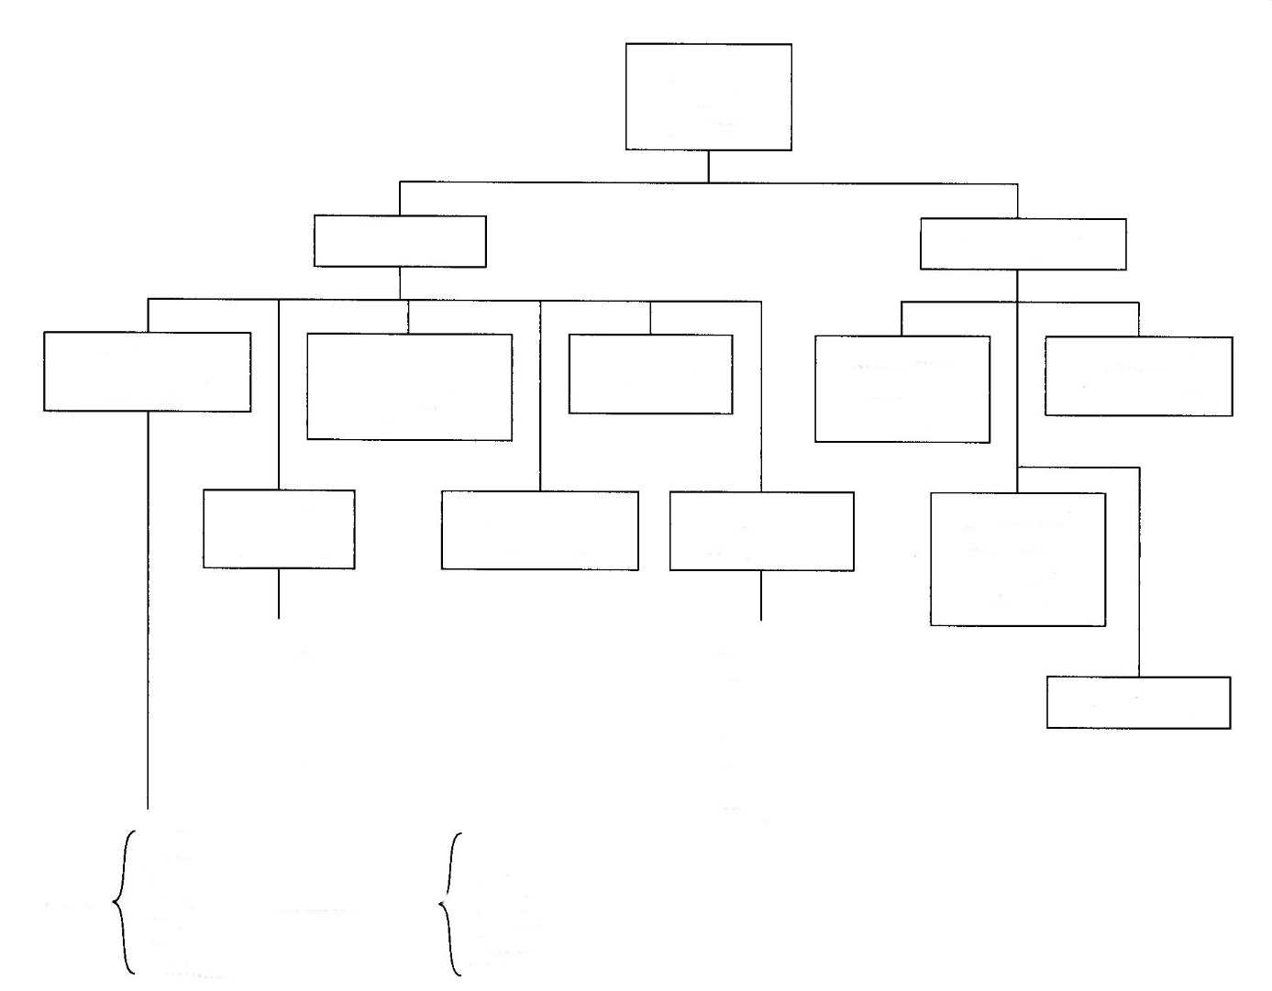
Ducts
Tanks
Pipes
Stacks
Scrubbers
Pumps
Troughs
Thermoplastic
Reinforced
tapes/fabrics
Pultruded
shapes
Bulk moulding
compounds
Laminates
FRP
components
Bulk moulding
compounds
Prepreg products products
Glass
Graphite
Boron
Aramid
Ceramics
Metals
Polyester
Epoxy
Phenolic
Vinyl ester
Silicones
Polyimides
Sheets
Tape
Roving
Fabric
Fibers
Thermoset
Reinforced solid phase moulding sheets
Sheet moulding compounds (SMC)
Reinforced moulding resins
Polymer composite products
Figure 49. Spectrum of commercially available products for forming polymer composites. [1]
Cost.
The decision to use or not to use polymer composites often depends on whether they offer some cost advantage over other candidate materials. Each potential application requires consideration of many factors, but the basic materials used in many polymer composites are low in cost. Glass reinforcements can be low in cost; chopped strand may be only 50 cents per kg; and woven cloths typically cost 2 dollars or so per kg. The high-modulus fibres are still expensive, but chopped strand graphite may cost only $50 per kg; aramid fibres can cost $550 per kg, and the ceramic and other very high modulus fibres may cost $660 per kg. Resins can be as low as $28 per kg (general-purpose polyester) or double or triple digits per pound. The cost of a planned application of polymer composites will depend on the cost of the starting materials and the fabrication costs. The use of polymer composites for a structural member often allows the user to make a structure monolithic - one part - and if the same part were made from, for example, metal, the cost comparison should include the cost of the individual parts and their assembly. The corrosion/environmental resistance of polymer composites often allows a longer service life. This is also an important cost factor to consider. In conclusion, one of the main reasons for the increasing use of polymer composites is that they are often lower in cost than metals.
Properties.
Table 4 shows some of the important mechanical properties of thermosetting polymer composites, and Table 5 presents similar data on thermoplastic composites. The former table illustrates one of the biggest reasons for using the high-performance polymer composites; they can be stronger and stiffer than high-strength metals, with a weight reduction. The thermoplastic composites do not compete with metals as well, but they fit into the niche between unrein-forced thermoplastics and the reinforced thermosets.
Table 4. Room temperature mechanical properties of polymer composites compared with high-strength lightweight metals. [1]
Mechanical Property | Boron Epoxy | S-Glass Epoxy | E-Glass Epoxy | E-Glass Polyester
Tensile strength MPa | 1365 | 1068 | 482 | 344
Tensile yield strength MPa | - | - | - | -
Compressive yield strength MPa | 1758 | 565 | 489 | 344
Shear strength MPa | 62 | - | - | -
Percent elongation | 0.7 | - | - | -
Tensile modulus MPa | 214×10³ | 44.1×10³ | 31.02×10³ | 31×10³
Density g/cm³ | 2.04 | 1.8 | 2.2 | 1.9
Mechanical Property | E-Glass  Vinyl Ester | Carbon Fibre  Epoxy (60% CF) | Titanium  6A14V | Aluminium  7075T6
Tensile strength MPa | 379 | 303 | 1000 | 538
Tensile yield strength MPa | - | - | 930 | 468
Compressive yield strength MPa | - | - | 965 | 468
Shear strength MPa | - | - | 579 | 317
Percent elongation | - | - | 6 | 5
Tensile modulus MPa | 43.4×10³ | 54.9×10³ | 110×10³ | 71.1×10³
Density g/cm³ | 1.9 | 1.59 | 4.43 | 2.8
Table 5. Room temperature mechanical properties of selected thermoplastics containing 40% chopped glass reinforcement. [1]
Property | PA 6/6 | PP | PC | PPS | PSF | PES
Tensile strength (MPa) | 220 | 110 | 145 | 138 | 131 | 159
Tensile modulus (GPa) | 13 | 9 | 11.7 | 13.8 | 11.7 | 13.8
Flexural strength (MPa) | 275 | 131 | 180 | 202 | 172 | 214
Flexural modulus (GPa) | 117 | 6.2 | 6 | 11 | 8.2 | 11
Compressive strength (MPa) | 158 | 89 | 151 | 172 | 165 | 151
Izod impact (notched) (J/m) | 138 | 106 | 116 | 74 | 85 | 80
Heat distortion temperature at 1.8 MPa (°C) | 249 | 149 | 149 | 260 | 185 | 215
Sometimes it is desired to replace a metal part with an injection-moulded plastic, but unreinforced moulding resins simply are not strong enough or stiff enough; reinforcing the thermoplastic with chopped glass or carbon fibre may raise the strength enough to allow the replacement to be made, and still maintain the economies of injection moulding.
The mechanical properties of polymer composites depend on the nature of the matrix and the reinforcement. Boron and graphite fibres produce the stiffest composites. The user must decide whether the additional cost of the high-performance reinforcements is economically important.
One of the most significant properties of polymer composites is their environmental resistance. It is beyond the scope of this discussion to present details on how each matrix resists the plethora of environments that are likely to be encountered, but corrosion handbooks are available that list this type of information. In general, reinforced thermoplastics will have corrosion characteristics similar to those of the unreinforced matrix material. Continuous reinforced thermosets are somewhat more complicated to deal with. A thermoset polymer composite designed for chemical resistance will require design of the laminate. The wetted surfaces usually are resin rich, and special woven fabrics called veils are used as the surface for improved appearance. The veil is often backed with a resin-rich mat, and, finally, the structural reinforcing scheme is determined. A new user may have to rely on fabricator's recommendations in this area. The general-purpose unsaturated polyesters (orthophthalic resins) are not particularly resistant to chemicals, and they are mostly used for structures not intended for chemical contact. Heat resin polyesters are resistant to many oxidizing media such as acids, but they are not resistant to alkaline and many solvents. They are flame retardant. Vinyl esters are probably the most popular matrix resins for chemical service, but they have a temperature limit of about 120°C. Furan matrix resins are extremely chemically resistant, but they have poorer fabricability compared with the previously mentioned matrix resins. A factor to consider in the use of unsaturated polyester composites is their susceptibility to surface degradation in sunlight, outdoors, and in water. UV and other wavelengths of light, which cause chemical reactions in polymer structures, cause photolytic decomposition. Free radicals are broken, bonds are broken, and complex chemical reactions can occur that essentially turn upper layers into a powdering substance that is eroded by weather. The manifestation is usually called "fibre bloom" (Figure 50).
Figure 50. Fibre bloom in an FRP street lamp pole after eight years outdoors. [1]
In glass-reinforced UP composites, the reinforcement starts to show and glass fibres appear in a dull roughened surface. This surface was glossy and smooth when put in service. The damage is usually only 10 μm or so per year, but after about 10 years of exposure to sunlight, the topsides of the fiberglass boats look as if they need a paint job. The damage usually is only cosmetic, but it is still undesirable. Additives are the common way of slowing this form of degradation, but they do not stop it.
Water attack of UP composites is most prevalent in boats. Water can diffuse through the gel coat and form blisters that fill with stagnant water, which increases in volume when microbiological organisms grow in it. The phenomenon is referred to as osmotic blistering - boat pox to us victims. The mechanism is not known, but the solution is to coat wetted surfaces with a barrier layer of epoxy (usually, five to seven layers of epoxy primer). The lack of a solution to osmotic blistering makes unsaturated polyester a potential problem material for boats that will remain in the water for extended periods.
As is the case with all material systems, it is the responsibility of the user to decide on the properties that are critical to an application and then match these properties to candidate materials. There are many tabulations of properties of polymer composites, but when it comes to the properties of a specific composite laminate, the user should use data on the specific composite, and not generic properties. Each composite structure can be unique; properties depend on the nature of the resin, the cure, and the reinforcement in that composite.
Applications.
Where are polymer composites used and where should they be used? Half of the total usage of composites in the United States is in the construction and transport industries. The other big users are marine, electrical, military, leisure, and industrial markets. One current big user of FRP is in the marine industry; some 90% of all non-commercial craft are made from unsaturated polyester laminates. Without a doubt, this application is the most noteworthy testimonial to the performance of these materials in highly stressed structures. FRP hulls over 25 years old have been cut up and tested for degradation of mechanical properties over this time. The changes measured were insignificant. The famous testimonial in the transportation industry is the fact that Corvette types of automobiles are still in use and still bring large resale prices after 25 years. Many other testimonials show that polymer composites are suitable for applications requiring long service lives. Many parts on current automobiles are made from reinforced composites, and more parts are converted from metals each year. In the agricultural industry, the corrosion resistance and ruggedness of composites are prompting their use for all sorts of structural parts on tractors and similar farm machinery. The appliance industry has used composites for many years for parts that see wet/chemical conditions - air-conditioner parts, dishwasher pumps, laundry tubs, and the like. Countless parts on present-day aircraft are made from composites. Polymer composites are widely used in the chemical process industries: piping, roofing, siding, silos, tanks, and all types of structures. Polymer composites currently are a hot item in the construction and housing industry in one-piece showers and tubs, saunas, spas, pools, skylights, and sinks. Finally, the leisure industry is using polymer composites, even the most advanced composites, for an amazing variety of applications. Lightweight kayaks and canoes are being made from aramid composites; tennis rackets, skis, and golf clubs are made from graphite- and even boron-reinforced composites; and off-road vehicles are invariably made from polymer composites, as are jet skis and snowmobiles. We could go on, but it should be clear that these materials are widely used and that they will be used in the future for all types of structures in all sorts of industries.
Examples of typical applications for Ultramid® in automotive engineering:
Engine and gears: inlet pipe and intake manifold, charge air end caps, charge air pipes, cylinder head cover, hood, air mass sensor, oil sump, oil filter housings, oil sensors, chain guide rails, toothed belt covers, transmission controllers, sensors, roller bearing cages, gear wheels, fastening clips
Radiator system: radiator end caps, thermostat housings, coolant pipes, fan wheels, fan frames
Fuel supply system: fuel filter housings, fuel lines, quick-action couplings
Suspension: engine bracket, torque support, torque roll restrictor, transmission cross beam, bodywork and add-on parts
Interior: pedals and pedal brackets, levers and operating elements, speaker grilles, door handles, seat structures
Exterior: structural parts, exterior door handles, mirror base, wheel covers, front end, crash absorbers, lower bumper stiffener (LBS)
Electrical system: cable harnesses, straps and connectors, lamp holders, fuse boxes, contact and brush holders, cable ducts, actuators and actuating drives.

8. Production process selection.
We have just described about 30 processes that are used to form and shape plastics and polymer composites. How does a material user pick a process to shape the plastic? The short answer is experience. Many process details must be considered to make an informed decision. We have only introduced newcomers to the more generic plastic-forming processes. We do not have space to discuss these processes in detail. Our recommendation to newcomers in the plastics field is to select a process through discussions with plastic fabricators or use a published standard if one applies (ASTM, MIL, etc.).
We did not list the universal forming process in our discussion of forming plastics and composites, but the shaping process that any user can specify is machining from a stock shape. Many thermoplastics, some thermosetting plastics, and some composites are available as stock shapes (Table 6). This may be the best forming process for prototypes and for one-of-a-kind parts. An important factor to keep in mind in using stock shapes for prototypes is that the surface properties and, possibly, the mechanical properties will be different if the part is converted to a moulding process. This is especially true for structural and wear parts. Moulded surfaces of reinforced plastic parts are resin rich; this resin-rich surface and the mould surface finish will not be present on machined parts. This could affect properties. If you want to perform simulated service tests on prototype parts, you should use moulded parts if the end part will be moulded.
Table 6. Readily available plastics
General-Purpose Plastics
Polyethylene (HD, LD, UHMW) (PE) | Polymethyl methacrylate (PMMA)
Polypropylene (PP) | Vinylidene fluoride (PVF)
Polyvinyl chloride (PVC) | Polystyrene (PS)
Polyester (PETG) | Acrylonitrile butadiene styrene (ABS)
Engineering Plastics
Nylon (PA) | Fluorocarbons (PTFE, FEP, PFA, ECTFE)
Acetal (POM) | Polyphenylene oxide (PPO)
Polycarbonate (PC) | Polyetherether ketone (PEEK)
Polyimide (PI) | Polysulfone (PS)
Polyamide- imide (PAI)
Polyphenylene sulphide (PPS)
Phenolic (PF)
Casting Resins
Polyester (UP) | Silicone (SI)
Epoxy (EP) | Polyurethane (PUR
The factors that pertain to selection of forming processes other than machining are illustrated in Figure 51. [1]
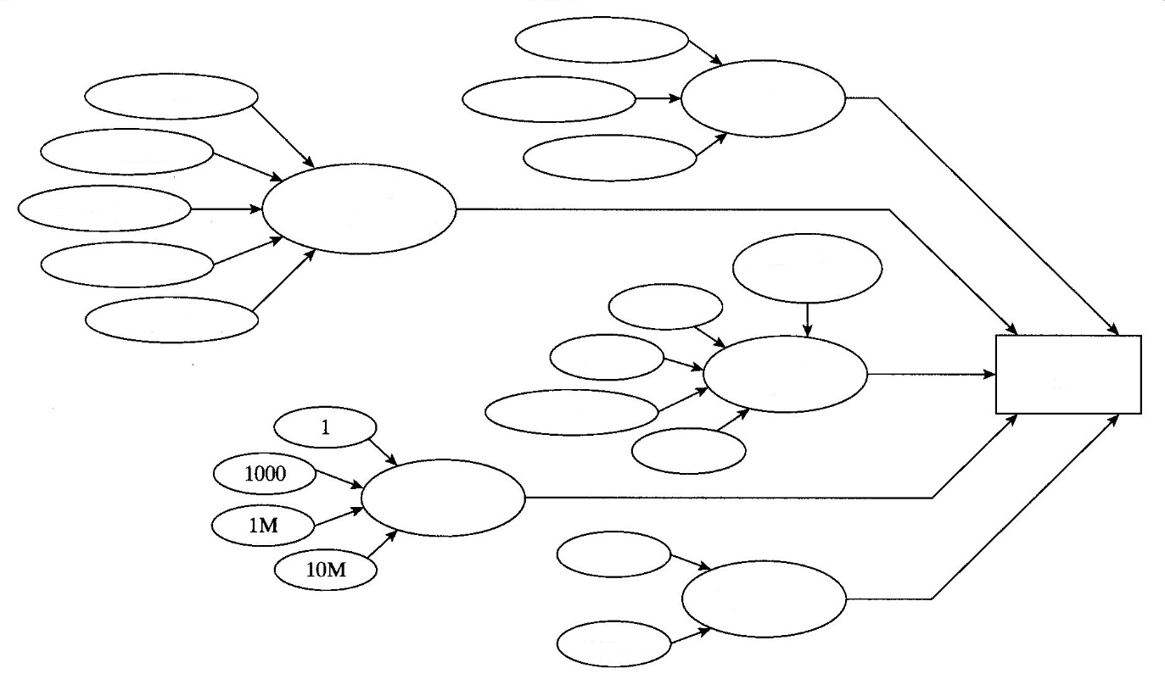
Part
shape/size
Quantity
Quantity
Quantity
Type of
plastic/composite
Paintability
Thermoset
Thermoplastic
Recyclability
Composite
Process
specification
Dimensional
accuracy
Big
Small
Huge
Complicated
Part
shape/size
Vendor
In-house
Equipment
availability
Quantity
Figure 51. Considerations in plastic process specification. [1]
This looks very complicated; it is. It is very difficult to specify a forming process for plastic and polymer composite parts. The first step is to decide on the type of plastic that meets your property needs. The part size, shape, cost, and quantity often determine the specific process or at least narrow the process selection to a very few candidates. For example, if you are making one 5000-liter vessel, you immediately limit process selection to the few processes that can be .used for big hollow containers (resin transfer of RTP, hand layup of RTP). If you are designing an automotive part, you may need a high-production process such as injection moulding. Here are some process selection considerations that apply to all plastics:
- Chopped fibre and particulate reinforcements reduce injection mouldability.
- Continuous reinforcement requires the use of thermoset and composite processes.
- Moulded surfaces may have different properties than bulk material has.
- Moulded surfaces can contain cosmetic challenges (knit lines, porosity, fibre bloom, etc.).
- Moulded surfaces take on the surface texture of the mould surface (including defects).
- Properties can be affected by fabrication process; if properties are very important, the fabrication
process must be thoroughly specified.
- Moulding resins often require pre-treatment, such as drying, before they are used. These needs add cost, which should be considered.
- Wherever possible, use consensus or published standards for the forming process.
- Consider the recyclability and disposal of the process scrap.
Essentially the only polymer forming process that can be easily specified is machining. All of the others probably need specification of the process details. Most companies in the United States specify the material for plastic parts by generic material and trade name, and then list a process specification that covers process details:
Material: High-impact polystyrene (Grade A, 300 Ajax Corp., or Sanyu, Vespil Corp.) See process specification X457 for moulding details.
The drawing should show approved suppliers if the part is to be made by an outside vendor. Invariably, plastic fabricators will have documented process specifications for every plastic that they work with. Consistently reliable plastic parts require detailed process specifications (moulding temperature, pressure, drying, dwell time, mould release, gating, runnering, venting, mould preheat, etc.). Process details affect use properties in plastics more than they do in metals and some other material systems.

9. Composites machining
Drilling
Hole drilling in composite materials is different from drilling holes in metal aircraft structures. Different types of drill bits, higher speeds, and lower feeds are required to drill precision holes. Structures made from carbon fibre and epoxy resin are very hard and abrasive, requiring special flat flute drills or similar four-flute drills. Aramid fibre (Kevlar®)/epoxy composites are not as hard as carbon but are difficult to drill unless special cutters are used because the fibres tend to fray or shred unless they are cut clean while embedded in the epoxy. Special drill bits with clothes pin points and fishtail points have been developed that slice the fibres prior to pulling them out of the drilled hole. If the Kevlar®/epoxy part is sandwiched between two metal parts, standard twist drills can be used.
Equipment
Air-driven tools are used for drilling holes in composite materials. Drill motors with free speed of up to 20,000 rpm are used. A general rule for drilling composites is to use high speed and a low feed rate (pressure). Drilling equipment with a power feed control produces better hole quality than drill motors without power feed control. Drill guides are recommended, especially for thicker laminates.
Do not use standard twist drill bits for drilling composite structures. Standard high-speed steel is unacceptable, because it dulls immediately, generates excessive heat, and causes ply delamination, fibre tear-out, and unacceptable hole quality.
Drill bits used for carbon fibre and fiberglass are made from diamond-coated material or solid carbide because the fibres are so hard that standard high-speed steel (HSS) drill bits do not last long. Typically, twist drills are used, but brad point drills are also available. The Kevlar® fibres are not as hard as carbon, and standard HSS drill bits can be used. The hole quality can be poor if standard drill bits are used and the preferred drill style is the sickle-shaped Klenk drill. This drill first pulls on the fibres and then shears them, which results in a better quality hole. Larger holes can be cut with diamond-coated hole saws or fly cutters, but only use fly cutters in a drill press, and not in a drill motor.
Figure 52. Klenk-type drill for drilling Kevlar® [8].
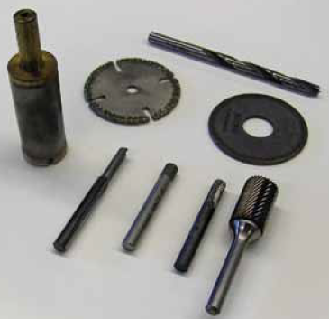
Figure 53. Drilling and cutting tools for composite materials [8].
Processes and Precautions
Composite materials are drilled with drill motors operating between 2,000 and 20,000 rpm and a low feed rate. Drill motors with a hydraulic dash pod or other type of feed control are preferred because they restrict the surging of the drill as it exits the composite materials. This reduces breakout damage and delaminations. Parts made from tape products are especially susceptible to breakout damage; parts made from fabric material have experienced less damage. The composite structure needs to be backed with a metal plate or sheet to avoid breakout. Holes in composite structures are often predrilled with a small pilot hole, enlarged with a diamond-coated or carbide drill bit and reamed with a carbide reamer to final hole size.
Back counterboring is a condition that can occur when carbon/epoxy parts mate metal substructure parts. The back edge of the hole in the carbon/epoxy part can be eroded or radiused by metal chips being pulled through the composite. The condition is more prevalent when there are gaps between the parts or when the metal debris is stringy rather than small chips. Back counterboring can be minimized or eliminated by changing feeds and speeds, cutter geometry, better part clamp-up adding a final ream pass, using a peck drill, or combination of these.
When drilling combinations of composite parts with metal parts, the metal parts may govern the drilling speed. For example, even though titanium is compatible with carbon/ epoxy material from a corrosion perspective, lower drilling speeds are required in order to ensure no metallurgical damage occurs to the titanium. Titanium is drilled with low speed and high feed. Drill bits suitable for titanium might not be suitable for carbon or fiberglass. Drill bits that are used for drilling titanium are often made from cobalt-vanadium; drill bits used for carbon fibre are made from carbide or are diamond coated to increase drill life and to produce an accurate hole. Small-diameter high-speed steel (HSS) drill bits, such as No. 40 drill, which are used to manually drill pilot holes, are typically used because carbide drills are relatively brittle and are easily broken. The relatively low cost of these small HSS drill bits offsets the limited life expectancy. High-speed steel drill bits may last for only one hole.
The most common problem with carbide cutters used in hand drill operations is handling damage (chipped edges) to the cutters. A sharp drill with a slow constant feed can produce a 0.1 mm (0.004-inch) tolerance hole through carbon/epoxy plus thin aluminium, especially if a drill guide is used. With hard tooling, tighter tolerances can be maintained. When the structure under the carbon/epoxy is titanium, drills can pull titanium chips through the carbon/epoxy and enlarge the hole. In this case, a final ream operation may be required to hold tight hole tolerances. Carbide reamers are needed for holes through carbon/epoxy composite structure. In addition, the exit end of the hole needs good support to prevent splintering and delaminations when the reamer removes more than about 0.13 mm (0.005-inch) on the diameter. The support can be the substructure or a board held firmly against the back surface. Typical reaming speeds are about one-half of the drilling speed.
Cutting fluids are not normally used or recommended for drilling thin (less than 6.3 mm, or 0.25-inch thick) carbon/ epoxy structure. It is good practice to use a vacuum while drilling in composite materials to avoid that carbon dust freely floats around the work area.
Countersinking
Countersinking a composite structure is required when flush head fasteners are to be installed in the assembly. For metallic structures, a 100° included angle shear or tension head fastener has been the typical approach. In composite structures, two types of fastener are commonly used: a 100° included angle tension head fastener or a 130° included angle head fastener. The advantage of the 130° head is that the fastener head can have about the same diameter as a tension head 100° fastener with the head depth of a shear-type head 100° fastener. For seating flush fasteners in composite parts, it is recommended that the countersink cutters be designed to produce a controlled radius between the hole and the countersink to accommodate the head-to-shank fillet radius on the fasteners. In addition, a chamfer operation or a washer may be required to provide proper clearance for protruding head fastener head-to-shank radii. Whichever head style is used, a matching countersink/chamfer must be prepared in the composite structure.
Carbide cutters are used for producing a countersink in carbon/epoxy structure. These countersink cutters usually have straight flutes similar to those used on metals. For Kevlar® fibre/epoxy composites, S-shaped positive rake cutting flutes are used. If straight-fluted countersink cutters are used, a special thick tape can be applied to the surface to allow for a clean cutting of the Kevlar® fibres, but this is not as effective as the S-shaped fluted cutters. Use of a piloted countersink cutter is recommended because it ensures better concentricity between the hole and the countersink and decreases the possibility of gaps under the fasteners due to misalignment or delaminations of the part.
Use a microstop countersink gauge to produce consistent countersink wells. Do not countersink through more than 70 percent of the skin depth because a deeper countersink well reduces material strength. When a piloted countersink cutter is used, the pilot must be periodically checked for wear, as wear can cause reduction of concentricity between the hole and countersink. This is especially true for countersink cutters with only one cutting edge. For piloted countersink cutters, position the pilot in the hole and bring the cutter to full rpm before beginning to feed the cutter into the hole and preparing the countersink. If the cutter is in contact with the composite before triggering the drill motor, you may get splintering.
Cutting Processes and Precautions
The general rule for cutting composites is high speed and slow feed.
Carbon fibre reinforced plastics: Carbon fibre is very hard and quickly wears out high speed steel cutters. For most trimming and cutting tasks, diamond grit cutters are best. Aluminium-oxide or silicon-carbide sandpaper or cloth is used for sanding. Silicon-carbide lasts longer then aluminium-oxide. Router bits can also be made from solid carbide or diamond coated.
Glass fibre reinforced plastics: Glass fibres, like carbon, are very hard and quickly wear out high-speed steel cutters. Fiberglass is drilled with the same type and material drill bits as carbon fibre.
Aramid (Kevlar®) fibre-reinforced plastics: Aramid fibre is not as hard as carbon and glass fibre, and cutters made from high-speed steel can be used. To prevent loose fibres at the edge of aramid composites, hold the part and then cut with a shearing action. Aramid composites need to be supported with a plastic backup plate. The aramid and backup plate are cut through at the same time. Aramid fibres are best cut by being held in tension and then sheared. There are specially shaped cutters that pull on the fibres and then shear them. When using scissors to cut aramid fabric or prepreg, they must have a shearing edge on one blade and a serrated or grooved surface on the other. These serrations hold the material from slipping. Sharp blades should always be used as they minimize fibre damage. Always clean the scissor serrations immediately after use so the uncured resin does not ruin the scissors.
Always use safety glasses and other protective equipment when using tools and equipment.
Cutting Equipment
The bandsaw is the equipment that is most often used in a repair shop for cutting composite materials. A toothless carbide or diamond-coated saw blade is recommended. A typical saw blade with teeth does not last long if carbon fibre or fiberglass is cut. Air-driven hand tools, such as routers, sabre saws, die grinders, and cut-off wheels can be used to trim composite parts. Carbide or diamond-coated cutting tools produce a better finish and they last much longer. Specialized shops have ultrasonic, waterjet, and laser cutters. These types of equipment are numerical controlled (NC) and produce superior edge and hole quality. A waterjet cutter cannot be used for honeycomb structure because it introduces water in the part. Do not cut anything else on equipment that is used for composites because other materials can contaminate the composite material.
Prepreg materials can be cut with a CNC Gerber table. The use of this equipment speeds up the cutting process and optimizes the use of the material. Design software is available that calculates how to cut plies for complex shapes.

10. Summary
This paper has intended to show how plastics and composites are fabricated into shapes. The following are some parting thoughts on subjects considered:
- Injection moulding requires significant equipment (moulding machine and moulds) and long lead times to make tools.
- Thermoforming is one of the lowest-cost forming processes, from the standpoint of tools and equipment.
- Adding chopped fibre reinforcement to thermoplastics can have a significant effect on mouldability.
- Free-form prototyping processes are powerful tools for conceptualizing designs.
- The scrap from thermoset forming processes is not recyclable.
- Foaming is an excellent tool for reducing material costs.
- Moulded surfaces may contain cosmetic defects that must be dealt with by painting and other extra-cost techniques.
- Casting often is a low-cost fabrication process for limited numbers of parts.
- Vulcanizing usually is the process of choice for rubbers, but some rubbers (e.g., thermoplastic elastomers, or TPEs) are injection mouldable.
- Aramid reinforcement usually produces the highest tensile properties in a composite; boron
and graphite produce the stiffest composites.
- Continuous composite reinforcing usually requires design (reinforcement loading, direction, layers, matrix resin, etc.).
- Glass and polyester are the lowest-cost thermoset composites, followed by glass and epoxy.
Aramid and carbon reinforced composites are considerably more expensive.
- Reinforced composites can be abrasive to tools used in postforming operations.
- Government building codes may be applicable to large composite structures such as tanks and piping.
- Safety factors on composite structural members often are higher than those for traditional building materials. Safety factors can be as high as 10 in tension and 5 in buckling.
- It is common practice to specify non-destructive testing of large composite structures in order to ensure their integrity.
- Reinforcing of thermoplastics can affect their recyclability.
- Moulding processes for recyclable plastics should include accommodations for SPI or other recycling codes.
Overall, forming of plastics into shapes is more "net shape" than for other materials. Hardly any metals can be formed into a finished part with absolutely no secondary operations. This is not the case with mouldable plastics. Most are formed to final shape in one of the processes described in this chapter. However, to obtain parts that are usable as formed, it is necessary to be meticulous in process specification and control. We conclude this chapter with an admonition to the designer investigate plastic fabrication processes thoroughly before committing to a process. We have seen costs on injection moulded parts go awry when the parts had to be painted to hide flow lines. Make sure that a fabrication process gives you the properties that you need.

11. Sources
[1] Engineering Materials: Properties and Selection. Ninth Edition. Kenneth G. Budinski, Michael K. Budinski. 2010, Pearson Education, Inc., 774 pages.
[2] Modern Materials and Manufacturing Processes. Third Edition. R. Gregg Bruce … [et al.]. 2004, Pearson Education, Inc., 468 pages.
[3] Engineering Materials in Mechanical Design. Principles of Selection with Q&A. Sujeet K. Sinha. 2010, Research Publishing Services, 267 pages.
[4] A. Baker , S. Dutton , D. Kelly. Composite Materials for Aircraft Structures, Second Edition (AIAA Education) 2nd Edition., 602 pages.
[5] BASF, http://www.standort-ludwigshafen.basf.de/group/corporate/site-ludwigshafen/en/general-info:/Brand+Ultramid.
[6] https://wikicourses.wikispaces.com/Composite+materials+essay+(HW+2)
[7] http://www.aeronautics.nasa.gov/pdf/composites_k-12.pdf
[8]http://www.faa.gov/regulations_policies/handbooks_manuals/aircraft/amt_airframe_handbook/media/ama_ch07.pdf
[9] Tools for Machining Composite Materials. http://www.iscar.com/newarticles.aspx/countryid/1/newarticleid/1588

