Machine Vision assessment paper

Name and surname: ____________________________ Date: _____________________
Ʃ 100 points
Points:

Written test
Ʃ 10 points

Learning outcome 1 (execusion): Explain the relationship and impact of parameters on the digital image (10 points)
- Camera has lens Focal length 8 mm and observing part of the object is 12 mm x 12 mm. At which the working distance we have to mounting the camera?
1 point

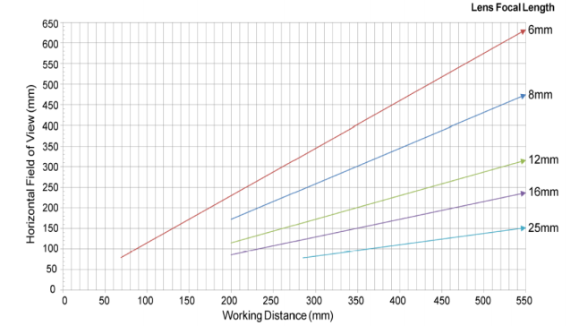
Source: Cognex installation manual

1 point
- Distance between the camera and subject is 220 mm, lens Focal length is 6 mm. Specify the horizontal Field of View (mm).

- Camera has resolution 800 x 600 mm and working distance 400 mm. Observing object has hole with diameter 4 mm. How many pixels are on the length of diameter?
1 point

1 point
- What is the minimum number of frame rate if the maximum time of image processing is 50 ms?

- Name at least two software tools for the part location?
1 point

- Name at least two software tools for the geometry recognition?
1 point

1 point
- Name at least two software tools for the Feature comparison.

Oral test

1 point
- Explain your choice of software tools for coins value recognition.

1 point
- Explain your choice of software tools for damage coins recognition.

1 point
- Explain the system settings you choice to identify unsuitable currency (kuna).

Practical exercise
Using Machine Vision as a tool for identifying coins. The machine vision system will identify coins on the basis of their characteristics such as diameter, edge width, currency (€, kuna) … Each candidate will have to define the basic feature of the object, camera settings, lens and recognition of a foreign object (unsuitable coin, token).
Ʃ20 points

Learning outcome 2 (execusion): Prepare imaging environment and set lighting

- The candidate suggested or chose the appropriate lens.
2 points

- The candidate set the camera properly according to the camera-to-object distance.
2 points

- The candidate set suitable lighting settings according to the measured object.
2 points

- The candidate selected a suitable feature of the object for ligthing the object.
2 points

- The system recognizes the value of the coin according to the currency.
2 points

- The candidate selected a suitable feature of the object to recognize the value of the coin.

2 points

- The system recognizes a foreign object (foreign currency, token ... ).
2 points

2 points
- The candidate selected a suitable feature of the object for recognizing a foreign object.

2 points
- The system recognizes a damaged coin edge.

- The candidate selected a suitable feature of the object for recognizing a damaged coin edge.

2 points

Learning outcome 3 (planning): Choose an optimum camera and lens
5 points

The candidate explains the choice of lens and camera.

Learning outcome 4 (execusion): Connect camera with PLC and create inspection program
Ʃ20 points

10 points

- The connection between PLC and camera is working.

The pre-prepared programme on the PLS responds appropriately.
10 points

Learning outcome 4 (documentation): Connect camera with PLC and create inspection program
5 points

Picture of suitable object | Picture of unsuitable object

Based on taken photos, the candidate explains why the system recognized a particular object as suitable/unsuitable.
____________________________________________________________________________________________________________________________________________________________________________________________________________________________________________________________________________________________________________________________________________________________________________________________________________________________________________________________________________________________________________

Learning outcome 5 (execusion and documentation): Measure and take a test on the operation of the machine
20 points
Test system operation on a sample of 50 objects/coins. Explain the results.

________________________________________________________________________________________________________________________________________________________________________________________________________________________________________________________________________________________________________________________________________________________________________________________________________________________________________________________________________________________________________________________________________________________________________________________________________________________________________________________________________________________________________________________________________________________________________________________________________________________________________________________________________________________________________________________________________________________________________________________________________________________
Learning outcome 4 (planning): Connect camera with PLC and create inspection program
5 points
The candidate planned the software on the camera properly.

Learning outcome 5 (presentation): Measure and take a test on the operation of the machine

15 points
The candidate demonstrates and discusses the operation of the system.

