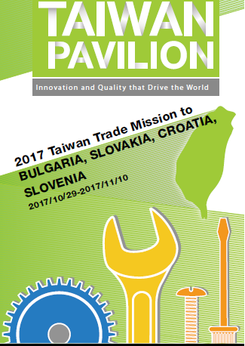
B2B srečanja s tajvanskimi podjetji
Ljubljana, 8. november 2017
SEZNAM TAJVANSKIH PODJETIJ (po abecednem redu, v angleškem jeziku)

No. | Company  Representative | Products
 | AEDICE CO., LTD.  Vincent Tsai, Sales Engineer Manager | Plastic Injection Molding machine, Plastic Injection Mold
 | AMBITION WORLDWIDE CO.  Karis Chang, Sales Director | Fitness & Wellness
 | ANSEN QUARTZ CO., LTD.  Irene Wen, Section Manager | Quartz Crystal, Oscillator
 | A-SONIC INTERNATIONAL CO., LTD  Erwin, CEO | Motor, Bench grinder, Drilling machine, Hand tools, PVC HOSE
 | CHANG YUE INDUSTRIAL CORP.  Chloe Su, Sales | Food dehydrator, Chicken rotisserie, Steamer, Yogurt maker, Coffee roaster
 | CHEN KONG TRADING CO., LTD.  Ching Chun Yeu, President | Slitter machine, Cut to length and accessories
 | CHUN YU WORKS & CO., LTD.  Arthur Wu, Sales Manager | Fasteners
 | CIU CO., LTD.  Amanda Wu, Sales Manager | Industrial inspection camera, Encrypted communication, RF detector
 | FSP TECHNOLOGY.INC  Arthur Chen, Product Director | PSU, UPS, Adapter, Open frame, LED
 | HO YU TEXTILE CO., LTD.  Charles Jwo, VP Marketing | Fabrics for Outdoor Apparel, Backpack, Luggage, Inflatable Life Jacket, Raft, Medical Inflatable Mattress, Transfer Sheet, Sling
 | JAI YANG CO., LTD.  Lonita Wang, General Manager | Metal turning parts, Auto parts, Motorcycle spare parts
 | OMA LIGHTING CO., LTD.  George Shen, Sales Manager | LED smart/connected street light, CMS platform, Gateway and control node
 | PACIFIC CYCLES INC  George Lin, President | Bicycles
 | PATTA INTERNATIONAL LIMITED.  Yu-Ning Huang, Sales Representative | Screws, Blind Rivets, Tools.
 | REDSKY INTERNATIONAL CO., LTD.  Lisa Chiang, Sales Manager | Bicycle Parts & Accessories, Outdoor Accessories, Various CNC Parts
 | ROUND LIGHT INDUSTRY CO., LTD.  Jason Lu, Sales Representative | Hand tools and hardware
 | SKYLINE METALWORKS GROUP LIMIT  Amy Yeh, General Manager | Custom design parts, Blade and knives for outdoor and scuba-diving, Kevlar scissors, Fishing line scissors, Ceramic knives
 | SOLEN ELECTRIC CO., LTD.  Yeh, Ching-Chuan, CEO and Chairman / Yang, Yung-Hsu, General Manager /Stan H.Y. SHU, Manager | Solenoid, Solenoid Valve (Pneumatic & Fluid), Magnetic Clutch, Motor (Stepper, Mini, Brushless) &Unit Assembly
 | SOLID GOLD HARDWARE CORPORATION  Louisa Liu, General Manager | Building Hardware, Locks, Fasteners
 | TEAM TEMA LTD.  Shu-Ling Liao, Manager | Industry Parts
 | TRISCO TECHNOLOGY CORPORATION  Emily Chen, Sales Manager | Automotive Testers
 | UMC-UNITED MATALS CO.  Kevin Lin, General Manager | Shaft, High alloy product

