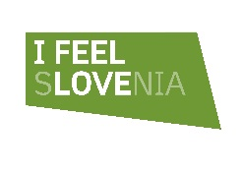
Vladno gospodarska delegacija v Združene arabske emirate
Dubaj, 20.-23. september 2016
PRIJAVNI OBRAZEC

Prosimo, da skrbno izpolnite prijavni obrazec za udeležbo vašega podjetja v delegaciji. Podatki bodo osnova za organizacijo b2b srečanj v okviru programa obiska. Podatke navedite v angleškem jeziku.

Company Name
Web | www.
Representative Name, Family Name
Position in the Company
Phone | +386
Email
Sector  Industrial/service sector your company belongs to: | - ICT  - energy  - electro industry  - interior design products and services  - food processing industry  - tourism
Company Description
This section will be forwarded to Dubai based companies to introduce who you are, what you do, and your specialty
Target companies for B2B meetings
In this section, please clarify the target sectors/industries you wish to meet with, and the typical companies that would benefit from the services/products you are offering. If you have specific names of companies you wish to meet with, please indicate them so we approach them
Type of Investment Partnership Sought
Investment value

Prosimo navedite podatke o predstavniku vašega podjetja, ki se bo delegacije udeležil.

Company REPRESENTATIVE:
Name, Family Name:
Position in the Company:
Representative’s e mail ID:
GSM: | +386

Datum in kraj prijave:

Podpis in žig odgovorne osebe:

