Viscose fibres – a way to design paper properties?

F.Weber^{1,2} ; R.Schennach^{1,2}; R.Eckhart³

¹CD-Laboratory for Surface Chemical and Physical Fundamentals of Paper Strength
²Institute of Solid State Physics, Graz University of Technology, Graz (A)
³Institute for Paper, Pulp and Fibre Technology, Graz University of Technology, Graz (A)

Abstract
Beginning already in 2009 the Institute for Paper, Pulp and Fibre Technology started to investigate viscose fibres and their influence on paper properties. This was done in cooperation with the specialty viscose fiber producer Kelheim Fibres.
The ‚CD-Laboratory for Surface Chemical and Physical Fundamentals of Paper Strength’ is focused on the bonding mechanisms of paper fibres to get a better understanding of paper strength and therefore to improve paper properties.
By the end of 2010 these two research areas merged by forming a new Module within the CD-Laboratory having two objectives, to investigate the effects of viscose fibres in paper products on the one hand and to get a better understanding of the bonding mechanism using the highly defined viscose fibres on the other.

Viscose fibres are synthetic fibres made of cellulose and Kelheim Fibres can provide them with defined dimensions and differing cross sections (Fig. 1). Furthermore it is possible to incorporate additives and thereby induce surface charges to the fibres. Thereby these fibres give the opportunity to change specific properties of paper such as water retention value, tear resistance or breaking length.

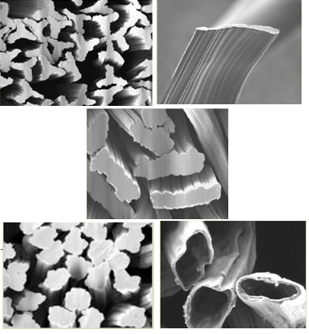
Figure 1: The viscose fibre varieties produced by Kelheim Fibres. The standard textile fibre in the lower left corner, a Y-shaped fibre in the upper left, a circular hollow fibre (similar to native pulp fibres) in the lower right corner and two flat fibre products (width to thickness 1:4 in the middle, 1:20 in the upper right corner).

Introduction

The idea to use regenerated cellulose fibres to improve or design paper properties is nothing new, several groups have investigated the potential improvement by means of mixing viscose fibers and wood pulp in the past [1], [2], [3]. The addition of viscose fibres gives a sheet with improved dewatering ability, decreased density, increased tear strength but in most cases, decreased tensile strength due to the rather low bonding ability. To overcome this drawback we try to take a closer look at the bonding of viscose fibres
Paper made of standard, round viscose fibres turns out to give a weak and fluffy sheet with low inter-fibre-bonding. The fibres of circular cross section are rather rigid and hard to bring into close contact during drying. One way to increase the bonding ability of viscose fibres are different cross sections. As an example it is shown that pure viscose paper sheets can be formed with flat fibres. The better bonding behaviour results from a greater bonding area and a higher conformability compared to circular fibres. Besides the bonding area, parameters like the surface chemical composition and the swelling behaviour are expected to have a considerable effect on the bond-strength. The work presented in this paper takes a closer look at these parameters based on circular standard viscose fibres.
An interesting feature of viscose fibres is the possibility to modify the fibres using additives, during the spinning process. Anionic as well as cationic modifications are possible. The incorporation of additives can lead to a higher water absorptive capacity and as is shown in the following is a way to enhance the bonding forces between two viscose fibres. In these tests fibres with different amounts of incorporated Carboxymethylcellulose (CMC) were investigated, because the addition of CMC is known to enhance paper strength, leads to stronger swelling and additional surface charges are induced [4]. In comparison to the anionic-CMC-treated fibre, a cationic fibre will be tested as well. The mechanism, why or in which way charges improve the fibre-fibre-bonding shall be investigated. On the one hand stronger swelling leads to a larger bonding area during the drying process. On the other hand, surface charges are also important in fibre-fibre bonding. The question is, if the induced surface charge or the greater swelling of the fibre make a greater contribution to the enhanced fibre-fibre-bond.
Fourier Transform Infrared Spectroscopy (FTIR) is used to visualize and to determine the amount of CMC on the fibre surface. The swelling behaviour of the different viscose fibres is studied via light microscopy and ESEM investigations.

Methods and Materials

Four different kinds of viscose fibres were investigated: A standard round viscose fibre without any additives, a cationic fibre (Deep Dye 15) and two anionic fibres (Verdi20 – 16.7% CMC and Verdi 40 – 28.6% CMC) with different amounts of CMC. Having the same cross section (see Fig. 1, circular cross section) and coarseness (dTex 1.7), these fibres only differ in surface charge and or swelling behaviour.
As a first step we tried to determine the amount of CMC located on the fibre surface. Infrared spectroscopy is a method to investigate surface species on thin films or paper. For this reason IR- ATR spectra of Verdi 00 -, Verdi 20 - and Verdi 40 – paper sheets were measured (Fig. 2). Verdi 00 matches with the standard round viscose fibre and contains no CMC. All corresponding CMC peaks are growing with the content of CMC. For these spectra, paper sheets of pure viscose were used. Although the measurement is not entirely restricted on CMC on the fibre surface as at least some CMC in the bulk might contribute to the result of the measurement, it does seem to be a useful tool to quantify the amount of additives on the fibre surface.

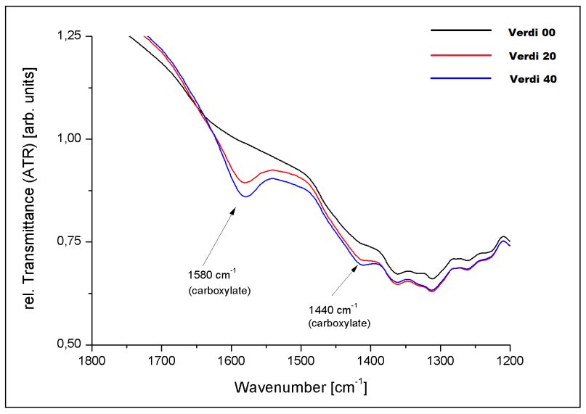
Figure 2: IR-spectra of Verdi 00, Verdi 20 and Verdi 40

In addition to the studies of the amount of CMC via IR, the swelling of the fibres with different amount of CMC and of the cationic fibre were investigated by means of light microscopy. The fibre was fixed to a glass slide by superglue. Thereby it was possible to investigate the same fibre in dry and wet state and the fibre was allowed to stretch during wetting. The fibre width was verified every 2-3 min. After 20 min the width was verified every 5 min and the last 3 data points were taken at min 45, 60 and 75. The average width of two measurement points was taken and used as swelling width. In addition to the investigation of the swelling behaviour via light microscopy, the results were verified by Environmental Scanning Electron Microscopy (ESEM) as well.
To determine the corresponding tensile strength of paper formed of these 4 fibre varieties, conventional laboratory sheets were formed on a Rapid Köthen Sheet Former.

Results and Discussion

As was already described, FTIR could be an easy and fast tool to determine the amount of CMC on the fibre surface in a non destructive way.
The swelling behaviour was investigated by light microscopy as well as via ESEM. As it is shown in Fig.3 we have investigated 10 fibres of each fibre type via light microscopy. The gray columns represent the average swelling of each fibre, determined by two measurement points. One fibre of each fibre type was investigated by ESEM (blue column).
The green columns represent the average swelling of each fibre type without the ESEM data. As is evident both measurement methods give comparable results. We see an increase in fibre width of 34.5% for class Viscose and for Deep Dye 15. Verdi 20 shows an increase of 45.9% and Verdi 40 of 55.6%.
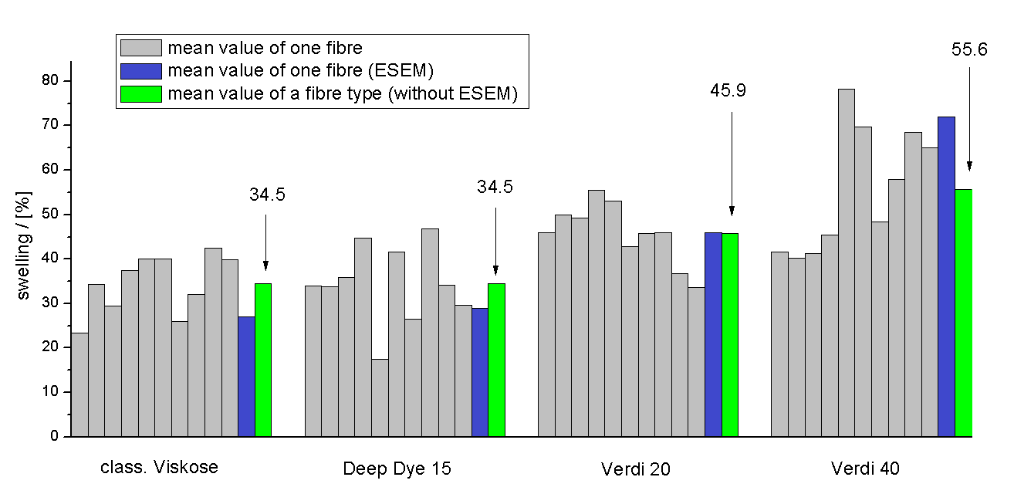
Figure 3: Swelling data for the four viscose fibre varieties with different surface charges

In addition to the swelling behavior, the tensile strength (represented by the breaking length) of each fibre type was investigated as well. As it is shown in Fig. 4 there is almost no breaking length for standard circular Viscose. Deep Dye 15 shows a breaking length in the same range than Verdi 20 and there is another huge increase in breaking length for Verdi 40.
Although Deep Dye 15 shows the same swelling behavior than standard Viscose the breaking length of this fibre type is considerably higher. This indicates that the increased tensile strength can almost exclusively attribute to the surface charge for cationic fibres, as the swelling behavior and thereby the bonded area is not affected. Based on these data we can hardly quantify the effect of swelling and/or surface charge for the CMC-treated fibres.

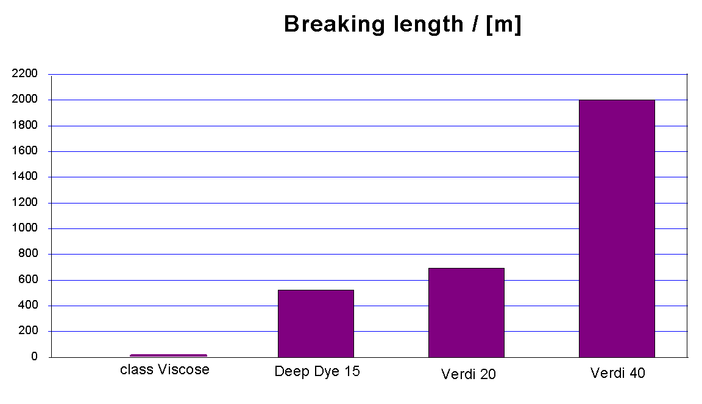
Figure 4: Breaking length of the four viscose fibre varieties with different surface charges

Outlook

To get a clearer picture of these effects the next steps are the determination of the surface charges of the investigated fibres as well as their bonding area. We hope this will give us a further indication which mechanisms are responsible for the improved fibre-fibre bonding of fibres containing CMC. The surface charge will be determined by titration. Bonding area is determined by polarized light microscope as well as via microtome slices.
In addition to these measurements, we will try to investigate the softness of the fibre surface in the swollen state via Atomic Force Microscopy (AFM). Thereby we hope to get an even better understanding for the effect of induced fibre swelling and for the improve bond strength of fibres containing CMC.

[1] N. A. El-Shinnawy, S. O. Heikal. Synthetic paper 2-viscose rayon fibre in papermaking. Cellulose Chem. Tech-nol., 14:919-927, 1980
[2] K. Niskanen, Y. Yu, H. Kettunen.Can viscose fibres reinforce paper? Journal of pulp and paper science, 25:398-402, 1999
[3] J.H. Young. Bonding in paper made from viscose fibres. Paper Technology, 13:25-26, 1972
[4] E. Duker, T. Lindström. On the mechanism behind the ability of CMC to enhance paper strength. Nordic Pulp and Paper Research Journal 23:57-64, 2008

