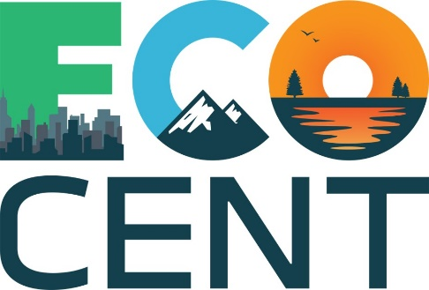
Innovation Ecosystems
for Circular Economy Entrepreneurs

AGENDA

LTTA
April 19th – April 21st 2023
Ljubljana, Slovenia

Please find following logistical information about Ljubljana.

Venue of the meeting:
Chamber of Commerce and Industry of Slovenia
Hall E (Mezzanine)
Dimičeva ulica 13
1000 Ljubljana
https://www.gzs.si/
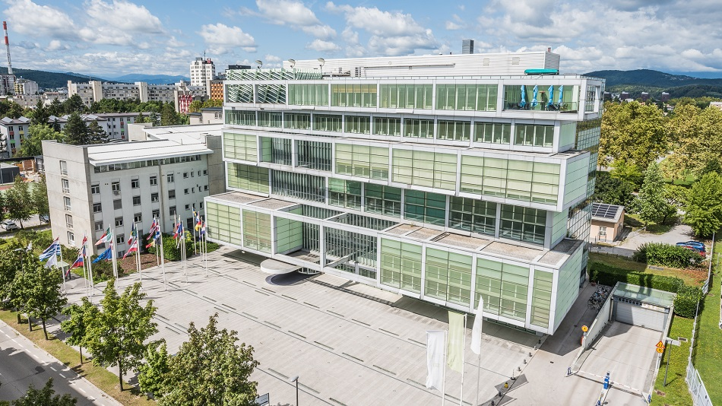

LTTA Schedule (TBC):
LTTA begins: Wednesday, April 19th 2023 @ 10:00 CET
LTTA ends: Friday, April 21st 2023 @ 16:00 CET

Contact in Ljubljana
Ana Lučka Pirnat
Chamber of Commerce and Industry of Slovenia
+386 31 643 623
+386 1 5898 444
ana.lucka.pirnat@gzs.si

Day I (Wednesday, April 19th 2023)
Time | Activity | Facilitator
10:00 – 10:30 | Welcome of the participants | CCIS
10:30 – 11:20 | Icebreakers and presentation of participants | CCIS
11:20 – 11:40 | COFFEE BREAK
11:40 – 12:40 | Project overview, presentation of in-service training, assessing expectations for the LTTA | CCIS
12:40 – 13:30 | LUNCH BREAK
13:30 – 14:00 | Introduction to Module 1: Introduction to the Circular Economy and the European Green Deal | FHB
14:00 – 15:30 | Module 1: Workshop 1 | FHB
15:30 – 15:40 | COFFEE BREAK
15:40 – 17:10 | Module 1: Workshop 2 | FHB
17:10 – 17:15 | Wrap up of day I | CCIS

Informal: Social dinner at Restavracija Šestica, Slovenska cesta 40, 1000 Ljubljana at 19:30

Day II (Thursday, April 20th 2023)
Time | Activity | Facilitator
09:00 – 09:30 | Introduction to Module 2: Addressing the skills gap in a transition to a circular economy | CCIS
09:30 – 11:00 | Module 2: Workshop 1 | CCIS
11:00 – 11:10 | COFFEE BREAK
11:10 – 12:40 | Module 2: Workshop 2 | CCIS
12:40 – 13:30 | LUNCH BREAK
13:30 – 14:00 | Introduction to Module 3: Circular Business Models | SRC
14:00 – 15:30 | Module 2: Workshop 1 | SRC
15:30 – 15:40 | COFFEE BREAK
15:40 – 17:10 | Module 2: Workshop 2 | SRC
17:10 – 17:15 | Wrap up of day II | CCIS

Day III (Friday, April 21st 2023)
Time | Activity | Facilitator
09:00 – 09:30 | MOOC presentation | CARDET
09:30 – 10:00 | Module 1: MOOC | FHB
10:00 – 10:30 | Module 2: MOOC | CCIS
10:30 – 11:00 | Module 3: MOOC | SRC
11:00 – 11:10 | COFFEE BREAK
11:10 – 12:40 | Skunkworks Session (part I) | ML + CARDET
12:40 – 13:30 | LUNCH BREAK
13:30 – 15:00 | Skunkworks Session (part II) | ML + CARDET
15:00 – 15:10 | COFFEE BREAK
15:10 – 16:00 | Summary, Evaluation, Wrap-Up | CCIS

