September 2016

PRESS RELEASE

Presentation of the NEW-D CURRICULUM

New Didactical Approaches in the

Dual Educational System

The main objective of the New-D project is to develop an innovative didactical model for VET teachers, trainers and company tutors dealing with disadvantaged young learners and NEETs (young people not in education, employment or training), in order to prevent their drop-out or to get them back into the VET system.

Therefore, the New-D Training Curriculum provides an innovative contribution to VET pedagogy and may act as an update-training for teachers or a core training for other (company) staff and gives practical guidelines how learning processes for the target group - formally, non-formally or even informally - can be planned and structured according to their life reality, their motivation factors and needs.
The New-D Training Curriculum is the 3rd Intellectual Output of the present project and it is based on the New-D Research Study (O1), containing data from each partner country on the experiences and opinions of young people in VET system and reasons for their drop-out, as well as on the New-D Guidelines (O2) that provide practical hints in seven main areas to support teachers/trainers/tutors in their daily work with disadvantaged young persons.
The present New-D Training Curriculum, therefore, is aimed to train teachers/trainers/tutors working in schools, training institutions and companies in order to improve their skills when dealing with the target group and acquire new methodologies and approaches in the seven main areas identified in the New-D Guidelines, as crucial in drop-out prevention:
- learning theories
- learning environment
- classroom-based work
- non-classroom-based work
- attitude towards learners
- role of teachers / trainers / tutors as a link between school - work - private environment
- conflict resolution and mediation.

The New-D Training Curriculum has a modular format: each training module is based on the respective guideline for a total of 7 modules and 30 hours of training. The Curriculum is developed by using the Learning Outcome approach, therefore contains a description of ECVET credits in terms of knowledge, skills and competences acquired by participants after having attended each module, for a total of 10 units of learning outcomes. Furthermore, each module has been developed by a different project partner and has been revised by two other partners to ensure a European perspective.

The New-D curriculum has been successfully presented at the last final conference of the project that was held on the 27th September 2016 in Graz/Austria.

More than 100 participants learnt about the project outcomes and especially about the New-D curriculum and also had the possibilities to work on the outcomes during some workshops organized during the conference.

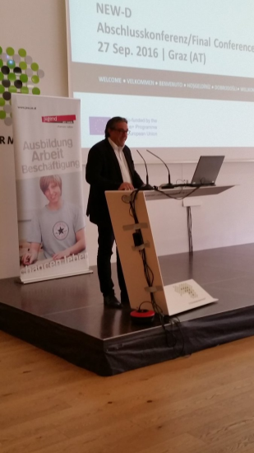  Mr. Berger from JAW | 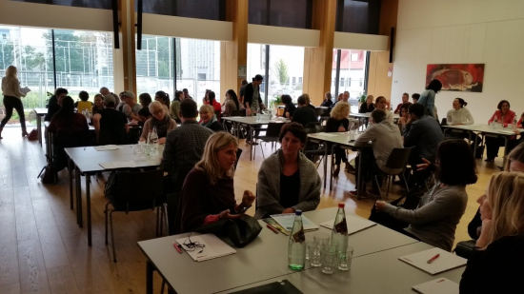  Workshop discussions

For further information about the curriculum and all other outcomes please visit the project website:
www.new-d.eu

Press Contact
If you would like to learn more about the NEW-D project:
- visit the NEW-D project website http://www.new-d.eu
- contact Mr. Robert Schuen (robert.schuen@jaw.or.at) – Jugend am Werk Steiermark GmbH

