Strokovna ekskurzija na specializiran sejem
MINERAL, METAL, METALLURGY MATERIALS 2014
Vrniti najkasneje do
1. julija 2014 na:
E: natasa.turk@gzs.si
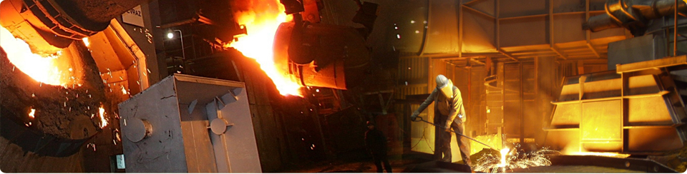
PRIJAVNICA
Prosimo izpolnite v angleškem jeziku!
COMPANY Name:
Contact Person (name and designation):
Contact Details:
Address:
Phone:
Fax:
Email:
Website: www.
Company profile (main products/services, core activities, strengths, final customers):

Sector of interest (please select one or more options):
- Aluminum Production  - Automation Technology  - Base Metals Production  - Bearings  - Gears  - Casting Machines & Technologies  - Copper Production  - Energy Conservation  - Exploration  - Ferro-Alloy  - Ferrous and Non-Ferrous Production  - Fire Detection & Suppression Systems  - Forging  - Foundry  - Furnaces  - Heat Treatment  - Instrumentation  - Iron and Steel Making  - Machine Tools |  | - Material Handling  - Measuring, Testing and Control  - Metal and Scrap Recycling  - Metal Engineering  - Metal Shaping and Finishing  - Metallurgical Equipment  - Mining  - Mineral Processing  - Plant Machinery and Equipment  - Process Control  - Pumps and Valves  - Raw Materials  - Refractory Products  - Rolling Mills  - Tube and Pipes  - Welding Technology  - Wires and Cables  - Zinc Production  - Materials Processing and Technologies
Others (please specify):
What is your role in the purchase decision taking process: | None
What is your role in the purchase decision taking process: | Influence
What is your role in the purchase decision taking process: | Specify
What is your role in the purchase decision taking process: | Authorize
What factors influence your decision to visit the exhibition (please select one or more options): | Variety of products on display
 | New Suppliers
 | Networking opportunity with Industry
 | Opportunity to buy new products/services
 | Opportunity to look for dealership
 | New launches
 | Parallel programmes
 | To gather information
 | International exhibitors
 | Supporting associations

Prosimo vas, da v nadaljevanju označite interes za sodelovanje:
 | Udeležba na dogodku:
Obisk sejma 4M | DA | NE
B2B srečanja v okviru sejma 4M | DA | NE
Zanima me ponudba za skupinski potovalni aražma. | DA | NE

Datum in kraj: Podpis in žig odgovorne osebe:

