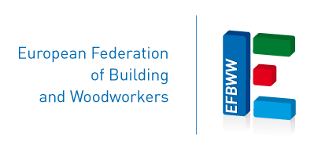
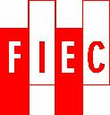
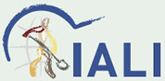

Dissemination project EFBWW-FIEC
“Guide for developing a H&S management system” and “Information modules for the safer handling of asbestos”

Final Seminar – Brussels 14th November 2014

8:30 - 9:00 Registration

9:00 Welcome

Morning Session: moderated by Gerd Albracht

9:15 Keynote speakers
- Jorge Costa-David - European Commission: "New EU Strategic Framework on Health and safety at Work 2014-2020 – the prevention of work-related diseases, including the ones caused by asbestos".

Discussion

10:00 Keynote speakers
- Ralf Hammesfahr: OSH-Management in SMEs – Needs, problems and solutions
- David Chauvin French Labour Inspectorate: Labour inspectorates as facilitator and supporter for better working conditions and social dialogue

Discussion

11:15 Coffee Break

11:30 Panel 1 – Asbestos Information Modules
- Moderated by: Lars Vedsmand
- Participants from four countries: Austria, Germany, Slovenia and Serbia

- Aspects for this panel discussion are:
- Their expectations regarding the asbestos problem
- Social partner and labour inspection needs for prevention and better implementation of OSH policies
- Challenges and experiences with cross country cooperation amongst IALI, FIEC and EFBWW members
- Their expectations towards the EU policy and the European Social Partner structures

12:30 Lunch Break

14:00 Panel 2 – OSH Management Systems
Moderated by: Domenico Campogrande
Participants from four countries: Bulgaria, Latvia, Slovenia and Spain

Aspects for this panel discussion are:
- Experiences of social partner organisations and social partner from company level with using the “Guide”
- Which specific activities about OSH management systems have been carried out at national level?
- Which results have been achieved? What are the priorities for the future?
- What are your expectations towards the EU-level

15:00 Final Discussion amongst all participants

15:30 End of seminar
Project carried out
with the financial support of the European Commission

